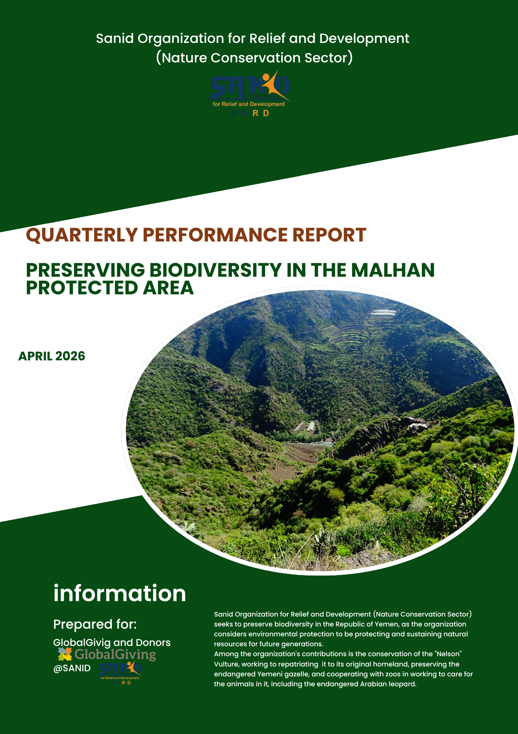

Project Title: Biodiversity Conservation in the Malhan Protected Area
Reporting Period: February 2026 – April 2026
Project Location: Yemen – Al Mahwit Governorate – Malhan District

1. Organization & Contact Information
- Implementing Partner: Sanid Organization for Relief and Development (SORD)
- Headquarters: Capital Secretariat – Shu'ub District – Al-Habari
- Project Manager: Shaif Ezzeldin
- Email: Programs.officer@sanid.org
- Website: www.sanid.org

2. Contextual Overview
The Malhan Protected Area in Al Mahwit Governorate is a unique natural sanctuary in Yemen, established by government decree in 2010. It is famously known as the "Arabian Leopard Reserve" because it hosts the rare Arabian leopard, the caracal, and various other wildlife species alongside ancient forests and perennial trees. Prior to the conflict, Yemen had prepared a comprehensive file to nominate Malhan for the UNESCO World Heritage list. This project seeks to resume conservation efforts to protect this cultural and natural heritage.

3. Implemented Activities (Feb – Apr 2026)
During this quarter, the following technical and field interventions were completed:
- Field Monitoring: Conducted site visits by the SORD team to monitor progress and identify urgent environmental needs.
- Violation Tracking: Maintained a volunteer team to monitor and report violations against rare migratory and resident birds.
- Institutional Coordination: Held meetings with the Environment Protection Authority (EPA) and legal consultants to advocate for the enforcement of national laws protecting rare birds and the reserve's integrity.
- Community Awareness: Executed awareness sessions in bird-nesting areas to teach local residents how to report environmental risks.
- Educational Outreach: Visited schools, universities, and institutes to educate students on the importance of protecting the Malhan Reserve.
- Legal Advocacy: Engaged with government authorities to activate protective measures and pursue legal action against those committing environmental crimes.
- Veterinary Care: Deployed a veterinary team to provide medical check-ups, vaccinations, and specialized nutritional support for rare birds and Arabian leopards under specialist supervision.
- Resource Mobilization: Continued efforts to secure funding for specialized bird-tracking and monitoring centers.

4. Challenges & Constraints
The project faced several significant hurdles during the implementation period:
- Economic Instability: The deteriorating economic situation in Yemen has negatively impacted environmental conditions.
- Government Capacity: A lack of government resources to meet the basic needs of the reserve, including forest and wildlife management.
- Legal Enforcement: Weak application of existing environmental laws against those who violate natural resources.
- Technical Gaps: Insufficient tools and equipment for the tracking and monitoring of migratory birds.
- Funding Shortages: Low levels of donations and financial support for specialized conservation activities.

5. Recommendations
- Strengthen the role of local communities and relevant authorities in safeguarding the reserve's biological components.
- Prioritize the implementation of service and tourism projects in the area to transform it into a sustainable attraction that supports local livelihoods.
- Activate rigorous legal prosecution against those responsible for illegal logging and environmental degradation.

Prepared by: Shaif Ezzeldin Project Manager

