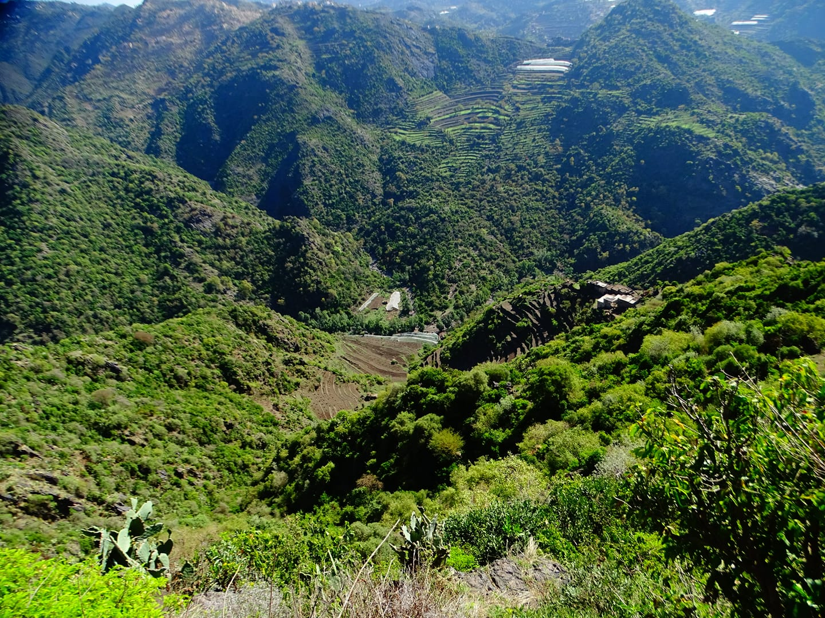

|  |
| --- |
| Conservation of wildlife and biodiversity in the Malhan Protected Area |
|  |
| **15 NOV 2024**  Sanid Organization for Relief and Development  Autor : Shaif Ahmed Ali Ezadeen |



|  |  |  |  |
| --- | --- | --- | --- |
| Project Name | Preserving biodiversity in the Melham Protected Area | | |
| The Protect Location | Yemen - Al Mahwit Governorate Melman District | | |
| Organization | Sanid Relief and Development Organization | | |
| Report Duration | Three and a half months​ | | |
| Starting Date | 2024-08-01 | Expiry date | 15-11-2024 |
| Organization address | Municipality of the Capital - People's District - Al-Habbari | | |
| Phone Number | *0096701205757* | | |
| Report Preparer | Shaif Ahmed Ali Ezadeen | | |
| Current Position | Project Manager | | |
| E-Mail | programmes.officer@sanid.org | | |
| Mobile Number | *00967 778515109* | | |
| WEB SITE | www.sanid.org | | |

Project Data

Overview

The project aims to preserve the endangered biodiversity in the Malhan Nature Reserve, which is a unique site that still maintains its ecological system , represented by the Arabian leopard, which became extinct in the Arabian Peninsula due to the threats and risks surrounding its environment in the Malhan area, as well as the distinctive plants with cash crops, such as medicinal and aromatic plants and perennial trees that reach more than 300 years and varying heights of up to more than 100 meters.   
  
All plants and trees that are part of the stabilization process for soil and humans as a result of climate change factors, erosion factors and natural disasters such as landslides due to its location near the towering Malhan Mountains. Therefore, the spotlight was shed on this reserve and many studies of a traditional nature and self-financing were carried out, which prompted all those interested in nature to pay attention to this distinctive patch of land, as the state had previously been interested in issuing a decision to declare it a nature reserve by a decision issued by the Prime Minister’s Office No. (349) of 2010.

All this biodiversity is reflected in the life of the individual and society, which depends entirely on these natural resources and practices its main activity in agriculture and some handicrafts and traditional professions. Rural women have an important and prominent role in visible and invisible activities and businesses such as farming the land, raising livestock, raising wild bees, and increasing the breeding of wild carnivorous birds such as Arabian partridges, rabbits and wool. All the local residents of the reserve depend on these natural resources as the only source of their livelihood and feeding their children in the old traditional ways. They also depend on wildlife and animals (mammals, reptiles and insects).   
  
The reserve includes various plant and animal species, including some rare and endangered species. The project aims to develop an administrative plan that takes into account all aspects and establishes a relationship between the reserve and the local community based on partnership and cooperation in preserving the animal and plant components of the reserve. This is limited to hunting and commercial purposes, determining and organizing grazing seasons, and raising community awareness of the importance of biodiversity and the sustainability of natural resources. The project will also implement cleaning campaigns throughout the reserve and find alternatives, especially to reduce excessive logging. The main target group for this project is the local community located in the Malhan Reserve area with parts of five regions representing seven sub-regions. The expected direct outcome of this project is the conservation of animal and plant species, especially threatened species, and the sustainability of natural resources for future generations. The importance of this project for international conservation lies in the fact that the Malhan Reserve represents a unique combination of physical factors that support many different ecosystems of great biological value, including endemic and endangered species, as well as the unique use of the land itself. The preservation of these vital values is part of the universal values because the environment has no borders and is considered an extension of other environments.

Implemented Activities :

* Implementation. Training. To volunteer local activists in the targeted areas to monitor and report on these violations.
* Conducting 4 awareness sessions in areas where rare birds of all kinds are found, criminalizing smuggling and killing, and reporting any dangers to which these birds are exposed.
* Holding 3 meetings with the relevant authorities through a legal office to follow up on the activation and implementation of the laws in force in Yemen related to the protection of rare birds and the reserve in general and preserving their beauty as an authentic Yemeni cultural and civilizational heritage.
* Field visit by the organization's team to the reserve to conduct a field survey and inspect the reserve and its emergency needs.
* Ensure the safety of birds in these areas, and that they do not die or are exposed to hunting.
* Continuing to monitor violations against rare birds, whether migratory or resident, through a volunteer team.
* Field visit to educational institutions (4 schools, 2 universities and 4 institutes) for the purpose of raising awareness and informing students of the importance of preserving and protecting reserves, the most important of which is the Malhan Reserve, in coordination with educational institutions.
* Implementing 3 meetings with the relevant government authorities to activate the role of protection and legal prosecution of perpetrators of crimes against the demolition of reserves.
* . Hold two meetings with Trusted and experienced partners on the ground to work on protecting the reserve.
* Conducting 2 field visits to the reserve, accompanied by a veterinary team, to check on the health of animals and birds. And to ensure that citizens do not cut trees again and use them as firewood .
* Providing medical care to some birds and animals by giving them vaccines and special food supplies to keep them alive.

