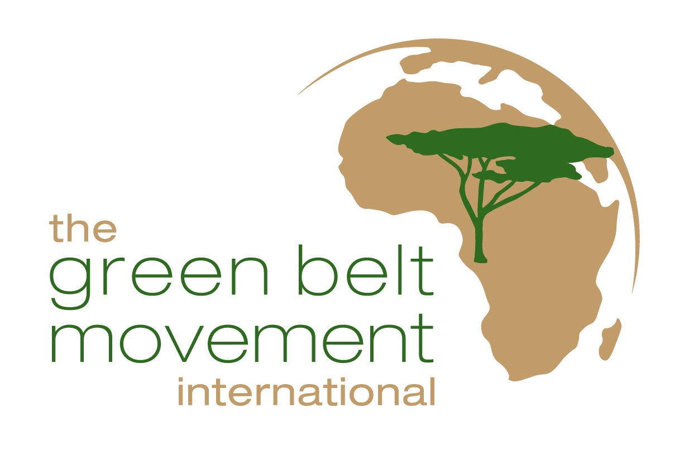

Community Tree Planting in the Mount Kenya ecosystem

This project will support communities adjacent to the Mt Kenya Forest Ecosystem to rehabilitate 65ha of degraded gazetted forest land and 60ha of public and private sites through tree planting and resource management,

Contents:

- Introduction
- Background
- Aims and objectives
- GBM suitability and potential project expansion / replication
- Any other information

1. Introduction

Community tree planting in the Mount Kenya ecosystem is a project in one of the Green Belt Movement’s (GBM) identified critical mountain catchment areas. The project builds upon GBM’s experience of working with communities to create sustainable livelihoods that support environmental and forests rehabilitation.

The overall aim of the project is empowering local communities in Kenya to benefit from their sustainable land-use and forest resource management activities.

To empower the local communities and rally them to conserve forests in Kenya, GBM plans to initiate a rehabilitation project in Runyenjes and Manyatta Constituencies within Mt Kenya ecosystem. The aim of this project is to restore degraded areas for improvement of hydrological functions, conservation of local biodiversity and ultimately betterment of livelihoods for the local communities. Thus, this 17-month project will support communities adjacent to the Mt Kenya Forest Ecosystem to rehabilitate 65ha of degraded gazetted forestland and about 60ha of public and private sites through tree planting and resource management.

2. Background

The Green Belt Movement (GBM) was founded in 1977 by Wangari Maathai (Nobel Laureate 2004). Since then over 45 million trees have been planted and hundreds of thousands of women in rural Kenya have lifted their families out of poverty, using tree-planting as the first step in mobilizing people to restore their natural environment and create sustainable livelihoods. Despite this there are still enormous challenges in Kenya and throughout Africa.

At the beginning of the twentieth century, closed canopy forests covered about 30% of Kenya’s land area. Today the figure is less than 2%. It is estimated by the United Nations that for sustainable development to occur, a nation, such as Kenya, needs to have at least 10% forest cover to provide all the vital services, which these important and fragile ecosystems supply. The reforestation needed to achieve 10% cover is about 50,000 sq km, which equates to over 4 billion trees.

World forests, which are critical for the continuation of life as we know it and for the maintenance of planetary conditions which support human society, continue to be removed at a catastrophic rate. To date environmental and developmental policies have failed to enable people in the developing world to access the wealth of their natural resources sustainably i.e. without endangering future generations.

The drivers of deforestation and forest degradation are multiple and complex. However, many are well understood such as unsustainable agricultural practices. As agricultural land degrades, farmers expand into new areas using destructive farming methods such as slash-and-burn, often at the expense of forests and savannah grasslands. With the loss of vegetation, follows the loss of the exposed soil and soil fertility, which are prerequisites for desertification. By addressing the issues of forests along with land-use, education and sustainable capacity building of indigenous peoples and local communities, forest protection and conservation can be significantly enhanced.

- Aims and objectives

- Engage over 181 GBM community groups in 42 networks to reach directly 3,545 people and at least 20,000 indirectly.
- Plant over 125,000 trees in the project period.
- Improve food security by promoting growing indigenous foods, organic farming, kitchen gardens and agro forestry.
- Implement water-harvesting approaches by cut off drains, run off collection in open drains/ dams, roof tapping by gutters and tanks, underground tanks and terracing.
- Through restoration of the environment, at least 50,000 people will benefit directly from improved access to firewood, food and clean water by the end of the project period.

The area targeted by the project consists of 65ha of forestland and 60ha of public and private sites. In the gazetted forest land in Mt. Kenya and Aberdares there are no settlements. The only buildings are those of Kenya forest service staff. However, Community Forest Association members have access to forest resources known as Non Timber Forest Products (NTFP) such as grass, herbs, fruits, honey and fallen branches as a source of fuel wood.

Public sites are lands meant for public utility such as schools, churches, market / shopping centers, cattle dips, watering points, natural springs, play grounds, hospital or dispensary lands. These sites are communally owned by the community of specific areas.

Overall, this initiative aims to provide long term funding opportunities for the networks GBM works with, to strengthen them and establish income generating activities and sustainable agriculture to ensure long-term sustainable livelihoods.
These networks are formed by tree nursery groups, with whom GBM works directly, and each group member represents one household/family where each household has got a minimum of five members

4. GBM suitability and potential project expansion / replication

The Green Belt Movement has been working with communities in rural Kenya on environmental conservation and development for 30 years. During this time it has established a proven and internationally recognized ten-step model of community development in which local people themselves identify problems and solutions; it is a truly grassroots approach. By restoring their environment, women and their families are able to access to basic resources like food, firewood, building, and fencing materials for fodder.

Tree-planting is used as the entry point to mobilize communities on a broad range of issues. They become not only champions for their local environment and demand good and equitable governance over the resources, but are empowered to stand up for their rights related to education, access to water and health. Working in this integrated way, GBM recognizes that sustainable development can only take place when the linkages between the environment, poverty and conflict are understood.

It is for developing and championing this holistic approach to sustainable development that, in 2004, our founder Wangari Maathai became the first environmentalist and the first African woman to win the Nobel Peace Prize. Since this time, GBM has grown into an international organization that seeks to empower individuals worldwide to protect the environment and promote good governance and cultures of peace.

5. Any other information relevant to the project

Appendix A: GBM’s ten step approach
Appendix B: Tree species suitable for the Mt. Kenya area

Appendix A

The GBM Ten Step Approach: How We Work

The GBM works mostly with rural populations. In order to ensure ownership of the programs and sustainability, the following steps are used to guide groups. This ensures that not only are trees planted but that they are followed up to secure a high rate of survival. The 10-step procedure is summarized here below:

Step 1: Sensitization & Mobilization
This is done in communities through Civic and Environmental Education (CEE) seminars to disseminate information on the importance of protecting their immediate environment (Primary Environmental Care), teach GBM goals and values, and assist groups to identify problems in their community. The seminars also bring out the importance of communities understanding the role of governance in the management of resources and their own roles and responsibilities in solving the problems they have identified.

Through the seminars the groups also identify collective action that they can take to protect the environment, practice democratic principles, engage in the governance process, and solve other specific community development problems. Tree planting is identified as an entry point through which groups can commit to environmental action and begin to organize. Civic and Environmental outreach seminars are also involve local leaders and other stakeholders.

Step 2: Group Formation
CEE seminars are open to anyone interested in participating in GBM activities which starts with group formation. The groups are largely formed around women’s groups but men and youth also participate. Once formed, the groups obtain legal registration with the relevant government authority.

Step 3: Group Registration with GBM
Once registered with the government authority, groups submit their request for registration to the GBM. This officially opens up communication with GBM headquarters where they receive support to begin their activities. The groups can now approach the government authorities for a site to establish their tree nursery.

Step 4: Tree Nursery Establishment
Once a tree nursery site has been identified, groups receive assistance on the preparation and establishment of tree nurseries. Through the CEE seminars groups will have been taught how to collect seeds (indigenous, fruits and exotic) from their surroundings and forests. In some instances, GBM provides initial seeds and potting bags to get the groups started.

Step 5: Tree Nursery Management
The women sow the seeds in seed beds. Once the seeds germinate, the young seedlings are pricked out into individual potting bags filled with fertile soil. There they are allowed to grow and develop their root systems until they achieve an adequate size (45 cm and above). The women provide GBM headquarters with monthly reports on the status of the nursery with the assistance of extension staff. The photograph below shows an established tree nursery with thousands of seedlings in potting bags.

Step 6: Promotion Activities
Once seedlings are ready to be distributed, the groups announce to their communities that seedlings are ready for issuing. They request those interested and ready (including themselves) to prepare holes for planting. Promotion activities ensure that communities understand the importance of, not only planting, but also reducing wastage and enhancing survival.

Step 7: Checking Holes
Group members check the holes to ascertain they are properly dug prior to supplying seedlings for planting. This is important because unless seedlings are properly planted they will not survive. Where soil is of poor quality, manure or forest soil is applied.

Step 8: Issuing of Seedlings
Once the dug holes are approved by the staff, the groups issue seedlings for planting and the report of seedlings issued is sent to the GBM headquarters in the monthly report. Community members conduct continuous follow-up of the planted trees to ensure proper planting and aftercare to enhance survival. Throughout this period, the groups send monthly reports to the headquarters.

Step 9: First Verification of Seedling Survival
Two months after planting, the first verification exercise is conducted by GBM extension staff to validate the survival of the planted trees. The results of this exercise are sent to the headquarters. This involves inspecting the trees planted and determining that they are being well taken care of. No payment is made to the groups at this point.

Step 10: Second Verification of Seedling Survival
A second and final verification exercise is conducted by GBM staff. This is not only to ensure survival but also to encourage participants to appreciate the need for trees to nurture planted trees. It is for this reason that survival of seedlings is the basis for compensation to the groups. GBM does not compensate for seedlings on a “Pay As You Plant” basis. Payment is delayed until after the 2nd verification exercise because seedlings are by then well established and able to survive on their own. The compensation of women is a token of appreciation for the groups’ involvement in tree planting activities. The strenuous exercise of verification by
GBM staff to ensure survival of seedlings is the secret of GBMs success. Although this process is time-consuming and expensive, it is extremely important because the campaign would be worthless if trees planted do not survive. One of the reasons for CEE seminars, the extension service, monitoring & evaluation and verification is to ensure survival. This can not be overemphasized.

In addition to planting trees in their immediate surroundings, GBM groups also engage in tree planting activities in the forest and in the planting of fruit trees on their farms. This is one of the ways in which groups are expected to improve their food security. GBM also encourages these groups to commercialize their tree nurseries to earn additional income.

Appendix B

Botanical name | Local name | Common name
Olea welwitschii | Mucarage | Elgon teak
Podocarpus falcatus(glacilior) | Muthengera | Podo
Podocarpus latifolius | Muthengera | Podo
Prunus africana | Muiri | Prunus
Polyscias kikuyunensis | Mutati | Polysciaas spp
Teclea nobilis | Munderedu | Teclea
Olea europacea sub sp. africana | Mutamaiyu-kumutamaywa | African Olive
Dombeya torrido | Mukeu | Dombeya
Croton macrostachyus | Mutundu-kumukikhili | Croton
Olea hochstelteri | Mucharage | Olea spp
Newtonica buchananii | Mukui | Newtonia
Makhamia lutea | Muu-kumusola | Markhamia
Warbugia ugandansis | Muthiga | Green Heart
Syzygium guineese | Mukoe | Szygium
Croton megalocarpus | Mukinduri-kumuasio | Croton
Bridelia mccrantha | Mukoigo-kumulondamwombe | Bredelia
Callonderon capensi | Muraracii | Cape chestnut
Trchilia ovata | Murirui | Cape mahogany
Vitex Kiniesis | Muhuru | Meru Oak
Junierus procera | Mutarakwa | African pencil Cedar

