Introducing…… The Kenya Connect LRC Annex

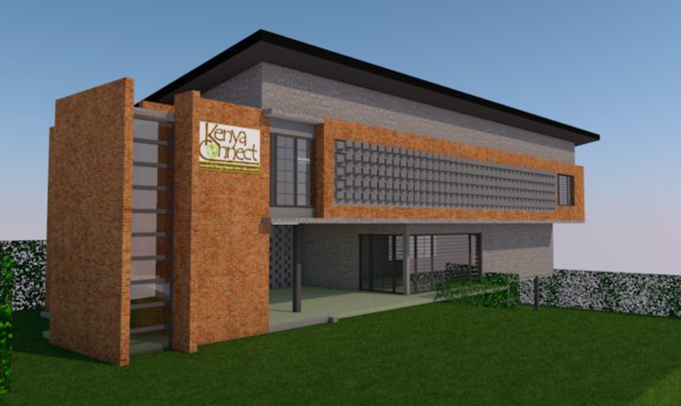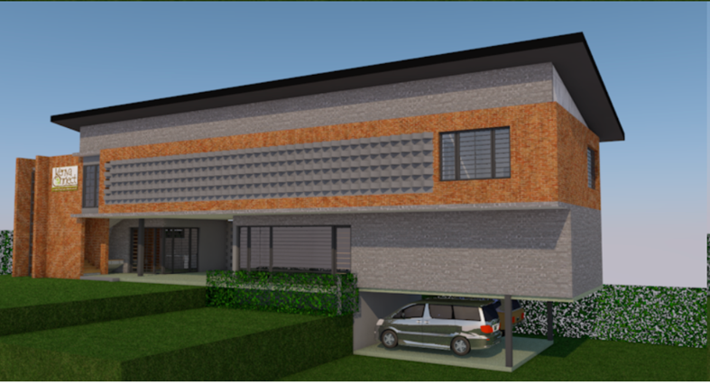

The Kenya Connect LRC Annex will be located adjacent to the Learning Resource Center property on recently purchased land. The building will feature a proper library, conference room, staff offices, sound studio/radio station, and storage space. In addition, a Maker Space will be created in the current Learning Resource Center. The properties will flow together as ONE Kenya Connect Campus with seating, plantings, and play space. This expansion will allow us to expand our reach to the 18,000 students at our 61 partner schools, 500 teachers as well as community members.
We are excited! Will you help make this project a reality?

LRC Annex and Maker Space Naming Opportunities

In appreciation and recognition for the donors making the LRC Annex and Maker Space a reality, we are inviting donors to be recognized for their gift. As gifts are received, the Executive Directors will reach out to discuss the options. (Naming is based on gift and not GlobalGiving match.)

Amount Naming Opportunity
$15,000+ Maker Space (already reserved)
Library (already reserved)

$10,000 Library Kiddie Corner
Front Veranda Gathering Space (already reserved)
Conference Room
Audio Studio/Radio Station

$ 5,000 LRC Annex Gate Entrance
Reception Area
Solar Panels
Water Tank

$ 2,500 Offices x 10
Kitchenette

$1,000 Study Carrel in library x 10
Library Seating Section x 4 (one already reserved)
Outdoor Reading Benches x 5

$ 500 Trees Planted around Perimeter of Property (x 20)

$ 250 Book Shelf (20)
White Board in Maker Space (1)
Art/Supply Cabinets in Maker Space (6)

$100 Bookplate in 5 books honoring the new library

