 Monthly Report

|  |  |
| --- | --- |
| Center Name | Alzahraa Medical Center (AMC) |
| Prepared by: | Youssef K. Aouli |
| Name of Coordinator / Manager:  *Name, email, and phone* | Name: Youssef K. Aouli  Phone Number : +961 3041125 Email : health.pM@aica-lb.org |
| Reporting period  *From – To* | From 1st May 2024 to 31st May 2024 |

# Management Update:

)Administrative decisions , new projects…)

* We are expecting to sign a new project with the World Bank in collaboration with the Ministry of Public Health. This project encompasses medical packages tailored for low-income individuals registered with the Ministry of Social Affairs.

# Department Update:

(numb of ben, services, activity implemented on filed ….)

AMC is a Primary health care center located between Mankoubin& Jabal Mohsen- Tripoli operating under AICA. In partnership with MoPH, the center was established in November 2008 as a dispensary based on the gap in healthcare provision within the community and has evolved since then into a Primary Health Care Center in late 2016.The center has established a partnership with MoSA as of 2011 and has undergone several partnerships with Médecins Sans Frontières (2012 – 2017), Relief International (2017), and other two active partnerships with YMCA(2008)&Première Urgence – Aide Médicale Internationale(PU-AMI 2019 - 2023). AMC receives patients without any discrimination in gender, color, race, or religion providing general and specialist examination for minimal fees as well as free medicines, chronic medications and vaccination in addition to a bundle of health services. The center receives an average of 7000 beneficiaries / month visiting from different areas within the North governorate. Since the pandemic, AMC developed an emergency plan partnering with CRS to serve better the community.

**● Activity 1:** We have maintained all services at supported prices in collaboration with AICA and the Ministry of Public Health. General physician consultations are priced at 400,000 LBP, and specialist consultations at 600,000 LBP, in addition to free vaccines and medications.

**Activity 2:** We started implementing the project with MSF, which includes providing services related to non-communicable diseases and mental health to populations in need. The subsidy for renewing chronic medications has been modified from 100,000 LBP to 50,000 LBP per patient through our general practitioner, with great interest from patients in renewing medications at this subsidized price. In addition, we have contracted a new pharmacist to speed up the distribution and purchase of patient supplies, and the center is now equipped with a pharmacist and assistants. Moreover, psychological treatment began to work starting from the first of May, as we examined 16 people from the first month.

**Activity 3:** Medication Dispensing: Prescription medications issued by our center's physician are promptly prepared and dispensed by our pharmacist. Each medication includes a label indicating appropriate usage, administration, and timing. Additionally, applications are submitted for patients suffering from chronic diseases to benefit from the Young Men's Christian Program in cooperation with the Ministry of Health, which provides chronic medications free of charge.

**Activity 4:** We are facing the challenge of achieving our goals due to the high volume of services and patients, necessitating the need to provide services to all.

**Activity 5:** We adhere to high-quality standards in all our operations.

**Activity 6:** We are still waiting for the project with the World Bank, as this project includes the distribution of medical packages specially designed for people with limited income who are registered with the Ministry of Social Affairs.

# Finance Update:

(Finance request – donation …. Payments)

Action plan for next Month:

|  |  |  |  |  |
| --- | --- | --- | --- | --- |
| Activities | Description of the activity | Modality (value, frequency…) | Location of activities | Number of Target Group |
| Activity 1: | Maintained services at supported prices in collaboration with AICA and the Ministry of Public Health. General physician consultations priced at 400,000 LBP, specialist consultations at 600,000 LBP, free vaccines and medications. | Value: 400,000 LBP (GP), 600,000 LBP (Specialist), Frequency: Ongoing | AMC | All patients seeking consultations |
| Activity 2: | Implemented project with MSF for non-communicable diseases and mental health services. Subsidy for renewing chronic medications changed from 100,000 LBP to 50,000 LBP per patient. New pharmacist hired to expedite supply distribution. Psychological treatment started in May, examining 16 people in the first month. | Value: 50,000 LBP per patient (subsidy), Frequency: Monthly | AMC | Patients with non-communicable diseases and mental health needs |
| Activity 3: | Medication Dispensing: Prescription medications prepared and dispensed by pharmacist with usage labels. Applications submitted for chronic disease patients to benefit from the Young Men's Christian Program for free chronic medications. | needed for prescriptions, Ongoing applications for chronic medications | AMC | Patients requiring medication, especially those with chronic diseases |
| Activity 4: | Faced challenges in achieving goals due to high volume of services and patients, necessitating service provision to all. | Ongoing | AMC | |  | | --- | |  |  |  | | --- | | All patients | |
| Activity 5: | Adhere to high-quality standards in all operations. | Ongoing | AMC | All patients and staff |
| Activity 6: | Awaiting project with the World Bank for distribution of medical packages to people with limited income registered with the Ministry of Social Affairs. | Pending project initiation | AMC | Low-income individuals registered with Ministry of Social Affairs |

## Challenges

*Overview of any challenges encountered during the reporting period and how they were tackled*

|  |  |
| --- | --- |
| Challenge(s) | Response(s) |
| High volume of services and patients necessitating the need to provide services to all | Maintained all services at supported prices in collaboration with AICA and the Ministry of Public Health. Ensured pricing remains accessible (400,000 LBP for GP, 600,000 LBP for specialists). |
| Need to provide timely and efficient medication dispensing | Hired a new pharmacist to speed up the distribution and purchase of patient supplies, ensuring medications are promptly prepared and dispensed with appropriate labels. |
| Demand for affordable chronic medication renewals | Modified the subsidy for renewing chronic medications from 100,000 LBP to 50,000 LBP per patient, which increased patient interest in renewing medications at this subsidized price. |
| Psychological treatment needs | Initiated psychological treatment services starting from the first of May. |

## Monitoring

|  |  |  |  |
| --- | --- | --- | --- |
| Indicators | Number achieved during the reporting period | Overall target | Progress towards target |
| **Health activity 1:** Services | 3,216 | 6,000 | 53.6% |
| **Health activity 2:** Individuals (with duplication) who benefited from services, disaggregation between male and female. | Female: 1,949  Male: 1,267 | Female: 3,000  Male: 3,000 | Female: 64.96%  Male: 42.23% |
| **Health activity 3:** Individuals who benefited from medication chronic. | 464 | 1470 | 31.56 % |

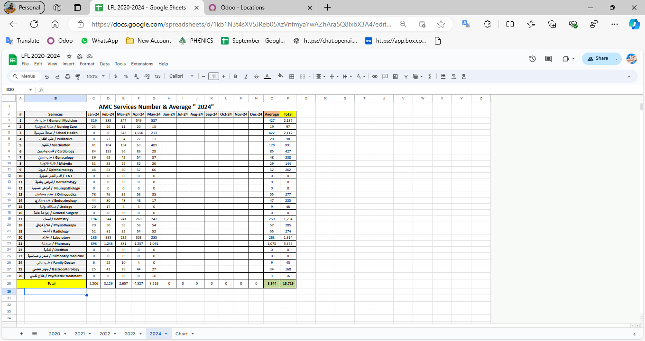

|  |  |  |  |
| --- | --- | --- | --- |
| Monitoring tools used (satisfaction surveys, discussions with beneficiaries…) | Sample size | Primary findings from these tools | Actions taken/to be taken in response to these findings |
| Complaints Box | 0 | N/A | N/A |
| Hot line | 0 | N/A | N/A |
| Individual interviews. | 40 | - Incorrect Appointments  - Suggestion for Night Shifts  - High Cost of Specialized Services | - Improve appointment scheduling system - We cannot because of a ministerial decision  - Review pricing structure of specialized services |
| Beneficiaries Satisfactory | 0 | N/A | N/A |

## Coordination and communication

*Please list any coordination meetings or communication with national response actors (Government of Lebanon, municipalities, local community, FGOs, INGOs…)*

|  |  |  |
| --- | --- | --- |
| Date [dd/mm/yyyy] | Response actor | Type of coordination [meeting, email, phone call] and purpose |
| 8 – May – 2024 | WVL – Dima Moussa | Phone call, about FR |
| 13 – May – 2024 | MSF – Field (Karim, Zeina, Ita and Nisreen) | Meeting and Email, About new support |
| 27 – May – 2024 | Chantal Lichaa | About AMC |

## Annex II: Success Story

(About your team activity, or may be from beneficiary or good implementation for activity …)

One of the most rewarding aspects of our work has been the opportunity to follow up with our beneficiaries and ensure they receive the care they need, even amidst challenging circumstances. Through regular phone calls and appointment bookings, we've been able to check on their health and well-being, providing a sense of reassurance and support.

The feedback from beneficiaries has been overwhelmingly positive, with many expressing gratitude for the attention and care they've received. Despite facing various adversities, our commitment to improving their lives remains unwavering.

This success story serves as a reminder of the importance of our work and motivates us to continue striving for excellence in everything we do.