 Monthly Report

Center Name | Alzahraa Medical Center (AMC)
Prepared by: | Youssef K. Aouli
Name of Coordinator / Manager:  Name, email, and phone | Name: Youssef K. Aouli  Phone Number : +961 3041125 Email : health.pm@aica-lb.org
Reporting period  From – To | From 1st April 2024 to 30th April 2024

Management Update:

)Administrative decisions , new projects…)
- We are expecting to sign a new project with the World Bank in collaboration with the Ministry of Public Health. This project encompasses medical packages tailored for low-income individuals registered with the Ministry of Social Affairs.

Department Update:

(numb of ben, services, activity implemented on filed ….)

AMC is a Primary health care center located between Mankoubin& Jabal Mohsen- Tripoli operating under AICA. In partnership with MoPH, the center was established in November 2008 as a dispensary based on the gap in healthcare provision within the community and has evolved since then into a Primary Health Care Center in late 2016.The center has established a partnership with MoSA as of 2011 and has undergone several partnerships with Médecins Sans Frontières (2012 – 2017), Relief International (2017), and other two active partnerships with YMCA(2008)&Première Urgence – Aide Médicale Internationale(PU-AMI 2019 - 2023). AMC receives patients without any discrimination in gender, color, race, or religion providing general and specialist examination for minimal fees as well as free medicines, chronic medications and vaccination in addition to a bundle of health services. The center receives an average of 7000 beneficiaries / month visiting from different areas within the North governorate. Since the pandemic, AMC developed an emergency plan partnering with CRS to serve better the community.

● Activity 1: We have maintained all services at supported prices in collaboration with AICA and the Ministry of Public Health. General physician consultations are priced at 400,000 LBP, and specialist consultations at 600,000 LBP, in addition to free vaccines and medications.
Activity 2: We have initiated the implementation of the project with Médecins Sans Frontières (MSF), which includes providing services related to non-communicable diseases and mental health to populations in need. We have also started supporting the renewal of chronic medications at a nominal price of 100,000 LBP per patient through our general physician, with significant interest from patients for medication renewal at this subsidized rate. Additionally, we have contracted a new pharmacist to expedite the distribution and procurement of patient supplies, now equipped with a pharmacist and two assistants. Furthermore, we have contracted a psychotherapist who will commence work from May 1st. We also expect to support the consultation for cardio and endo starting the first of May.
Activity 3: We are working on starting a contract with Monla Hospital. This contract plays a role in capacity building and improving the quality of medical services provided.
Activity 4: Medication Dispensing: Prescription medications issued by our center's physician are promptly prepared and dispensed by our pharmacist. Each medication includes a label indicating appropriate usage, administration, and timing. Additionally, applications are submitted for patients suffering from chronic diseases to benefit from the Young Men's Christian Program in cooperation with the Ministry of Health, which provides chronic medications free of charge.
Activity 5: We are facing the challenge of achieving our goals due to the high volume of services and patients, necessitating the need to provide services to all.
Activity 6: We adhere to high-quality standards in all our operations.
Activity 7: We anticipate that the project with the World Bank will commence on May 1st. This project includes distributing specially designed medical packages to low-income individuals registered with the Ministry of Social Affairs

Finance Update:
(Finance request – donation …. Payments)

Action plan for next Month:

Activities | Description of the activity | Modality (value, frequency…) | Location of activities | Number of Target Group
Activity 1: | Maintaining all services at supported prices with set consultation fees and free vaccines/medications. | Consultation fees set at 400,000 LBP for general physicians and 600,000 LBP for specialists, with free vaccines and medications provided. | AMC | All patients
Activity 2: | Implementation of the project with Médecins Sans Frontières (MSF), providing services related to non-communicable diseases and mental health for populations in need. | Implementation of project activities as outlined by MSF, ongoing throughout the month. | Triage and GP room in AMC | All patients with YMCA membership
Activity 3: | Negotiating a capacity-building contract with Monla Hospital to enhance medical service quality and capacity. | Contract negotiation and establishment of partnership activities. | AMC | Medical staff and beneficiaries
Activity 4: | Dispensing prescribed medications and collaborating with health programs. | Immediate dispensing of medications with proper labeling; applications for chronic disease medication support. | Pharmacy in AMC | Patients with chronic diseases
Activity 5: | Addressing challenges associated with high service demand through strategic management and operational planning. | Management and planning activities throughout the month. | AMC | Staff
Activity 6: | Ensuring adherence to high-quality service standards. | Continuous monitoring and evaluation of service quality. | Across all activities within AMC | Staff, Patients
Activity 7: | Launching the project with the World Bank to distribute medical packages to low-income individuals registered with the Ministry of Social Affairs. | Project initiation and distribution activities. | AMC | All patients registered with the Ministry of Social Affairs

Challenges
Overview of any challenges encountered during the reporting period and how they were tackled
Challenge(s) | Response(s)
Handling large service demand | Implement strategic management and operational planning to optimize resources, streamline processes, and prioritize critical services to efficiently accommodate the high volume of patients and service demands.
Capacity building and quality improvement with Monla Hospital | Engage in negotiations and collaboration with Monla Hospital to establish a comprehensive partnership for capacity building and quality enhancement.
Initiating projects with MSF and WB | Facilitate ongoing consultations and preparations for projects with MSF and WB, ensuring alignment with organizational goals and effective implementation of planned initiatives.
Ensuring medication availability and chronic disease support | Maintain partnerships with relevant programs YMCA to secure medications for patients with chronic illnesses and streamline dispensing processes.

Monitoring
Indicators | Number achieved during the reporting period | Overall target | Progress towards target
Health activity 1: Services | 4,527 | 6,000 | 75.45%
Health activity 2: Individuals (with duplication) who benefited from services, disaggregation between male and female. | Female: 2,827  Male: 1,700 | Female: 3,000  Male: 3,000 | Female: 94.23%  Male: 56.66%
Health activity 3: Individuals who benefited from medication chronic. | 464 | 1470 | 31.56 %

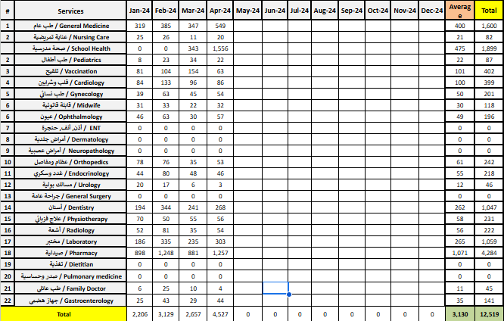

Monitoring tools used (satisfaction surveys, discussions with beneficiaries…) | Sample size | Primary findings from these tools | Actions taken/to be taken in response to these findings
Complaints Box | 13 | - Papers were numbered and sorted into categories: complaints, compliments, and canceled papers.  - Beneficiaries with complaints were contacted by phone for full clarification.  - Beneficiaries providing compliments were thanked for their positive feedback.  - Canceled paper was addressed accordingly. | - Each complaint was objectively addressed by the concerned party.  - Encouraged beneficiaries to contact for further inquiries or feedback.
Hot line | 0 | N/A | N/A
Individual interviews. | 15 | - Long waiting periods for appointments noted.  - Concerns raised regarding high consultation fees.  - Request for additional gynecologist and pediatric doctors.  - Desire for more specialist doctors. | - Implementation of Odoo System for appointment scheduling to reduce waiting times.  - Exploring partnerships with INGOs to support consultation fees.  - Recruiting more gynecologists and pediatric doctors to address the demand.
Beneficiaries Satisfactory | 0 | N/A | N/A

Coordination and communication

Please list any coordination meetings or communication with national response actors (Government of Lebanon, municipalities, local community, FGOs, INGOs…)
Date [dd/mm/yyyy] | Response actor | Type of coordination [meeting, email, phone call] and purpose
9 – 25 – April – 2024 | WVL – Dima Moussa | Phone call, about FR
5 – 8 – 17 – April – 2024 | MSF – Field (Karim, Zeina, Ita and Nisreen) | Meeting and Email, About new support

Annex II: Success Story

(About your team activity, or may be from beneficiary or good implementation for activity …)

One of the most rewarding aspects of our work has been the opportunity to follow up with our beneficiaries and ensure they receive the care they need, even amidst challenging circumstances. Through regular phone calls and appointment bookings, we've been able to check on their health and well-being, providing a sense of reassurance and support.
The feedback from beneficiaries has been overwhelmingly positive, with many expressing gratitude for the attention and care they've received. Despite facing various adversities, our commitment to improving their lives remains unwavering.
This success story serves as a reminder of the importance of our work and motivates us to continue striving for excellence in everything we do.

