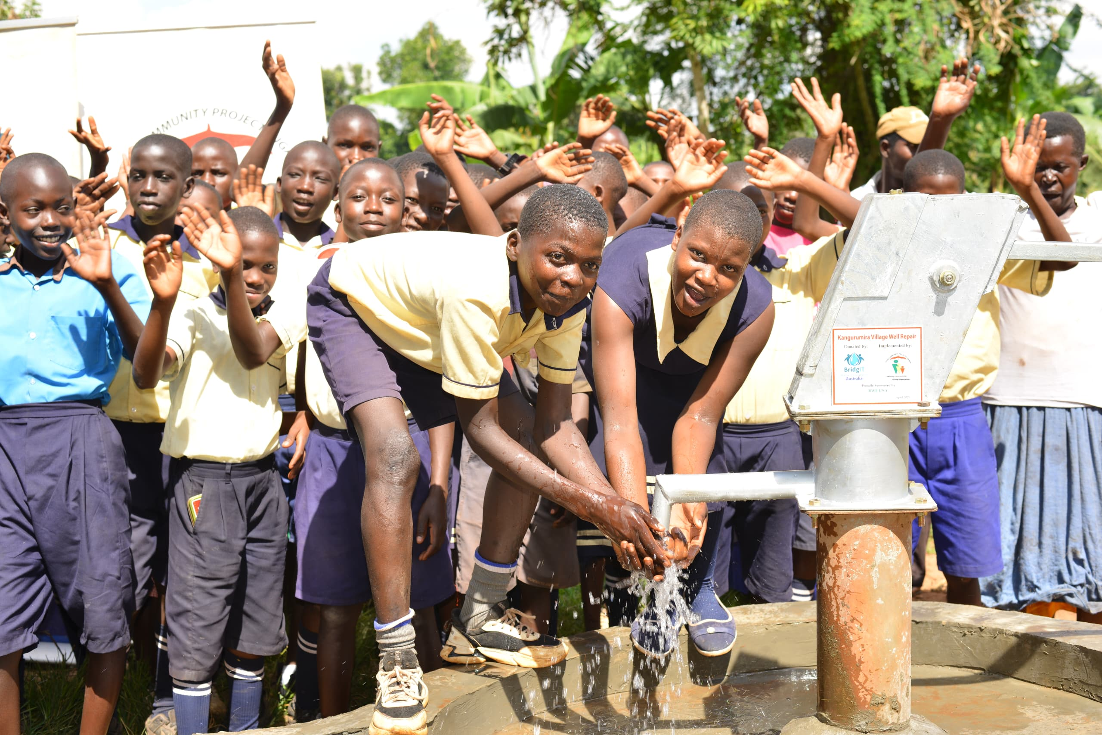

**Completion Report**

**2025 Rural** **Village** **Well** **Refurbishment Program**

**Uganda**

**Sponsored by: BWF USA**

**Duration: 1st April 2025 to 16thApril 2025**

Managing Partner: **BridgIT Water Foundation, Australia**

Implementing Regional Partner: **Suubi Community Projects, Uganda**

**Introduction**

|  |  |  |  |  |  |
| --- | --- | --- | --- | --- | --- |
| Organisation (Partner) Name: | | Suubi Community Projects Uganda (SPCU) | | | |
| Partner Contact: | | Steven Beingana | | **Report Date:** | 24th April 2025 |
| Partner Contact Title: | | Director | | | |
| Country: | | Uganda | | | |
| Project / Program Name: | | 2025 Refurbished Well Program Uganda | | | |
| Email: | [info@scpuganda.org](mailto:info@scpuganda.org) | | **Website:** | [www.scpuganda.org](http://www.scpuganda.org) | |
| Donor: | BWF USA | | **Project Status:** | Completed | |
| This project is now successfully completed. This report shows how project funds were spent and the impact project funds have made to the beneficiary communities. | | | | | |

**Brief Implementing Partner Introduction & Approach:**

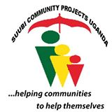**Suubi Community Projects Uganda (SCPU)** is a registered community-based organisation in Uganda.

SPCU’s mission is “**to help improve access to clean and safe water and the quality of health and education service delivery for the neediest communities in rural Uganda”.**

For the past 10 years, SCPU has been working in the rural areas of Uganda on programs that are focused on: increasing access to safe water and sanitation, improving health service delivery, improving education service delivery and economic empowerment for rural community members.

SPCU’s approach is based on the **self-help model** and community ownership of all the projects; believing this is a more sustainable approach to foster the development of rural communities.

SPCU has broad experience working with both local and international donors and volunteers in managing and implementing WASH projects. For the past 12 years the organization has implemented the construction and/or repair of 500+ boreholes.

**Background to Project**

In April 2025, SCPU received a grant from BridgIT Water Foundation Australia (BWF) under the sponsorship of **BWF USA** for the refurbishment of **1 community water well** in Kayunga District.

**Project Rationale & Context**

In sub-Saharan Africa, one in every three wells are in non-working order, most commonly due to broken hand pumps, used to pump the ground water to the surface. This is because in the past, many governments and non-government organizations have simply come in with a drill team, drilled a well, and left. There was rarely any training on well maintenance, the establishment of a water user committee, or routine follow-ups.

When the hand pump eventually needs repair, the communities are unable to do so because of the lack of resources, proper management, and sense of ownership.

In most cases, the repair simply requires an overhaul of the hand pump system, but this cost is way too high for the communities to fund if they have not been pooling together a maintenance fund for the past couple of years.

**Description of Funded Activities - Action & Methodology**

The scope of work involved the refurbishment of (1) existing borewell by the re-construction of the apron/platform (where necessary), the replacement of all the hand pump parts, and the implementation of water sustainability strategies by establishing and training a Water User Committee.

The borewell was successfully repaired by a trained site team by installing new hand pump parts including riser pipes, connecting rods, cylinder pump, water tank, and complete head assembly (Indian MarkII) and any necessary masonry work on the platform.

**Beneficiaries & Stakeholders**

The project beneficiaries are the **1,260** residents of Kangulumira B Village in Kayunga District.

This borehole was constructed by the government more than 20 years ago to provide safe water to the community. 3 years ago, the borehole broke down and needed major repairs that the community could not afford. Community members were forced to start using unsafe/dirty water from surface ponds. Women and Children have been walking up to 4km into swamps to collect dirty water.

|  |  |  |  |
| --- | --- | --- | --- |
| Coordinates | Community Names | H/Holds | People Impacted |
| [0.58179N, 33.02665E](https://www.google.com.ua/maps/place/0%C2%B034'54.4%22N+33%C2%B001'35.9%22E/@0.5817954,33.0240751,1065m/data=!3m2!1e3!4b1!4m4!3m3!8m2!3d0.58179!4d33.02665?entry=ttu&g_ep=EgoyMDI1MDQyMy4wIKXMDSoASAFQAw%3D%3D) | **Kangulumira B** | **210** | **1260** |

* Populations figures are based on the number of households per community, allowing for 10 people per household.

**Pictorial of Work in Progress**

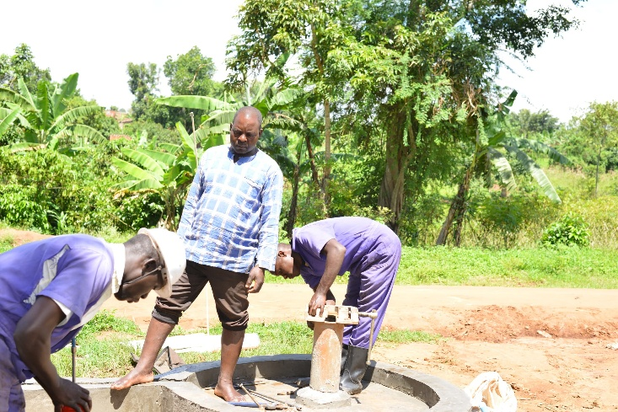 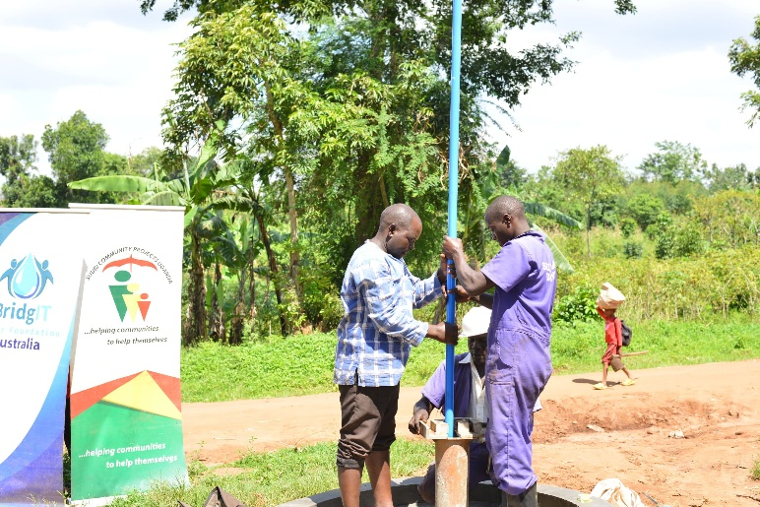

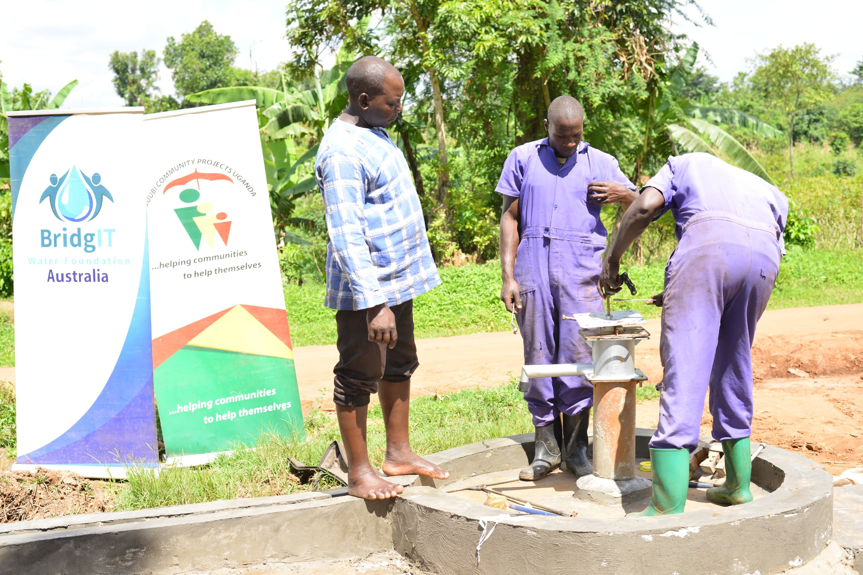

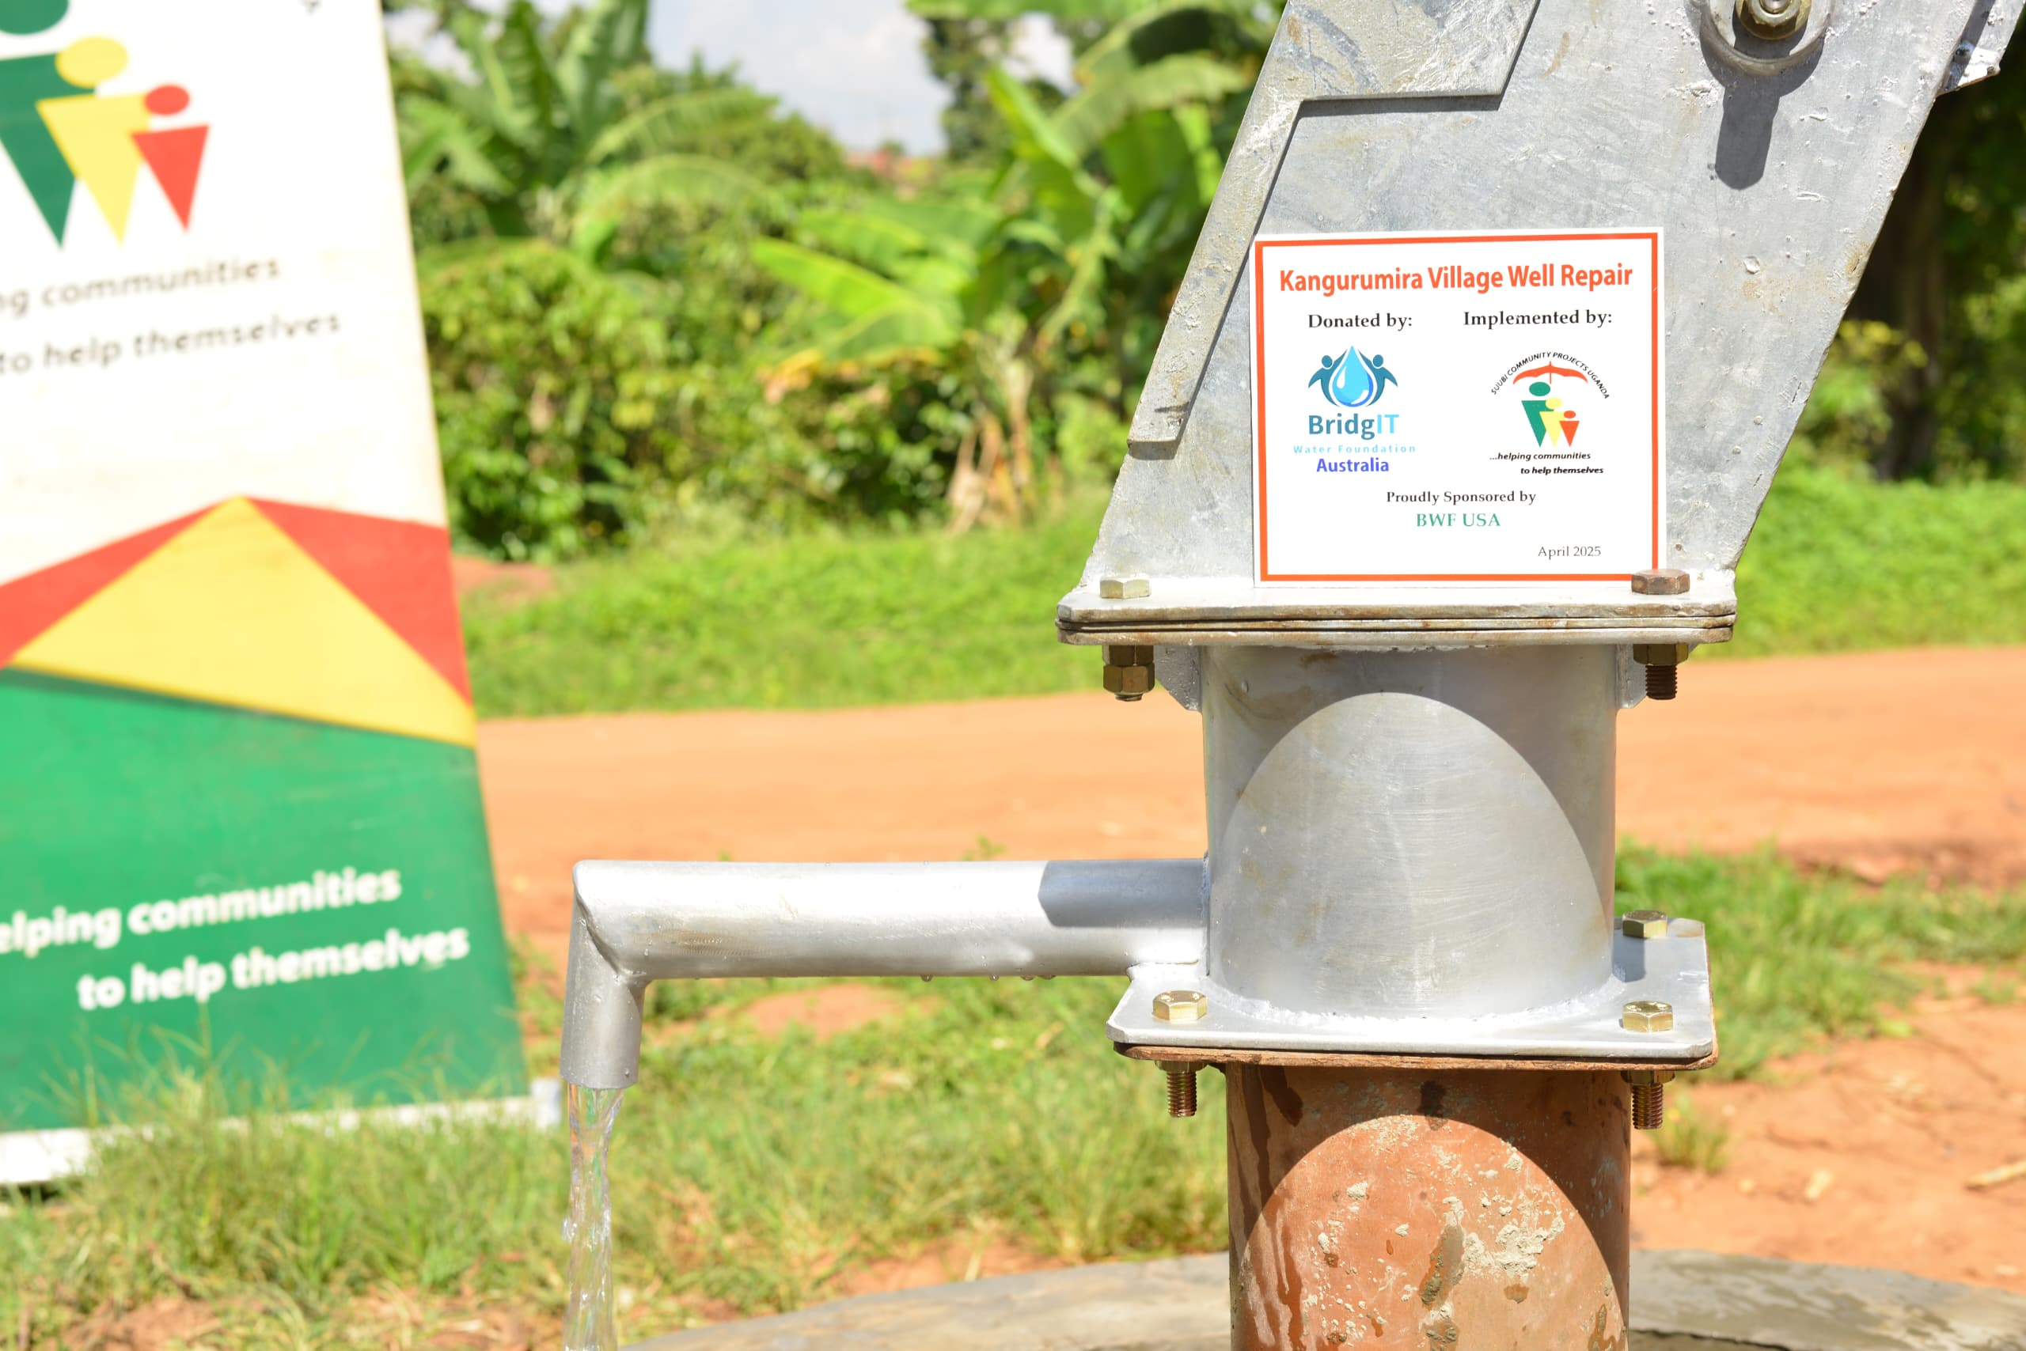

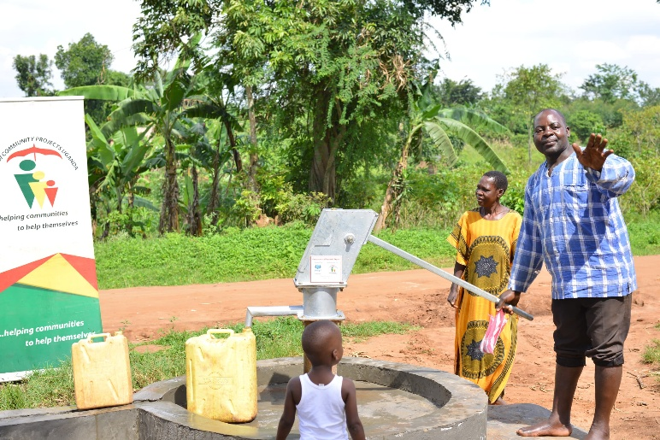 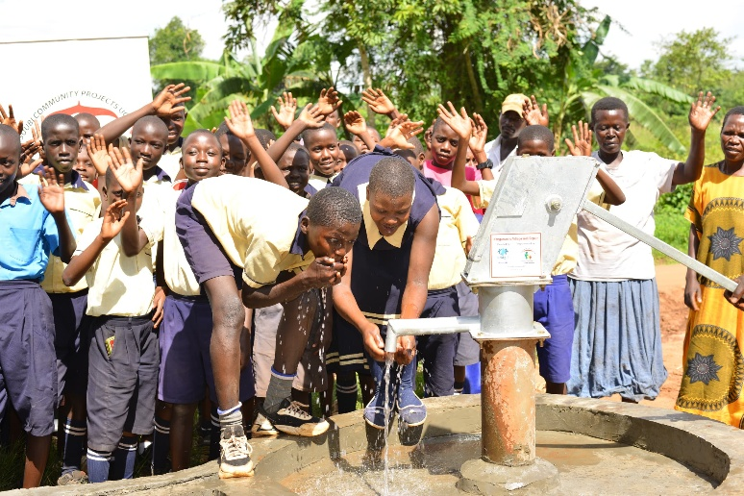

For more photos and videos, click [HERE](https://drive.google.com/drive/folders/1NtZ5SM_vAkMOgRdQiSVsk-xjuKX2gBGw?usp=sharing)

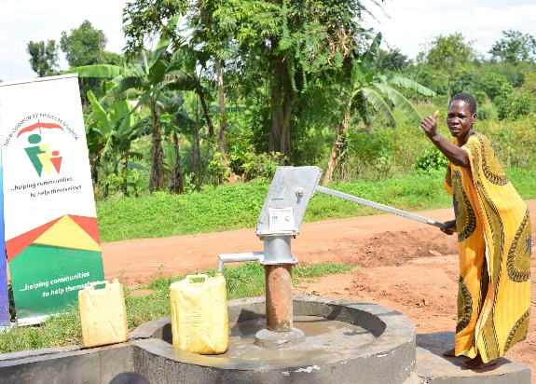**Testimonial**

Jesca, a 52 year-old, resident of Kangulumira B Village and the treasurer for the Water User Committee said; “Our borehole was functioning properly and giving us very clean water for many years. 3 years ago, it started failing and we could mobilize the users and pay for repairs. How ever at some stage, the mechanic told us that most of the parts of the handpump had grown old and rust was causing them to disconnect. The rust was also making the water dangerous. The money that was needed to do a complete repair was so much for us. We could not raise it! Families resorted to looking for water elsewhere, even very dirty water, and the borehole was neglected.

We have now been trained about the right way to prepare for future repairs. We will be more committed to always be prepared with funds.

We thank so much our dear friends who have supported us to have the well repaired. We are very happy to have safe water again.”

**Project Impacts**

Impact is expected in four areas:

1. ***Access (ii)safety (iii) Health (iv) Education (v) Labour force participation and hours worked***

* Access to clean and safe water has been restored to 1,260 people including school children.
* The safety of children and women who risked facing all kinds of violence while our in the swamps looking for water, has now been restored.
* The beneficiaries can wash their hands as a way to prevent the spread of disease.
* On average, people will walk 500mtrs to access the water, as opposed to the 3-4km before the wells were repaired.
* Incidences of diarrhoea and typhoid, especially among children less than 12 years are expected to reduce.
* Incidences of back pain especially among women and older girls is expected to reduce. This is because they no longer move long distances while carrying the heavy containers filled with water.
* There is an average 2hours saved everyday especially by women who have the responsibility of fetching water. This time is now used for productive work on family businesses.

**Community Ownership & Sustainability**

**It is crucial that community ownership is established for the sustainability of the refurbished wells.**

The sustainability of the wells largely depends on the beneficiary community.

The community has been empowered to take complete ownership of the borewell and trained on how to plan for future maintenance and repairs. To ensure sustainability of project benefits, it is importantthat, after construction, physical conditions of infrastructure, water yield, and the status of operation, water quality, sanitary hazards, and financial viability are regularly monitored; initially by the implementing agency jointly with concerned Water User Committees, so that timely corrective measures can be taken without disruptions to the Well’s function ability.

**Community Capacity Building & Training**

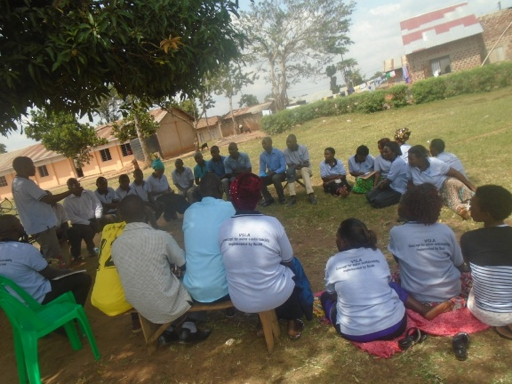BridgIT aims to create sustainable improvements to rural development in the areas we work, therefore it is our intention that the infrastructure we provide to our rural communities will last for years and provide clean, safe water to the people far into the future. The community must have a clear understanding that the water system installed is a valuable piece of infrastructure – **it is an asset and responsibility**.

The first training was offered to all members of the beneficiary communities at the pre-construction meetings. During this first encounter with the beneficiaries, we educate them about their responsibility during the project implementation and as well as the long-term commitment to acquiring the water resource.

* **Establish and Train and a Water User Committee (WUC)**

A WUC is essential to ensure the sustainability of any community water system. BridgIT and its implementing partners have observed that it is important that the community feels responsible for, and develops the capacity to manage the maintenance and operation of its own water access points. The establishment and training of a WUC is an integral part of every water project we implement; in every community we work with.

A Water User Committee of 8 people was selected and trained for the community. The committee is made up of a Chairperson, Vice Chairperson, Secretary, Treasurer, 2 Caretakers and 2 members.

At least 3 members must be women, and the post of Treasurer is specifically reserved for a woman. 2 young people must also be on the committee and at least 1 person with disability (PWD).

* **Health & Hygiene (WASH) Awareness Training**

Meetings entail good water, sanitation and hygiene (WASH) practice guidance. The WUC was trained in basic maintenance and management of the water resource, and how they can help to maximise impact by enforcing other good sanitation practices like use of clean containers, boiling all drinking water, latrines for homes, and use of tippy taps.

* **Equipment Maintenance Training**

Generally, the community is trained and enforced to always collect minimal and affordable user fees so that any future maintenance and repairs can be self-funded.

The community recommends 3 people who are trained in the basic maintenance of the hand pump like applying grease to the chain, bolts and nuts every month. They are also trained in how to identify any indications of need for repair before there's a major breakdown. That way, they can inform our hand pump technicians to act.

**Follow up & Monitoring**

Suubi’s team will continue to monitor the WUC regularly and work with them to provide support and continue capacity building as required.

**Cross Cutting Themes & Social Inclusion on BWF Programs**

The impact of stereotypes and prejudice against women and girls, disability and PWDs and other social issues and pro-vulnerable strategies on the effective implementation of programs can’t be understated. BridgIT Water Foundation and its partners are committed to avoiding, minimizing, and mitigating adverse environmental impacts as well as adopting a gender-sensitive and gender-equitable approaches for all its projects.

**Gender equality approaches were employed**: We are aware that the success and effective use of water facilities depends on the involvement of women and men, boys and girls in selecting the location and technology of such facilities, and taking responsibility for management, operation and maintenance. The role of women, men, boys and girls in maintaining the borehole was not underestimated; it varies from preventive maintenance and repairs, to paying of user fees. Women, men and youth all hold equal representation on the Water User Committee, with the post of the Treasurer being reserved for a woman.

**PWD Inclusion approaches were employed**: The composition of the Water User Committee reserves a special slot for the representation of a PWD. PWD’s were equally consulted during site location, and they are empowered to equally participate in the maintenance and operation of the water source. Where they are heads of families and have active income, they as well contribute by paying user fees.

**Environmentally friendly practices were employed**: The refurbishment project did not have any adverse environmental impacts for the communities. The beneficiaries were trained to observe environmentally friendly approaches while they access and use the Well

**Project Challenges**

The Project was successfully implemented with minimal challenges.

**Lessons Learned**

A healthy engagement with partners, the local government and the project beneficiaries has been helpful in finding the solutions for some of the challenges encountered.

**Acknowledgements**

Our gratitude goes to **BWF USA for** the support and generosity towards this project.

We thank BridgIT Water Foundation for managing and coordinating the project.

Locally, we appreciate the members of the WUC, program implementation team, local leadership and the beneficiary population for their cooperation during the implementation of the project. The project succeeded with the efforts of all of you, thank you so much.

**Compiled by: Steven Beingana**

**Suubi Community Projects, Uganda**

**Edited by: BridgIT Water Foundation Australia**