

Freedom Foundation
Changing Lives... Making a Difference!

ANNUAL REPORT

2019-2O20

Our Vision:

To pioneer affordable treatment and rehabilitation that make a difference in the lives of those affected by alcohol/drug addictions and those living with HIV/AIDS and also reduce stigma associated with these conditions.

Our Mission:

Freedom Foundation will enhance access to quality health care & treatment for people living with alcohol/drug abuse and/or HIV/AIDS through a commitment to increasing awareness, treatment, care, support, advocacy, expanded linkages & networking and create a platform for best practice and cross learning.

Our Ethos:

FREEDOM FOUNDATION – ‘Changing Lives Making a Difference!’

We Are
A secular, non-for profit, Registered Charitable Trust

Objectives
- To provide comprehensive treatment and rehabilitation for persons living with alcoholism/drug addictions.
- To provide comprehensive care, support and treatment to men, women and children living with HIV/AIDS.
- To expand access to treatment with Highly Active Anti-Retro-Viral treatment including monitoring of CD4 counts.
- To provide residential care for those children who are orphaned and abandoned due to HIV/AIDS.
- To provide access to education, nutrition and medical care for children infected/affected living within the community.
- To conduct Educational, Awareness, Training and Sensitization Programs for Substance Abuse and HIV/AIDS.
- To work for the rights of persons affected by HIV.
- To build and strengthen the capacities of different stakeholders and enable them actively to participate in similar initiatives.
- To provide a platform of opportunity for cross learning for effective implementation

CONTENTS

  - FOREWORD

  - BANGALORE

- CHILDREN CARE CENTRE (RESIDENTIAL)

  - EDUCATION & NUTRITION ASSISTANCE PROGRAM

  - OTHER ASSISTANT PROGRAMS

SECUNDERABAD

- DIYA – THE LIVING LAMPS INITIATIVE(RESIDENTIAL)

  - EDUCATION & NUTRITION ASSISTANCE PROGRAM

  - OTHER ASSISTANT PROGRAMS

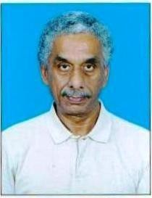

FOREWORD

Dear well-wishers, supporters, donors, and friends; welcome to another eventful year of activities that have changed the lives of our beneficiaries. I do hope that you would spend a little time to go through this annual report and give us your valuable feedback on the various projects and activities. Please do mail me at ashokrau@hotmail.com

The year 2019/20 was another challenging year with further cut in resources. Our team at the foundation continued to provide all necessary support to enable communities to have a better quality of life and not be bogged down with the diseases of HIV/AIDS and addiction. The resilience, commitment and dedication shown by our community members in valuing whatever life has to offer has been truly inspiring

I take this opportunity to thank all our donors, well-wishers and supporters who have come forward to help us address the issues on hand. I further would like to thank all the staff and community workers for their exemplary passion and commitment in helping our children, women and men affected by HIV/AIDS and addiction in enhancing their wellbeing and helping them have a better quality of life.

Thanking you,
Yours sincerely

Dr. ASHOK K. RAU
Executive Trustee & CEO

CHILD CARE COMPONENT – BANGALORE

Residential care HIV Positive Orphans

- Education & Nutrition Assistance for HIV infected / affected community children.

Location: Bangalore
Partners Supported: This is primarily supported by three major donor agencies:

  - United Way Bengaluru (Deloitte CSR -SD project)

FF is receiving the consistent support for a group of HIV infected/affected children in various aspects of shelter, health, education, nutrition, etc. through UWB. FF along with the support of UWBe functions from the belief that ‘no child needs sacrifice quality of life to an illness. The two components supported by UWBe are:

    - Education & Medication for HIV Positive Orphan children
    - Education & Nutrition program for HIV infected / affected children in the community.

On behalf of all the beneficiaries, the Foundation is very thankful to UWBe for the sustained support over the years.
This consistent support for a group of HIV infected/affected children in various aspects of shelter, health, education, nutrition, etc. has brought a great change in the life of each family or child giving them new hope and determination.

OWC (Overseas Women’s Club)

The grant through Overseas Women’s Club for support of education to children living with or affected by HIV was awarded to Freedom Foundation in 2011. Children living with HIV or affected by HIV and from poor socio- economic families fall under the category of “orphan & vulnerable children” (OVC). This support helps us to ensure access & support for completion of secondary education of these children. Apart from the consistent support for the community children, through OWC FF has also received a very valuable support for the residential children since few years both in terms of funding and volunteers.

Through the past 15 years, the Foundation endeavors to ensure that the basic rights of all children accessing care through different programs are protected. This includes children infected and affected with HIV. The childcare component at FF comprises both institutional & community with the essential crosscutting components of Protection, Health, Education, Nutrition and Rights.

This Child Care Component looks into two main concepts of:

Protected Residential Environment, Education / extra-curricular activities, Medical Treatment and Nutritional support for Orphan HIV +ve children.

This is an orphan care program where FF plays the role of guardian providing a home and educational/medical support for HIV +ve children. This program does not receive complete funding but only partial cost sharing from UWBe and is very much dependent on donors and volunteers as there is no other income through which this initiative can be run effectively.

Education & Nutrition for HIV infected / affected children & their families in the community.

This focuses on supporting education for HIV infected / affected children from economically poor families of Bangalore rural and urban in order to sustain the fundamental right to education of children and is being run since 2004. Nutritional support is consistently provided through quarterly Support Group Meetings during which all families receive provisions of cereal, pulses, oil and sugar.
Apart from primary support from the three major donor agencies, the program receives additional support from few other corporate agencies and many individual volunteers.

1. Residential care and services for HIV Positive Orphans
Started: Year 2018
Supported by: UWBe

During the year 2019-20 through the program ‘Positive Kids’, 20 HIV +ve orphan children were cared within the residential facility, which is partially supported by UWBe for education, extra-curricular activities, transportation, clothing, rent, medicines, hospitalization, birthday celebration and personnel costs. Among these 20 kids, 12 are boys and 8 are girls.

Age group and Gender of Children at Positive Kids
Age group in yrs | Total | Girls | Boys
0-8 | 2 | 0 | 2
9-12 | 3 | 1 | 2
13-16 | 6 | 2 | 4
>16 | 9 | 5 | 4

Activities for the year:

At the Child Care Centre:

For this year, there are 20 children under residential care. All other kids are regular with their food, medication, education, etc.

One of the students was taken by her relatives to her home town for continuing the studies there. The children in LBS school were shifted to Banyan school as per the suggestion and help of an old well wisher. We were given discount in fees and we enrolled the children in Banyan school. It has very good prospects for our children. Yuvaloka children are continuing in the same school.

Anupama(Anu John) started volunteering for Freedom Foundation in July and joined Freedom officially in January 2020.

New system of ordering vegetables from Narayanapura was put in place in November in which they would deliver the vegetables when the list is send by whatsapp. The payment is made via cheque by the end of each month which is a better system of accounting.

UWBe had not released funds till October which put us in a very difficult situation to manage the expenses. This year also Freedom Foundation participated in Christmas bazaar from OWC in St Patrick’s hall.

On Mar19th, Corona lockdown started. We educated the kids about the importance of personal hygiene. How to wash hands and sanities the house and tables. Educated the care givers also about the importance of hygiene.

Education & Career:

Education plays a paramount role in every child’s life. FF ensures that all the children receives the best possible education and to be successful in life. All are regular to their schools & colleges and are maintaining their study hours. They are regular to their study hour. Tuition teacher is taking class everyday between 5pm to 7pm for children from LKGto 10th STD.
Ms. Margaret Xavier is an old volunteer and well-wisher of Freedom Foundation who came by to propose The Banyan Tree School under Lovedale Foundation for the children of Freedom. The Banyan school was finalized as the new school to which majority of the Freedom kids will be shifted and fees discussed. All the children except one 10th standard child were shifted to Banyan school. The children in Yuvaloka are continuing in the same school. Took admission for 4 kids in Yuvaloka School. One boy joined for PUC 2nd year. Two children started their 3rd year degree.

One of the students studying in LBS school had attendance problem and was told that he won’t be allowed to sit for the public exam. The same boy had to be sent back home due to disciplinary issues.

Some children are interested in extracurricular activities like dance and many are talented artists and sportsmen. The Project coordinator of Child Care Unit visits the schools of all the children regularly for to know about their studies, academic performance in each exam, their discipline, cleanliness, etc. The residential children were counseled and motivated by the childcare staff to maintain themselves well in all aspects. Few children over the years have left from the residential care are working and started their independent lives. They are under close monitoring by FF and they occasionally visit the center, spend time with staff and children, discuss regarding their health, career, etc. The social worker is in close touch with them.

Few Success Stories:

Namitha

Namitha is an outstanding student who finished her 12th from Crystal House and received scholarship for higher studies from Guardians of Dreams. Unfortunately, her relatives have taken her home to continue studies in their home town. She came to FF at the age of 12yrs. She is from Uttar. Both her parents are no more. She had issues in medical.

Recreation and Extra-Curricular Activities:

All the children are regularly & actively engaged with different refreshing activities. Every evening after having their snacks they play for half an hour and during the weekends they play many outdoor games like football, badminton, cricket, etc. Watching movies, washing clothes, cutting vegetables, cleaning their rooms/cup boards, etc. are scheduled on Sundays & holidays. Couple of girls goes for dance classes.
Also, Asha Foundation conducts regular camps, both residential and one day, for awareness and support of HIV. The children have a good time learning and connecting with each other. During May 2019, four children participated in camp rainbow program conducted by Asha Foundation. It was four days in house training, all the kids shared that they had a very good time with fun & enjoyment and also gained a very good experience & learning through this camp. The key points discussed were life skill training, ART effect and HIV-AIDS stages. In July, Sambu, Nagraj and Pranay went for volunteering training in ASHA foundation. This would enable them to be volunteers in the outside world. In November, Asha Foundation meeting in the Freedom center gave coaching for the children about the importance of hygiene and discipline.

In June Sandeep, Umesh, Rajeswari and Sathya went to Mysore for a day trip from school. In December, Avinash went for Tour from the school.

Banyan school had activities for big children for Independence Day. Sandeep helped in hoisting the flag in the school.

Mahalakshmi and Manasa matured and it was celebrated with sweets.

This year,

In the last quarter of last year, three main events took place
- Impact day
- SHG meetings
- Shopping from FBB and food from KFC

Impact Day: On 29th November 2019, Deloitte planned and conducted their ‘IMPACT DAY’ program with prior discussion & plan with Freedom Foundation and the related activities were scheduled in advance by both FF staff and Deloitte members. As beneficiaries from freedom Foundation, 50 children (both residential and from community) and 60 adults participated in this program. Nutritional kit for 60 families was distributed. Also partial educational support of Rs.5000/- was given to 30 kids. Children enjoyed all the activity and had a good interaction with the volunteers. During the activities, the members from the community shared about their experience & benefits with Freedom Foundation. Most of them shared that they are associated with FF from more than 15 years and how FF has changed their lives by providing medication, treatment, counseling and other psychosocial support which gave them all the courage to go ahead in life. All the Deloitte members were very much inspired by these sharing of women. Lunch was provided and the busy and fun filled day was called off with vote of thanks from both FF and Deloitte team.

SHG meetings: 4 SHG meetings were conducted in this year. Due to delay in release of funds from UWBe, the SHG meetings and community support with nutrition and education were delayed. We did the SHG meetings in October, November, February and March. Nutrition kits were distributed with community meetings, encouraging them to share their experiences and support each other for their own benefit.
Shopping from FBB and food from KFC:

Shivani is a regular donor who has supported freedom from very long years. She sponsored clothes and food for children during Christmas. The children shopped from FBB in Elements mall on the 24th December making their own choice. After that, they had food from KFC.

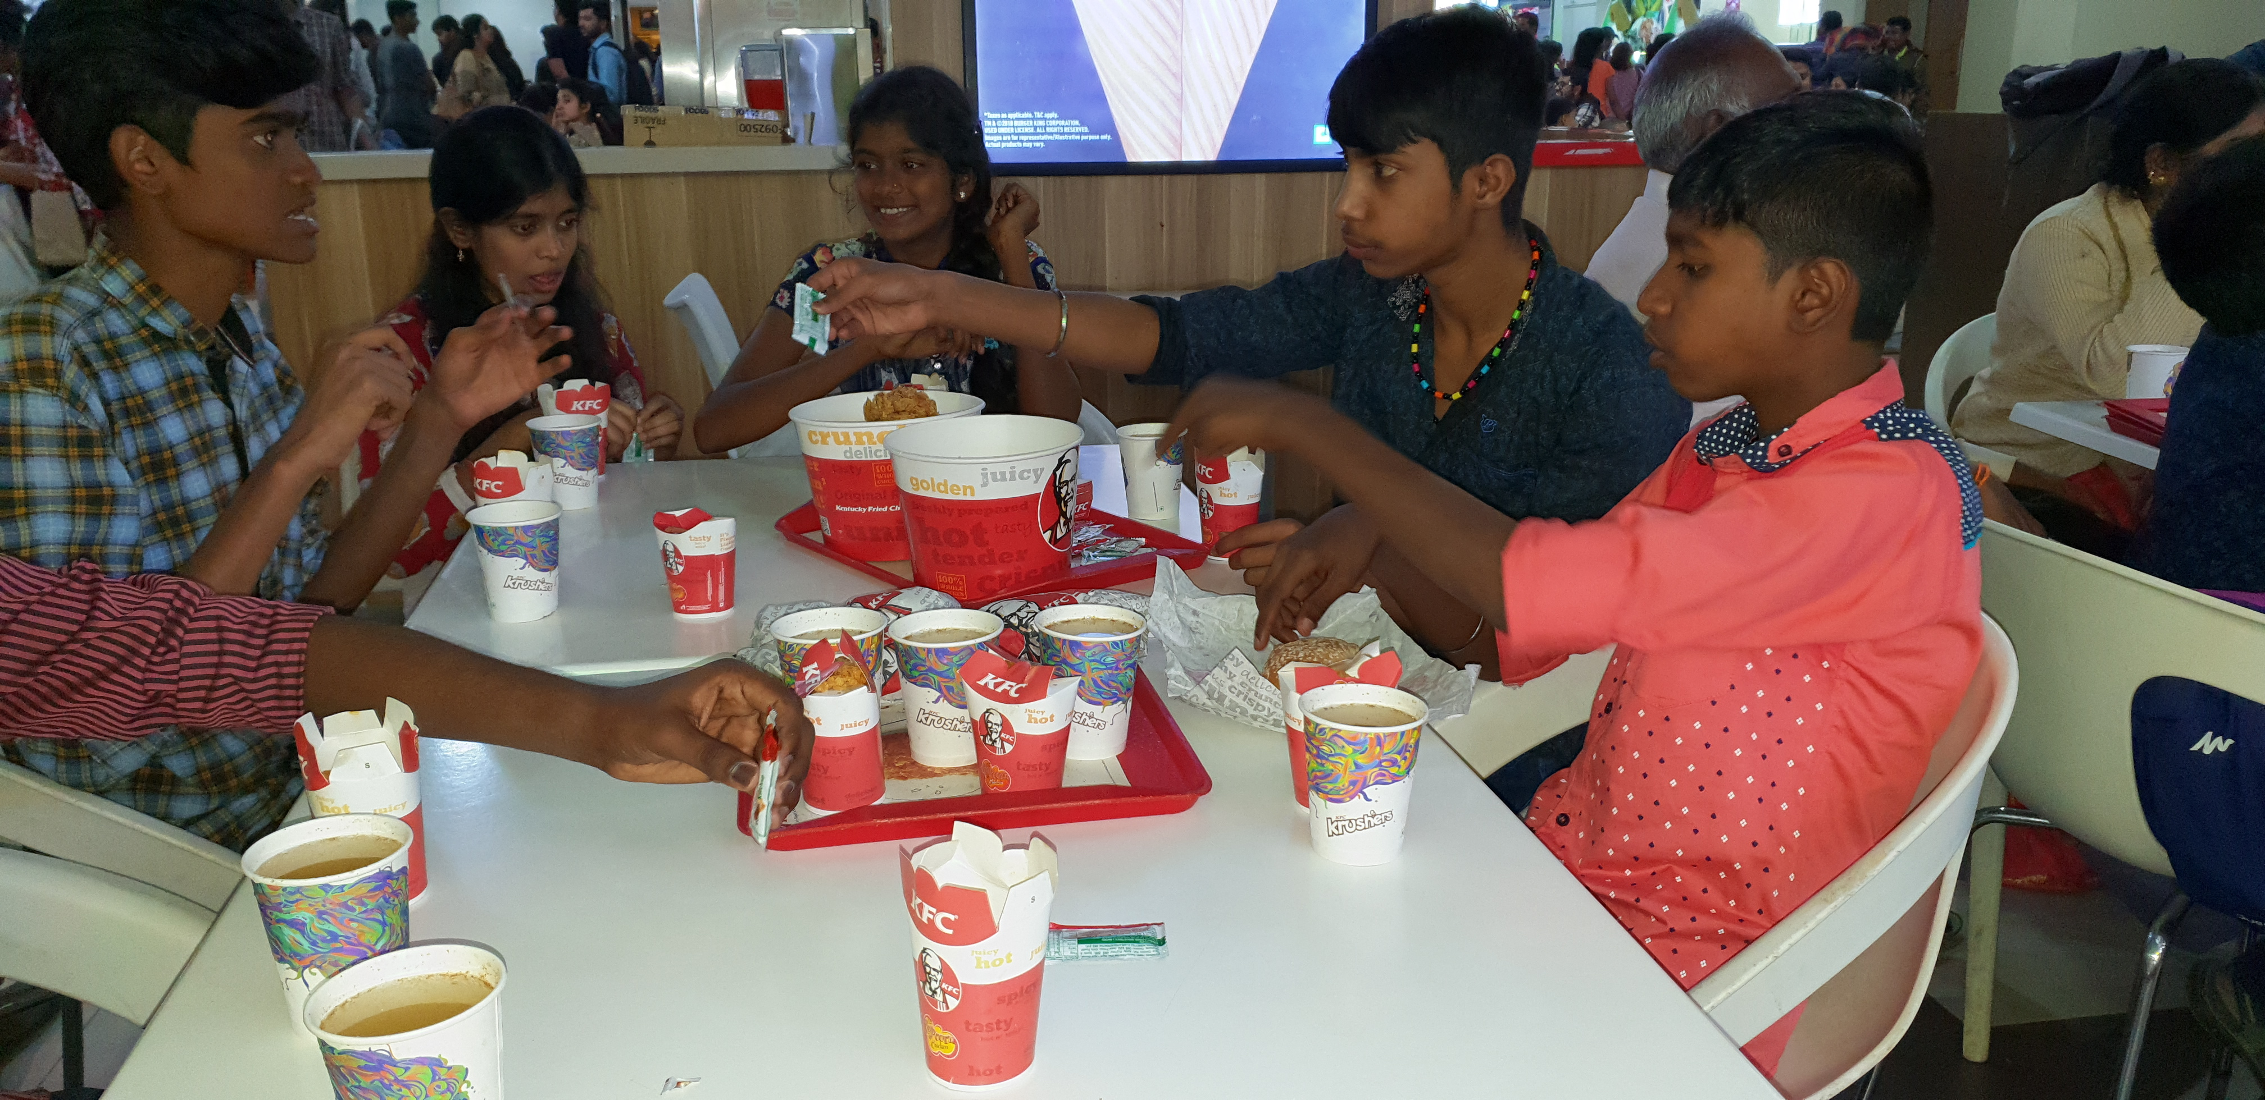

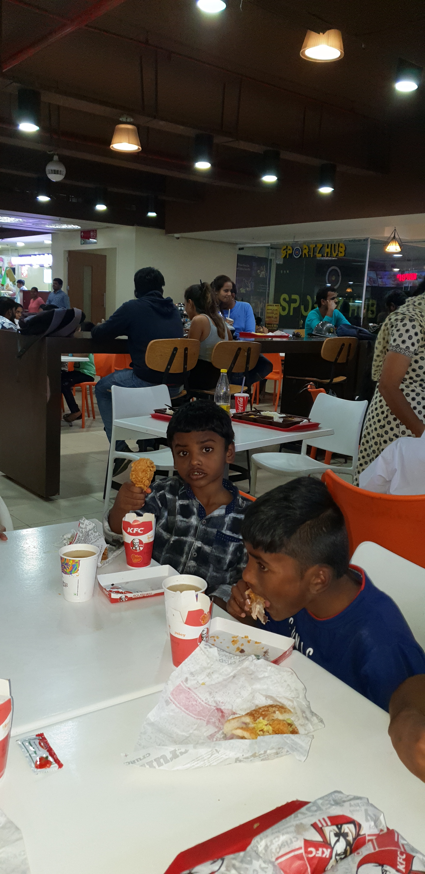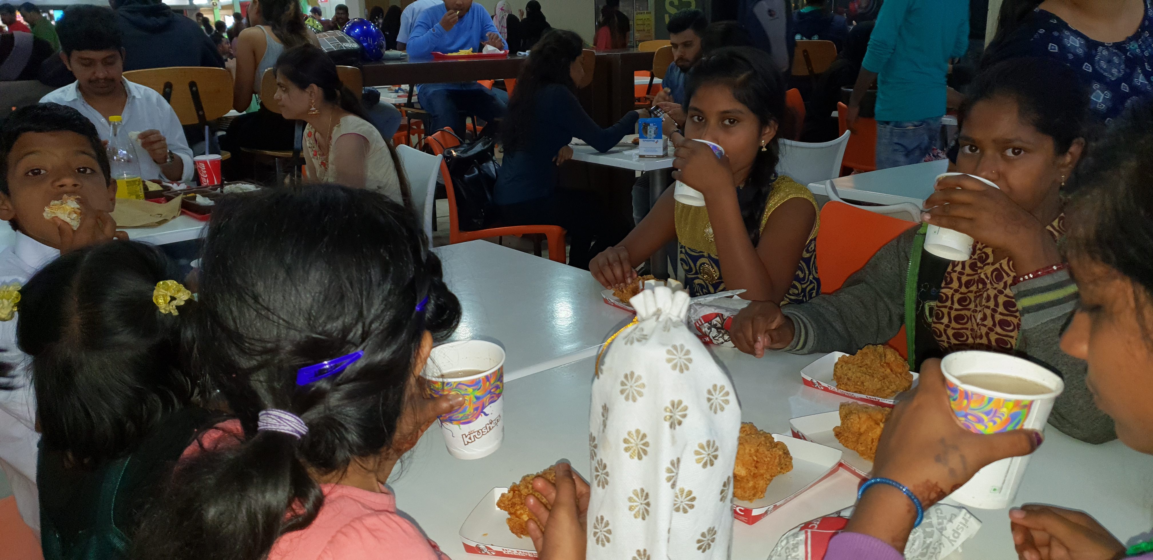

Medical Support with HAART:

All the children who are on HAART (Highly Active Anti Retro Viral Treatment) continued availing their medicine from the respective government hospitals. Regular CD4 counts and viral load test are done once in every 6 months.
One child is under continuous treatment and follow up for his chronic eye infection has improved 50% and asked to continue treatment.

Two children were on TB medicines along with their ART medicine. To balance the overall situation and make the children understand the importance, regular counseling and discussions with both children were done. Both of them were given extra nutrition to cope up. During the year, all visited hospitals once in a month along with caretaker and collected their medicines. One child’s course was completed. Tests run and found to be cured and normal.

One of the children is giving very much trouble to rest of the children .His behaviors are extremes and multiple complaints have come from both school and the center. He is not changing despite giving multiple warnings and counseling. The school was not able to continue with him and we considered special school options for him. But the efforts were discontinues as the cost would be too much for Freedom to bear. He was taken to St.John’s hospital Venu for consultation to Psychiatrist. He was referred to Nimhans to continue treatment.

One child who was placed for apprentice job came to centre with viral fever. He was later diagnosed with TB in the lymph nodes and was in the center for the whole year as he had to take medicines and take rest for the whole duration.
During the corona time, only the care takers went for the medicines and got the medicines for 2 months at a time.

Investigations, Treatment, Hospitalization & others:

Apart from HAART, the children were also taken to hospitals as per need for different general health problems like cold, throat infection, fever, headache, nausea, stomach pain, warts treatment etc. All received timely treatment for their problems and were also regularly monitored.
One child Pranay is under continuous treatment and follow-up since Oct 2017 for his chronic eye infection reported as “Hyperplasia and moderate dysplasia”. From Vitalla Eye hospital, he has been referred to Prabha Eye Clinic and is being regularly monitored & followed up. It has improved a lot.
Couple of children was admitted for severe infection in the stomach and for urinary tract infection.

Psychological Support:

All the children are regularly counseled in group and need based individual counseling is also done in regard to all aspects of medicine, health, education, behavior, nutrition, hygiene, etc.
There will be a general group discussion regarding maintaining the timings for study, food, sleep and work, proper food & water intake, studies, exams, etc. Individual discussions & counseling is done as per requirement on personal issues are also being regularly done after group meeting.

Meeting with children: -

Fortnight meetings are regularly conducted with all the children on alternate Saturdays in the afternoon. Conducted sensitization classes on how HIV affects our immune system how can an individual keep the virus under control and lead a healthy normal life – role of ART medicines and importance of balanced diet in this regard. Children are encouraged to eat well especially the vegetables and to drink sufficient water. There will be a general group discussion regarding maintaining the timings for study, food, sleep and work, proper food & water intake, studies, exams, etc. Individual discussions & counseling is done.

All the children who were writing their board exams & final years were individually counseled and discussed regarding their future education / career plan in accord to their line of interest & strengths / weaknesses.
Special awareness was given with regards to Corona. Both the care takers and the children were given special coaching on washing and sanitizing hands properly and on wearing masks.

Volunteer Visits:

Both individual and group of volunteers visit the center, spend time with children, conduct some activities of drawing, dancing, singing, playing games, etc. During the year, nearly 20 individual volunteers visited the center among which, few celebrated birthdays of their family members by cutting cake & providing snacks/lunch/dinner, few visited to just spend some time with children. Few volunteers provided some stationary items to the kids, fruits & snacks like biscuits, chips, juice, etc. Due to Covid we had taken a policy as a center not to entertain any visitors. So that also cut down the number of visitors.
We had Indian academy students coming for their social commitment sessions. They did games for the kids and also got some snacks. Volunteer Margret came for couple of sessions to interact with the elder children who are ready to go out soon to empower them.

Volunteers from ‘Helping Hands’ regularly visit once in a month, spend time with children, gave in kind donations of rice, sweets, dry dates, dry coconuts, etc. OWC also gave toys and some clothes for the kids.

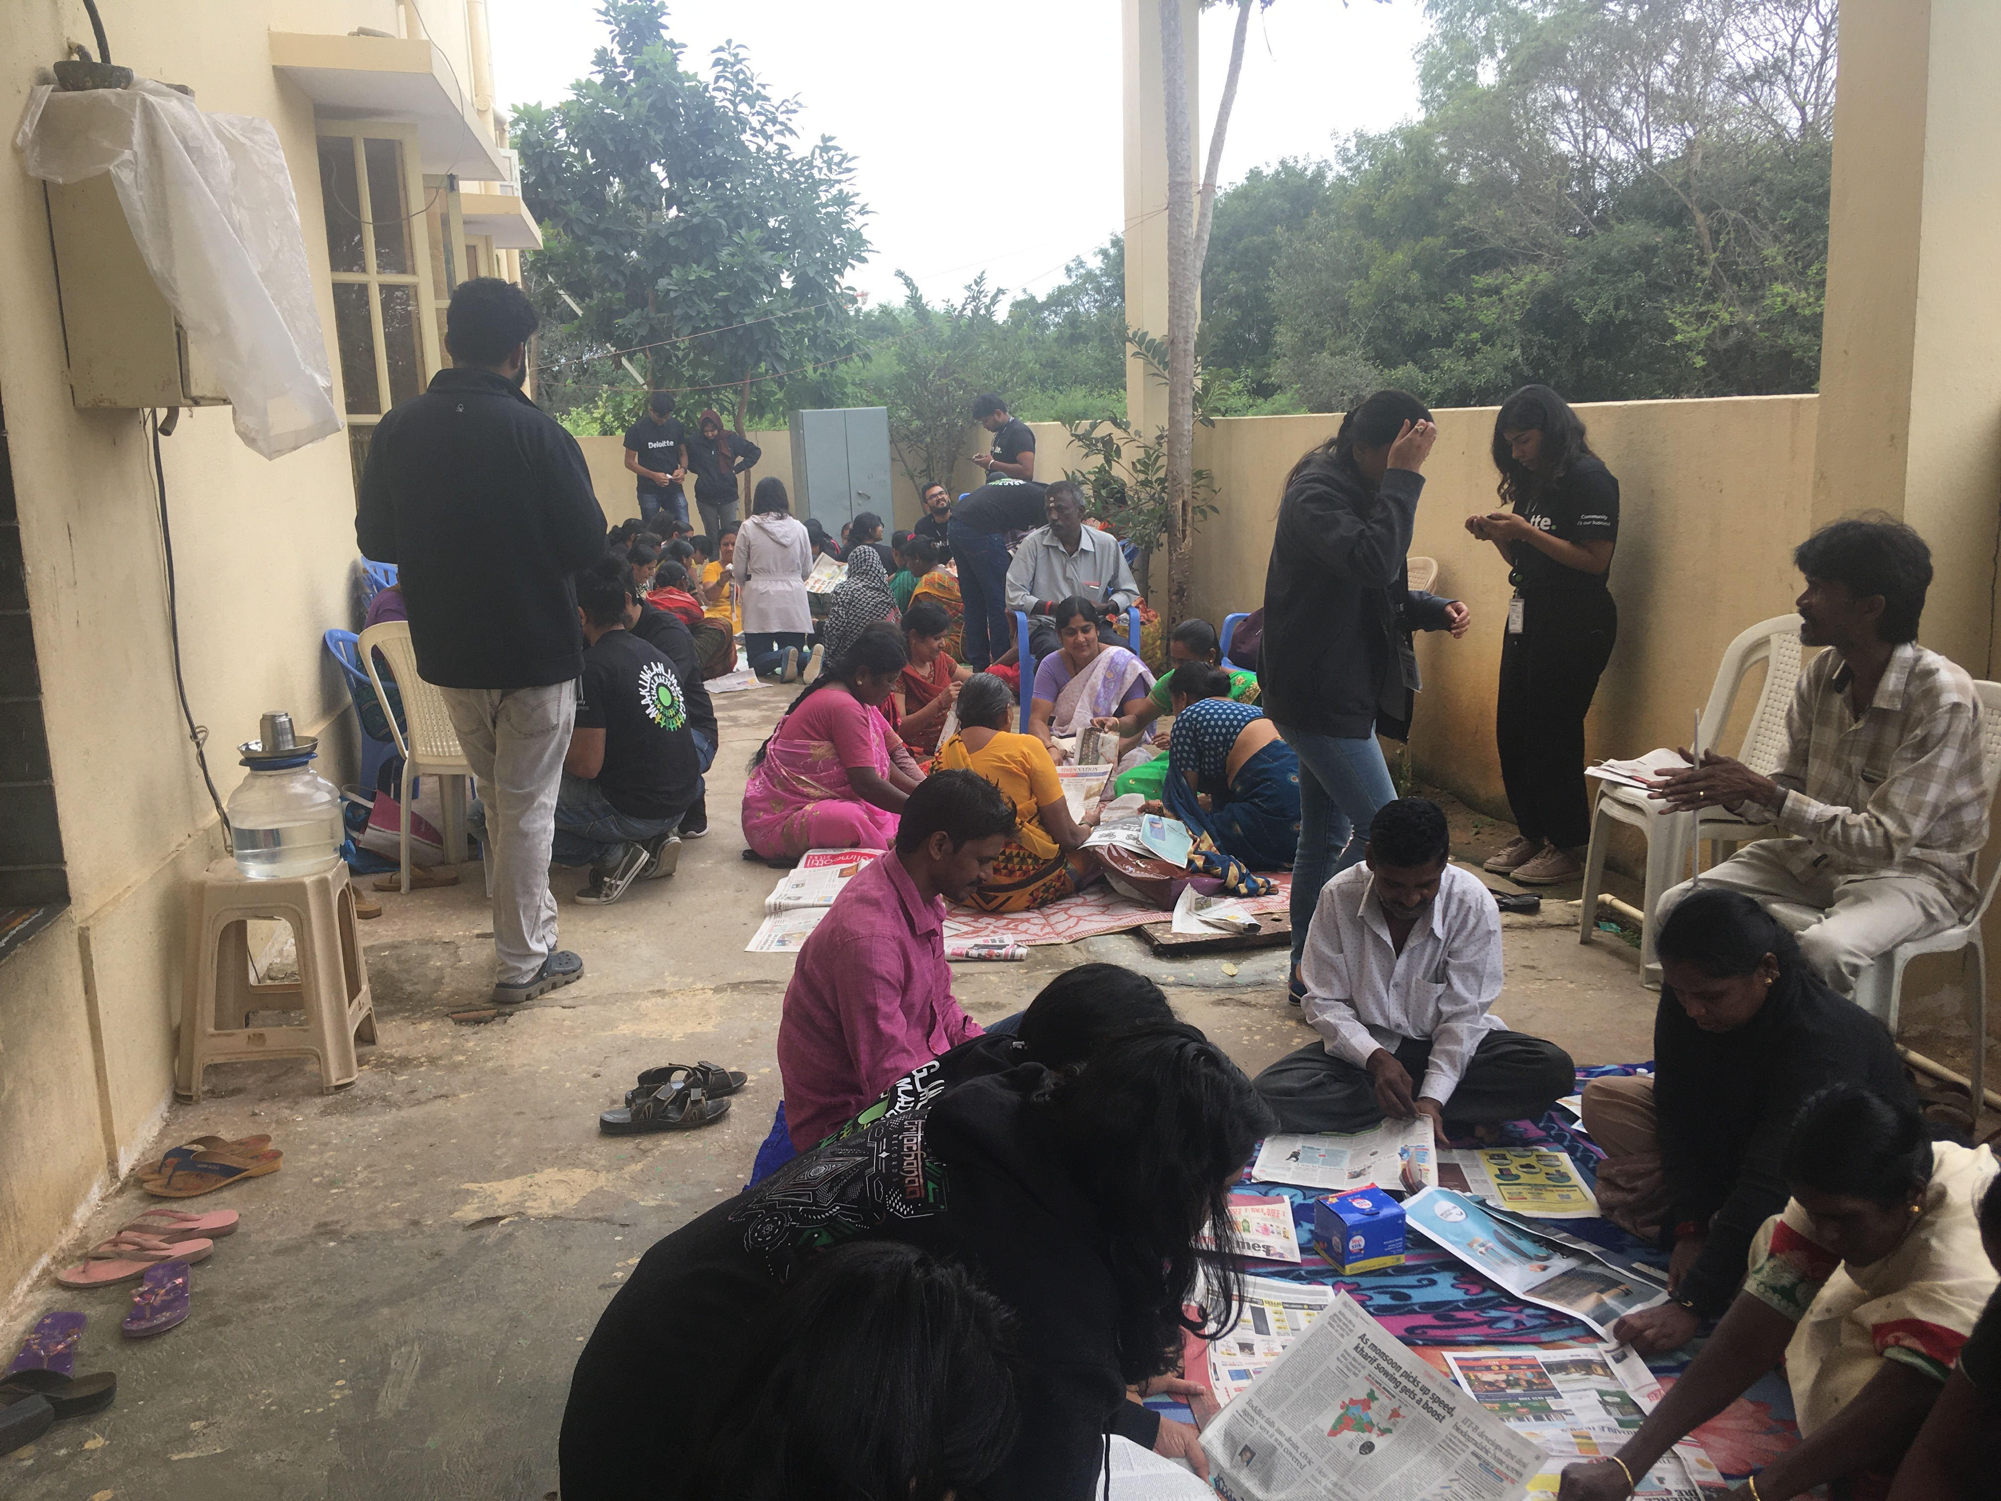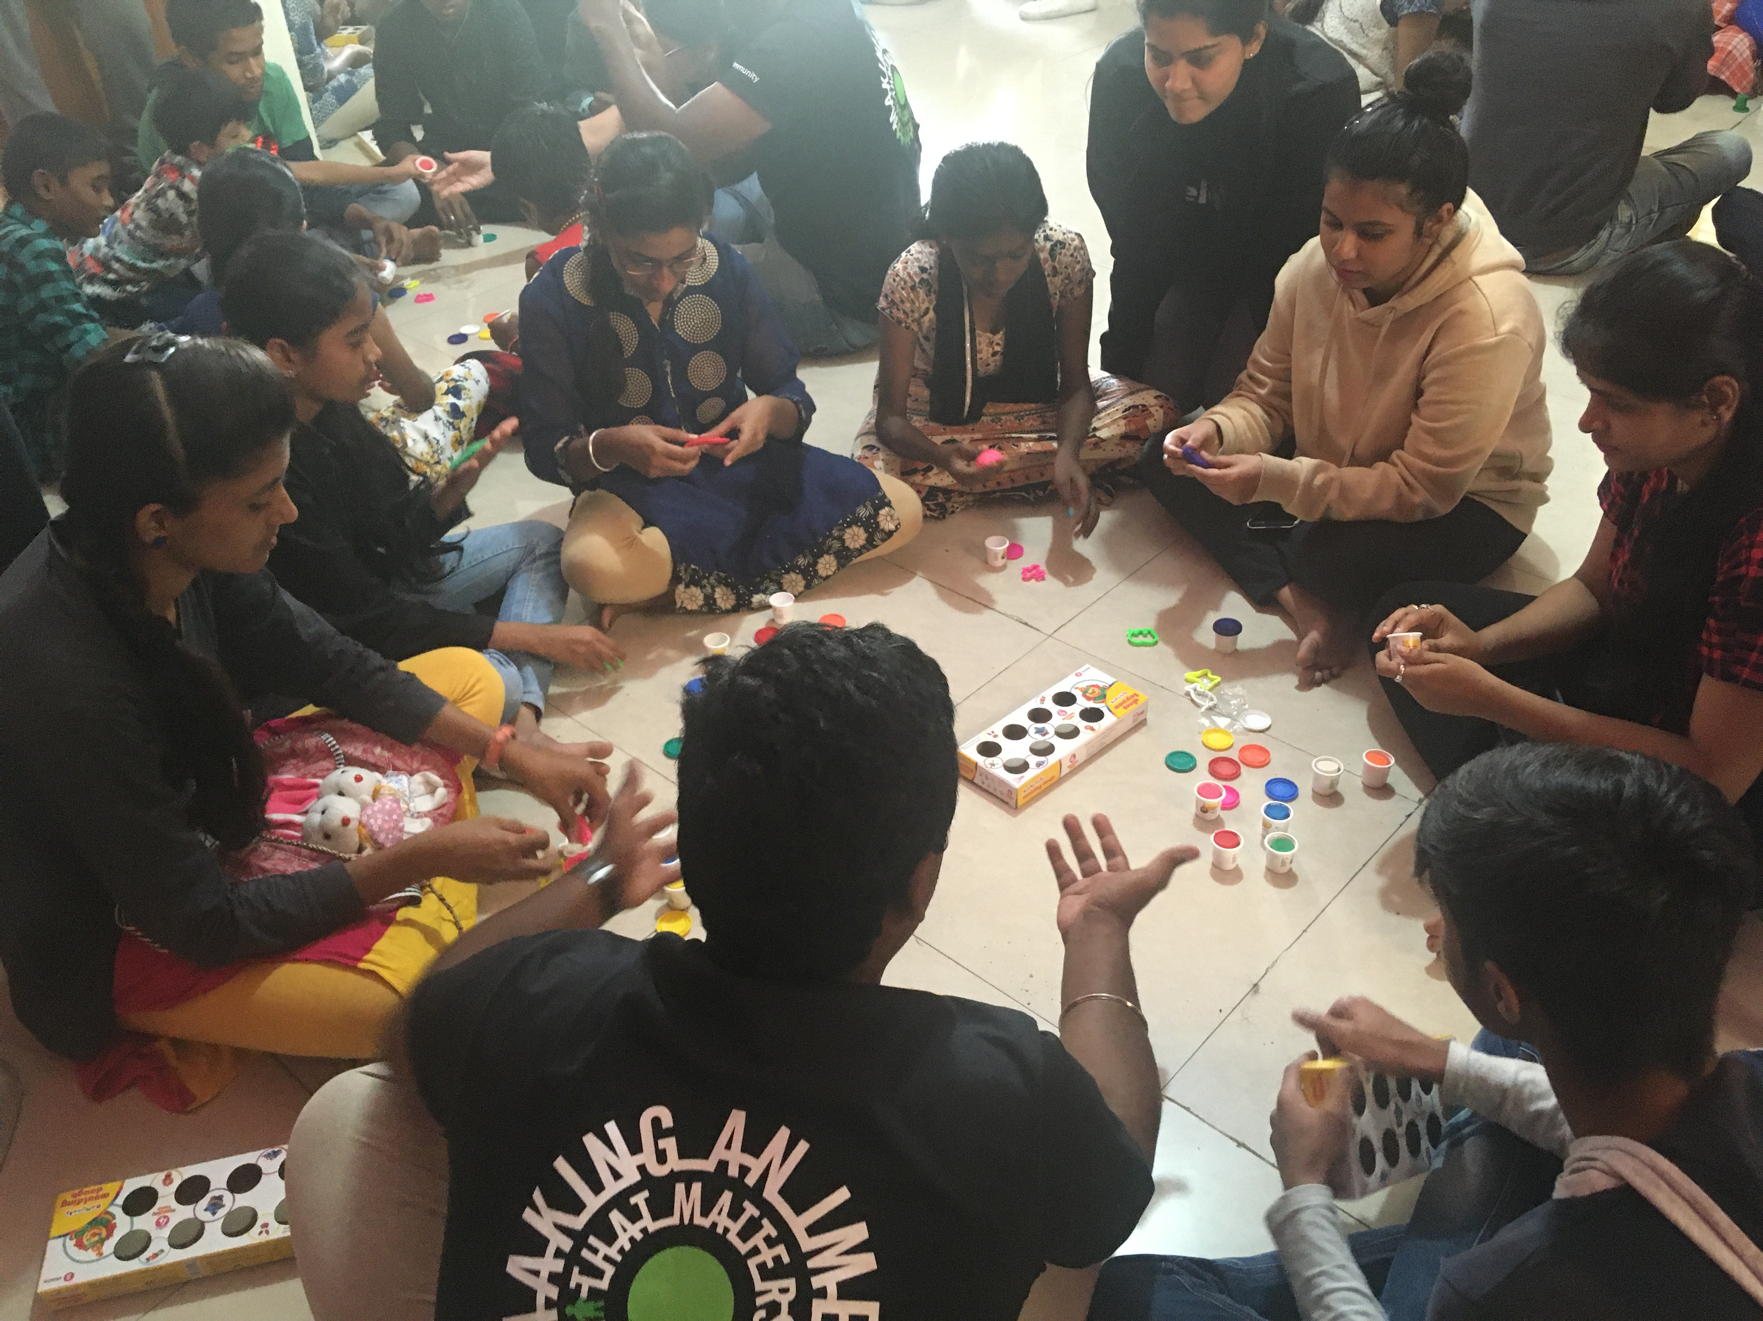

Birthdays & Other Occasions:

All children celebrated their birthdays with a new set of clothes and cutting cake. Every birthday celebration means a lot to our kids as it reminds them that they are a family meant to share their joy. The care takers prepare chicken or mutton as per the child’s wish.
During the year, celebrations of different festivals / occasions like Ugadi, Independence Day, Ganesha festival, Rakshabandhan, Sankaranthi, Christmas, New Year, etc. were done by the kids along with staff with special food and snacks at the center.

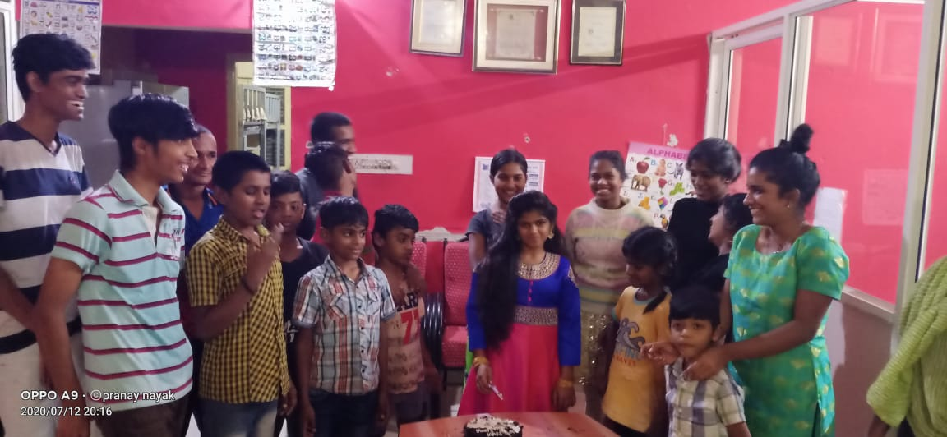

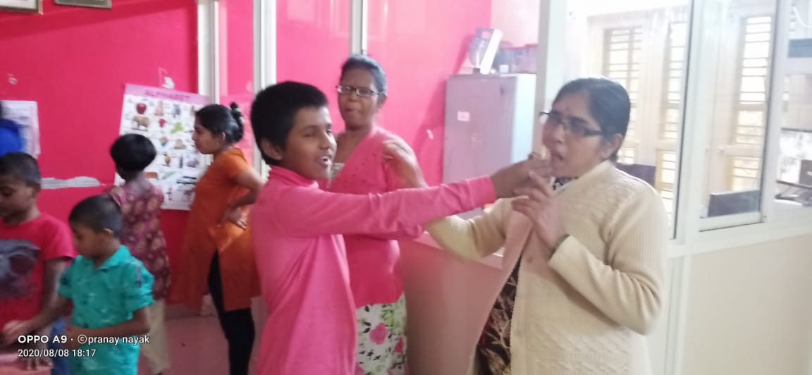

Child Protection Policy (CPP):
The concept of ‘Child Protection’ was initiated with the training workshop from KNH in the previous years and was continued during last year and this year with different training sessions, discussions, etc. FF finalized a CPP document 2015 and was circulated to the donors, sponsors, funders, volunteers, etc. In regard to CPP, the regular meetings were conducted.

Education & Nutrition Assistance for HIV infected/affected community Children. Started: Year 2018
Supported by: UWBe
For this year 2019-20, Freedom Foundation is providing partial support for education and nutrition to children &
Families from community to withstand each child’s right to study and to lift themselves out of their situation. During the whole year, the following activities were conducted through FF:
  - Communicated with the enrolled families for education and nutrition.
  - The social worker visited few houses & schools. The beneficiaries’ submitted appropriate documents and collected the respective vouchers & receipts.
  - Social worker collected and documented their previous year mark sheets & details of each enrolled child/ family.
  - SHG meetings were conducted 4 times.

During the year, 30 children from the community were supported under this program (Rs5000/ per child) for their Primary, Middle / High school, Diploma and PUC education.
There are 60 families enrolled for Nutritional support. They are provided with rations (Rice, Dhal, Wheat, Oil and Sugar) once in a quarter (4 times in a year) during their Support Group Meetings.

Activities for the year:

School Visits:

The social worker counseled & encouraged the community children along with their family to give proper guidance to the children to be regular to school, to maintain daily study timings, to improve their studies, etc.

House Visits:

House visits wherever needed were planned and done by the social worker to interact with the parents, take feedback & provide necessary counseling in regard to their kids’ progress and health status of family. Initially a general discussion was held with the parents to emphasize on children performance for the completed year & plans for the next year followed by admissions of children. Also discussed with them about the restriction of funds in the coming years and so they should be able to plan & manage a major part of this for their children. Many parents acknowledged and expressed their gratitude for the support they receive through this project which lessened their burden of concern for their children’s education.

Nutritional Support
Peer Support Group (PSG) meeting is a platform where the members gather together, to discuss their obstacles in terms of OI treatment, diagnosis, hospitalization, enrolling to HAART and other socio-psychological issues and also their peer support for the same. This support is of great help for them to manage their family because most of these women are widows and also undergo frequent health problems where they are not able to sustain any permanent job or stable earnings. This gathering means them a lot as this is a platform where they discuss regarding different issues that they face due to HIV which they cannot discuss elsewhere.
For the year 2019-20, four PSG meetings were conducted. The meetings were delayed due to the late dispersal of funds from UWBe. In these meeting, the members shared & discussed among them in regard to their health, treatment, self-employment, education of children, etc. The group was also addressed about taking care of their health in the winter by sufficient intake of water, proper nutritious food, fruits, etc. Then the nutrition pack with rice, dhal, sugar, oil and wheat flour were distributed

Problems/Difficulties faced, and challenges overcome:

Staff meeting was not done till Anu John joined as the replacement for Parimala. But all staffs are advised to keep log of their daily activities. Mr. Subrahmani is keeping a written record of the same.

Children who are moving on to higher studies are not able to take a clear decision about their further education & career. It’s a challenge to counsel, motivate and make them aware of their own strengths / capacity & then to select their line of study.
- Complete support for food component and managing sudden high medical expenses is a major challenge in this program and FF is trying the best to overcome this.
- Few kids who are facing continuous health problems are finding very difficult to manage their studies, health, medication, etc. and are pushed to mental stress. It is a challenge to motivate these kids by giving regular psychological support through counselor, caretakers & volunteers.
- Managing and counseling the adolescent children & sorting out various issues in regard to their adamant attitudes & behavior is a great challenge as these issues should not affect the other children around.
- Every year, the staff of schools – principals/teachers and parents of the enrolled community children are regularly counseled by the FF staff in regard to education, discipline, healthcare, etc. through house visits and school visits.

Major Challenges and related responses:

As reported earlier, Foundation is facing the major challenge of funding constraint under all the projects. Though we were able to overcome the challenge of rent component by shifting the Childcare facility to a smaller & more affordable premise, we are still facing difficulties to manage travel, accessibility, etc. as the place is little interior.
To efficiently plan for the kids who are completing tenth & PU colleges and those who have completed 18yrs of age and find out a proper & safe place for their future.
To handle adolescent issues, counsel & motivate these children and make them understand their responsibilities in planning their life.
Due to lack of timely funding, the organization has continuous discussions with many funders to run the project. There is no committed funding for next financial year. This is a major challenge in the coming years.

Future Plans:

- Streamline childcare activities with dedicated interface.
- Scale up the number of children to 25.
- Maintenance of the children care center – Painting, Furniture, CCTV, Electrical/Plumbing/Carpentry works, etc. Water is also scarce as the bore well often goes for repair or is dry and we are depending on tankers for water supply.
- Discussion with various funders to receive the major funding for the ‘Children care project’ for the coming years.
- Focus on gender specific care at both Bangalore & Hyderabad centers.
- Plan and undertake fundraising activities by approaching various kinds of donors, corporate sectors & individuals to involve and engage them in specific funding, to strengthen and improve the support for nutrition, medication and education.
- Future and career plans for the kids who are completing their tenth and PU colleges & those who are completing 18yrs of age.

=============== ===============

DIYA – THE LIVING LAMPS INITIATIVE (RESIDENTIAL) – SECUNDERABAD

Supported by: UWH (United Way of Hyderabad- Real page Grant, DST Grant)

- Residential care and services for HIV Orphans

During this year 2019-20, 7 of the boys out of 15 children were placed in other homes as we were directed by the government to have only gender specific homes. So there was only 8 girl children that were cared within the residential facility, which has no formal support to support for Shelter, Education, Medication, Nutritious food, Extra-curricular activities, Transportation, clothing, Hospitalization, Birthday celebrations and other personnel costs. It has been functioning with the support of well wishers and individual donors who has helped in kind and in cash for specific needs.

Objective:

The overall objective of the program is to improve the HIV children’s health through continuum of care, hygiene, nutrition, education and contribute in the development of future of the child’s wellbeing through empowering them to demand their rights and link them to PLHIV networks for safer tomorrow.

Activities:

Health:
Health is the core aspect of the childcare center and is facilitated by regular ART adherence monitoring and treatment of Opportunistic Infections. Although children have a normal life, but they experience a range of symptoms/ OI’s that affect their day to day life for which they need care and assistance.

Support with HAART:

Among the currently residing 8 children, 3 maintain pre-ART status. All continued availing their medicine from the respective hospitals and three children maintain pre- ART status. All are under regular monitor and follow up for their CD4 tests. For those who are on ART regimen, they receive their medicines from Nilufer Hospital and some purchased from outside.

Investigations, Treatment, Hospitalization & others:

All the kids were monitored with regular investigations & counseling and were treated accordingly.Apart from support for HAART, all the children are regularly monitored and taken to respective facilities for general check-ups, investigations, consultations, treatments for side-effects of HAART & OIs.Few children who are in need were treated for general health issues of stomach pain, fever, migraine headache, dental problems, eye infections, skin problems, etc.

Nutrition:

Good nutrition cannot cure AIDS or prevent HIV infection but can help maintain and improve the nutritional status of children with HIV/AIDS and delays the progression from HIV to AIDS-related diseases. A holistic diet plan with specific attention to each nutritional component such as proteins, carbohydrates, minerals, vitamins and fats is designed for daily intake. Every child at the DIYA Center gets meals which includes one or more foods from the three food groups – Carbohydrates, Proteins, Vitamins & Minerals.
A planned weekly diet menu is prepared so that children get adequate vital nutrition such as proteins, vitamins, carbohydrates and fats, accordingly weekly diet chart is prepared and food is served healthy and testy food including of fruits, eggs ,high protein non-veg food ( chicken, mutton, fish) etc, once in a week.
There is regular consumption of vegetables & fruits received either through donations of being purchased eggs, milk and curd are being regularly purchased and used. The daily food menu will be periodically changed after discussion with the children as per their choice. Safe drinking water is consumed by the residential children & staff through the aqua guard filters fixed at the care center.

Education:

The year started with summer holidays for all the children. Four children completed their board exams in April 2019. They received results in May 2019, passed with the good marks, then joined inter 1st year in a private college at Secunderabad, Telangana.
All travel to their schools by bus and also a constantly arranged auto is available if needed and are good in their academics. The head of their schools & other school staff are regularly oriented to provide them a stigma and discrimination free environment. Volunteers visit the care centre and help the children in their studies.
Towards the end of the year, all the school going children have finished their exams, smaller kids are promoted to their higher classes.

Psychosocial Support:

All children are being given regular counseling for various issues in times of need, they are further strengthened with Yoga & meditation classes and gains required mental strength.

Celebrations, Recreations, Special Events and Volunteers Visit:

The birthday of every child at the residential care is celebrated with new dress, cake and chocolates. And for the year too, the birthdays of all the kids were celebrated with full of fun & joy at the center.
During the year, the children attended the marriage of one of the resident girls, Akhila, 20 years old. She came to Freedom at the age of 3. She was brought up and educated till 2nd PUC. Nilofaur hospital people referred an HIV positive boy for marriage with her. We checked the background of the boy and agreed for the marriage. The marriage was possible with the help of all well wishers, especially Shivani and Joy of Giving team. . All kids enjoyed this occasion and also celebration; they had lot of fun and also grand food. It is a success story for Freedom Foundation.

Apart from studies, the kids also involve themselves with other extracurricular activities of dance, music, drawing, etc. through which they are able to grow in their individual talents. During the year, the children participated in a dance competition program and also in World AIDS Day program.
During the year, more than 100 volunteers visited the center from different organizations like Joy of Sharing, Nice People Friends club, Deloitte, etc. and also many individual volunteers visited and spent time with the children with different activities of quiz, games, songs, dance, etc. they provided breakfast / lunch / snacks/ stationeries / groceries, etc.
Throughout the year, the children celebrated all kinds of festivals – Ganesha chaturti, Ugadi, Christmas, Holi, Diwali, Dasara, Rakhi Pournami, New Year, Independence Day, Republic day, etc. with crackers, light decorations, stars, spraying colors, visiting temples / church, special sweets/snacks & food, etc. They enjoyed lot of fun and togetherness along with the residential staff.

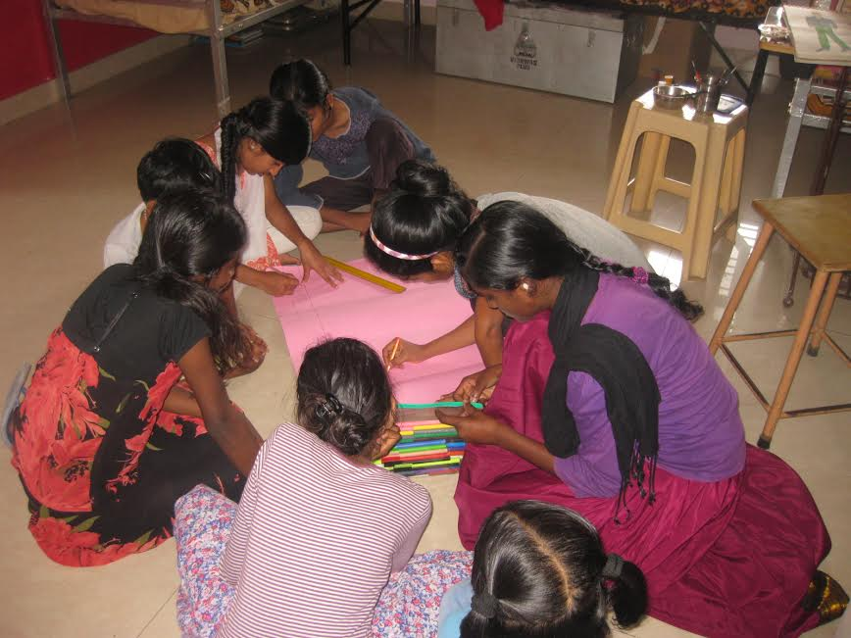

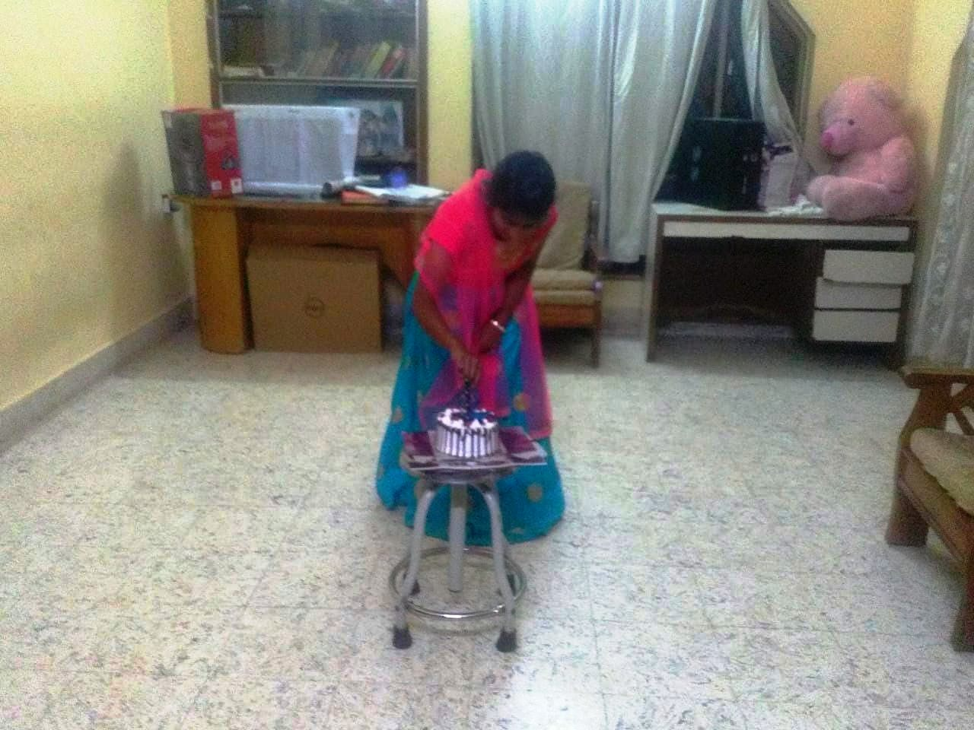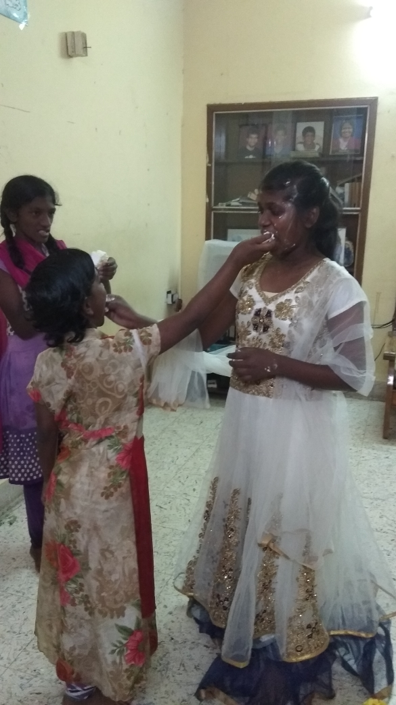

Challenges:

There was no formal funding for this project this year. In this regard, Freedom Foundation has approached other funders for support and is regularly in discussion and follow up for the same. Till the required support is received, it’s a great challenge for the organization to run this program and this withdrawal of support will surely affect the program till a stabilized funding is established through another funder.

    - Children who are moving on to higher studies are not able to take a clear decision about their further education & career. It’s a challenge to counsel, motivate and make them aware of their own strengths / capacity & then to select their line of study.
    - Complete support for food component and managing sudden high medical expenses is a major challenge in this program and FF is trying the best to overcome this.
    - Few kids who are facing continuous health problems are finding very difficult to manage their studies, health, medication, etc. and are pushed to mental stress. It is a challenge to motivate these kids by giving regular psychological support through counselor, caretakers & volunteers.
    - Managing and counseling the adolescent children & sorting out various issues in regard to their adamant attitudes & behavior is a great challenge as these issues should not affect the other children around.

Future Plans:

      - Discussions and follow ups with different funders to receive funding for the whole program due for lack of support.
      - Liaison with government bodies and authorities to garner more support for basic amenities like converting the electricity plan from commercial to low tariff category, free water supply and to convert the cooking cylinder to subsidized category.
      - Approach government authorities to provide land / building as per the various schemes for Orphans Homes.
      - Multiply and optimize on donor interactions in order to reap more funds in kind or cash to meet the market inflation.
      - Planning additional awareness and fundraising activities to enhance acceptability and providing prosperous & thriving future to our children.
      - Participating and interacting in capacity building programs to strengthen the capacities of our staff with an aim of generating improved responses towards childcare.
      - Enhancing the psychological aspect of the staff so that they could deliver additional emotional support to our children.
      - Commence knowledge building sessions on Adolescent Behavior Changes, Puberty etc, and the various issues they could face in their adolescence.
      - Proposal to budge the children to one school which provides enhanced standards and to facilitate a better monitoring.
      - Co-ordination with institutions which provide care and support to special children in order to construct a positive and self-reliant belief in our special children.
      - Liaison with government institutes which could impart skilled vocational training programs to our children consequently preparing them to cope up with ground realities of the world.
      - Aspire to re-unite our children to their respective extended family members to ensure better future prospects.

=============== ===============

