- OUR FOUNDING PRINCIPLES

Narrative Hub, a nonpartisan non-profit provides innovative, community-based, and sustainable approaches to solving South Sudan’s intractable problems. The hub strives to influence programming through creating an environment in which positive developments and, thus, positive stories can unfold in sectors ranging from rights, access to justice, protection, and emergence response to protection, education, and livelihoods improvement.

Narrative Hub was formed 2017 in response to the challenges following the breakout of the 2013 and 2016 crises that led to massive displacements and loss of human life and dignity, set education back years, and increased the incidence of GBV and loss of protection for children and women.

We rely on the strength of our innovative approaches and incisive knowledge of the local contexts to develop local capacities. We empower communities to meet through innovation, information sharing, participatory decision making, and protection of human dignity and respect to all. We are governed by a 7-member Board that meets semi-annually. An executive director heads the day-to-day running of the organization.

- VISION, MISSION, PRINCIPLES AND VALUES.

Mission

Improve Information sharing, livelihoods through community empowerment, respect for human life, rights and accountability, decision-making and community participation in alleviating suffering.

Vision

A socially, politically, and economically advanced society.

Principles

Grass-roots based, community participation and integration in advancing lives of the vulnerable, women and children, and society overall.

Values

Accountability, transparency, respect for human and women's rights, transformation through innovation and empowerment.

Goals

To work with the community, identifying needs and responding together for the better transformation of the society.

- Core interventions

1. Human Rights

- Protection (Voice raising, GBV, child protection, Encouraging freedom of speech and expression)
- Women rights and Empowerment
- Human rights and advocacy

2. Good Governance

- Access to Justices and Rules of laws
- Peace and Human security
- Civil Education.
- Youth promotion in peace building

- Health and Nutrition.

- Provision of Nutrition programs
- Community awareness on Immunization diseases.
- HIV/Aids awareness.

- Cross cutting and Essential Services.

- Provision of NFI to the returnees and IDPs.
- Provision of seeds and vegetable kits (Improvement of food security and livelihood).
- DTM Data Tracking Matrix.

4. Core Values.

- Diligence, excellence and distinction to the quality of services to the people.
- Integrity, accountability and transparency in all actions demonstration for factual professionalism.
- Fairness justice and collective responsibility.
- Respect for Human Rights, constitution and the rule of law.
- Impartial, upholding spirit, principles of inclusivity and equality of all humans as we respect anyone and not to consider his or her origin, sex or beliefs, economic, social and neither of the political affiliation.
- Recognize and respect all the traditional institutions, culture practices and their dignity.
- Friendly approaches to development in all sectors and affirmation the people’s ownership.

5. Geographical Location.

Narrative Hub operates and/or plans to operate in Central Equatoria (Jubek, Yei, Terekeka and Wonduruba) (Eastern Equatoria( Magwi, Ikwotos, Lafon, Torit and Nimule), Western Equatorial (Ezo, Maridi, Ebba and Yambio), Jonglei (Duk, Bor, Twic and Pigi).

6. Current Activities.

- Responding to Covid-19 through advocating for women reproductive health/right in Juba as a result of Covid-19 pandemic funded by Urgent Action Fund- Africa.
- Lead the Straight talk and young talk clubs in secondary and primary schools respectively to deal with climate change, child marriage, early pregnancy, SRH, Menstrual Hygiene management and other social factor affecting youth age 10-24 country wide.
- Reduction of Tribal Consciousness and peace building at secondary schools in Jubek state, by empowering Students to be agent of change
- GBV Prevention and response for the affected population in Maridi, awareness at schools through GBV clubs and community outreach, sensitization, and dialogue with FGDs on GBV mitigation. (Maridi.
- Providing mentor ship and life’s kills coaching for adolescent girls in DMI school and non-school girls in Managateen Camp Juba
- Partnering with Community Initiative for Development Organization as (women led organization) to conduct a policy study to amplify women’s voices and enhance their participation, accountability, and advocacy in humanitarian action.
- Collaborating with other like-minded, non-profit partners to conduct needs assessments across South Sudan, including in camps.
Partners

- CARE South Sudan.
- Global giving
- UNSECO
- State ministry of Education.
- UNFAO
- CIDO
- Urgent Action Fund- Africa. UAF

Narrative Hub main office.

Narrative Hub is located in Tongping Juba-nabari in Suk wewe, opposite search for common ground.
Torit Coordination Office.

Narrative Hub is located in Nagute Zone.

- ORGANOGRAM

Figure1: Narrative Hub Organogram
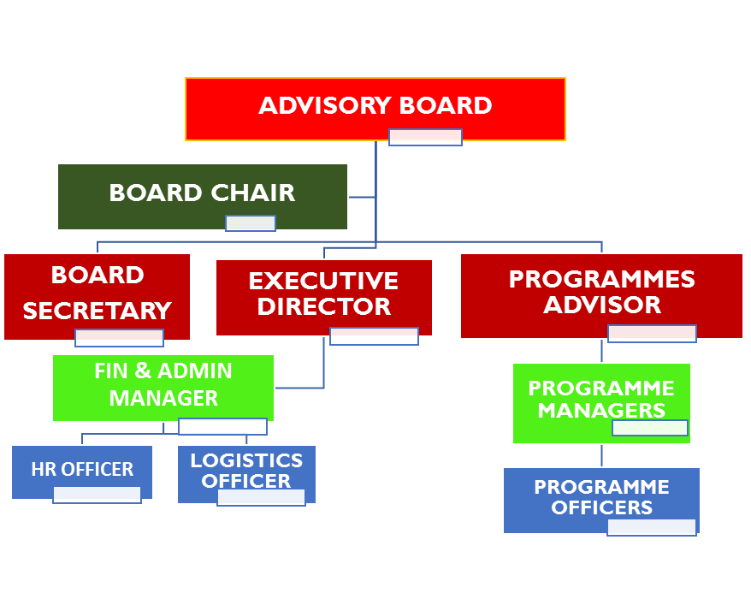
- Contacts Persons.

- Ayoo Janet Oyet
Executive Director
Tel: +211926145270/ 0929226564
Email: Narrative.hub2@gmail.com,
Janetnancyayoo@gmail.com

- Bernard Ochieng
Programmes Coordinator
Tel: 0916068812
Email: stbernards114@gmail.com

END

