NARRATIVE REPORT FORMAT

1. GENERAL INFORMATION:

- Name of organization: Fundación Oriéntame
- Country: Colombia
- Project year: 2021
- Project name: SECOND PHASE - Live your menstrual care: Access to menstrual hygiene for girls and adolescents.
- Reporting period: March 19 to April 2, 2021.
- Date of preparation of the report: 21 April.
- Name of the person in charge: Lady Alba.

2. OBJECTIVES OF THE PROJECT:

- Improve access to long-range menstrual hygiene products for girls and adolescents in Cúcuta, Villa del Rosario, Los Patios and Palenque (Colombia).
- Strengthen the self-knowledge and self-care of the bodies of girls and adolescents in Cúcuta, Villa del Rosario, Los Patios and Palenque (Colombia).

3. ACTIVITIES CARRIED OUT:

During the period from March 19 to April 2, 2021,the planning process of the project activities was outlined and the implementation of the activities began:

3.1 Develop educational content and didactic exercises for training sessions on menstrual care, hygiene and self-care.

- The design of the virtual course of menstrual hygiene was carried out, the contents were developed through 4 recorded and animated units: "knowing my body"; "my menstrual cycle, my rules"; "my menstrual hygiene and care"; and "the menstrual cup as a great option".
- Three informative and educational capsules on how to talk about menstruation, and recognize different menstrual products, were developed to invite adolescents to enroll in the virtual course.
3.2 Invite girls and adolescents to training activities on menstrual care and hygiene, self-knowledge of the body.

It had two components:
The invitation to launch the project was widespread among different stakeholders, such as community leaders, institutional leaders and teachers, with the aim of making the course available to them and promoting it among girls.
We also directly invite girls and young people between 13 and 25 years old in Cúcuta, Villa del Rosario, Los Patios and Palenque as well as community leaders. The invitation was shared through different virtual means such as social media, email, WhatsApp and phone calls.

Invitation to register for the project:
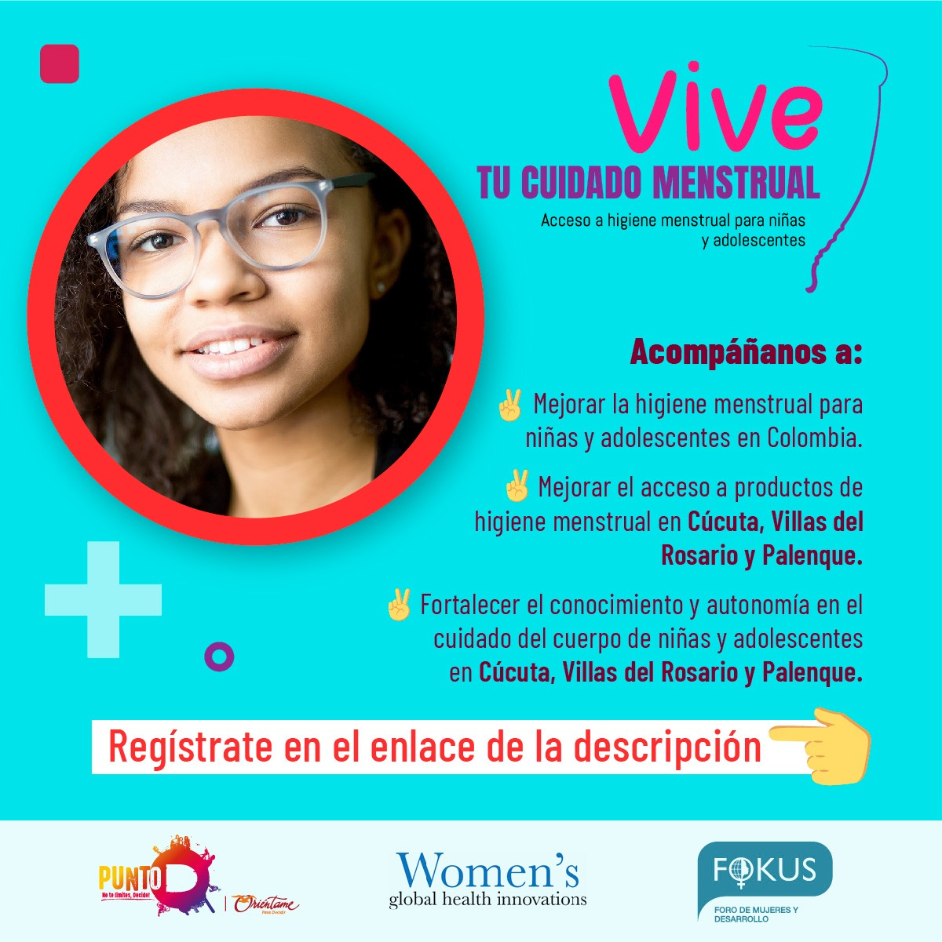
Three WhatsApp groups were created, to share information and reminders of important dates with participants, as well as the tutorial calendar and any news related to the virtual course. The content was developed according to their age for 3 groups: the first was composed of adolescents between 13 and 15 years old; the second group consisted of adolescents between the ages of 15 and 17, and the third group consisted of women aged 18 and over.
A total of 851 girls, adolescents,young people and leaders wanted to enroll in the project from different locations of Cúcuta, Villa del Rosario, Los Patios and Palenque, whose dynamics on this occasion were of two modalities: Virtual and face-to-face, the virtual course strengthened the knowledge and autonomy in the care of the body of 376 young people and in person was carried out through workshops with 441 adolescents between 13 and 25years. At the same time, 34 leaders, professionals and mothers were registered to participate in the menstrual health training cycle.

3.3 Carry out a virtual training in menstrual care and hygiene, focused on the self-knowledge of their body by girls.

- The virtual course began on March 19 to April 2, 2021. Each unit contained the following activities:
- Let's learn together - introductory video of the topics to be discussed in each unit.
- Fun facts - a PDF with important facts to consider.
- Let's clarify the questions: let's participate in the forum by asking questions or exploring a topic.
- Let's chat- to attend the virtual tutorials meetings (synchronous meeting) or to watch the pre-recorded tutorial sessions.
- What did you learn? – answer questions about the content studied in the unit.
- Four synchronous tutorials were conducted after each unit to answer questions posed by forum participants, or to discuss a specific topic more deeply.
Image Forum:
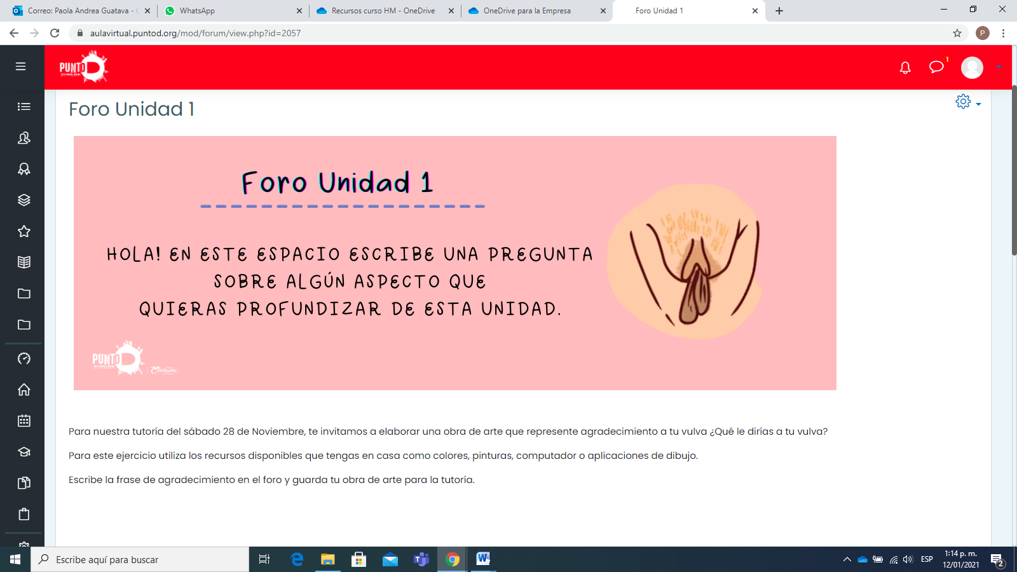

Virtual course image:
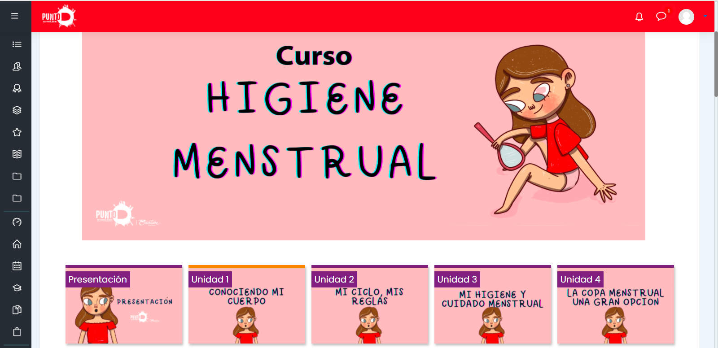

- A total of 117 people participated in the course, including high school and college students, teenagers, professionals and mothers who were not attending school and some others who were working.

3.4 Prepare the general concept for the campaign and graphic pieces on the use of the menstrual cup, as well as menstrual hygiene.
Seventeen graphic pieces were designed within the framework of the virtual course, emphasizing key aspects about the use of the menstrual cup, the concept of menstrual hygiene, the menstrual cycle, menstrual products and knowledge of our body.
Graphic use of the cup piece:
Graphic piece of the menstrual cycle:

3.5 Raise awareness.
Informational capsules about menstruation were posted on social media and WhatsApp groups. Messages were also posted from participants expressing their appreciation for the course, as well as sharing a drawing of their vulva. We collect some images, highlighting your creations and your messages to your vulva.
3.6 Identify the leaders of the participating municipalities.

- Community leaders, institutional referents, teachers, parents from the municipalitiesof Cúcuta, Villa del Rosario, Los Patios and Palenquewere convened, inviting them to participate in the project through telephone callsand/or emails.
- A total of 34 people, including leaders, professionals and mothers, signed up to participate in the project.

3.7 Develop a work plan with leaders

- The cycle of training of coaches in menstrual hygiene was carried out with leaders and mothers, through five virtual sessions through Zoom: 1) Empower us about our body -Menstrual cycle and female anatomy. 2) Management of menstruation - to understand our menstruation and be in harmony with it. 3) Know menstrual hygiene products-A personal choice. 4) To discover the menstrual cup -An option to know our body. 5) Finding the connection with our menstrual care- How do I take care of my magical universe?
- Participation during the training cycle remained active, with 14 people attending the first session and 10 people attending the entire cycle. In the end, they were given a certificate for their consistent participation.

Image of the training cycle session:
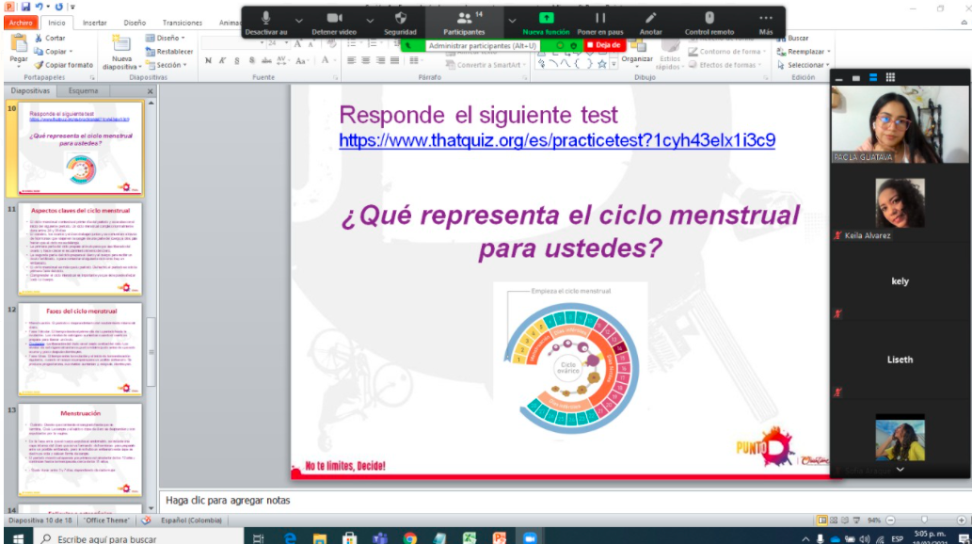
3.8 Conduct virtual talks on menstrual hygiene, use and maintenance of the menstrual cup, myths about menstruation and the cup.

In the four sessions developed within the training cycle of coaches, topics such as the correct use of the cup, the good and bad practices of use of the cup, the myths and advantages of menstruation, the knowledge of the body, different definitions and menstruation practices in different contexts were included.
3.9 Purchase of menstrual cups.
With the support of Fokus and Women's Global Health Innovations, it was possible to purchase 800 menstrual cups of three different sizes, of very good quality and at affordable prices.

4.0 Providing menstrual cups to girls and adolescents
We mappedthe municipalities of Cúcuta, Villa del Rosario, Los Patios and Palenque to identify strategic delivery points that were close to as many participants as possible. Five community leaders were in charge of delivering menstrual cups in Villa del Rosario, los Patios, Cúcuta and Palenque.

- results:

4.1 Virtual course on hygiene and menstrual care given to girls and adolescents

- The virtual course strengthened the knowledge and self-care of 107 girls andadolescents from the municipalities of Cúcuta, Villa del Rosario, Los Patios and Palenque between 13 and 25 years old. We provide timely information on menstrual health management, through activities, readings, videos, participation forums and synchronous tutorials. We managed to carry out 4 sessions to reinforce the content of the course.
- Although 376 girls, young women and women enrolled in the course, during telephone and message tracking, some of them expressed difficulties in having an Internet connection or mobile devices, and were unable to continue with the course. For that reason 107 students completed the entire course virtually.
- The virtual course and WhatsApp groups aimed to create support networks among adolescent girls as it was possible through these means to communicate and share different topics related to menstrual education. It was also possible for the participants to freely express different experiences, taboos and myths about menstruation and menstrual products in an environment free of judgment, generating a space of trust that allowed to solve questions.

Course results:
virtual
TOTAL REGISTERED TO THE PROJECT | Enrolled in the course | # of Girls, young people and women enrolled in the course | Started the course | Completed the entire course |  |  | Delivery of glasses
 | Enrolled GROUP 1 | 37 | 1 | 1 |  |  | 1
382 | Enrolled GROUP 2 | 61 | 24 | 18 |  |  | 18
 | Enrolled GROUP 3 | 278 | 99 | 88 |  |  | 88
 | total | 376 | 124 | 107 |  |  | 107
Face
TOTAL REGISTERED  FACE-TO-FACE SESSIONS | group | attendance | Attended sessions |  | Delivery of glasses
 | Enrolled GROUP Villa del Rosario-Juan Frio (Let's talk) | 140 | 23 |  | 23
441 | Enrolled Cúcuta (Alejandra) | 200 | 170 |  | 170
 | Registered Villa del Rosario (Las Mijas) | 64 | 41 |  | 41
 | Palenque (Solvay) | 37 | 21 |  | 21
 | total | 441 | 255 |  | 255

- Before starting the course, 25 girls and adolescents (8 per group), who had started attending the course, were selected to apply the baseline to identify the conditions and knowledge base of each adolescent in terms of menstrual health management. At the end of the course, the same baseline was appliedtoonly 25 teenagers, however, only 9 completed it.
- Prior to conducting the training cycle, 8 leaders and 2 mothers who were enrolled in the project were selected to apply the baseline. At the end of the cycle, the same baseline was applied to the 8 leaders and the 2 mothers.

  - Menstrual hygiene awareness campaign targeting girls and adolescents

- There was a positive response to the graphic pieces shared on social media by leaders, professionals, teachers and teenagers and WhatsApp groups. They express interest in knowing the management of menstrual health, the menstrual cup and its proper use. They contribute by replicating this information in their WhatsApp state.
- Awareness plan for leaders and parents who support girls and adolescents
- It was possible to attract the attention and participation of public entities such as the Women's Corporation denounces and moves, associationof palenqueras women Kasimba,Las Mijas, Asociación ser Negro es Más Sabroso, Fundación Hablemos and Wome ́s Helth Innovation and Fokus.
- The launch of the project was a key space to start implementing it as it allowed us to have contact with community leaders, professionals, teachers interested in accompanying the educational process and the delivery of menstrualcups.

4.3. Menstrual cups given to adolescents for menstrual care.
- 627 girls and adolescents learned the correct use of the menstrual cup, through explanatory videos, graphic pieces, participatory meetings where the demonstration of the insertion and extraction of the cup was carried out, many doubts were clarified, in order to disprove misconceptions about the menstrual cup and provide information about its use.
- A total of 627 menstrual cups were awarded: 10 of them to leaders who attended all the sessions of the training cycle, and 617 to girls and adolescents who completed the virtual course.

5. EVALUATION OF THE PROGRESS OF THE PROJECT:

5.1 Main achievements

- A significant achievement was to maintain the attention of the leaders and mothers in the menstrual hygiene training cycle, from the beginning to the end of it, 34 participants were enrolled and 10 remained active throughout the process.
- The invitation to enroll in the project had a major impact on social media, contact lists, emails, replicating and sharing the pieces, achieving greater reach to young people and other leading organizations interested in accompanying the menstrual health management process.
- The attendance of adolescents in synchronous tutoring remained high, the average attendance per group from beginning to end was 20 adolescents, actively participating in the forum and tutoring.

5.2 Challenges, barriers or obstacles faced and solution

Difficulties with internet connection, lack of band-with and/or mobile devices was a major obstacle to developing the virtual course and connecting to tutorials. Such connectivity issues prevented several participants from completing the course and obtaining their menstrual cup.
In times of Covid-19 pandemic, it was a challenge to conduct all synchronous sessions virtually as some topics were suitable to be held in person due to their large content. Additionally, it was not possible for adolescents who did not have internet to access the course content in person, due to the high contagion and restrictions on gatherings in public spaces. However, an attempt was made to establish communication with a close relative to convey accurate information about the virtual course.

5.3 Lessons learned

It is importan to take into account connectivity barriers for a project like this, since the attendance of the participants is something that we have less control over. This leads us to consider an additional effort to achieve participation and coverage goals.
We have learned that menstrual health management should continue to be addressed broadly, in order to provide safe and truthful information about menstruation, the advantages, and disadvantages of various menstrual products, and to emphasize knowledge of girl´s and wome´s bodies. From that knowledge, we are aware of the power we have to make decisions about it, engage in safe sex, and understand natural processes such as menstruation.

6. List in the Annex:
See capsules: https://fundaorientame-my.sharepoint.com/:f:/g/personal/aguatava_orientame_org_co/EvgL_PyKq3ZJnbiXfXhNjmsB5rDC-dXCJmuzM43NJedbWA?e=l0taUw
See list of courses enrolled and enrolleds: https://fundaorientame-my.sharepoint.com/:x:/g/personal/aguatava_orientame_org_co/Ee8j1lWvgnVJouZmpGINtDkBPcJC6qdVtZqA1KbwB5M5kg?e=yZCUwT
See list of registered leaders: https://fundaorientame-my.sharepoint.com/:x:/g/personal/aguatava_orientame_org_co/EQTKotq-1_dFijN1tTFzd0IBIWCkI4BC0KHGgT1_bqci1g?e=ABJWXh
See delivery of drinks: https://fundaorientame-my.sharepoint.com/:x:/g/personal/aguatava_orientame_org_co/ER5NWGh6niRDprhBIX0POwQBdDqFbQ6iu7KsX6jA8YX1hA?e=i653Db
View launch log: https://fundaorientame-my.sharepoint.com/:x:/g/personal/aguatava_orientame_org_co/EWu_4VtezkpMrXdCXPC1rZIBWKfmIyUijtdu02R_lVGC0A?e=laUkOL

