NARRATIVE REPORT FORMAT

1. GENERAL INFORMATION:

- Name of the organization: Fundación Oriéntame
- Country: Colombia
- Project year: 2020
- Name of the project: Live your menstrual care: Access to menstrual hygiene for girls and adolescents.
- Report period: October 7th to January 26th, 2021.
- Report preparation date: February 1th.
- Name of the person in charge: Lady Alba.

2. OBJECTIVES OF THE PROJECT:

- To improve access to long-range menstrual hygiene products for girls and adolescents in Palenque, Soledad, Villas del Rosario, Soacha, and Cuba (Colombia).
- To strengthen self-knowledge and self-care of girls’ and adolescents’ bodies in Palenque, Soledad, Villas del Rosario, Soacha, and Cuba (Colombia).

3. ACTIVITIES CARRIED OUT:

During the period between October 7th and December 20th, the planning process for the project activities was outlined, and the execution of activities started:

3.1 To develop educational content and didactic exercises for training sessions on menstrual care, hygiene, and self-care.

- The design of the virtual menstrual hygiene course was carried out, the contents were developed through 4 recorded and animated units: “getting to know my body”; “my menstrual cycle, my rules”; “my hygiene and menstrual care”; and “the menstrual cup as a great option”.
- The development of three informative and educational capsules took place on how to talk about menstruation, and to recognize different menstrual products, to invite teenagers to enroll in the virtual course. (See capsules)

3.2 To invite girls and adolescents to the formative activities on menstrual care and hygiene, self-knowledge of the body.

It had two components:
The invitation to launch the project was widespread among different stakeholders such as community leaders, institutional referents, and teachers, with the purpose of making the course available for them, and promoting it among girls.
We also directly invited girls and adolescents between 13 and 19 years old from the municipality of Soacha. The invitation was shared through different virtual means such as social networks, email, WhatsApp, and phone calls.

Project registration invitation:
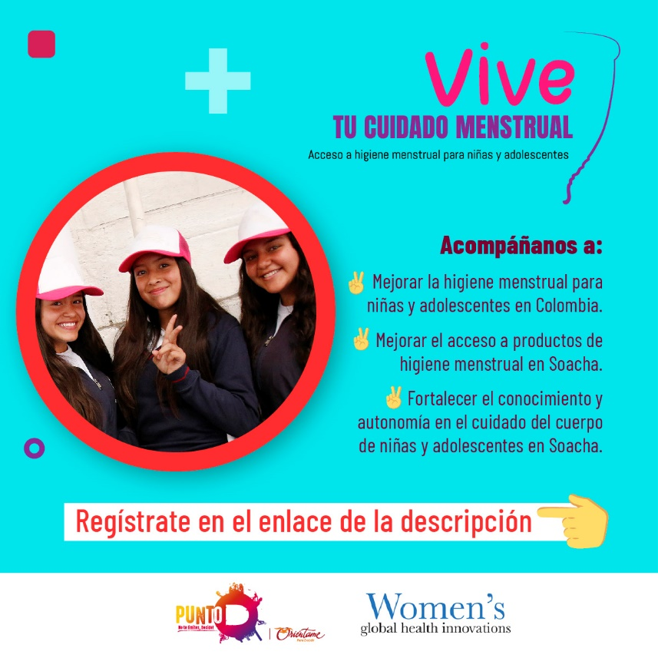
Three WhatsApp groups were created, to share information and reminders of important dates with participants, as well as the tutorials schedule and any news regarding the virtual course. The content was developed according to their age for 3 groups of adolescents: the first one consisted of adolescents between 13 and 15 years old; the second group was formed by adolescents between 15 and 17 years old, and the third one was integrated by women 18 and older.

WhatsApp groups image:
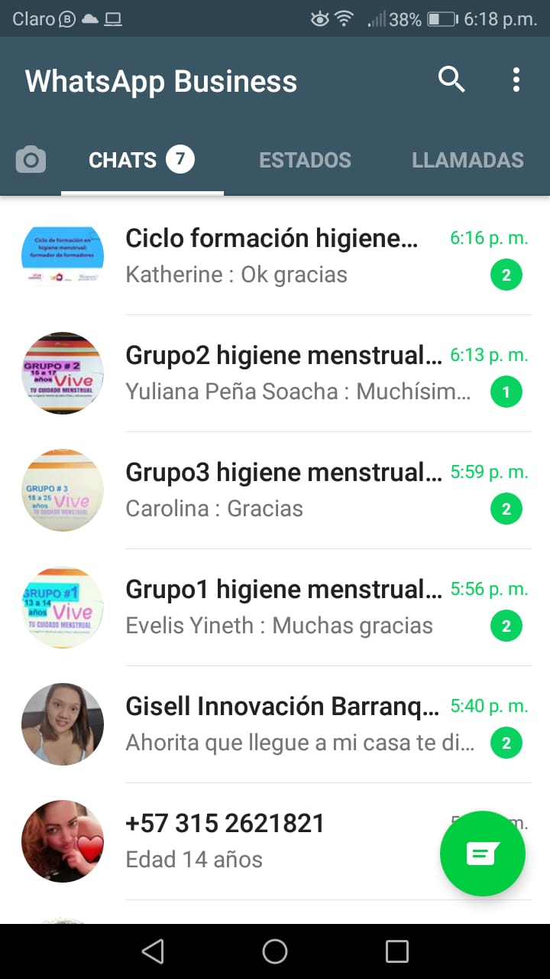

A total of 505 girls and adolescents wanted to be enrolled in the project from different locations in Bogotá, however, from them only 399 adolescents between the ages of 13 and 25 where from Soacha. (See list of people registered and enrolled in the course).

3.3 To carry out virtual training in menstrual care and hygiene, focused on girls’ self-knowledge of their bodies.

- The virtual course began on November 25th and it ended on January 26th. Every unit contained the following activities:
- Let us learn together - introductory video of the topics to discuss in each unit.
- Fun facts - a PDF with important facts to consider.
- Let’s clarify questions – Participating in the forum by asking questions or exploring a topic.
- Let’s chat- to attend the virtual tutorial meetings (synchronic meeting) or to watch the pre-recorded tutorial sessions.
- What did you learn? – to answer questions regarding content studied in the unit.
- Four synchronic tutorials were carried out after each unit to answer questions raised by the participants in the forums, or to discuss more deeply a specific topic.
Picture forum:
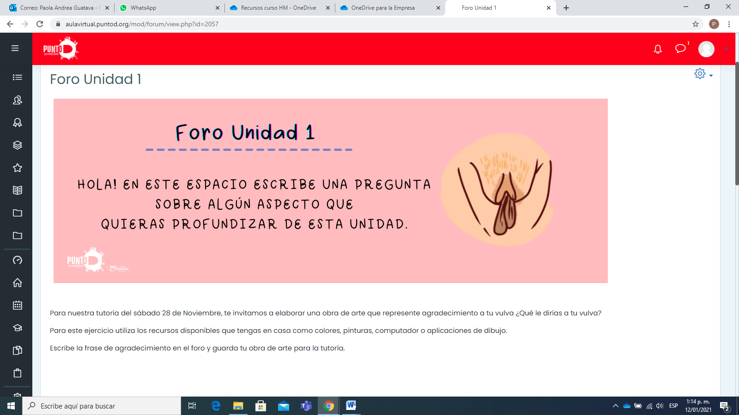

Image tutorial: 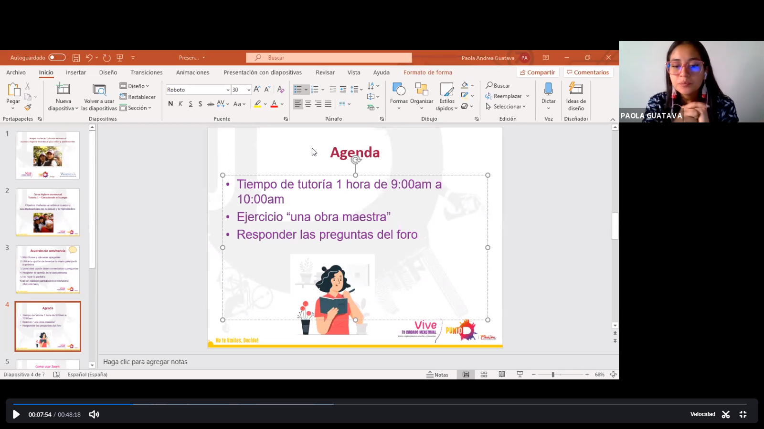

Virtual course image:
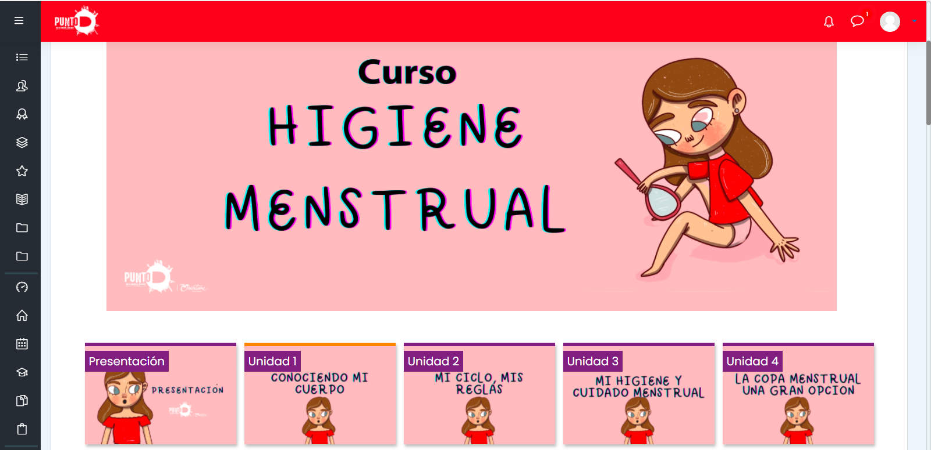

- A total of 158 people participated in the course, among them were high school and college students, adolescents who were not attending school, and some others who were working.

3.4 To prepare the general concept for the campaign and graphic pieces on the use of the menstrual cup as well as menstrual hygiene.

Seventeen graphic pieces were designed within the framework of the virtual course, emphasizing key aspects regarding the use of the menstrual cup, the concept of menstrual hygiene, the menstrual cycle, menstrual products, and knowledge of our body.
Graphic piece use of the cup:

Menstrual cycle graphic piece:

3.5 To raise awareness.
Information capsules on menstruation were published on social media and WhatsApp groups. Messages from the participant expressing their appreciation for the course were also published, in addition to sharing a drawing of their vulva. We compiled some images, highlighting their creations and their messages to their vulva.
Vulva drawings image:

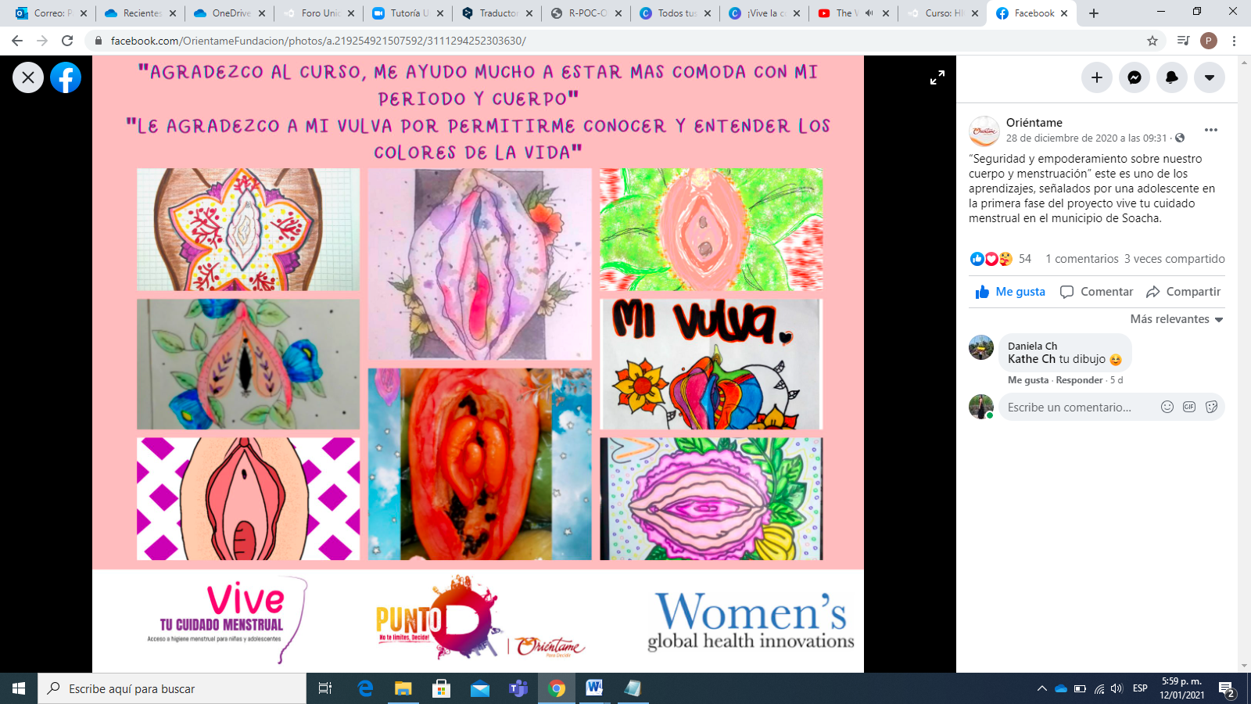
3.6 To identify leaders of the participating municipalities.

- We searched for community leaders, institutional references, teachers, fathers, and mothers of the Soacha municipality, inviting them to participate in the project through phone calls, and /or emails.
- A total of 33 people, including leaders, professionals, and mothers, signed up to participate in the project. (See list of the project leaders’ registration)

3.7 To develop a work plan with the leaders
- The train of trainers cycle in menstrual hygiene was carried out with leaders and mothers, through five virtual sessions using Zoom: 1) Empowering ourselves about our body -Menstrual cycle and female anatomy. 2) Menstruation management -to understand our menstruation and to be in harmony with it. 3) Getting to know menstrual hygiene products-A personal choice. 4) To discover the menstrual cup -An option to know our body. 5) Finding the connection with our menstrual care- How do I take care of my magical universe?
- The participation during the training cycle remained active, with 16 people attending the first session and 15 people attending the entire cycle. In the end, they were given a certificate for their constant participation.
Training cycle session image:
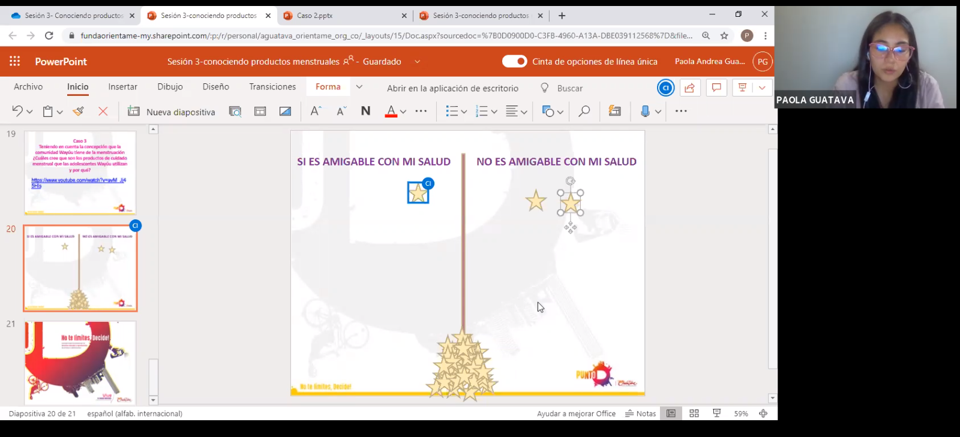
3.8 To conduct virtual talks on menstrual hygiene, use, and maintenance of the menstrual cup, myths about menstruation, and the cup.
In all five sessions developed within the train of trainers’ cycle, topics such as the correct use of the cup, good and bad practices using the cup, myths and advantages of menstruation, knowledge of the body, different definitions, and menstruation practices in different contexts were included.
3.9 Purchasing menstrual cups.
With the support of Women’s Global Health Innovations, it was possible to buy 300 menstrual cups of three different sizes, of very good quality, and at affordable prices.
4.0 To provide menstrual cups to girls and adolescents
We mapped the municipality of Soacha to identify strategic delivery points that were close to as many participants as possible. Five community leaders were in charge of delivering menstrual cups in San Mateo, León XIII, Hogares Soacha, Ducales, and Sutatausa. (See delivery of menstrual cups)

- OUTCOMES:
  - Virtual course on hygiene and menstrual care imparted to girls and adolescents

- The virtual course strengthened the knowledge and self-care of 115 girls and adolescents from the municipality of Soacha between the ages of 13 and 25. We provided timely information on the management of menstrual health, through activities, readings, videos, forums of participation, and synchronic tutorials. We got to carry out 4 sessions to reinforce the content of the course.
- Although 158 students started the course, during the telephone and message follow-up, some of them expressed difficulty of having internet connection or mobile devices, and were unable to continue with the course. For that reason, 56 students completed less than two units, whereas 115 students completed the entire course.
- The virtual course and the WhatsApp groups aimed at creating support networks among adolescents as it was possible through these means to communicate and share different topics related to menstrual education. It was also possible for participants to freely express different experiences, taboos, and myths on menstruation and menstrual products in a judgment-free environment, generating a space of trust that allowed questions to be solved.

Virtual course outcomes:

- Before starting the course, 36 girls and adolescents (12 per group), who had started attending the course, were selected to apply the baseline to identify the conditions and knowledge base of each adolescent in regards to menstrual health management. At the end of the course, the same baseline was applied to the same 36 adolescents, however, only 25 fully filled it out. For this reason, 11 forms were discarded. (See adolescent baseline)
- Before carrying out the training cycle, 5 leaders and 2 mothers who were enrolled in the project were selected to apply the baseline. At the end of the cycle, the same baseline was applied to the 5 leaders and the 2 mothers. (See leaders and family baselines).
4.2 Awareness campaign on menstrual hygiene aimed at girls and adolescents

- There was a positive response to graphic pieces shared on social networks from leaders, professionals, teachers, and adolescents and WhatsApp groups. They express interest in knowing about the management of menstrual health, the menstrual cup and its proper use. They contributing by replicating this information in their WhatsApp status.

  - Awareness plan for leaders and parents who support girls and adolescents
- It was possible to attract the attention and participation of public entities such as the Secretary of Health of Soacha, Secretary of Health Dimension of Sexual and Reproductive Health, Assembly of Women of Soacha, Municipal Mayor's Office of Sutatausa, ICBF - Gestando Futuro APC, and leaders who perform community work in Soacha.
- The launch of the project was a key space to start implementing it since it allowed us to have contact with community leaders, professionals, teachers interested in accompanying the educational process and the delivery of menstrual cups (See launch registration).

4.4 Menstrual cups given to adolescents for their menstrual care.
- 115 girls and adolescents learned the correct use of the menstrual cup, through explanatory videos, graphic pieces, participatory meetings where the demonstration of the insertion and removal of the cup was carried out, many doubts were clarified, in order to debunk misconceptions about the menstrual cup and to provide information about its use.
- A total of 126 menstrual cups were delivered: 11 of them to leaders who attended all the sessions of the training cycle, and 115 to adolescents who completed the virtual course.

5. EVALUATION OF THE PROJECT'S PROGRESS:

5.1 Main achievements

- A significant achievement was maintaining the attention of leaders and mothers in the cycle of training in menstrual hygiene, from the beginning to the end of it, 33 participants were enrolled and 11 remained active throughout the process.
- The invitation to register to the project had an important impact on social networks, contact lists, emails, replicating and sharing the pieces, achieving a greater scope to young people and other leading organizations interested in accompanying the process of menstrual health management.
- The attendance of adolescents in the synchronic tutorials remained high, the average attendance per group from the beginning to the end was 15 adolescents, actively participating in the forum and the tutoring.

5.2 Challenges, barriers or obstacles faced and solution

The difficulties with the internet connection, the lack of band-with and or mobile devices was a significant obstacle to develop the virtual course and to connect to the tutorials. Such connectivity issues prevented several participants from completing the course and obtaining their menstrual cup.

In times of the Covid-19 pandemic, it was a challenge to carry out all the synchronic sessions in a virtual way since some topics were suitable to be carried out face-to-face due to their great content. Additionally, it was not possible for adolescents who did not have internet to access the content of the course in person, due to the high contagion and the restrictions of meetings in public spaces. However, an attempt was made to establish communication with a close relative to convey precise information about the virtual course.

5.3 Lessons learned

Connectivity barriers have to be considered for a project such as this one, given that the attendance of the participants is something that we have less control. This leads us to consider an extra effort to accomplish the participation and coverage goals.

We have learned that the management of menstrual health must continue to be addressed broadly, in order to offer safe and truthful information on menstruation, advantages, and disadvantages of different menstrual products, and emphasize knowledge of one's own body. From that knowledge, we are aware of the power we have to make choices about it, engage in safe sex, and understand natural processes such as menstruation.

6. Annex List:
See capsules: https://fundaorientame-my.sharepoint.com/:f:/g/personal/aguatava_orientame_org_co/EvgL_PyKq3ZJnbiXfXhNjmsB5rDC-dXCJmuzM43NJedbWA?e=l0taUw
See list of enrolled and enrolled course: https://fundaorientame-my.sharepoint.com/:x:/g/personal/aguatava_orientame_org_co/EbmEvSgOBtxHpqr2rZPoeHIB_qsXWHP1KslLS9qMbJPAjg?e=cVM1Wq
See list of project leaders registration: https://fundaorientame-my.sharepoint.com/:x:/g/personal/aguatava_orientame_org_co/EcGfpDrUEaZGqWy4KJSJom4BOIBxkEUE9-1li1d9NZLKMg?e=sXzwzn
See delivery of glasses: https://fundaorientame-my.sharepoint.com/:x:/g/personal/aguatava_orientame_org_co/EchP3eJlsZVBnCiF1SNdZFABwsWE4ukpcNRteqkWEcQs4Q?e=ItM5e4
See adolescent baseline: https://fundaorientame-my.sharepoint.com/:x:/g/personal/aguatava_orientame_org_co/EfhP6Ygvw5tGu6QsK7Qs-wQBb-dRUpn2F0ivYLagh2AsyQ?e=xyfb6Z
See baseline leaders: https://fundaorientame-my.sharepoint.com/:x:/g/personal/aguatava_orientame_org_co/Ed179X37VLdJthzJB1PixYABt8RBy0uT4GBXLmPnb5p1dw?e=a5BY0j

See family baseline: https://fundaorientame-my.sharepoint.com/:x:/g/personal/aguatava_orientame_org_co/EZh8oZQfnlpJuauMjNee8xMB8v9yrMFtvuuj8tEZf35btw?e=xvQhHA

See launch registration: https://fundaorientame-my.sharepoint.com/:x:/g/personal/aguatava_orientame_org_co/EQsmeLUchldPsRtchn4NkDoBbvg3ug6qRrrNVigpTfxO1g?e=CyWaeu

