**NARRATIVE REPORT FORMAT**

**1. GENERAL INFORMATION:**

1. Name of the organization: Oriéntame Foundation
2. Country: Colombia
3. Year of project: 2021
4. Project name: **THIRD PHASE** - Live your menstrual care: Access to menstrual health for girls and adolescents.
5. Reporting period: September 8 to December 6, 2021.
6. Report preparation date: December 23
7. Name of person responsible: Lady Alba

**2. PROJECT OBJECTIVES:**

1. To improve access to long-range menstrual health products for girls and adolescents in Pereira and Dosquebradas (Colombia).
2. To strengthen self-knowledge and self-care of the bodies of girls and adolescents in Pereira and Dosquebradas (Colombia).

**3. ACTIVITIES EXECUTED:**

During the period from September 08 to December 06, 2021, the planning process of the project activities was outlined, and the implementation of the activities was initiated:

**3.1 Develop educational content and didactic exercises for training sessions on menstrual care and self-care.**

The design of the virtual course on menstrual health was carried out; the contents were developed through four recorded and animated units: "knowing my body"; "my menstrual cycle, my rules"; "menstrual care"; and "the menstrual cup as a great option."

**3.2 Inviting girls and adolescents to formative activities on menstrual care and health, body self-knowledge.**

It had two components:

The invitation to launch the project was spread among different stakeholders, such as community leaders, institutional referents, and teachers, to make the course available to them and promote it among girls.

We also directly invited girls and young women between 13 and 25 years old in Pereira and Dosquebradas and community leaders. Furthermore, the invitation was shared through different virtual media such as social networks, email, WhatsApp, and phone calls.

Invitation to register for the project: 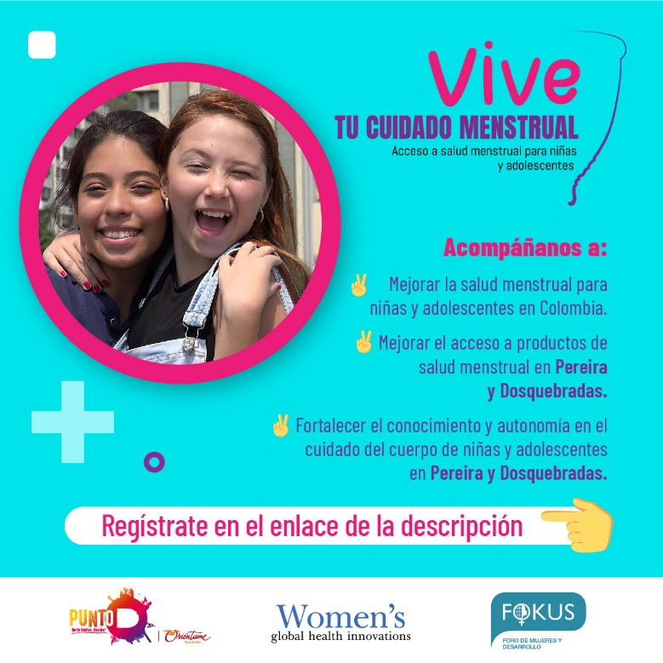

Three WhatsApp groups were created to share information and reminders of important dates with the participants, as well as the tutorial calendar and any news related to the virtual course. The content was developed according to their age for three groups: the first was adolescents between 13 and 14 years old; the second group was adolescents between 15 and 17 years old, and the third was made up of women 18 years old and older.

A total of 665 girls, adolescents, young people, and leaders enrolled in the project from different locations in Pereira and Dosquebradas, conducted virtually this time. This course strengthened the knowledge and autonomy in the care of the body of 161 young people between the ages of 13 and 25. At the same time, 28 leaders, professionals, and mothers registered to participate in the training cycle on menstrual health.

**3.3 Conduct virtual training in menstrual care and health, focusing on girls' self-awareness of their bodies.**

The virtual course began on September 27 to October 29, 2021. Each unit contained the following activities:

1. Let's learn together - introductory video of the topics to be discussed in each unit.
2. Fun facts - a PDF with important facts to consider.
3. Let's clarify questions - participate in the forum by asking questions or exploring a topic.
4. Let's chat - to attend virtual tutorial meetings (synchronous meetings) or to watch pre-recorded tutorial sessions.
5. What did you learn? - To answer questions about the content studied in the unit.
6. Four synchronous tutorials were held after each unit to answer questions raised by participants in the forums or to further discuss a specific topic.

Image of the forum:

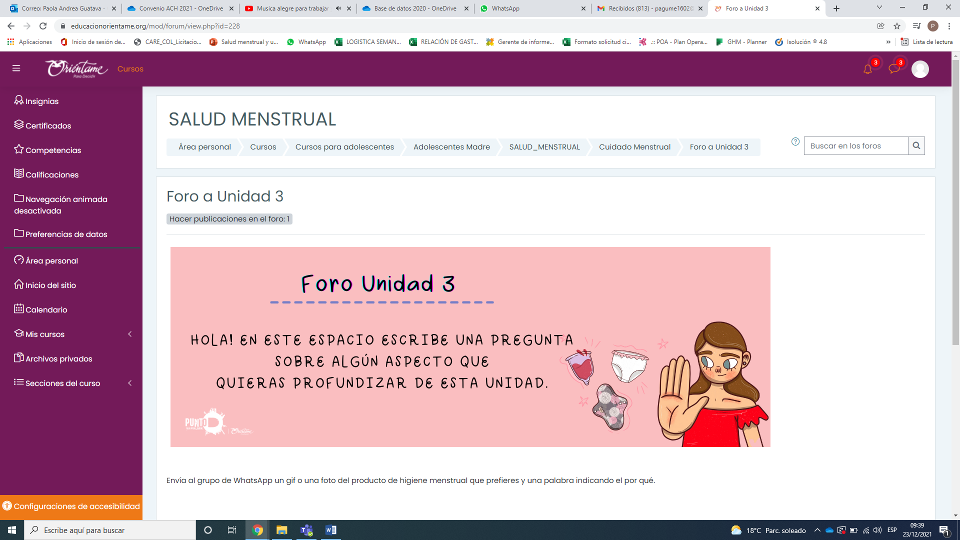

Image of the virtual course:

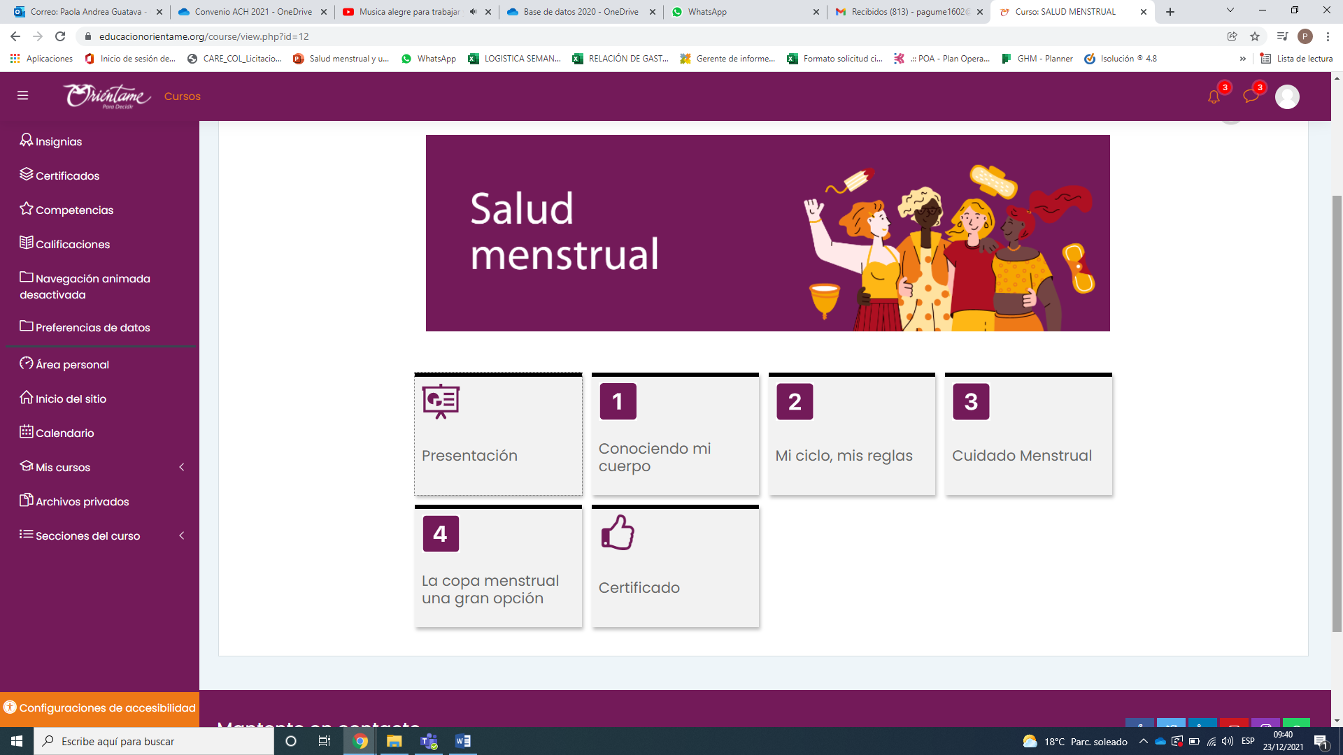

1. 161 people participated in the course, including high school and university students, adolescents, and young adults.

**3.4 Prepare the general concept for the campaign and graphic pieces on menstrual cup use and menstrual hygiene.**

Seventeen graphic pieces were designed within the framework of the virtual course, emphasizing key aspects of the use of the menstrual cup, the concept of menstrual health, the menstrual cycle, menstrual products, and knowledge of our body.

Graphic design of the menstrual cup:

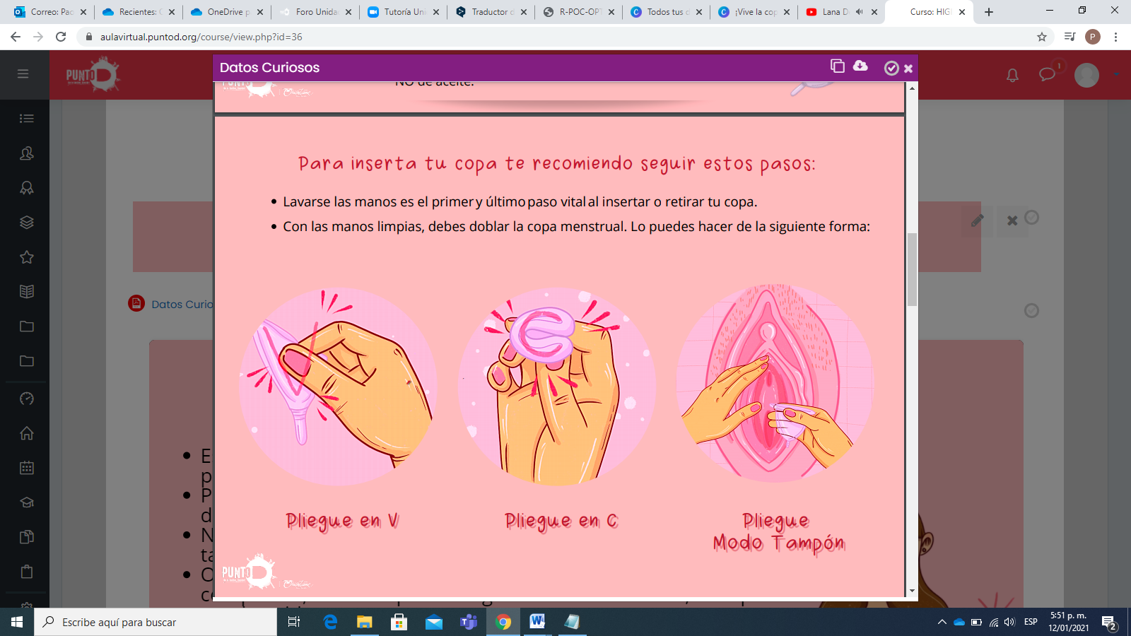

Graphic design of the menstrual cycle:

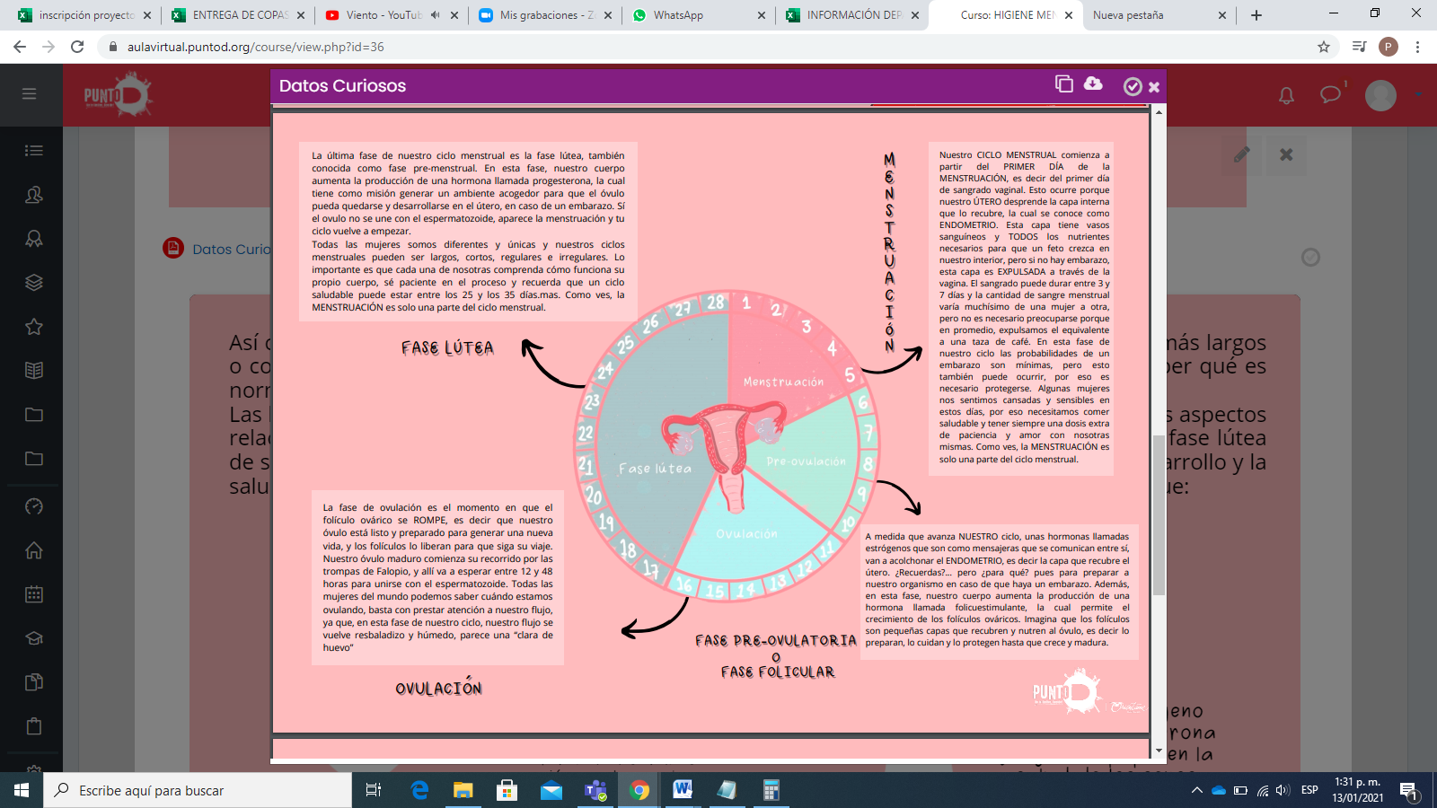

**3.5 Raising awareness.**

Informative capsules on menstruation were published on social networks and WhatsApp groups. Messages from participants expressing their appreciation for the course were also posted, as well as they shared a drawing of their vulva. We compiled some images, highlighting their creations and their messages to their vulva

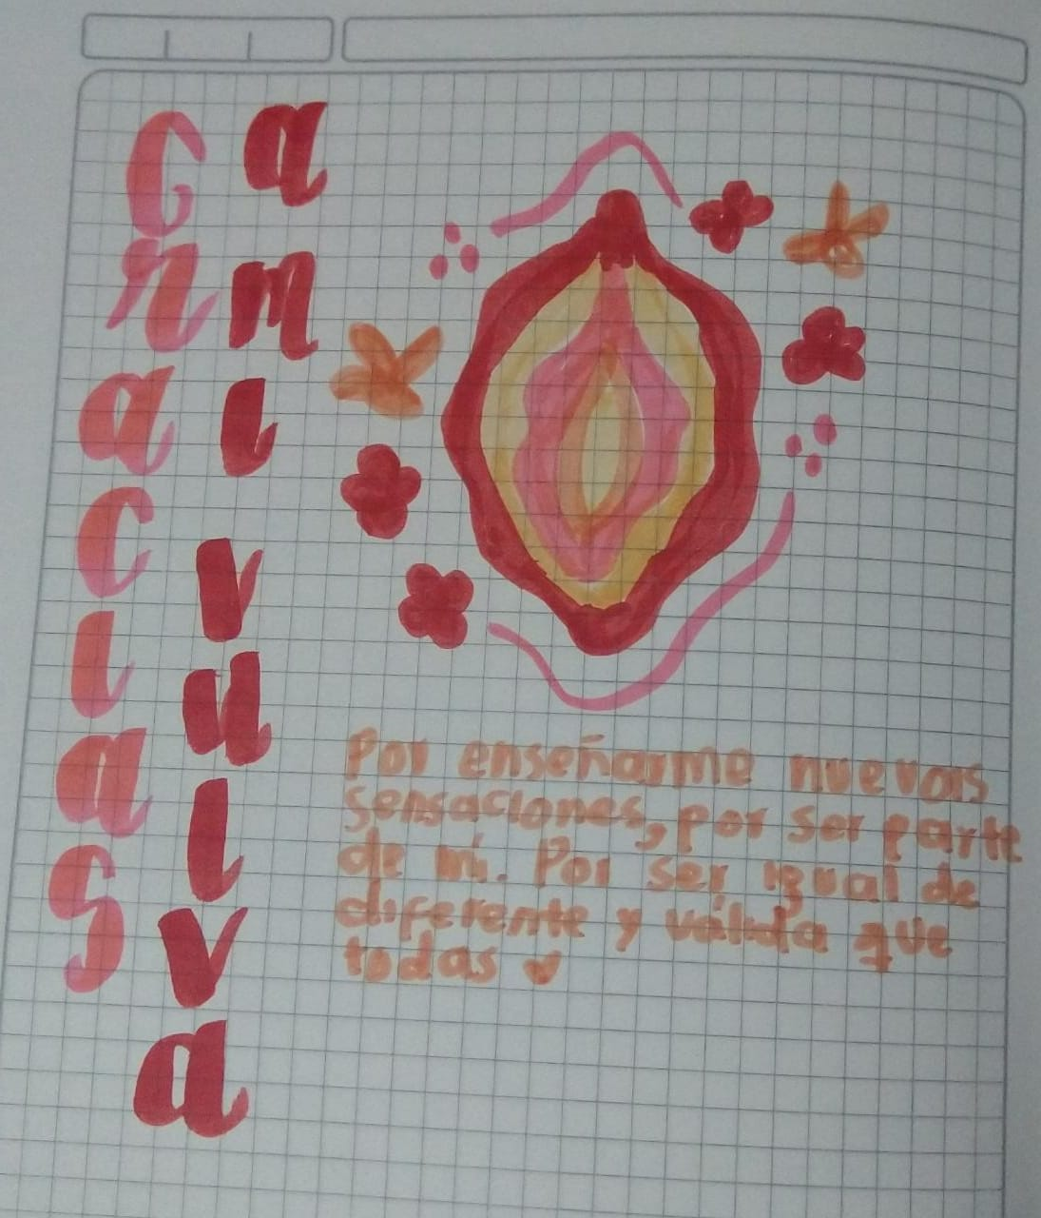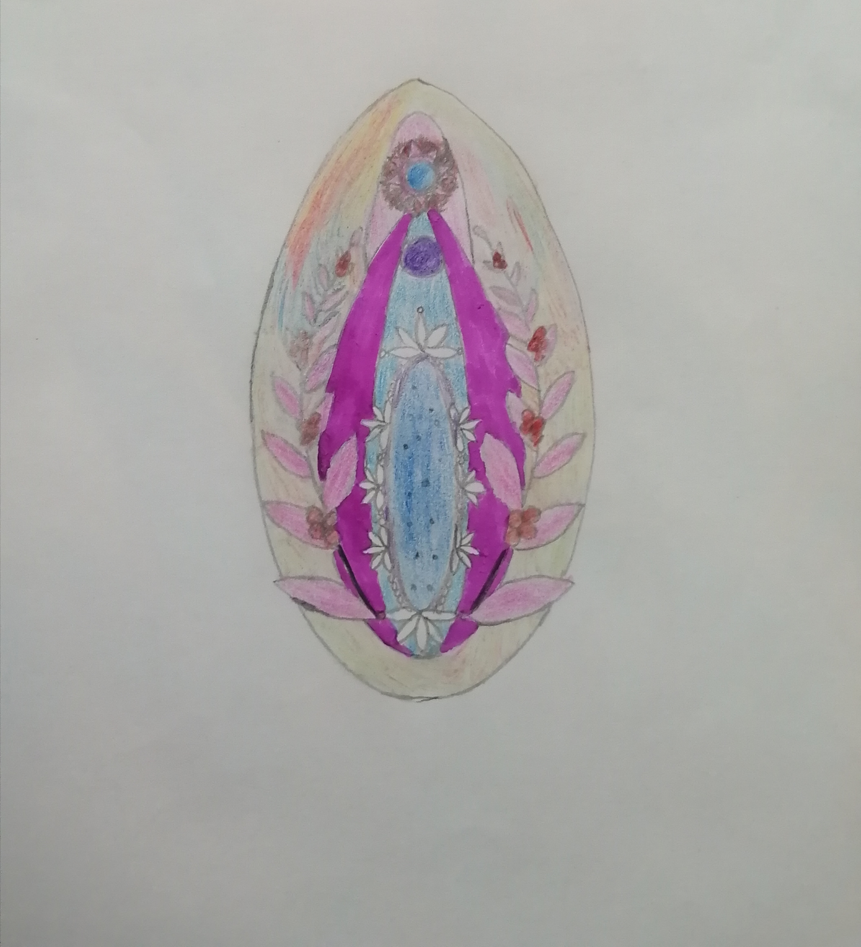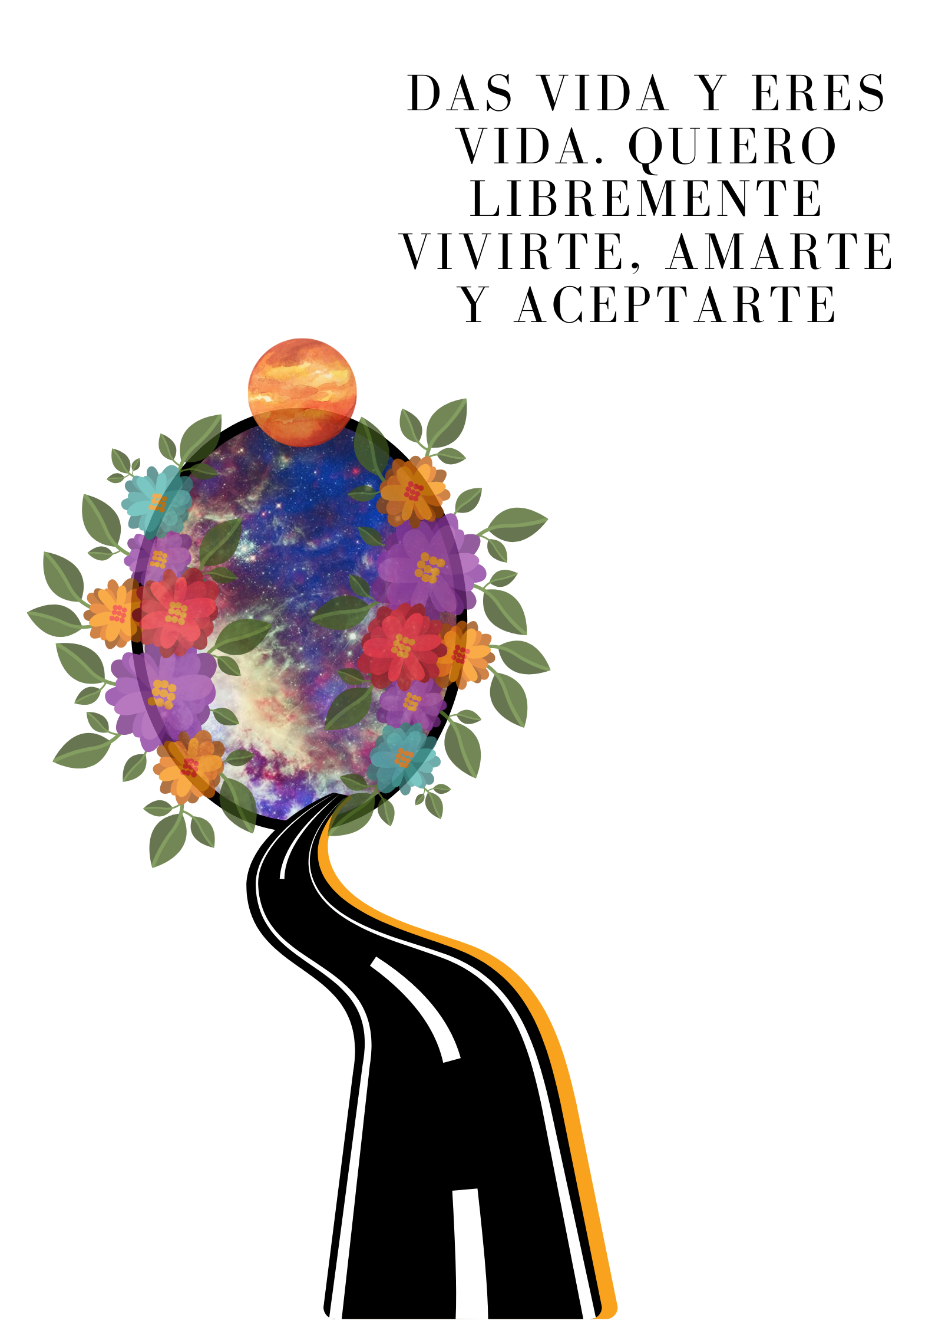

**3.6 Identify the leaders of the participating municipalities.**

1. Community leaders, institutional referents, teachers, fathers, and mothers of the municipalities of Pereira and Dosquebradas were invited to participate in the project through telephone calls and emails.
2. 30 people, including leaders, professionals, and mothers, signed up to participate in the project.

**3.7 Develop a work plan with the leaders.**

1. The formation cycle was carried out with leaders and mothers through four virtual sessions via Zoom: 1) Empowering ourselves about our body -Menstrual cycle and female anatomy. 2) Menstrual management - understanding our menstruation to harmonize with it. 3) Learn about menstrual health products - a personal choice. 4) Discover the menstrual cup - an option to know our body.
2. The participation during the training cycle had a significant difference since the first session started with 28 people, and during the whole cycle, 7 people attended. Through follow-up calls and messages, they could not continue due to work and personal commitments, and their schedules crossed with their mandatory activities. At the end of the cycle, a certificate was awarded for their constant participation.

Image of the session of the formation cycle:

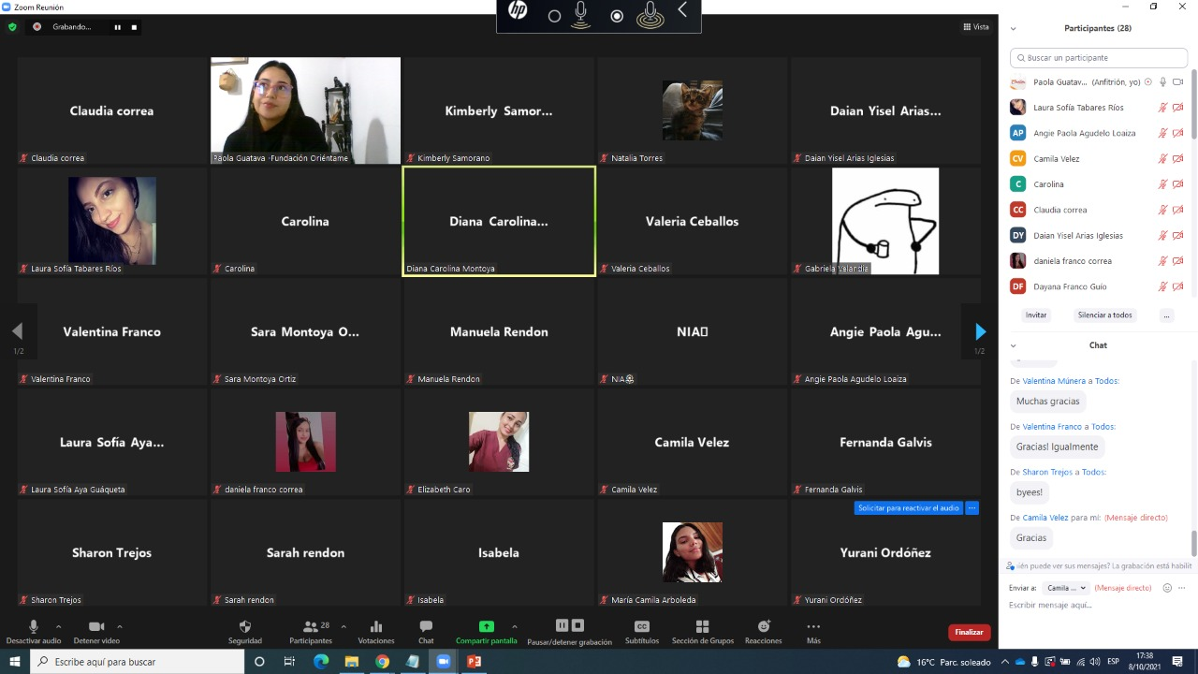

**3.8 Implement virtual chats on menstrual health, use, and maintenance of the menstrual cup, myths about menstruation, and the menstrual cup.**

The four sessions developed within the training cycle included the correct use of the cup, good and bad practices in using the cup, myths and advantages of menstruation, body knowledge, different definitions, and menstruation practices in different contexts.

**3.9 Purchase of menstrual cups.**

With the support of FOKUS and Women's Global Health Innovations, it was possible to purchase and deliver menstrual cups in two different sizes, of excellent quality, and at affordable prices.

**4.0 Provide menstrual cups to girls and adolescents.**

We mapped the municipalities of Pereira and Dosquebradas to identify strategic delivery points that were close to the largest possible number of participants. As a result, four community leaders delivered menstrual cups on November 20, 2021, at Olaya Herrera Park (Pereira) and Vahler Park (Dosquebradas).

**Results:**

**4.1 Virtual course on menstrual health and care delivered to girls and adolescents**

1. The virtual course strengthened the knowledge and self-care of 161 girls and adolescents from the municipalities of Pereira and Dosquebradas between 13 and 25 years old. We provided timely information on menstrual health management through activities, readings, videos, participation forums, and synchronous tutorials. In addition, we conducted up to 4 sessions to reinforce the course content.
2. Although 665 girls, young women, and women enrolled in the course, during the telephone follow-up, and through messages, some of them expressed difficulties to having an Internet connection or mobile devices, also due to academic issues and the end of the school year, they could not continue with the course. For this reason, 161 students completed the entire course virtually.
3. The virtual course and WhatsApp groups aimed to create support networks among adolescent girls since it was possible to communicate quickly and share different topics related to menstrual education. It was also possible for participants to freely express different experiences, taboos, and myths about menstruation and menstrual products in a non-judgmental environment, generating a space of trust that allowed questions to be answered and discussion spaces to be created.

**Results of the course:**

|  |  |  |  |  |  |
| --- | --- | --- | --- | --- | --- |
| **Virtual** |  |  |  |  |  |
| **TOTAL ENROLLED IN THE PROJECT** | **Enrolled in the course** | **# of girls, young women and women enrolled in the course** | **Started course** | **Completed the entire course** | **Delivery of cups** |
|  | Enrolled in GROUP 1 | 98 | 30 | 24 | 24 |
| 665 | Enrolled in GROUP 2 | 177 | 89 | 46 | 46 |
|  | Enrolled in GROUP 3 | 260 | 98 | 68 | 68 |
|  | **TOTAL** | **535** | **217** | **138** | **138** |
| **Results La Julita School** |  |  |  |  |  |
| **TOTAL ENROLLED IN THE PROJECT** | **Enrolled in the course** | **# of girls, young women and women enrolled in the course** | **Started course** | **Completed the entire course** | **Delivery of cups** |
|  | Enrolled in GROUP 1 | 27 | 15 | 10 | 10 |
| 68 | Enrolled in GROUP 2 | 35 | 23 | 10 | 10 |
|  | Enrolled in GROUP 3 | 6 | 3 | 3 | 3 |
|  | **TOTAL** | **68** | **41** | **23** | **23** |

1. Before starting the course, 15 girls and adolescents (5 per group), who had started attending the course, were selected to apply the baseline to identify each adolescent's conditions and knowledge base regarding menstrual health management. At the end of the course, the same baseline was applied to the same 15 adolescents; however, only 6 completed it.
2. Before conducting the training cycle, 6 leaders and 1 mother enrolled in the project were selected to apply the baseline. At the end of the cycle, the same baseline was applied to the 7 leaders and 1 mother.
   1. **Menstrual hygiene awareness campaign aimed at girls and adolescents.**
   2. There was a positive response to the graphic pieces shared on social networks by leaders, professionals, teachers, adolescents, and WhatsApp groups. They express interest in learning about menstrual health management, the menstrual cup, and its proper use. They contribute by replicating this information in their WhatsApp status.
   3. Awareness plan for leaders and parents who support girls and adolescents.
   4. It was possible to attract the attention, participation, and support of entities such as the Risaralda Women's Meeting, La Julita School, Comfamiliar Institute, Casa Mujer Risaralda, Women's Global Health Innovations, and FOKUS.
   5. The project's launching was a key space for its implementation. It allowed us to contact community leaders, professionals, and teachers interested in accompanying the educational process and the delivery of menstrual cups.

**4.3. Menstrual cups given to adolescents for menstrual care.**

1. 161 girls and adolescents learned the correct use of the menstrual cup through explanatory videos, graphic pieces, participatory meetings where the insertion and removal of the cup was demonstrated, and doubts were clarified to refute misconceptions about the menstrual cup and provide accurate information on its use.
2. 168 menstrual cups were delivered: 7 of them to leaders who attended all the sessions of the training cycle and 161 to girls and adolescents who completed the virtual course.

**5. EVALUATION OF PROJECT PROGRESS:**

**5.1 Main achievements**

1. A significant achievement was to have the support of several entities to carry out the dissemination and enrollment of the young women in the project.
2. Within the framework of this project, for the first time, an articulation was made with an educational institution. La Julita showed interest in participating in the menstrual health course and receiving education and access to the menstrual cup. This articulation was managed through the welfare area with the psychologist Daniela, who summoned the girls and accompanied the enrollment process and delivery at the school.
3. The invitation to enroll in the project had a significant impact on social networks, contact lists, emails, replicating and sharing the pieces, achieving a greater reach to young people and other leading organizations interested in accompanying the process of menstrual health management. After the launch of the course registration, the reception was very good, in three days there were 370 registered.
4. Adolescents' attendance in the synchronous tutorials remained high; the average attendance per group from the beginning to the end was 15 adolescents actively participating in the forum and the tutorial.
5. The cup delivery was a meaningful encounter with the teens, youth, mothers, and leaders who received their cup. The delivery of the cups was fun and creative. It allowed knowing the different opinions and perspectives of the young women in a more sensible and close way, thus building a space for learning and expression. The comments that left the delivery of cups were positive and allusive to the knowledge and care of the body (see photos delivery of cups).

Delivery of menstrual cups in Pereira:

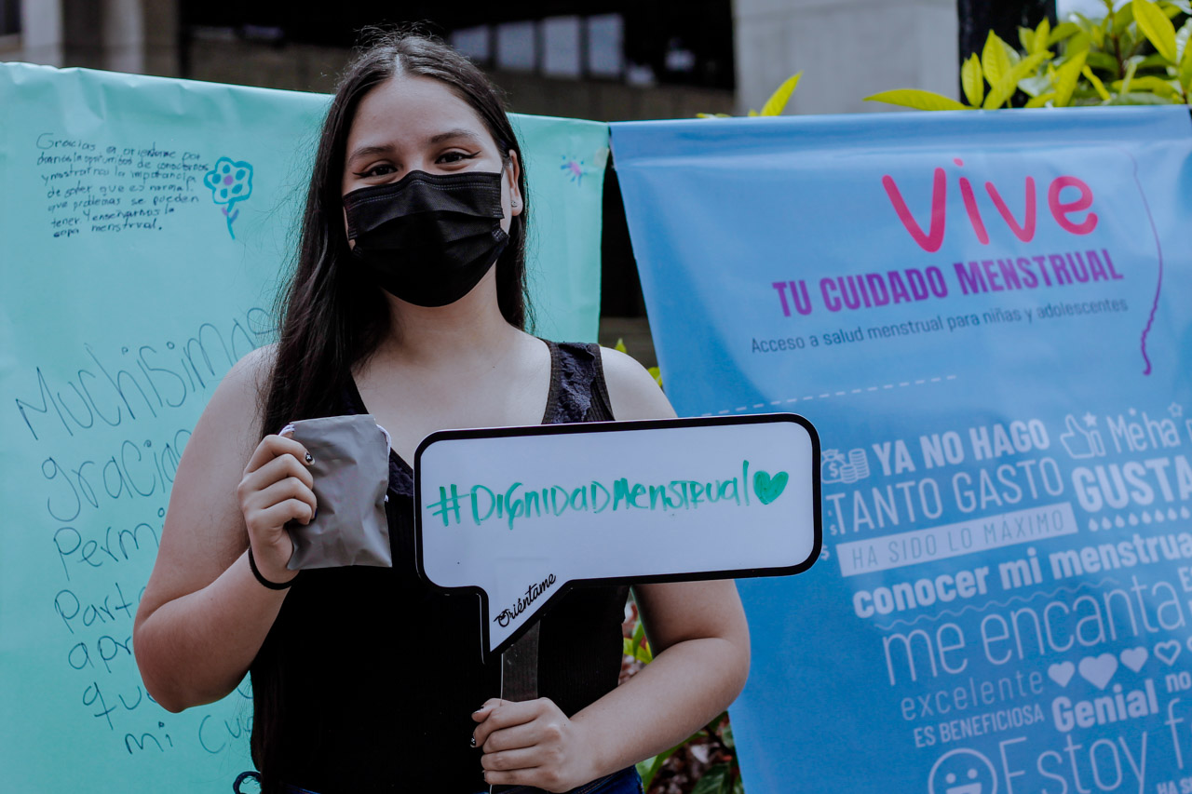

Delivery of menstrual cups in Dosquebradas:

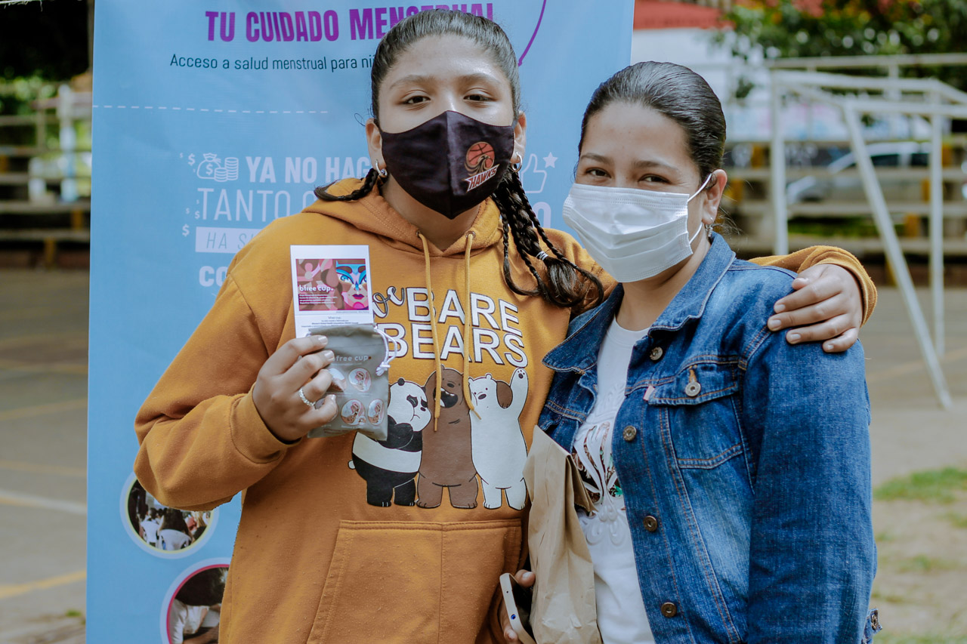

**5.2 Challenges, barriers, or obstacles faced and their solution**

The end of school represented certain difficulties for some girls and adolescents since their dedication focused on finishing their studies and completing assignments and evaluations. For this reason, they started the virtual menstrual health course but did not finish it due to time constraints.

Difficulty with internet connection was a significant obstacle for some young women to complete the virtual course and connect to the tutorials. However, in the face of this obstacle, the tutorials were recorded, sent via email, and uploaded to the course platform so they could see them, and it was reported as attendance.

In times of the COVID-19 pandemic, in this third phase, it was a challenge to carry out the menstrual health course in person since the institutions that were contacted did not provide the spaces and the caretakers of the girls, who did not have internet or mobile devices, were worried about the idea of meeting. However, this allowed the girls to have their parents' permission to participate from their phones or computers and thus complete the training process.

**5.3 Lessons learned**

We have to consider the barriers of connectivity and access to mobile devices for a project like this. Furthermore, the attendance of the participants in the course and the tutorials is something over which we have little to no control. This leads us to consider an additional effort to achieve the participation and coverage goals.

We have learned that menstrual health management should continue to be addressed broadly to provide safe and accurate information about menstruation, the advantages and disadvantages of various menstrual products, and the promotion of knowledge and care of one's own body. From this knowledge, we are aware of the power we have to make decisions, participate in safe sex and understand natural processes such as menstruation.

**6.** **Annexes***:*

View the capsules: <https://fundaorientame-my.sharepoint.com/:f:/g/personal/aguatava_orientame_org_co/EhwgvOfOS-1OqNqUxhCrz48BGWrVLrlEbz9dhtXX_6gZ5g?e=6QkcDj>

View the list of young women enrolled: <https://fundaorientame-my.sharepoint.com/:x:/g/personal/aguatava_orientame_org_co/EVxmDHiZkjpPn1stz0Mio7MBfTHJXyfhgHlHCQYPfD0i_g?e=e8Vtt7>

View the list of enrolled leaders: <https://fundaorientame-my.sharepoint.com/:x:/g/personal/aguatava_orientame_org_co/EcCpKX8eiAhNsB1uXto3-IgB2cVCl3L1TRvnBIymXIlpfA?e=q7V0dJ>

View the course results: https://fundaorientame-my.sharepoint.com/:x:/g/personal/aguatava_orientame_org_co/EU6NTmb4dKJKqc3GxpA8EOkBQGw6nhsB1TP7K1dPzleFdA?e=JakTD0

View photos of the menstrual cup delivery: <https://fundaorientame-my.sharepoint.com/:f:/g/personal/aguatava_orientame_org_co/EtvBpyN16qhKtdAYZKB-XxIB6cgtCRzOMdKMSZZ-h4y_4A?e=1qxRxs>