**LOVE IN ACTION ETHIOPIA**

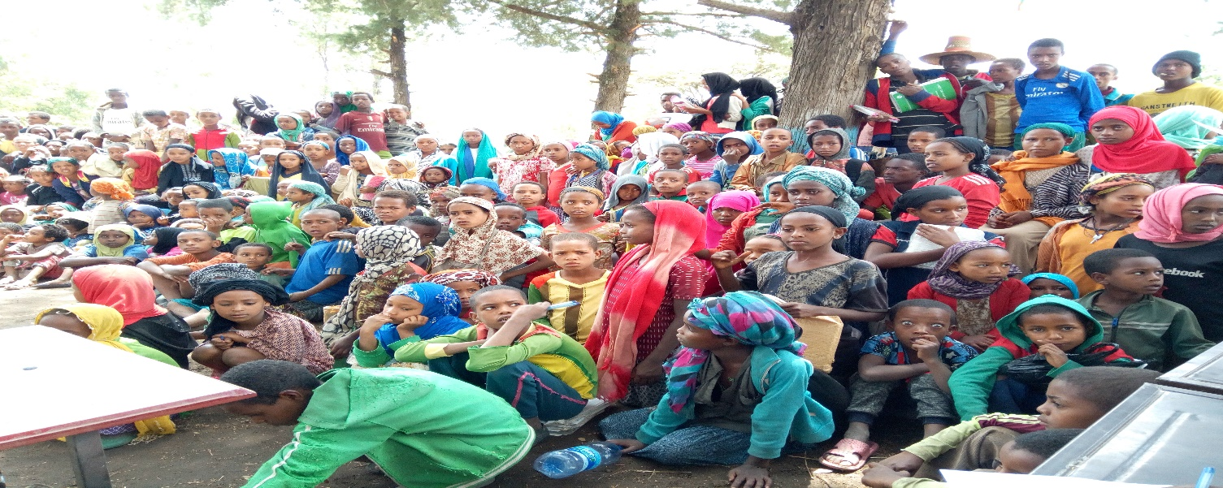

**Organizational Profile**

**Name of the Organization:** Love in Action Ethiopia (LIAE)

**Office Location:** Yeka S/City, Woreda 09, CMC Road, Cheshire Building 5th Floor.

Addis Ababa, Ethiopia

Email: [lia_ethiopia@loveinactionethiopia.org](mailto:lia_ethiopia@loveinactionethiopia.org)

Email: axumye2019@gmail.com

Phone: +25111667572

**Nature of organisation:**  Non-profit Organization / Non-governmental Organization

**Year & Place of registration:** 2001/Federal Democratic Republic of Ethiopia Agency for Civil Society

Organizations

**Legal Status of the Organisation:** re-registered & accorded legal personality as local non-profit organization under registry number 0286 on 24/06/2019 in accordance with civil society organizations proclamation No 1113/2019

**Organizational background**

Love in Action Ethiopia (LIA Ethiopia) is non-profit making indigenous non-governmental organization established on August 10, 2001 and re-registered on August 25, 2019 with the Civil Society Agency of Ethiopia as per new CSO Law. LIAE was established with a view to serving the poorest, underserved, most vulnerable, most at risk and marginalized segments of the population: including children, youth and women, people with disability. Over the years, LIAE has grown to serve its target beneficiaries through participatory development programs focusing on creating access to education for children and adults, HIV/AIDS prevention, care and support and capacity development. All through its periods of struggles, LIAE has grown beyond simply raising awareness and developing skills into rendering more sustainable and meaningful solutions for the multifaceted socio-economic problems of the community.

Love in Action Ethiopia has been operational in Ethiopia since August 2001. During the last 20 years, Love in Action Ethiopia has been making continuous and conscientious effort to strategically reach the various groups of the community and address the education, health, water and sanitation and capacity development needs of the people dwelling in various regions and hard to reach areas of SNNPR, Gambella and Oromiya regional states of Ethiopia and in different districts (Woredas) of Addis Ababa, the capital city. Love in Action is currently implementing different project in Health, Education for children and marginalized society, Capacity Building and Social accountability programs in different regions of Ethiopia. Across the programs, the organization is adapting the principles of inclusiveness so that no one should be left behind in any development interventions. Contextually, the approach of inclusiveness is to include people with disabilities (PWDs), socially marginalized people, and vulnerable groups of the society, neglected and excluded people from the perspective of maintaining and ensuring human rights for all.

**Overview and Statement of the problem**

Life on the streets proves to be treacherous for children without a place to call home. Ethiopia, being one of the least developed countries in the world due to interrelated and complex socio-economic factors including man-made and natural calamities, a large portion of our population - especially children are victimized by social evils like famine, disease, poverty, mass displacement, lack of education and family instability leading them to the street in their fight for survival. Many of these children do exhibit behavioural problems, aggression and substance abuse issues, but these are coping mechanisms of children who are in a great deal of psychological pain, because Street Children are traumatized children, abandoned, orphaned, chronically neglected, physically, sexually and mentally abused children, children who are exploited by others to beg, for commercial exploitation and other things. Most street children we know always wants to be back with their family, it’s just that they can’t because of the family situation or because being vulnerable they are being exploited and used by others.

The problem of street children and mothers has become a pressing problem in Ethiopia. Driven from their rural homes by family problems and lack of opportunity, more and more children are migrating to Addis Ababa, the capital city. In Ethiopia reports show that over 150,000 people live on the streets of which most are children. Out of this Addis Ababa is estimated to host around 60,000. The remaining are children on the streets who earn their living on the streets and go home to their families, relatives or friends. The majority of these children are living in conditions of severe deprivation which place them at both physical and psychological risk. Inadequate nutrition, long working hours and exposure to aversive weather conditions and physical abuse while on the street, endanger their development. The severity of the harsh living conditions is often amplified for young girls who face sexual abuse by adults, rape, unwanted pregnancy and early motherhood.

It is also evident that a considerable number of Ethiopian children are living under difficult circumstances. Children end on the streets for a number of reasons. They supplement their parents small income or support themselves with the small incomes they earn doing menial jobs. Some of the children are orphans, and others have left their homes to flee unsafe condition their villages. Others have done so because their families live in severe economic distress, either in rural villages or city slums and are unable to care for them. And considerable proportion of these children work on the street with some even totally living on the street without any adult care and protection. Many are forced to drop out of school or never get the chance to be enrolled at all and some drift into begging or petty crime.

Street children, especially young boys, have been increasingly visible in Addis Ababa (the capital city) in recent years. Thousands ply their trade at the city’s traffic-choked intersections, some hawking cigarettes and chewing gum, others begging. Many clutch plastic bottles filled with glue from which they take regular sniffs. Charity workers say glue-sniffing has increased dramatically over the past couple of years. The children do it to stifle hunger and numb the cold at night. Unfortunately, these very hard living conditions have a negative impact not only on their physical and psychosocial development.

In view of the COVID-19 pandemic, many health issues that street children normally face could also contribute to their vulnerability to the coronavirus. Due to their extreme poverty and the circumstances in which they live, street children are among the most exposed to the risk of contagion. In addition, many street-connected children and homeless youth commonly suffer from underlying health conditions. Infectious diseases, including respiratory infections such as pneumonia, have been shown to be more prevalent among children who live on the street than among their peers who live in a house. Their living conditions often do not allow physical distancing or self-isolation. The lack of access to sufficient clean water makes good hygiene practices difficult. Lack of access to sanitary facilities such as soap and water, poor nutrition, a problem faced by many street children, can weaken the body’s immune response and increase health vulnerabilities making them vulnerable to COVID-19. In the context of a pandemic, where access to health care is more important than ever, interventions that create access to hand wash facility, sanitizer, Masks and health care for street children are vital. Children’s mental health may also suffer as a result of the pandemic. Consortium for Street Children (CSC) Network Members around the world has expressed concern that their governments are overlooking the psychological impact the pandemic has on vulnerable children such as street children.

Some children live on the street full-time, whereas others spend their days on the street trying to earn enough income to support themselves and sometimes even their families. But both full-time and part-time street children face similar challenges in accessing education. This project works to bring street children back into the education system and make the transition away from street life. Street children need to be able to access school. Education can make living on the streets a temporary experience instead of a lifelong sentence. In order for street children to be able to go to school, these children need a supportive and flexible environment.

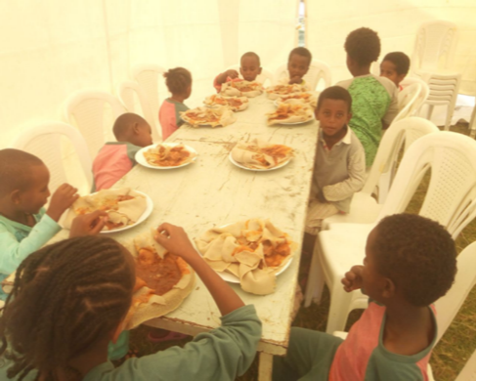Love in Action Ethiopia is apprehensive about vulnerable children who live on the streets, where they are exposed to all forms of harm, abuse, and exploitation and currently to contagion to the corona virus.LIAE had done outreach activity on street children and had been feeding and providing clothing for around 100 evident that holistic and comprehensive approach is needed to create lasting positive impact by helping street children, attain an education and giving them shelter, get the psychosocial support they street children. It had also provided new hand-washing facilities, water and soap, implementing behavioural change training and display of posters for prevention of COVID-19. But it has become need and reintegrating them back into their family and community. As many of street children are going without the food and nutrition they need, education and shelter.

Figure1 Feeding program for selected street children

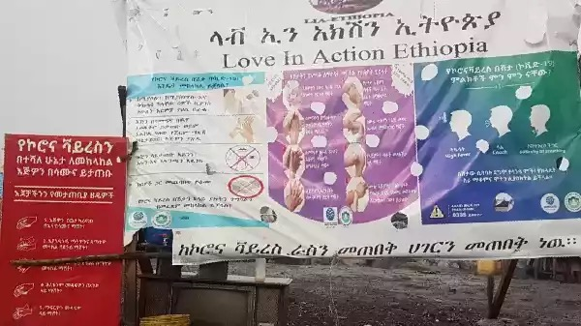**How we are helping the street children during COVID-19**

FigureBillboard/poster for awareness creation and risk-communication and hand wash facility in the slums of Addis Ababa

Love in Action Ethiopia has done an outreach activity and was able to reach out to 100 children at the beginning of the pandemic at the capital city, Addis Ababa, where the highest number of street children are found in Ethiopia, provided them with new clothes and provided them with food with its feeding programs which couldn’t be continued to lack of fund. In Addition, as part of its COVID-19 response, Love in Action Ethiopia placed billboard/ posters and hand washing facility with soap and water, in the slum areas of the capital where high number of street children live, as awareness-raising and risk-communications in order to ensure that people know the dangers of the disease. It should be noted that a holistic approach is needed during the corona virus pandemic in order to protect the street children.

**Project title** – Help for street children

**Project Goal**

The project supports street children by ensuring they have a safe home, education and the psychosocial support they need for the bright future they deserve. This project aims to help children off the streets, away from danger and into school. It aims to mitigate the impact the COVID-19 pandemic has on street children and their vulnerability to contagion. The project aims at rehabilitation and reintegration of street children with more focus on education and vocational training to discourage children from returning to the streets. The project works on the creation of a special centre offering shelter, food, psychosocial support and sanitation. The project aims to help reintegrate street children back into the society, either with their families or by foster care, entry into the education system and create opportunities for training and employment and make the transition away from street life.

**General Objective**

Help the Street Children Project seeks to be a support system for all children in street situation and assist them towards rehabilitation, through outreach, reintegration into families and access to basic education or skill training to them or to their parents. In response to the COVID-19 pandemic, provide children with food and temporary shelter with continued effort to integrate them back to the family and society.

**Our Primary Beneficiaries**

The project’s primary beneficiaries are vulnerable children who find themselves in street situation.

**Activities / what your donation will deliver/**

**Activity 1 – Street Outreach**

The first activity in the project will be outreach, setting the foundation to build a relationship of trust with the child, identifying and understanding how the child came to be living and working on the streets. The goals of the Outreach Team are to support street children who do not have – or have little – access to basic services such as medical care, shelter, and education.

The Outreach has already been implemented earlier with some of the street children, the project team built relationship with the children through regular visits to the area which continued to the provision of clothes and feeding program. The continuation of the outreach activity will be implemented to reach more street children and to inform the children of the transitional home so they can start imagining an alternative to life on the streets.

**Activity 2- Rehabilitation activities (Transitional home)**

This home will provide temporary shelter until safely reintegrated and especially at this much needed time of the COVD-19. In the process of rehabilitating the children, the transitional home offers accommodation in a safe and secure environment off the streets. In addition, the shelter gives them a opportunity to apply social distancing and the rest of the prevention and precaution methods. The home offers a family-like atmosphere, with full time social on hand to offer much-needed care and support. As part of the rehabilitation activities, regular counselling will be done to prepare the child to transit from street life into regular living conditions. It also motivated some children to think about different options available to them. The health of children growing up on the streets is strongly compromised. In fact, they do not have access to sanitary facilities. Also, because of their lack of hygiene, street children are exposed to different diseases. The transitional home will provides the children with access to hygiene facilities and with access to food and psychological care, child friendly and non-formal education, life skills training and playing activities. The shelter also offers access to vocational and business skill. The transitional home is made of social workers, medical worker, teachers and support staff. Child friendly non-formal education, that helps to bridge the gap between life on the streets with no rules and a formal classroom. Child friendly and fun non-formal education classes a child-friendly and fun where they catch up on school classes they missed and help to instil the desire to learn. This aims to reintegrate them into public schools once they are reintegrated to their family. On Saturdays, we do brain booster activities, such as arts and crafts, to develop their creativity and artistic skills.

**Activity 3- Family Investigation and Reintegration**

Through a process of counselling and mediation, our teams work to strengthen the child's family bonds - starting, if needs be, with family tracing and reunification. This projects aims to integrate the children into family, education, jobs and society. Together, the social worker and the child with progressive steps will work together with the families’ to understand and solve the initial reason of the child being to the street. Once the child is settled in a secure family environment, Street Child focus on helping them back to school, in cases where there is a need, introducing the family to our livelihood support teams to help ensure that the family has the financial strength to keep the child in school. This also includes providing support to selected families to start income generating micro business to prevent the child from returning to the street.

**Sustainability of the project:**

The Project holding organization and community will be responsible for the sustainability of the project. Once the project gets over the organization will seek support from local funders or other donor agencies with similar objectives and domestic resource mobilization. Project can also be extended by the present donor based on the need and performance of the project.

**Monitoring and Evaluation**

As an organization, LIAE also have sufficient operational guidelines and procedures including monitoring and evaluation manual put in practice, which will help to measure activities and use for reporting purposes. The project activities are monitored on bi weekly, monthly and quarterly basis by the personnel in charge of the task. The project planning, execution and evaluation will be done in accordance with guidelines of Donor agency through Global Giving. In addition, the project team will have monthly review meeting in which the project Director will review the activities carried out in the last month with every staff and accordingly plan for the next month activities. The project staff will prepare monthly and quarterly activity and financial reports, annual reports, case studies and success stories, and send them to Donor agency through Global Giving. The project will have a separate advisory committee. It will meet once in three months, review the activities carried out and advise the project team to carry out innovative activities for the children. It will comprise of Health and development consultants, few beneficiaries, project staff, Project Director and important stakeholders.

**With your support, we are able to give thousands more children the chance of a brighter future. By supporting the project, you'll be part of an amazing group of people having a lasting positive impact on some of the world's most vulnerable children and at high risk during the COVID-19 pandemic. Please keep giving us that vital support!**

**We highly appreciate your support.**