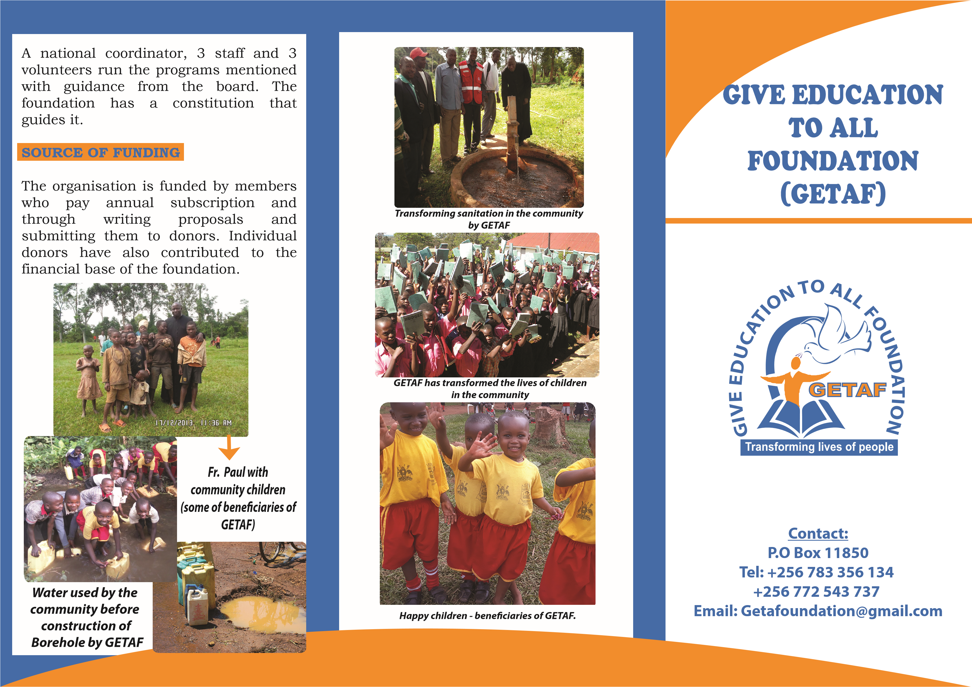

**ABOUT GETAF**

Give Education To All Foundation

(GETAF) is fully registered in Uganda with GETA UK as an associate member. GETAF’s overall aim is; to provide education opportunities to the orphans, destitute children, from financially poor families. GETAF strives to change the lives of children, youth, women and community development.

**VISION:**

To work with children, youth and women in developing their potential to attain sustainable levels of comfort and to have the best possible access to opportunities and self employment.

**MISSION:**

To see children, youth and women have the opportunity to maximize their potential and to influence decisions that affect their lives.

**GOAL:**

Young girls to attain formal primary education level enabling needy and orphaned children who would not otherwise be able to access even this first stage of education to do so by supporting them through provision of school uniforms, scholastic materials, and medical care.

**PURPOSE:**

Improve the economic and social wellbeing of the youth through income generating activities, education and training.

**CORE VALUES:**

Professional Integrity Human Rights Teamwork

**OBJECTIVES**

To provide education opportunities to the orphans, destitute children, from financially poor families by offering them full and half bursaries, sponsorship.

To work in collaboration with related professional bodies, Nationally, Internationally and other associations whose aims and objectives are geared towards the education, health and well being of the girl child and educate them on the dangers of HIV and AIDS. To carryout nationwide training aimed at imparting skills and proficiency enhancement for the girls, women and other vulnerable groups about developmental and income generating projects such as; To provide health care to the needy and orphaned children.

Providing the girls with marketable vocational skills and tool kits for Self-employment and increase their income levels. To provide the youth with entrepreneurship and life skills as an internal part of their livelihoods.

**PROGRAMS ENVIRONMENT**

* Education
* Child sponsorship
* Vocation skills development
* Community development programs
* Gender based violence
* End violence Against Children
* HIV and AIDS
* Promote human rights and good governance
* Improve sanitation **KEY ACTIVITIES:**
* Training
* Creating awareness
* Advocacy
* Lobbying
* Networking and collaboration

**GOVERNANCE**

Give education to all foundation is a registered company in Uganda. It has a

board comprised of experienced personnel. Currently there are 10 active board members.