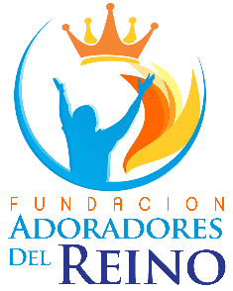

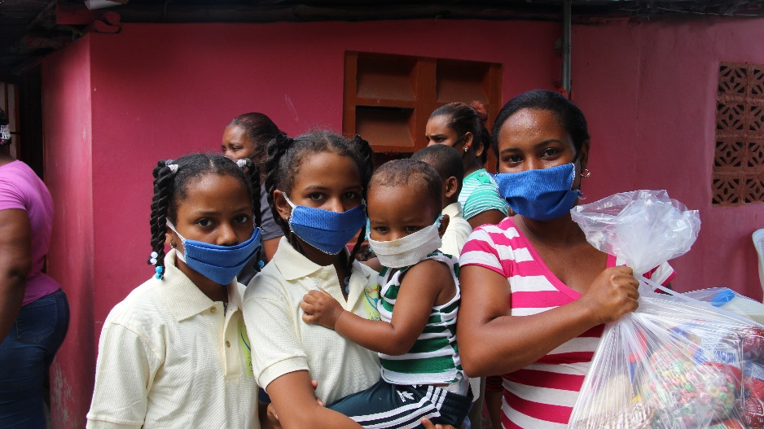

We are a non-profit institution dedicated to bringing hope to children and adolescents in the Dominican Republic.

Our foundation in a gesture of solidarity assists families in situations of extreme poverty, serving more than 2,000 children and adolescents annually, through a social assistance program, through balanced feeding days, as well as providing Student scholarships, uniform school supplies, primary medical care and orientation to socio-spiritual development are provided for a better future.

Our objective is to rescue children and adolescents, providing them with opportunities for social and spiritual growth, changing their way of thinking, so that they change their way of living. Motivate them through educational resources, and assistance through psychological and pedagogical guidance, which helps them develop their intelligence, discovering their abilities and talents, in order to stimulate their life project for a generation of excellence and a better world to live.

We are currently developing a project that helps us achieve this goal, it is as follows:

SUPPLY FOOD TO HIGH RISK CHILDREN
IN THE DOMINICAN REPUBLIC

The Fundación Adoradores del Reino-FUNDADER wants to raise $ 5,000 from 40 donors in the Accelerator to provide food to high-risk children in the Dominican Republic.

This goal will be achieved through the selection of 40 specific donors, who will be motivated through infographics, videos and explanatory letters that will be provided by different social networks such as Instagram, Facebook, WhatsApp and through personalized emails. In addition to the support of other organizations that will make the project public.

As our first participation in a fundraising campaign at GlobalGiving, we want to meet the goal of $ 5,000 among the 40 donors, however our goal is to reach $ 20,000 and some 100 recurring donors.

In the Dominican Republic there is a high index of extreme poverty, which affects children the most, our foundation seeks to impact 200 families of extreme poverty in vulnerable areas of the country, benefiting them with non-perishable food during the COVID-19 pandemic. In this way, we managed to feed 800 children in poverty, abandonment, hunger and education in the Dominican Republic.

$USD 50 Provide food to 2 families per month
$USD 125 Provide food to 4 families per month
$USD 315 Provide food to 12 families per month
$USD 625 Provide food to 25 families per month
$USD 1250 Provide food to 50 families per month
$USD 2500 Provide food to 100 families per month
$USD 5000 Provide food to 200 families per month
$USD 50 One month of transportation payment for 50 children
$USD 30 Purchase of school supplies for 1 child
$USD 25 Will provide food to 200 families per month
$USD 10 Feed 1 teenager in addiction rehab

