# ****Program components and Achievements****

# ****(From January 1/2017-December 31/2018)****

## ****1. Empowered and Strengthen Destitute Women and youth****

Improved the life of 14 orphaned and vulnerable children and living with HIV, their families/their care-givers in a sustainable manner as followed.

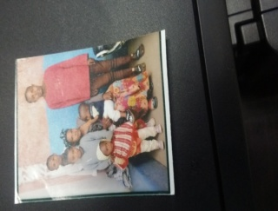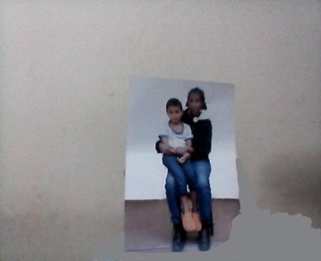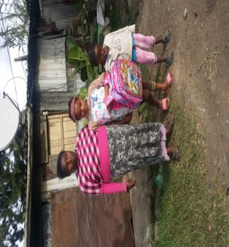

* 1. Capacity building training given and organized SHG and started saving/IGA
  2. Improved the quality of life for people living with HIV, their families or their care-givers in a sustainable manner through microenterprise development,
  3. Organized and Promoted SHGs and saving and credit options for disabled & PLHIV.
  4. Supported families/households infected/affected by HIV and accessed health, social and nutritional services
  5. Strengthen referral of HIV positive people for care and treatment and other services
  6. Carried out psychological support for people living with HIV & disabled
  7. Reduced stigma and discrimination against PLHIV through outreach efforts.
  8. Promoted keeping personal hygiene and sanitation and reduced infectious diseases and promoted better health among PLHIV including food hygiene. etc.
  9. Increased enrollment of non formal education (destitute women and youth)

**2. Community based Care and support of Orphans and Vulnerable Children (OVC)**

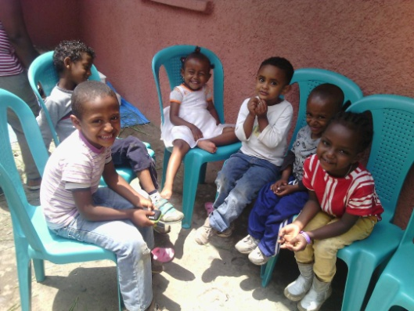I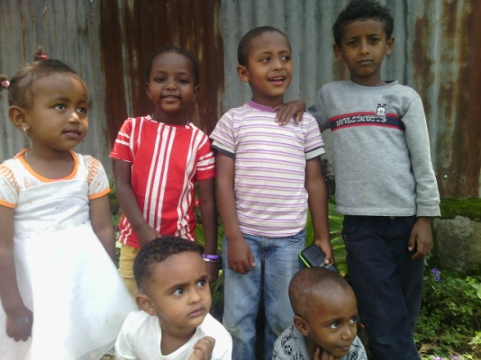improved the well-being of 14 orphans and vulnerable children and have got success in education in a sustainable manner.

1. Through microenterprise development, strengthen and promoted of self-help groups and other saving and credit options targeting OVC households
2. Carried out Vocational skills trainings for older OVCs and their care-givers and improved their livelihood
3. Provided life skills trainings, for orphans and vulnerable children targeting in school and out of school youth.
4. Supported OVC & their families & accessed health, social, protection and nutritional services
5. Promoted gender equality and reduced vulnerability to HIV risk
6. Organizing retreat program & Celebrated holiday festivals
7. Provided education material & increased women youth secondary school enrolment
8. Increased enrollment of non formal education (destitute women)
9. Introduced new agriculture/horticulture development techniques.

SYAD cares for abandoned babies/children, orphans and deprived women through its program in Addis Ababa and Oromiya Regions. Along its 2 years journey SYAD has performed incredible achievements that honors the interest of funding corporate, groups and individuals. SYAD is strengthening its effort to continue its commitment through collaboration and support of the stakeholders and those giving hands that includes yours.