MOUNTAINS OF HOPE CHILDREN’S MINISTRIES
BUSINESS SKILLS TRAINING IN KIRINGENTE,BUWAMA, MUDUUMA, KITUNTU, MPIGI TC, NKOZI AND KAMMENGO SUB- COUNTIES
ACTIVITY REPORT
FEBRUARY 2021

Date: 26 /2/2021
Compiled by: Kukiriza Gloria- Community facilitator
Reviewed by: James Malinga – Executive Director
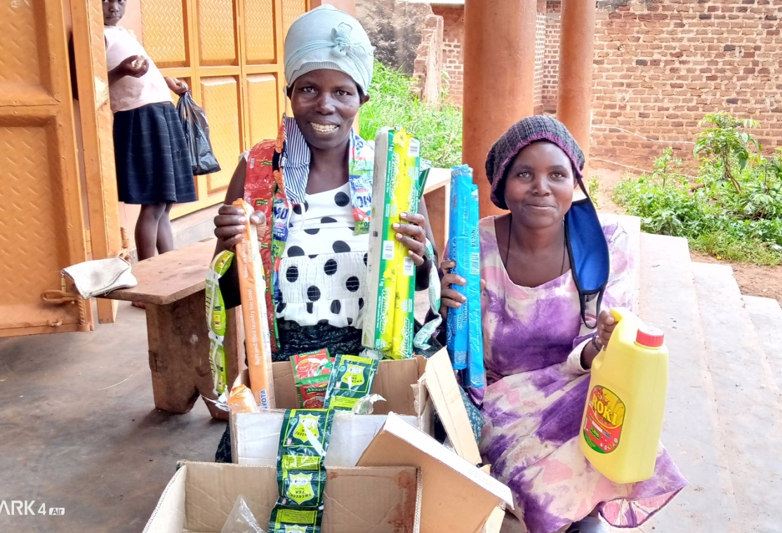

TRAINING OF PARTICIPANTS IN BUSINESS MANAGEMENT SKILLS.
Introduction.
The activity intended to equip participants of the different groups with requisite business skills necessary to initiate and run successful businesses. It was conducted in seven subcounties,that’s Buwama, Kammengo, Muduuma, Kiringente Nkozi,,kituntu and Mpigi town council attracted members from different groups.
The activity was conducted by Community Development Officersand CSO Staff
During the training, they focused on the following topics.
- What is a business
- How to start a business
- Business marketing
- Managing of cash inflow and outflows
- Keeping records in business
- Constitution amendments
During the training, group members managed to discuss and understand the following business components as follow;
- The meaning of a business and examples.
A business is an avenue where one can invest in and gain something. One can put in his or her energy and in turn gets rewards which can be in cash mainly or in-kind. For example; one can practice farming, poultry, run pet shops, vending with aim of getting rewards. During the meeting, we discussed that a business can be small or big depending on the intentions of the proprietor. Although the major focus of the training was to see that group members who are HIV and AIDs start up and strengthen their own businesses.
- Micro business management.
Here the group discussed that micro business management as a way of sustaining the already established businesses and also forget a way of improving on the business performance. During the training several strategies were identified. These included:
- Start small and add on small
- Quality strengthening
- Marketing and sustaining of customers
- Research making
- Visiting the successful proprietors
- Transparency and trustworthy
When the above business strategies implemented, there is no way a business can fail.
- How to start a business.
Training equipped the trainees with knowledge and skills of how to start small businesses in their respective villages, the nature and kind of business should be based on the available resources and skills that they have, this will in turn make it easy for them to run theses kind of businesses without requiring heavy financial obligations.
4. Business marketing a business.
The training focused on marketing as a key element in business growth, it was discussed that members should use all available avenues to tell people about their business be it in church or any social gathering, they were even advised to take on names of their businesses so that the public can identify them easily for example if one has a passion fruit business they can always introduce themselves as such ‘nzecaroomulimiwobutundakayingo’ so this can also be a good marketing strategy.
They were also advised to ensure quality in whatever they do since quality products usually attract customers through recommendations by consumers.
5. Importance of a business to a household.
The training highlighted the value and crucial role the presence of a business can play in a household.
These included:
- Procurement of household items
- Provide medical care to household members.
- Provide training ground for young ones on business management.
- Support to HIV and AIDs nutrition boosting.
- Support to education of the children.
- Control of domestic violence
6. Record keeping in business:
Trainees got knowledge about the advantage of keeping records in business especially that it helps you to track progress of a business and helps one to know whether he’s making profit or loss. It also helps when one is making decision for the business.
7. Involvement of members in government programs.
The Community Development Officers encouraged group members to observe and utilize available government programmes such as Operation Wealth Creation, Youth Livelihood, Uganda Women Entrepreneurship program Agriculture Cluster Development (ACDP) and SAGE programme.
8. What makes a business fail?
During the training, group members discussed the following barriers which can make a business fail. These included;
- Compromised quality of outputs
- Poor customer care
- Poor marketing
- Role confusion among leader
- Lack of proper accountability
- Lack of innovativeness
- Poor record keeping.
TABLE SHOWING ATTENDANCE IN DIFFERENT SUB COUNTIES
 |  | Members trained
Date | Sub county | Male | Female | Total
19/2/21 | Kiringente | 0 | 13 | 13
22/2/21 | Kitiuntu | 5 | 10 | 15
23/2/21 | Muduuma | 4 | 28 | 32
23/2/21 | Mpigi TC | 2 | 7 | 9
25/2/21 | Buwama | 3 | 10 | 13
24/2/21 | Nkozi- Nindye | 2 | 24 | 26
26/2/21 | Kammngo | 3 | 11 | 14

RECOMMENDATIONS MADE DURING THE TRAINING.
- All trainees without small businesses should start immediately after the training.
- All trainees who do not keep records should buy a book for records and start recording immediately
- Trainees were advised to elect good leaders who can manage the group properly
- Proper accountability on the cash inflow and out flows

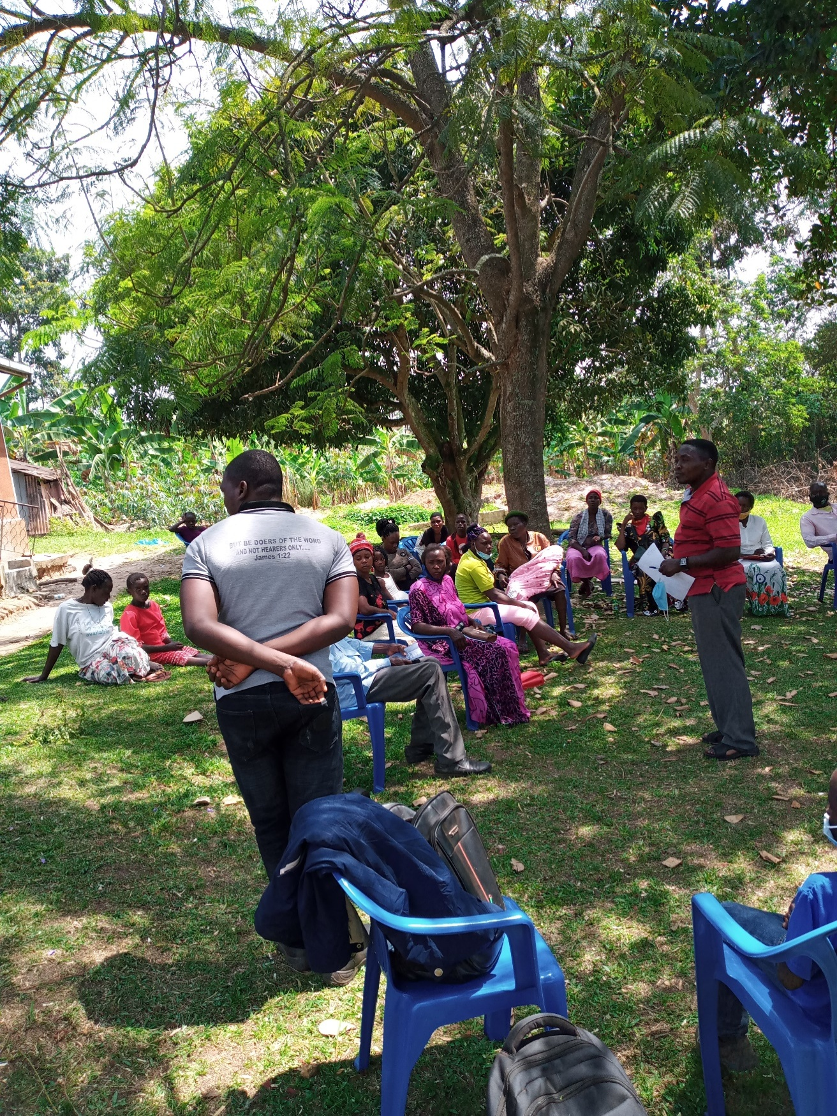
A section of members attending the training.

TEAM
NO |  | NAME | TITLE | TELEPHONE
1. |  | Anyait Caroline | Social worker | 0777036422
2. |  | Kukiriza Gloria | Social worker | 0706897218
3. |  | BalagaddeEnock | Social worker | 0706350489
4. |  | Kimbowa Simon peter | Social worker | 0757209324
5. |  | Nampeera Harriet | CDO –Kiringente | 0772832926
6. |  | Kyobe Anne | CDO-Buwama | 0772681633
7 |  | Nakalege Florence | CDO- Nkozi | 0704938061
8 | KibalamaBruhan |  | CDO-Muduuma |  | 0787982262
9 | MpagiEdirisa |  | CDO-Kammengo |  | 0704535493
10 | Lukyamizi Francis |  | Facilitator |  | 0705972768
11 | NiwemuliisaAnacleti |  | CDO-KITUNTU |  | 0758566530

