LITERACY AND NUMERACY TRAINING CONTINUES TO RESTORE DIGNITY AND SELF RESPECT TO MANY LIBERIAN WOMEN

“In the just finished elections, I voted with a check mark using ink pen in the ballot box without any one helping me, as it happened before.”

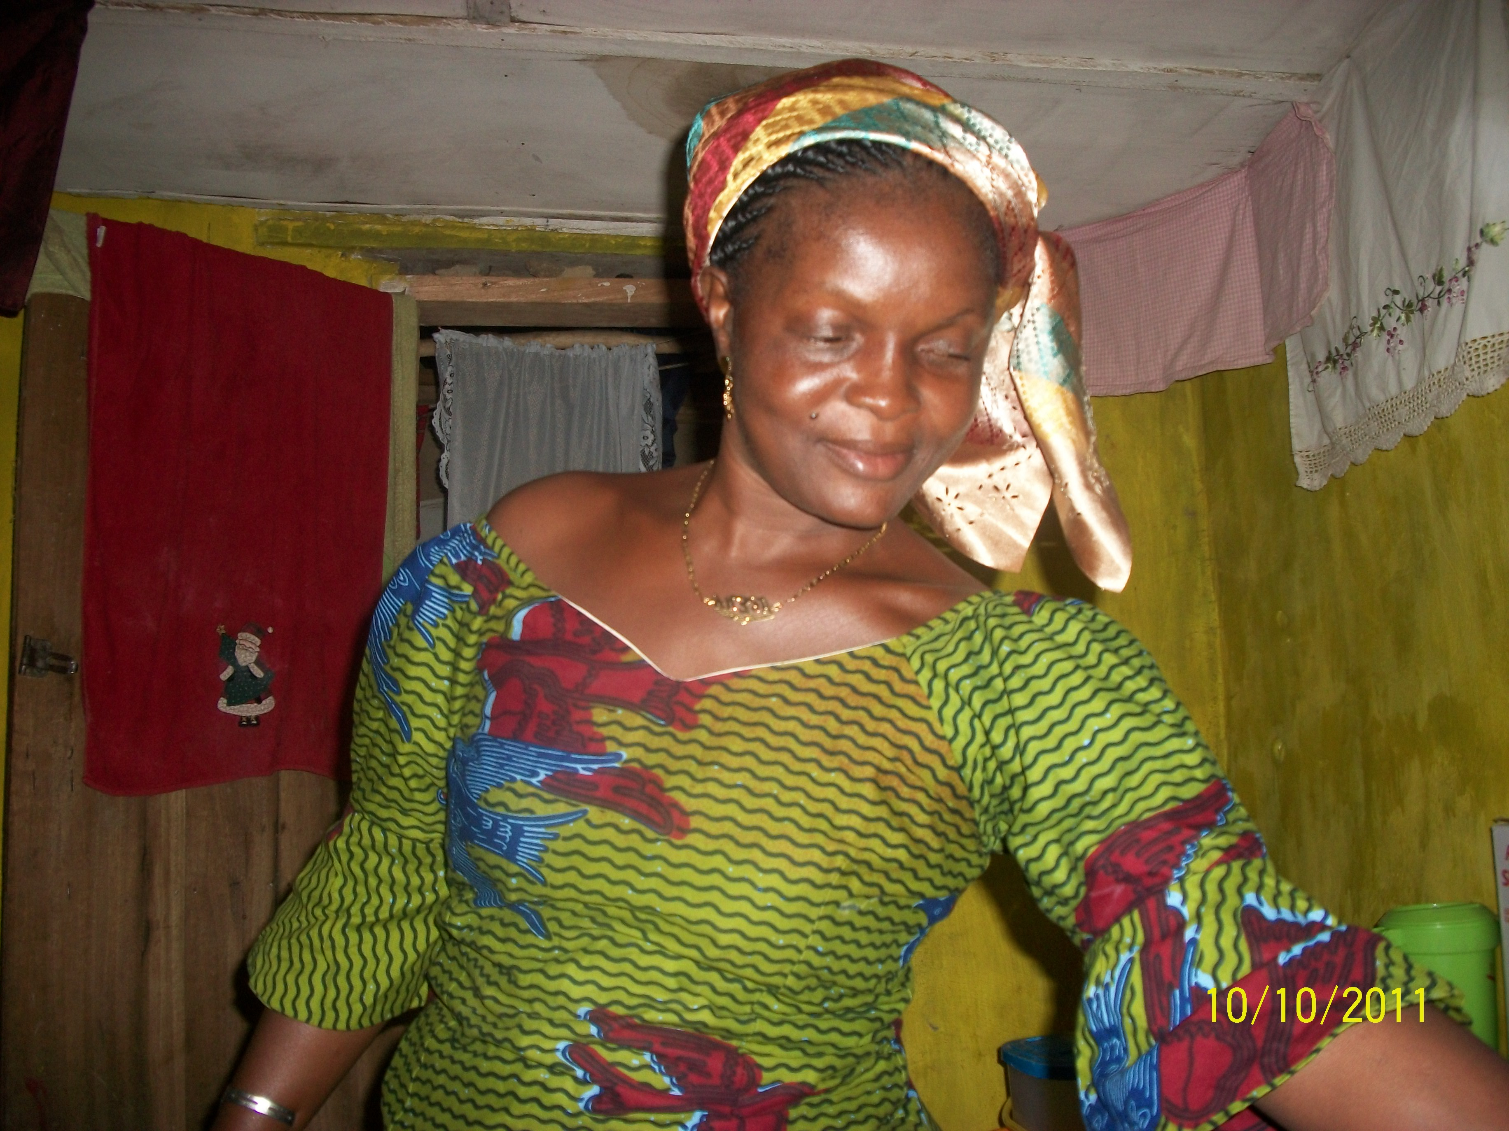
Mrs. Kumba Fayiah, 37 years old literacy beneficiary, is a resident of Koindu Pormbor in Foya Statutory District Lofa County, Liberia. During the participant assessment survey Kumba Fayiah informed project staff that because she was illiteracy condition she faced several problems such from how to purchase correct sizes of footwear school requirement for her two children (3 girls & 2 boys) in the local market. She also had difficulty operate her cell phone, since she did not the English alphabets and numbers, all in English. Lastly she mentioned whenever she went to a training program she had to use her finger thumb to sign, while many of the other participants use their pens. This situation, Kumba said, brought shame to her as a mother in the home. With this situation Mrs. Kumba Fayiah registered for the literacy and numeracy program run by Rights and Rice Foundation in May 2010, and completed the nine months training program early 2011, a long time dream being fulfilled.

Later on in 2011, our team met Madam Kumba Fayiah when they visited her community during the Liberia general and presidential elections during a civic education tour. When they inquired from Madame Fayiah as to how she was doing, she responded enthusiastically:

“Oh I’m very happy to see you people here who helped us to know small thing about book (education); to say the truth what I learned really is helping me in my home. Now I can write my children sizes in my note book to help me remember them in the future. You see how I get sense, so I took my note book and went in the market and bought everything I wanted to buy according to the right sizes. When I came back home, I presented the materials; each of my children was so surprise and happy to see their footwear neat with the right sizes; they were running around the house in joy telling friends that our mother can now read and write. My husband was also happy; I feel proud and happy.”

“In the just finished elections, I voted with a check mark using a pen in the ballot box and not my finger thumb, without any one helping me, as it happened before. Because I can write numbers and my name well, I’m also benefiting from BRAC-Liberia micro-finance program, which gave me a small loan to do my business. Thank you yea (very much).”

Rights and Rice Foundation is proud to be part of the transformation taking place in the individual lives and communities in which we work. Literacy for dignity, respect and democracy is truly working in Liberia. We thank each of our donors, and would like to encourage you during these Christmas and New Year Holidays, to donate to this worthwhile project in Liberia.

