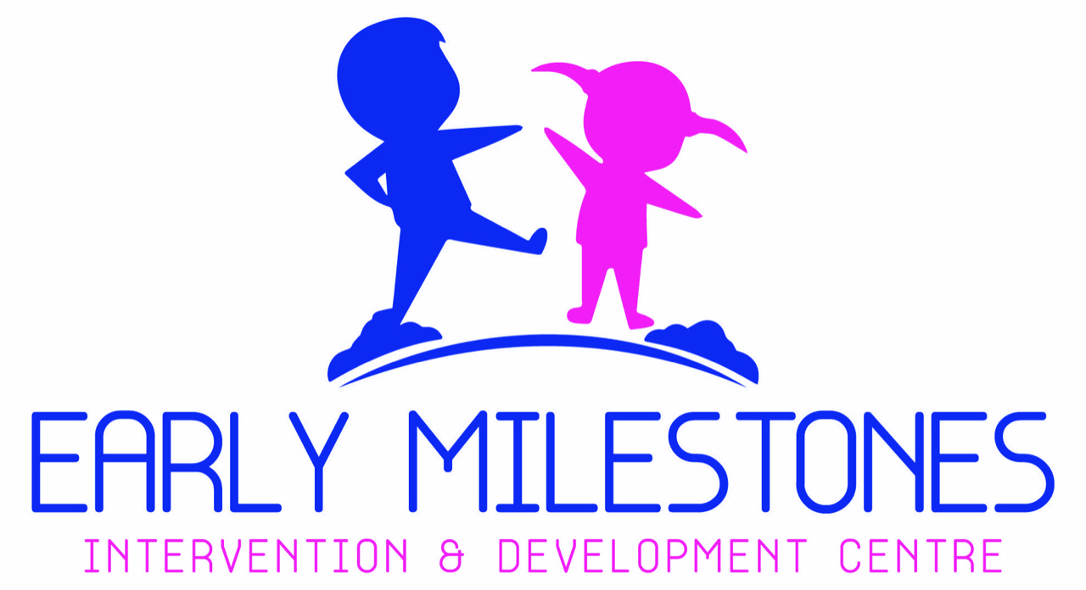
health project on cerebral palsy intervention

EARLY MILESTONES INTERVENTION & DEVELOPMENT CENTRE
WWW.EMIDC.ORG
https://goto.gg/47257

MISSION

This is a non- profit organization that raises funds to provide Rehabilitation and support services to children aged 0-8 years with intellectual and developmental disabilities in our community, giving them an opportunity to reach their full potential through early intervention.

VISION
To be a leading center that provides services that will help in developing the children with disabilities to their fullest potential, allowing them to become independent and productive members of the community.

Plan Overview
Practice: | Name
Name of Campaign: | Child Rehabilitation and Free Family Training program
PROJECT MANAGER | JULIET MUHIA
PROJECT COORDINATOR | PAUL NGIGI

Objective
Inclusion of children with disability in Kenya
- Background
The issue
Cerebral means “concerning the brain” and Palsy means paralysis or inability to move. Cerebral Palsy (CP), then is a kind of paralysis that results from damage to the brain. The damage can’t be cured, nor will it worsen. The disorder of movement and posture can, however, change. A child with CP, like all children, will grow and develop. As the child grows, the effect of the damage of the brain will be worse if the child is not helped to function as well as possible. This is why good intervention in the early months of a child’s life will help minimize the effects of CP.
While Cerebral Palsy is the most common childhood motor disability, we rarely hear about it. The cost of rehabilitation is a barrier for people with disabilities in high-income as well as low-income countries. Even where funding from governments, insurers, or NGOs is available, it may not cover enough of the costs to make rehabilitation affordable. People with disabilities are also less likely to be covered by employer-sponsored health plans or private voluntary health insurance. If they have limited finances and inadequate public health coverage, access to rehabilitation may also be limited, compromising activity and participation in society.
This is where our organization comes in. We have one of the best Occupational therapist in the country, with over 15 years of experience attached to our program ready to help children acquire important life skills i.e walking,speech development, sitting and other life skills that make a child independent.

Parent Stress:
Parents are the first to notice a developmental problem in their children. Along with this ability to identify a problem very early in life is the coinciding stress that is almost universally present in parents with a child with disability. Without proper tools to address atypical behaviors, anxious parents are likely to further descend into deeper levels of health problems, such as depression, possibly interfering with their ability to effectively parent.
However, providing them with the tools to address symptoms at the earliest point in time is likely to give them self- confidence and empowerment, thereby improving their own mental health along with their child’s behavior. In short, including parents in early intervention treatment has significant benefits for both the child and the parents’ wellbeing.
This is so because it can enable the children to function without the need for special support thus reducing community dependency.
By recruiting parents as active interventionists in the habilitation process at the earliest point in time, much less costly intervention is needed as the child grows.
That is where we come in as an organization. We help children with CP acquire important life skills so as to achieve some level of independence. We also work with the parents through training and support groups so that they can have better attitudes towards CP and child recovery.

The need
Worldwide, there are about 650 million persons with disabilities. This accounts for 10% of the global population. Children with disabilities experience stigma from birth and are more prone to exclusion, concealment, abandonment, institutionalization and abuse. Mortality rates among children with disabilities are 80% even in countries where under-five mortality has declined below 20%. Strikingly, 98% of children with disabilities in developing countries do not attend school. (UNESCO Policy Brief on Early Childhood).
The policy brief argues that early childhood care is a powerful means of nurturing diverse abilities and overcoming disadvantages and inequalities. Today, one in every ten children has developmental issues. Various experts are frantically researching to gain clarity and offer support in every manner to a large number of families. Ironically, success stories are more of chance than of certainty.
Therapies adopt trial and error methods and parents seek out anything that promises even a 20% improvement in hope that it would make the child independent. In August 2019 Kenya conducted its eighth Population and Housing Census. Disability data in the 2019 census was collected for adults and children above five years of age, meaning that disability data for children between 0-5 years is unavailable. This is an oversight given that disability begins from as early as birth. With early diagnosis and early intervention, some disability cases can be handled resulting in some form of independence. An example is children with mild cerebral palsy who could benefit from early intervention but due to lack of funds or access to healthcare, they develop a disability.
There are over 5 million children in Kenya, and even using 50% of the incidence rates in the developed world, there would be over 1 million children with developmental disabilities in Kenya.
People with developmental disabilities have problems with major life activities such as language, mobility, learning, self-help, and independent living. They begin anytime during development up to 22 years of age and usually last throughout a person’s lifetime. It also indicates a person who has a diagnosed physical or mental condition with a high probability of resulting into developmental delay. It reflects the person’s need for a combination and sequence of special interdisciplinary or generic care, treatment or other services that are of life long or extended duration and that are individually planned
and coordinated.
Disability continues to fall in the area of social welfare. While efforts are on to bring it into the rights arena, there is still a long way to go. Children with disabilities must cope with all the physical changes, emotional anxieties and social conflicts of their non-disabled counterparts, in addition to those produced by their disability. Along with the physical and communication-related limitations that their disability places on their daily activities, they constantly face discrimination -economic, educational, architectural ,legal, health e.t.c.
Consequently,
The objectives of Early Milestones project are:
- Provide funds for highly subsidized therapy sessions for children with delayed milestones as a result of Cerebral Palsy
- Provide thorough training to over 200 caregivers on the skills and knowledge required to help their children grow up to their fullest potential and thus become independent members of the society
- Provide funds for free mental health counselling for parents and families of children with cerebral palsy
- Provide funds for highly subsidized assistive devices to children with cerebral palsy in the program
- Provide funds for awareness programs to public to promote understanding of children with CP in the community so as to stop stigma enabling full participation in the society.
- Provide funds for purchase of rehabilitation equipment for use during therapy sessions

Target GROUP

Target Contact Demographics
Children with cerebral palsy aged 0-8 years and their families

Call to Action
Project Outcomes:
Our goal is to see children with delayed milestones becoming independent and start going to school just like the other children despite their disability/condition. Since this is an ongoing project, we hope to have as many children as possible (over 200) acquire important life skills such as walking, speech, sensory integration and many other such like milestones. Specifically:
- Therapy will greatly improve a child’s quality of life, as well as increase their independence
- family ties will be strengthened as everyone will be involved in the program.
- parent/caregivers will be empowered with knowledge and skills necessary for the development of the child to their fullest potential
- Benefits to society include reducing economic burden through a decreased need for special education and increased eligibility for employment.
- Reduced inequalities as a result of inclusion and diversity
- Increase in awareness of cerebral palsy will help challenge attitudes and mistaken assumptions about people with disabilities.
- The program will result in parents having improved attitudes about themselves and their child and improved information and skills for teaching their child.
- Assistive devices will aid children in sitting, standing and walking

Long-Term Impact
1. As children grow, they are gradually enabled to live optimal life of physical and mental health, emotional wellbeing and happiness
2. As children manifest their innate skills and talents are brought out, they find a path to become contributing members of the society
3. As children connect to the world, they inspire shift in societal attitudes to bring acceptance, compassion, tolerance and humaneness in our society

How shall we achieve the above?
Services
- Therapy and assistive technology
We shall offer occupational therapy, physical therapy and speech and language pathology.
Occupational therapy will play a vital role in making each child independent in the following areas:
Self-Help Skills, Gross Motor Skills, Visual Motor Skills, Fine Motor Skills, Sensory Integration Skills.
Physical therapy - Children diagnosed with cerebral palsy for example may have various degrees of muscle control, balance, and mobility, depending upon how severe the disorder is. Physical therapy will help with these issues by assisting children with: Balance, Posture, Crawling, Walking and build their Muscle strength
Speech and Language Therapy will be dedicated towards developing the communication skills of the children. Our Speech and Language Pathologists, who will be certified will work with the child to acquire Preverbal skills, Semantics, Syntax, Pragmatics, Voice, Articulation and Fluency
Assistive technology- Here we shall offer assistive devices that aid in sitting, standing and walking
- support programs
Our programs will guide parents in learning strategies that they can apply to their everyday life. Through the use of activities and group discussions, parents will learn to create and take advantage of everyday opportunities to improve their child’s communication skills.
- Counselling- we understand the stigma and parental stress faced by parents of children with disabilities therefore our mental health counselling will be available through group therapy or individually to help parents and families develop a proper mind-set that is needed to raise a child with special needs and overcome stigma.
- Trainings- families of young exceptional children often feel disappointment, social isolation, added stress, frustration and helplessness which may interfere with the child’s development. However, through our training program, parents will have improved attitudes about themselves and their child and improved information and skills for teaching their child thus improve their development.

RESOURCES
https://www.knbs.or.ke/

