How to Use The Crisis Penguin; Cory has a secret pouch under his Chin where we have an adoption signature card. (To love him, feed him and keep him safe. This card creates an attachment to Cory). and two Healing Cards created for the Newtown children.
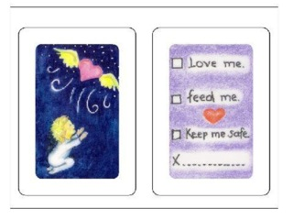

Two healing cards giving the children the OK to go play and be children, and answer the question where did my friends go. We recommend the counselors placing a small note book or a blank piece of paper into Cory's pouch for the children to draw or write down their fears or concerns. (Verbally showing and displaying the reason for the small notebook/ paper) Some things are just too scary to say to a counselor this way the therapist can request for Cory to come to the therapy sessions with the child, if the note pad or paper is blank you can ask the child why do they think Cory is looking so sad today?…..

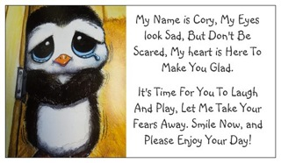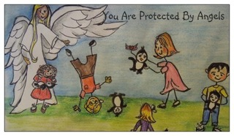

Cory will come with a Large Adoption Card Please have the parents aware of why we are implementing Cory the Crisis Penguin.
If the parents read the back of the Adoption Certificate to the children, in turn they are also giving their parental permission for them to go laugh and play without feeling guilty.
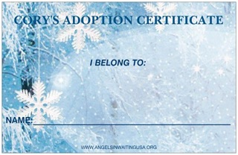

At AIW, we nurses see the most traumatized children from parental abuse, and have seen first hand how healing this crisis penguin can be with appropriate integrative therapy. Because our Cory’s are made in China it will take up to 90 days to get more of them. Please speak to your therapeutic community and distribute the crisis penguins to the children who are at the highest risk first and than, please, let me know how many more crisis penguins you think you will need, we are a small grassroots charity but some-how I'll get more Crisis Penguins to you if needed.

Warmest Regards,
Linda West - Conforti RN

Founder of Angels In Waiting
www.angelsinwaitingUSA.org
Founder of NursesFor Safer Access
www.nursesforsaferaccess.org
1 800 974-4274
PO Box 1221 Blue Jay ca. 92317

