The Social Grocery
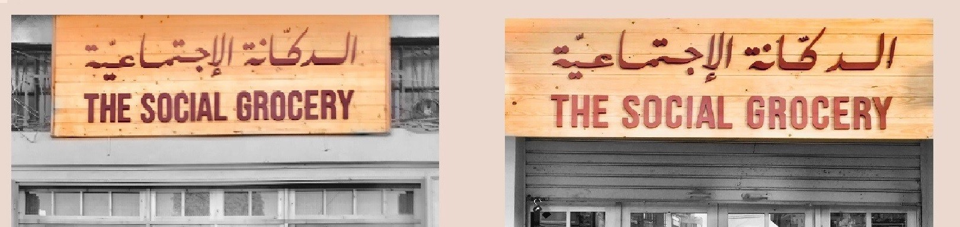
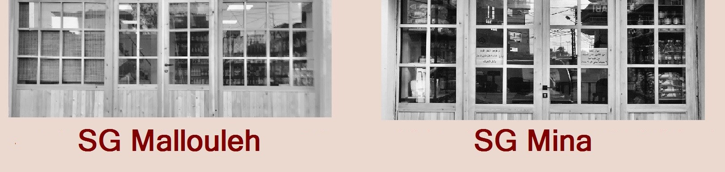
Donor’s Report V

The Social Grocery 2021 – Donor’s Report – (Nov 21-Feb 22)
Submitted to Global Giving

Table of Contents
Summary Table....................................................................................................................... 3
Financial Utilization Report Summary ................................................................................... 3
Executive Summary................................................................................................................ 3
Results Achieved To Date ...................................................................................................... 4
Summary of Results Achieved to Date: ................................................................................. 6

The SOCIAL GROCERY in Tripoli
The SOCIAL GROCERY in Tripoli is the first of its kind in Lebanon. It is a non-profit grocery store that sells basic households’ food and non-food goods for a reduced price. The SOCIAL GROCERY is a financially sustainable social enterprise model that aims at achieving public good by allowing poor families to purchase their basic items for affordable prices.
After this remarkable success achieved in its first branch, we are glad to announce the opening of our second branch in Tripoli Mallouleh to expand the target group and serve clients from Jabal Mohsen and Tebbaneh.

Fund Utilization

Report Summary Table
PLAN REPORT: | Progress Report
ASSISTED PROGRAMME: | Provision of a new SG non-profit grocery store that sells basic households’ food and non-food goods for a reduced price
FUNDED AMOUNT THROUGH GLOBAL GIVING | USD 840
ADDITIONAL FUNDRAISING AMOUNT RAISED | USD 0
UTILISED DURING REPORTING PERIOD: | USD 840
TOTAL UTILISED: | USD 840
BALANCE: | USD 0
REPORTING PERIOD: | November 2021 – February 2021

Executive Summary
This is the Fourth progress report submitted to GLOBAL GIVING Donors for The Social Grocery in Tripoli in regard to provision of a new SG non-profit grocery store branch that sells basic households’ food and non-food goods for a reduced price (November 2021 to February 2022).
The SOCIAL GROCERY is a financially sustainable social enterprise model that aims at achieving public good by allowing poor families to purchase their basic items for affordable prices.
This report covers the project activities undertaken during the period of May to September 2020. Due to the political, economic and financial crisis in Lebanon, there is an increase in the number of people living below the poverty line in Lebanon. The Ministry of Social Affairs estimates that 20 percent of the people who suffer from extreme poverty currently live below 4 dollars a day, compared to 8 percent in 2019. Some researchers are indicating that the rate of people living in poverty has increased to 40 percent and might even reach 50 or 70 percent. In addition to the ongoing challenges in the country, the covid-19 health crisis and the lockdown influenced significantly the economy of Lebanon and led to significant negative impact on vulnerable groups. Now almost half of Lebanon has fallen below that line. One of the most significant difficulties poor families are facing is the price rocketing of essential food and non-food items. With the currency losing more than half its value, food prices have soared. Some staples like rice have nearly tripled in price over the year. Long-term residents of Tripoli, including journalists who covered the civil war and subsequent conflict on their home turf, say they have never seen the city so depressed or tense. This increase in prices is sometimes justified due to the inflation in the national currency, but it is exaggerated in many cases. Poor families in Tripoli need cheaper options since commercial supermarkets are becoming extremely expensive.

The SOCIAL GROCERY welcomes 3 different segments of clients:
- Walk-in clients: buy products for shelf price (about 15% markup);
- Mousahama Card members: can buy products for an increased markup as a form of contribution and social solidarity (35%);
- Daam Card members: can buy products for almost wholesale price (up to 4% markup only)
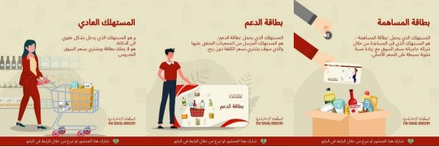

The main objective of the SOCIAL GROCERY is to serve the Daam cardholders who are poor families with low purchasing power, identified and referred by respectful and non-political partner NGOs. To be able to achieve this objective in a sustainable manner, the SOCIAL GROCERY should increase its income and compensate losses occurred due to selling for extremely low prices to Daam cardholders. In order to generate this income, the SOCIAL GROCERY is promoting the Mousahama card to mobilize the highest number possible of supporters.
The following key results were achieved through a number of activities

- Hiring Finance & Accounting Officer FAO
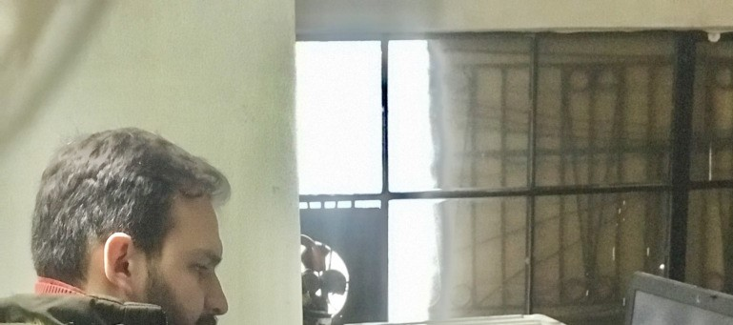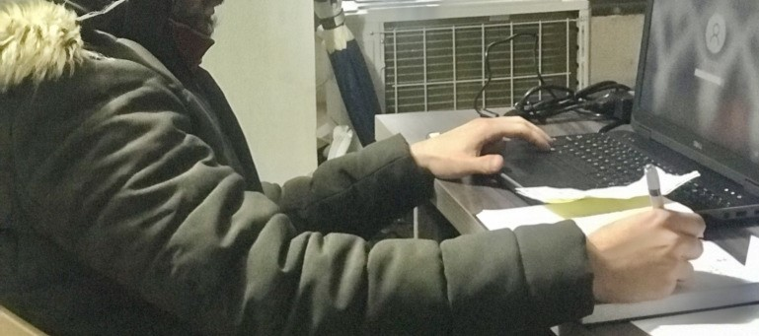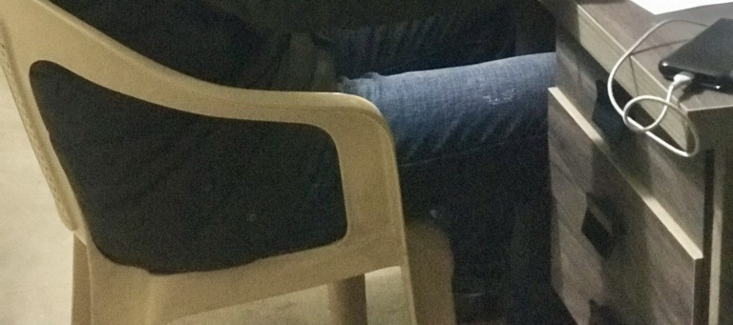

The SOCIAL GROCERY has currently two branches in
Tripoli (Mina and Mallouleh) and has plan to scale
up its
model through opening more branches in other areas.

Consequently, the financial operations of the enter
prise
became relatively significant and complex and requi
re a
dedicated Finance and Accounting Officer to ensure
transparency and division of labor.

- Supply & Goods
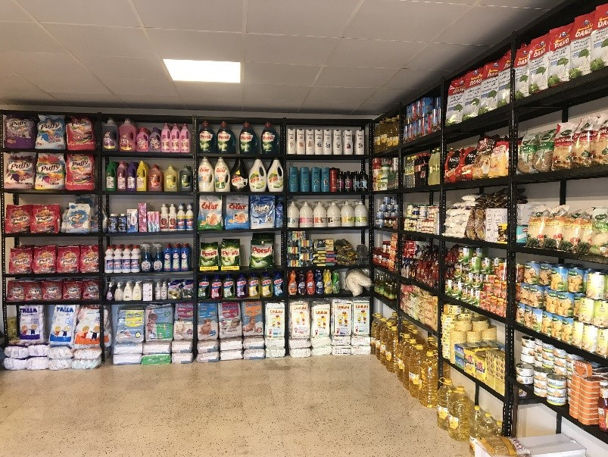

- Daam Cards
The Social Grocery Mallouleh in Tripoli managed to provide 30 Daam Cards to 10 beneficiaries who bought products for almost wholesale price
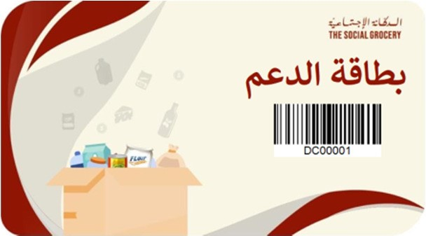
- Mousahama Cards
We managed to provide 1 Mousahama Cards to 1 beneficiary who bought products for an increased markup as a form of contribution and social solidarity
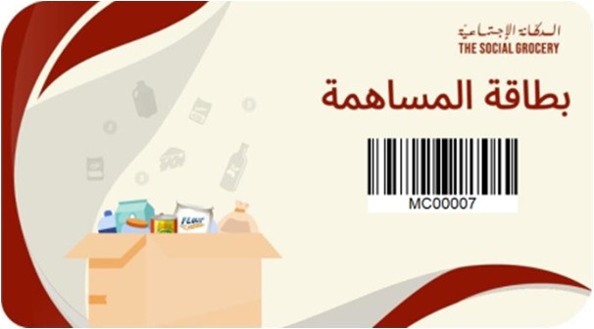
- Walk-in clients
We managed to serve more than 500 Walk-in clients who bought products for shelf price SG Mina Branch Achievements:
As for the first SG branch in Tripoli Mina, the SOCIAL GROCERY served more than 3000 walk-in clients as well as provided 130 very vulnerable clients with a card membership that allows them to buy products for almost wholesale price. In addition, 40 persons have signed up as members who buy products for an increased markup as a form of contribution and social solidarity.

Budget Overview
Items | Budget USD | Spent USD
DELL Laptop | 400 | 400
Desk | 150 | 120
Lighting | 50 | 40
New Battery for UPS | 160 | 190
Supply & Goods | 1000 | 90
Total Spent | 1750 | 840

