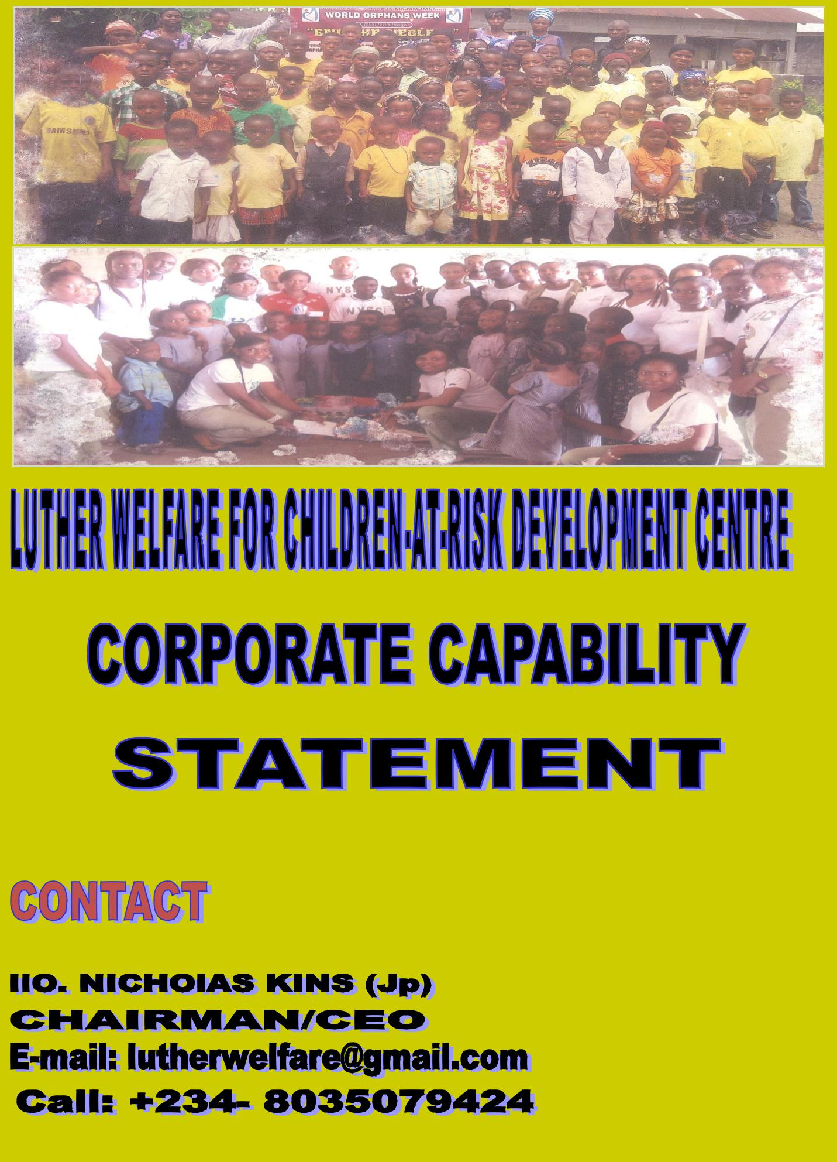
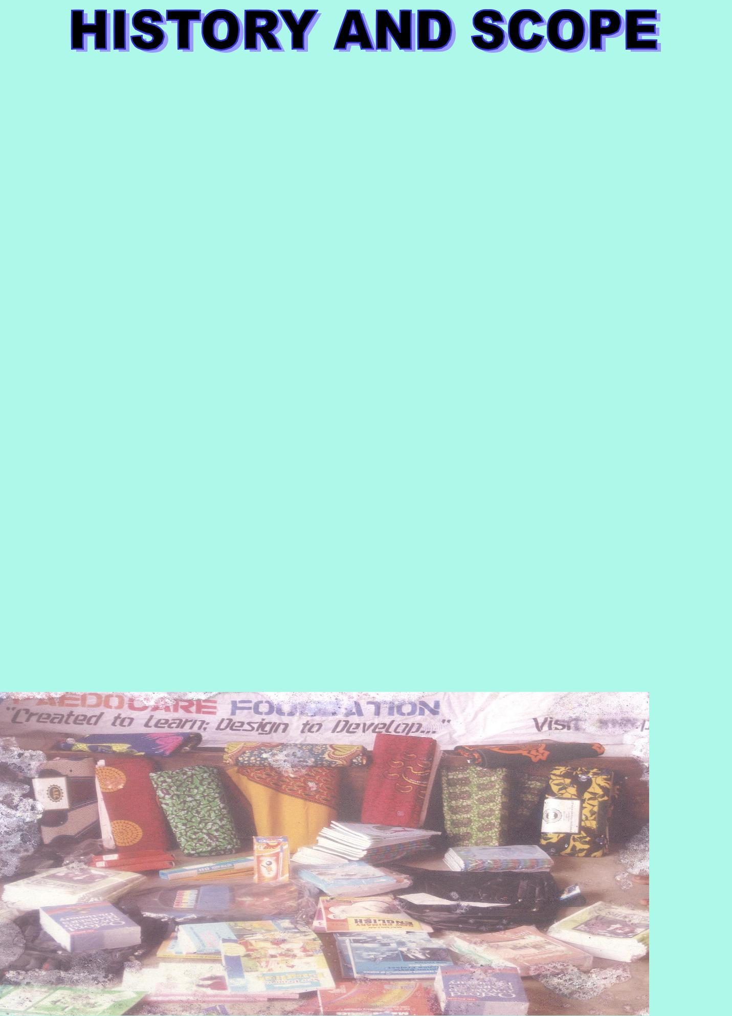

The Luther Welfare for Children At-Risk Development Centre is a non-profit, non-political foundation in Nigeria. (It was formerly ‘Paedocare Foundation (Children At-Risk Development.) The Centre seeks to motivate concerns of children helpers in addressing care needs for raising healthy children for sustainable future. The Centre started as an "Open Hands" care service for children (internally displaced in crises-torn areas; and those neglected as child witches, disabled, and orphans) etc.

Rev. Nicholas K. Iloh and his wife, Mrs. Ofonime Iloh (volunteer social workers of Social Welfare and Lutheran Church priests in Nigeria), pioneered the vision of the Centre; thus, founded the mission of saving lives of children through rehabilitating them from the traumatic crises of loss of parents under difficult circumstances in Ogoni. The focus is to relieve painful challenges of these children / their care-giver families, and re-store hope for them —by transforming their helplessness and urgent state of need —as trapped victims in vulnerable conditions.

The Cen-tre pro-viding educa-tional ma-terials and clothing to commu-nity or-phans in dire need

The aims and objectives of the Centre are:

- To plan for the welfare support of children in need

- To provide care, protection and development programmes for children

- To develop strategic intervention for welfare of children at-risk communities

- To fight against sexual exploitation of the girl-child and women

- To help youths and poor widows acquire skills

- To engage in charitable works, build orphanage homes and provide for shel-ter needs of abandoned children

- To help children and youths (most especially handicaps) to acquire skills

- To create awareness for youths in choosing their career path

- To assist persons attain self-discovery and to provide motivation and self-fulfillment

- To promote, encourage, assist and cooperate with other bodies that may have similar or related objectives.

Slogan: Created to learn; Designed to develop.... "

Words of Welcome: We have known you for child-love!

Vision:

A society with valuable positive outlook for the sustainable development of children at risk.

Mission:

⇒To build a synergy of individuals, organizations and community of groups in providing support for children in needs, through provision of community - based psychosocial support, education, Healthcare, Food/nutrition, economic strength-

s
ening (Basic life skills) and shelter .

- To establish Child Support and Protection centres creating enabling envi-ronment for the development and sustainability of children’s rights and access welfare.

Goal:

Improved service opportunity and welfare of children through harnessing resources and practical support for coordinating and responding to children in needs; and transformed families and children in at-risk communities with every-one meeting the needs of prevailing conditions.

Values:

- Care and Protection in the best interest of the Child

- Healthy development polices and collaboration

- Honesty and Accountability

- Compassion and Service

- Respect and dignity

- Confidentiality.
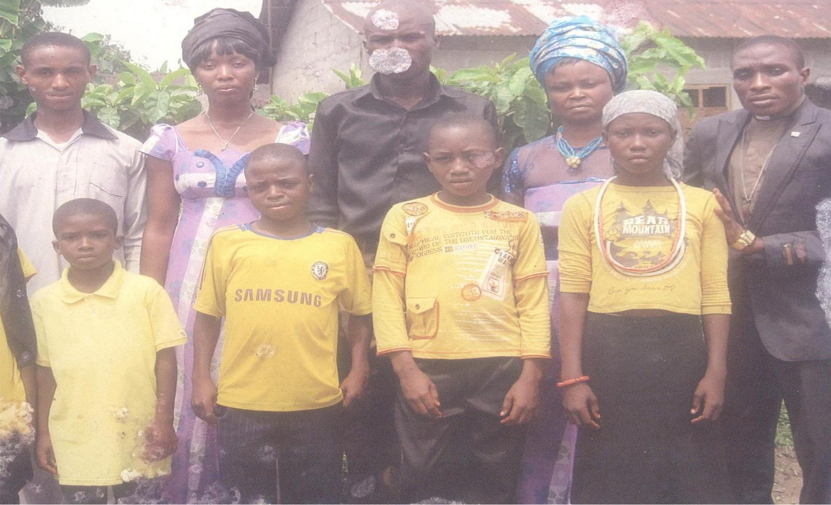

Staff of the Centre with most vulner-able children found out of homes

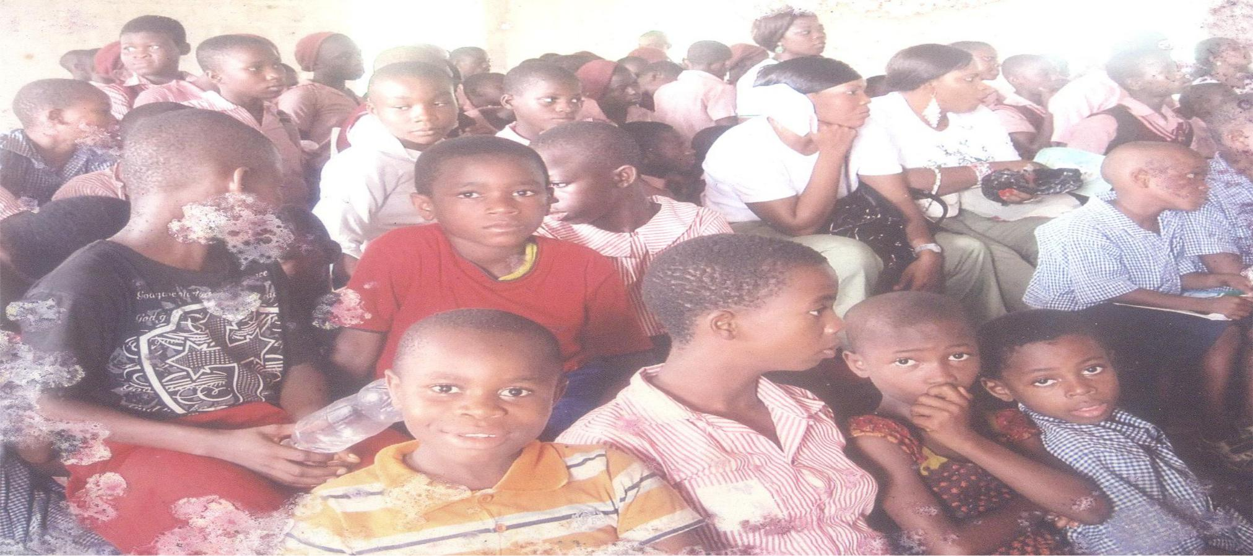

Community or-phans at a town hall gathering for support
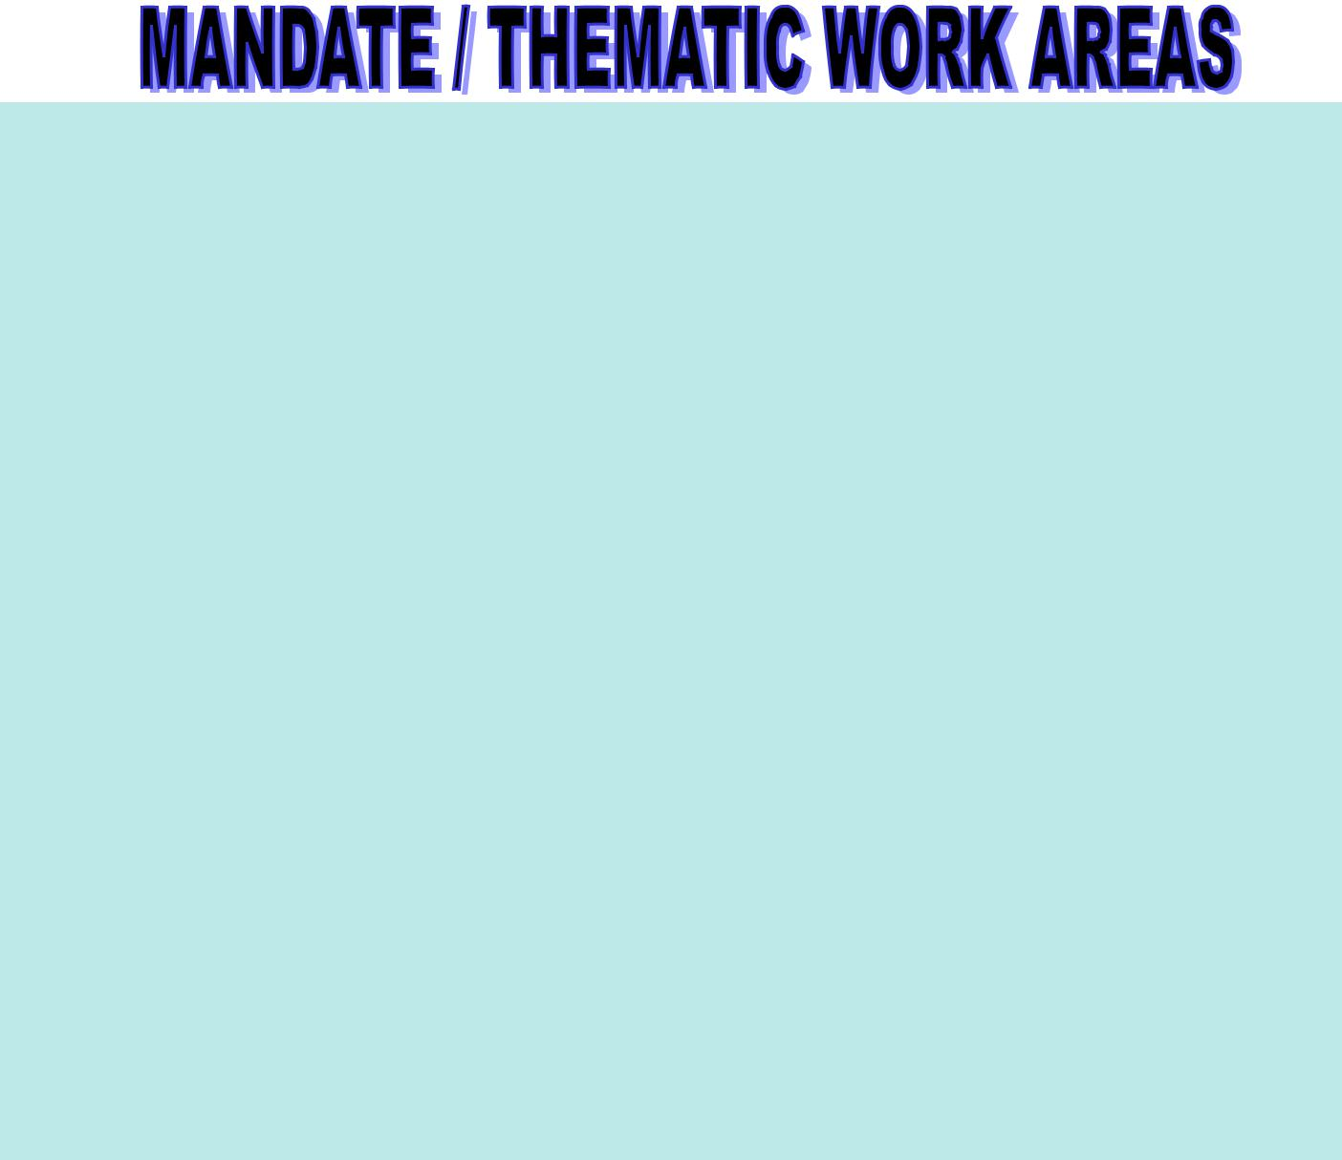

1. Direct core areas in attending to children in need include:

- Health and Nutrition

- Food/Meal Support

- HIV / AIDS care

- Development: Basic Education, Water, Sanitation Hygiene (WASH)

- Protection: Child’s Rights Protection (i.e. from trafficking, labour, exploitation, abuse prevention, and legal aid.)

2. Establishment of Community Child Support Centres:

⇒ Development - Retreats, camps & controlled resources for orphans

⇒ Health/Safety

⇒ Shelter/Resettlement plan, etc.

3. Guidance and Counseling:

- Emergency Services / Referrals

- Legal protection, and

- Psychotherapy

  - Research and Documentation into Position Statements for service.

- Trainings and Empowerment (mostly) for care-givers, youths of post-orphanage and disability focusing on basic life skills / livelihoods sustainability, effective parenting, parent-child communication, and Child's Rights.

- Mutual collaboration and partnership promotion for the welfare of children at-risk.

TARGET GROUP / BENEFICIARIES

These are Children in need:

- Orphans and Vulnerable Children

- Internally victimized/displaced children (e.g. children of special needs/with disabilities, cultural afflicted child witches, etc)

- Abandoned children and children of multiple birth

- Street children,
- Disaster prone and affected children.

Children At-Risk Parents (CARP)-widows, Single parents, Social mothers, etc.
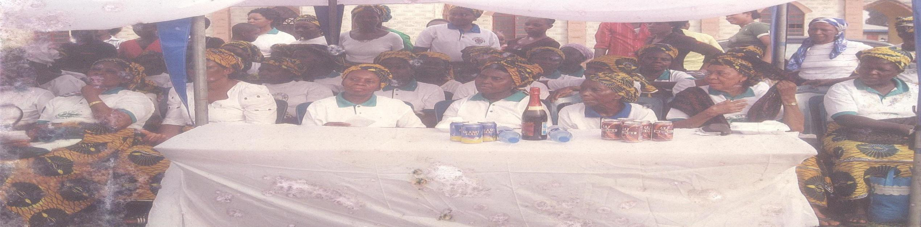

Mothers at inaugural Community Child Support Centre for OVC

At-Risk Family-Communities of need mostly, Africa as characterized by gross domestic violence, wars, abduction, environmental health hazards, child abuse and neglect.

STRATEGIC APPROACH / INTERVENTION

Support visits | Peace building
Negotiations/consultations | Social integration/Values development
Research /documentation | Partnership (Collaboration) building
Capacity building, | Monitoring/Evaluation and reporting

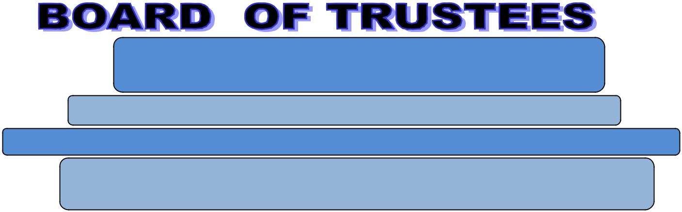

Rev. Iloh, Nicholas Kins (JP)- Chairman/CEO

Apostle Augustine Mgbo Matthew- Evidence of Faith Church

Deaconess Ime Ufford Ibanga (JP) - Welfare / Pension Director, University of Port Harcourt.

Pastor (MRS) Ofonime N. Iloh – Civil Servant/Event Consultant.

Executive Director

Secretary |  | Community Representatives

Center Coordinators

Teachers (15)

Consultants (5)

First Aiders(3)/Nurses(2)

Security (1)

Organizational membership/partnerships include:

- Representation in Council for Physically Challenged Entrepreneurs of Nigeria (COPCEN) for children of special needs (children with disabilities)

- Registered Member in Association of Orphans and Vulnerable Children NGO's in Nigeria (AONN), Rivers state chapter

- Pioneer/Approved Member in Child Protection Network (CPN), Rivers State -under the supervision of UNICEF, Nigeria, and

- Associate Member of the African Network for the Prevention and Protection of Child Abuse and Neglect (ANPPCAN), Rivers State chapter.

- Annual Celebration of "World Weekend of Prayer for Children At-Risk Development" (coordinated on 1st weekend of June since 2006)

- Conduction of the 1st Niger Delta Child Protection and Peace Summit with street match to the Rivers State Government House to condemn child's abduction.(observed annually to mark the "International Day of the African child" June 16)

- Induction of the Annual Public Lecture for "Children At-Risk Development" (the Centre offers 'an exclusive recognition’ - International Award of Significance for individuals/groups with outstanding efforts and contribution to save lives of children in need.

- Establishment of Community Child Support Centre (offering Children At-Risk Development-Retreats, Camps and Centralized Resources) in rural communities to promote child's rights and protection with non-institutional training for parents to prevent the occurrence and re-occurrence of comprehensive child's abuse and neglect –since December 24, 2011.

- Annual observation of "WORLD ORPHANS WEEK" with practical supports for orphans and vulnerable children. –since ……

- Observation of the "WORLD DISABILITIES DAY" with distribution of wheel chairs, clutches , blind slicks, etc (December 3rd annually) to assist lives of children with special needs –since October 6, 2012.

- Joint establishment of ANPPCAN-·PAEDOCARE INSTITUTE for Child-care and Protection training –since …….

- Promotion of media awareness program for child-care and protection e.g.

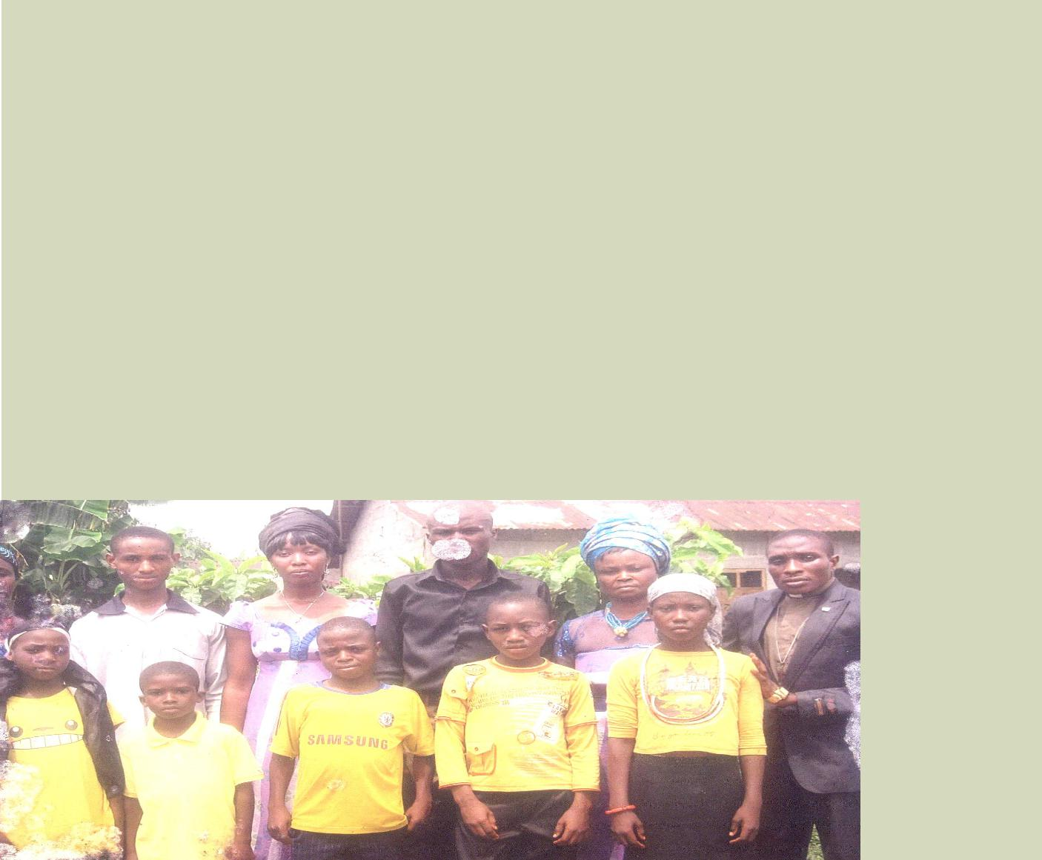
'STRAIGHT TALK' on Rivers State Television Authority (Channel-22 Port Harcourt) & ‘Touching Lives’ on Garden City Radio, 89.9 FM Port Harcourt.

- Introduction of Children's Environmental Health and Safety Conference to mark WORLD ENVIRONMENT DAY (June 5th) and the Global Hands Washing Day –since ……., and

- Celebration of the 'International Day for Street Children' (121h April) tagged Challenging Perspectives" with media awareness on Nigerian Television Authority HIGHLIGHTS (show), Port Harcourt since…..

Staff of the Cen-tre with most vulnerable chil-dren found out of homes

►Child Welfare Department of the Rivers State Ministry of Social Welfare &

Rehabilitation

- Council for Physically Challenged Entrepreneurs of Nigeria (COPCEN)

- Association of Orphans and Vulnerable Children NGO's in Nigeria (AONN), Rivers state chapter., and

- Child Protection Network (CPN), Rivers State under the supervision of UNICEF) Port Harcourt Field Office, Nigeria.

EXTERNAL AUDITOR: | BANKER:

Messrs. Gberebge & CO Chartered Fidelity Bank PLC Accountants/Consult
P.O. Box 9147, Oromenike Street, Federal Ocean Terminal (FOT), Onne D-Line Port Harcourt, Rivers State Eleme, Rivers State Nigeria.
Nigeria.

R.A. Inko-Dokubo (Esq.), Firm of Rose & | Child life Project, 9 Station Road-Port Har-
Associates (Legal Endorsement) | court.
Akuro George (Esq.), T. Amunokuro | Owners of Private Schools Association-
Chambers (Legal Endorsement) | Trans Amadi Branch
Azuabie Ministers Forum-Port Harcourt.(Partners in Children At-Risk Development Global Prayer Networks) | The Lutheran Church of Nigeria-Port Har-
 | court District
Rivers State Ministry of Culture & Tourism- | Nigerian Television Authority (NTA)-Port Harcourt on “Street Children” interviews
(Venue for World Weekend of Prayers for Children At-Risk Development)
Multi-Pro Enterprises ltd (Indomie) Food | Garden City Radio, 89.9 Fm, Port Harcourt  on “Touching Lives” At-Risk Show
Support
Tomseky Ventures-Event Planner/Decoration | Pabod Breweries Nig. Ltd
Deacon & Mrs Monday Lale Chu | Late Dame(Mrs) Victoria Chu &Mba Olea-Eteo
Sir (Hon.) / Lady Chidi Chu (Snr) Jp. | Late Chf. (Engr.) / Mrs Don Ngulube
HRH. Emere E.T.K. Akobe (JP) , One - Eh | Elder /Deaconess U.J. lbanga (Patron/Trustee)
- Eta - Eteo (X) with Chiefs and Elders in
Council - Eleme

For the purpose of accountability and transparency, the Centre keeps appropriate records of its financial transactions, and by order of the Executive Board, an Auditor is appointed to prepare annual Financial Report and appropriate Banker(s) are carefully selected in line with financial control standards.

Note: Copies of Audited Financial Statements are available on request.

 | Total Number of Children: | 183 (as at March 2012)
 | Community Orphans: | 173
 | Abandoned Children: | 04
 | Children with Disabilities: | 06

►Library ► Reading Room ► Reading Corners

►Sign-Out Books ►other Educational Materials

Inmate intake include referrals from: |  | Medical Support Treatment Services
 |  | ⇒Hospital
⇒ Individuals / Family Identification
⇒ Faith-Based Organizations |  | ⇒Health 'Centre
⇒ Community Organized efforts |  | ⇒Clinic

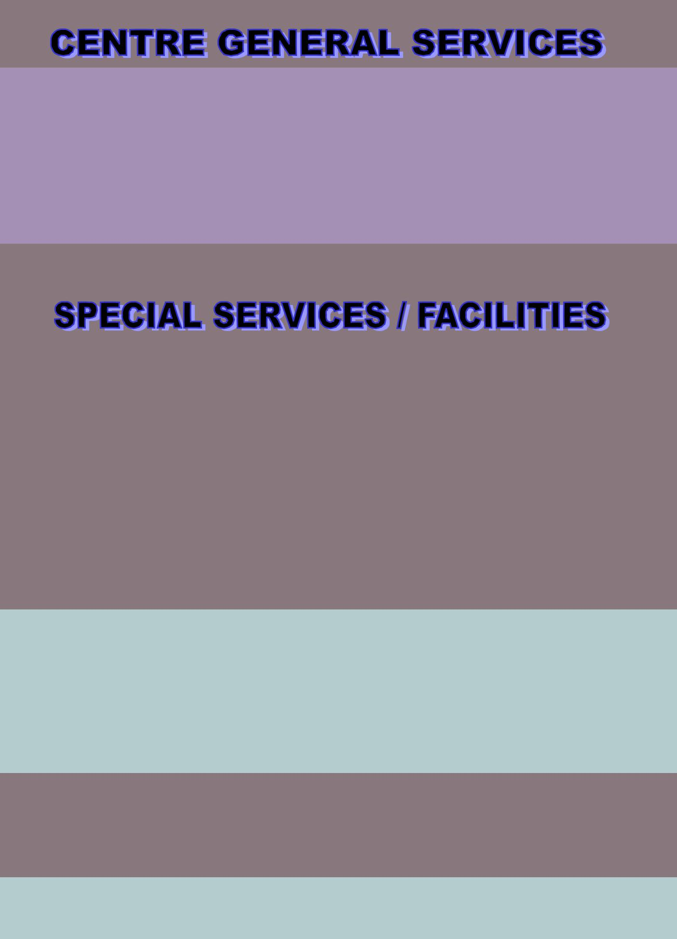

►Child Protection Awareness Training

►Orphans Scholarship Scheme

- Basic life Skills & Food / Nutrition Training

- Psychotherapy - Counseling, Spiritual Development, and Follow up

⇒ Renewable Sources of Water | ⇒ Power Generating Set
⇒ First Aid Service | ⇒ Creativity/Skills Development Center
⇒ Convenience Toilets Units | ⇒ Sports/Recreation Facilities
⇒ Community library | ⇒ Computer Training Facilities
⇒ Accommodation Facilities | ⇒ Cookeries / Daily Food /:Meals

CONTACT:

Ilo,. Nicholas Kins (Jp) (+234 818 7539 163) OR Lutheran Ext. Qrt.,35 Stream Way, Aluebo Eteo, P. O. Box 952, Nchia Eleme Rivers State-Nigeria, W/Africa.
E-mail: lutherwelfare@gmail.com;
Visit: www.lutherwelfare.com

Call / SMS: +234 909 3019 664; WhatsApp: +234 902 5518 253.

COVER PHOTOS:

1st Photo: The Centre hosting World Orphans Week to END THE NEGLECT in the Niger Delta-Eleme 2nd Photo: Youth Corpers and the Centre revisit to Eleme orphans with support

