TABLE OF CONTENTS Page
1.0 INTRODUCTION……………………………………………………….. 1
1.1 VISION ………………………………………………………………… 1
1.2 MISSION………………………………………………………………. 2
1.3 PROJECT OBJECTIVES…………………………………………….… 2
1.4 PROJECT BENEFICIARIES…………………………………………. 2
1.5 PROJECT SUMMARY………………………………………….…..… 3
1.6 PROBLEM STATEMENT……………………………………….…..... 3
1.7 POTENTIAL LONG TERM IMPACT…………………………….….. 3
1.8 ORGANIZATION STRUCTURE……………………………….…… 4
1.9 CHILD PROTECTION POLICY………………………………….…. 4
2.0 OUR PARTNERS………………………………………………….…. 6
2.1 PAST ACHIEVEMENTS………………………………………….…. 7
2.2 METHODOLOGY……………………………………………………. 7
2.3 WORK PLAN………………………………………………………… 8
2.4 PROPOSAL BUDGET….…………………………………………… 8
2.5 IMPACT ANALYSIS………………………………………………. 9
2.6 FILLING REPORTS………………………………………………… 10
2.7 PICTURE GALLARY………………………………………………. 10-17
2.8 ATTACHMENTS: INVOICES
C.V
SUPPORTIVE LETTERS
REGISTRATION CERTIFICATE

- INTRODUCTION
Ntimi home of hope is a non-profit making organization situated in Embakasi West Tena Estate Nairobi country. Ntimi is registered with the Ministry of East Africa Community, Labour and social protection department of social development and heritage as a charitable Institution. Ntimi takes care of the abandoned, orphaned, the neglected and whose rights have been violated.
Ntimi home of hope is an organization that was started in the year 2006 by Mr. George Onyango who was once a street boy and Ms. Rose Bhoke who was an Orphan, as a rehabilitation program for the street children. At that time, Nairobi city had more than 100,000 children who were living on the streets. It is the plight of those children who knew no other home, no other life apart from the streets that came into existence.
At Ntimi home of hope, children are rescued almost on a daily basis. On the streets, dustbins, sewage sites innocent souls are left on their own. In hospitals, mothers abandon especially young mothers. Police desks are equally busy with children found lost or left on their own without care or protection. All these children of 7 years and below are brought to Ntimi Home of Hope children’s home for care and protection. Upon intake, an individual placement plan is made. This is based on the background information. With time an alternative care is sought; this involves extensive case works, field visits, home visits, follow-ups and enough areas of networking. For those children whose guardians are found and assessed the children are given back to probation care. For those abandoned at birth and no one claiming for them, are released for foster care. Over the years Ntimi home of hope has grown both in quality and in magnitude. Currently, Ntimi home of hope is taking care and protecting 100 children in two different homes. A major challenge is that no one comes forward to adopt an HIV positive baby. As a result, children who have ever tested positive remain in the program forever or for a very long time before getting an alternative care.
Over the years Ntimi home of hope has steadily grown both in size and quality moving from an individual initiative to an organization based structure. It presently caters for 100 children including babies from one day old to 18 years (abandoned, orphaned and vulnerable children and those neglected. Ntimi home of hope strives to help these children understand that being orphaned or vulnerable is not their identity by offering a Godly home, a loving and a family environment. We also identify, develop each child’s unique and special talents, teach, transform and train the children through education and mentorship. We believe that every child deserves the best start in life and a chance to fulfill their potential, therefore, we support them, stand up for them and bring out the best in each and every child.
VISION
A society in which all children will be able to live a dignified existence with equal and just access to future opportunities in life.

1
MISSION
Ntimi home of hope shall endeavor to improve the situation of orphaned and vulnerable children by providing care and protection, guide the reintegration process into society and address the factors leading to their problems.
- PROJECT OBJECTIVE
- To provide parental care and guidance to the children
- Rehabilitation and reintegration of children back to the community
- To provide primary health care to the children
- To provide quality education to the children
- Preventing vulnerability of children by working with the community around Nairobi and empowering them with life skills. This is achieved through community child protection where Ntimi home of hope sensitizes members of the public to be ‘watchdogs’ for the abused children and report to the authority.
- To train caregivers in caregiving skills to enable these children to get adequate care, love and support.
- Supporting the orphans, needy and other vulnerable children in the society by providing them with humanitarian aid such as basic needs (food, shelter, clothing, education) psychological and spiritual support.
- Primary health offering.
- Empowerment programs through offering vocational and life skills communication skills and leadership skills.
- Boarding facilities.
- Mentorship /coaching by engaging the children in school holiday workshops and camps which identify nurture and develop their talents and careers that will help them become responsible citizens in future
- PROJECT BENEFICIARIES
This project will benefit this category of children.
- Abandoned children
- Orphaned children without any known responsible guardian
- Children of imprisoned parents
- Lost and Found children
- Children forced into early marriages
- Physically and sexually abused children
- The centers provide temporary care and enhance parental care and guidance, quality education and primary health care to the children before they are reintegrated back to the society through:
- Adoption
- Foster Care
- Reitragation
2

- PROJECT SUMMARY
Ntimi home of hope houses orphans and vulnerable children and needy families and provides care support and protection for them. This home has 10 workers among them cooks, cleaners, teachers, caretakers and administrators. All children are provided with 3 times nutritious food, books, school uniforms, clothing, beddings, sanitary pads, diapers, water, soap detergents and shoes as well as psychological and spiritual support. Every child has an opportunity for indoor and outdoor recreation and play facilities. We also support them to realize their potentials, careers and talents so as to become self-reliant and responsible members of the society .We as NTIMI HOME OF HOPE aim to bring a service of hope to the needy and vulnerable children and families in the community.
- PROBLEM STATEMENT
The problem of the orphaned, needy and vulnerable children is acute due to poverty levels in our communities thus most families are unable to afford basic needs for their children. There is also an increase of children who are affected and infected with HIV/AIDS while others have been orphaned as a result of the deaths of AIDS affected persons. The situation is also further aggravated by the absence of love and security and unwanted pregnancy of sexually exploited girls conflict, social injustices, gender violence etc. These children are involved in rag picking, pick pocketing, participating in anti-social, criminal activities.
- POTENTIAL LONG TERM IMPACT
This project has potential and impactful in main streaming the orphans, needy and vulnerable children. Their basic needs are met and they will get new life through gaining knowledge vocational skills and life skills. They will get love and affection as if their parents provides. Their confidence level will increase and become a good asset to the community. They are developed physically and psychologically and made good and productive citizens. The children who live at our Centre will also benefit from academic sponsorship as well as other children whom we support while staying with their parents or guardians. We will also have group fellowships for children, teenagers, youths mothers which will bring them together so as to share challenges that they are facing through encouraging each other by having healthy discussions that may lead to problem solutions.

3
- ORGANIZATION STRUCTURE
NTIMI HOME OF HOPE MANAGEMENT STRUCTURE
PROGRAM TRUSTEE

PROGRAM CO-OPDINATOR

COMMUNICATIONS
ACCOUNTS
MONITORING & EVALUTION

FUNDRAISNG OFFICER

PROGRAM ADMIN & IT

SOCIAL CASE WORKERS

VOLUNTEERS

- CHILD PROTECTION POLICY
Keeping Children and Young People Safe
Ntimi Home of Hope recognises that violence against children and young people is prevalent throughout the world and in all societies. We are deeply committed to eradicating violence against children and young people and take very seriously our duty to safeguard all children and young people and promote their welfare. This also means holding ourselves to account in ensuring that no child or young person is harmed or placed at risk of harm as a result of their association with us. Our child and young people safeguarding implementation framework, which is explained below, helps us ensure we do all we can to make sure children and young people stay safe and protected when they engage with us and With Those Who Represent Us.
Our Child and Young People Safeguarding Implementation Framework
We hold ourselves accountable to children. Ntimi Home of Hope has a clear and unequivocal safeguarding policy, Say Yes! to Keeping Children and Young People Safe and Protected, that aims to make sure no child or young person who is associated with Ntimi Home of Hope comes to any harm. The policy governs the behaviors of Ntimi Home of Hope staff, associates and visitors, ensuring we minimize risks to children and young people and report any concerns about
4
a child or young person’s welfare appropriately. Our programmer work is committed to ensuring child protection We run programmers designed to make a lasting difference in children’s lives by addressing the problem of violence against children. These programme activities are linked to, but distinct from our efforts to ensure that we as an organization ‘do no harm’ to children. We have developed several measures and mechanisms designed to prevent risk of harm to children and young people:
Policy and Guidance
We have a strong policy, related guidance and tools in place which: Embrace the organization commitment to safeguarding and respecting children and young people irrespective of age, sex, gender, gender identity, sexual orientation, nationality, ethnic origin, color, race, religious or political beliefs, disability, physical or mental health, socio-economic background, or any other aspect of their background or identity. Ensure we recognize and respond to the specific safeguarding risks and needs regarding gender and other identities, and challenge biases, discrimination and other forms of violence which may arise as a result of these. Ensure staff and associates work and interact safely – adopting appropriate codes of conduct – with children and young people.
Awareness and Prevention
We work on creating a culture of awareness where: All staff are aware of and understand the problem of abuse and their roles and responsibilities to prevent harm and keep children and young people safe and protected. Those associated with the organization understand their responsibilities to prevent harm and protect children and young people. Children, young people and communities we work with are aware of the policy so they know what behaviors to expect and how to report any concerns.
Staff, Associates, and Partner Development
We undertake capacity building programme which ensure the socialization of the policy, taking it from paper to practice. We ensure that staff and managers are appropriately skilled, confident and supported in meeting their gender responsive safeguarding responsibilities. We also ensure capacity building is cascaded down to partners and associates as appropriate.
Reporting and Responding
We ensure that staff and associates are clear on what steps to take when concerns arise and that the organization can respond effectively to these concerns.
Safe Engagement and Sanctions
We adopt measures and take action to prevent those who abuse or may be a risk to children and young people from becoming involved with the organization. We take stringent measures against any staff, associate or visitor who abuse a child or young person.
5
Managing Risks to Keep Children and Young People Safe And Protected
We include child and youth safeguarding in risk management to ensure that risks are identified and appropriate controls put in place.
Clear Management Responsibilities and Designated Staff
We ensure that managers and designated safeguarding focal point staff are aware of their responsibilities for creating safe environments for children and young people, implementing the policy and ensuring child protection measures are operating effectively and are clearly defined. The board of Ntimi Home of Hope is ultimately accountable for the child protection policy. The prime responsibility for the implementation of the policy lies with the director of each office. Managers have very clear responsibilities for making sure that child protection measures are in place and operating effectively.
Mainstreaming Children's and Young People's Safety Through Standards
We have standards in place to embed and implement safeguarding. This is one of the most important tools for creating a child and youth safe organization. These standards: Clearly state what is expected in relation to implementing the policy. Provide a benchmark and a basis for accountability. Provide targets. Help minimize risks to children, young people, staff and the organization. Managers are accountable for implementing the standards as they apply to their area of responsibility.
Monitoring and Evaluation
We monitor the extent to which safeguarding measures are in place, evaluating their effectiveness and undertaking safeguarding reviews/audits. In addition, we undertake staff surveys to monitor attitudes towards and awareness of safeguarding children and young people.
Visible and Committed Leadership
The role of leaders in changing an organization’s culture should not be underestimated. Our leadership is committed to role modeling our organizational values and behaviors and upholding the principles of our safeguarding commitment, ensuring the framework is effective. However, everyone within the organization is expected to take individual responsibility for creating positive changes for children and young people.
- OUR PARTNERS
Lift the children
Churches
Well wishers
Income generating project

6
- PAST ACHIEVEMENTS

We have managed to rescue over 100 orphans and vulnerable and needy children from the street all over the country. They are currently enrolled in different schools all over the country, 20 in high school and 70 in lower and upper primary. 10 are baby seated in the center. We are providing boarding facilities to the children arranging teaching facilities in nearby schools, health check-ups, medicines, books, uniforms, nutritious diet, indoor and outdoor recreation and play facilities. The children under our care are also receiving psychological and spiritual support as well as psycho-social support. They also benefit from children rights protection by engaging them in school holidays workshops, and camps which identifies, nurtures, and develops their talents and careers that will help them to be responsible citizens in future.

- METHODOLOGY
We trace and rescue the needy and vulnerable children through citizens, police and other government agencies e.g. the Children Department.
We counsel and arrange for emotional acceptance of the child. We provide boarding facilities at rented buildings in Tena estate. We have arranged teaching facilities in nearby schools. We also provide home tuitions, recreation and health care. Since the inception of NTIMI HOME OF HOPE in 2006 up to 2018, the activities of the home were running through a business that was started and operated by the Project Trustees. For 12years the Project Trustees (Mr. GEORGE ONYANGO and Ms. ROSE BHOKE) took the children as their own children and would facilitate all their needs through their business venture. No financial or humanitarian assistance was received within these 12 years thus the home remained un-known to the public. In 2018 a truck belonging to the Project Trustees was involved in an accident in Tanzania with goods worth over 1.8m shillings. The truck was totally written off and the goods vandalized resulting to total loss of both the goods and the vehicle. This immensely affected the operations/activities of the home thus from 2018 we have been running on local donations and contributions which are not sufficient to cater for the needs of the children resulting to the current humanitarian crisis that we are experiencing. We are mobilizing resources through donations and contributions from like-minded partners, the Kenyan Government, Churches, Organizations, Companies, Friends and Well-wishers. We have limited resources to take care of the children but day by day the number of children is increasing due to various reasons. We need additional support to meet the needs of the increasing number of the needy and vulnerable children and their families in our Centre. In the meantime we will continue to mobilize continuous local donations and contributions through exhibiting our good work and service. The homes have 10 workers who include caretakers, cleaners, cooks, teachers and administrators. The proposal covers 100 needy and vulnerable children. Every child will be provided with nutritional diet, uniforms, beddings, shoes, toiletries, indoor and outdoor recreation and play facilities.

7
- WORK PLAN

What Activity | By Who | By When
Payment of primary school cost | accountant | 15/02/2020
Purchase of uniforms and school supplies/education materials | accountant | 15/02/2020  02/05/2020  02/09/2020
Purchase of kitchen utensils | Head social worker | 14/04/2020
Psychological counseling | Head social worker | Ongoing
Purchase of food | Accountant | Ongoing
Reintegration and restoration | Hear social worker | Ongoing
Medical care | Head social worker | Ongoing
Purchase of beddings | Accountant | 25/02/2020
Purchase of clothes | Head social worker | 01/03/2020  03/04/2020  05/08/2020  08/12/2020

- PROPOSAL BUDGET

PARTICULARS | QUANTITY | UNIT COST | ANNUAL AMOUNT(KSH)
EDUCATION NEEDS
School fees-secondary | 17 | 47,500.00 | 807,500.00
School fees – primary | 75 | 18,260.00 | 1,369,500.00
Vocational training | 5 | 43,800.00 | 219,000.00
SUB-TOTAL |  |  | 2,396,000.00
UNIFORMS
Shirt | 192 | 480.00 | 92,160.00
Dress | 96 | 1,200.00 | 115,200.00
Shorts(pair) | 192 | 420.00 | 80,640.00
T-shirt | 192 | 360.00 | 69,120.00
Trousers( pairs) | 96 | 820.00 | 78,720.00
Sweater | 192 | 950.00 | 182,400.00
Track suits | 192 | 1,500.00 | 288,000.00
Socks (pair) | 384 | 1,200.00 | 46,080.00
Shoes(pair) | 192 | 1,999.00 | 383,808.00
SUB-TOTAL |  |  | 1,336,128.00
EDUCATION MATERIALS
Text books | 800 | 780.00 | 624,000.00
Exercise books | 10,950  8 | 30.00 | 328,500.00
SUB-TOTAL |  |  | 952,500.00
MEALS
Breakfast | 43,800 | 20.00 | 876,000.00
Lunch | 43,800 | 30.00 | 1,314,000.00
Dinner | 43,800 | 30.00 | 1,314,000.00
Snacks | 9,216 | 30.00 | 276,480.00
SUB-TOTAL |  |  | 3,780,480.00
ACCOMMODATION
Beddings | 30 | 24,133.00 | 839,850.00
Mattress | 60 | 5,077.00 | 353,400.00
Blanket | 102 | 1,200.00 | 122,400.00
Bed sheets | 204 | 650.00 | 132,600.00
Mosquito nets | 40 | 520.00 | 20,800.00
House rent | 12 | 100,000.00 | 1,200,000.00
SUB-TOTAL |  |  | 2,669,050.00
HEALTH CARE
Medicare | 100 | 5,000.00 | 500,000.00
Psychological fees | 12 | 24,000.00 | 288,000.00
SUB-TOTAL |  |  | 788,000.00
RUNNING COST
Transport | 1 | 215,000.00 | 215,442.00
Utensils | 200 | 350.00 | 70,000.00
Electricity bill | 1 | 192,000.00 | 192,000.00
Communication | 1 | 144,000.00 | 144,000.00
Charcoal | 86 | 2,500.00 | 215,000.00
Gas | 1 | 101,900.00 | 101,900.00
Miscellaneous | 1 | 320,000.00 | 32,000.00
SUB-TOTAL |  |  | 970,342.00
TOTAL |  |  | 12,892,500.00

- IMPACT ANALYSIS

The project will be monitored at regular intervals through a Project advisory Committee (PAC) constituted with the Program Trustee as the convener/ member secretary. The committee would meet periodically and advise on various aspects concerning implementation of the project and review of the programs/activities undertaken. The PAC will also review the accounts and audited statements.
Ntimi home of hope will keep updated record of all finances spent. All the transactions will be recorded with the following documents:
9
- Minutes of the word meeting held about the financial transactions
- Purchase/payment receipts from the institutions and shops where the payments were made.
- Cashbook of all incoming and outgoing funds.
Other project documentation will be:
- Care plan
- Pictures
- Social workers report
- Home report
- FILLING REPORTS
A monthly report will be sent to the children's Department with the number of children admitted in the children's home, the number of new comers and the number of reintegrated families.
All financial reports will be submitted to the street fund.
- GALLERY
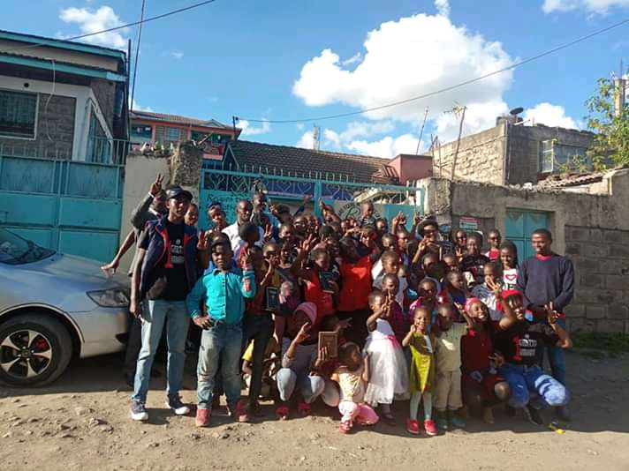
PART OF ORPHANS AND VULNERABLE CHILDREDB WHO ARE BEING SUPPORTED BY NTIMI HOME OF HOPE AND PART OF THE VISITORS WHO PAID THEM A VISIT AT THE HOME

10
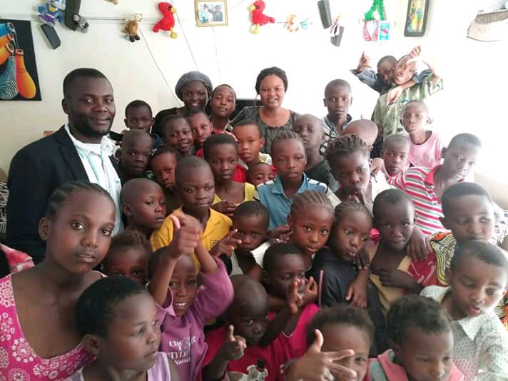
These are part of the orphans, vulnerrable needy children who are being supported by ntimi home of hope and part of the staff.

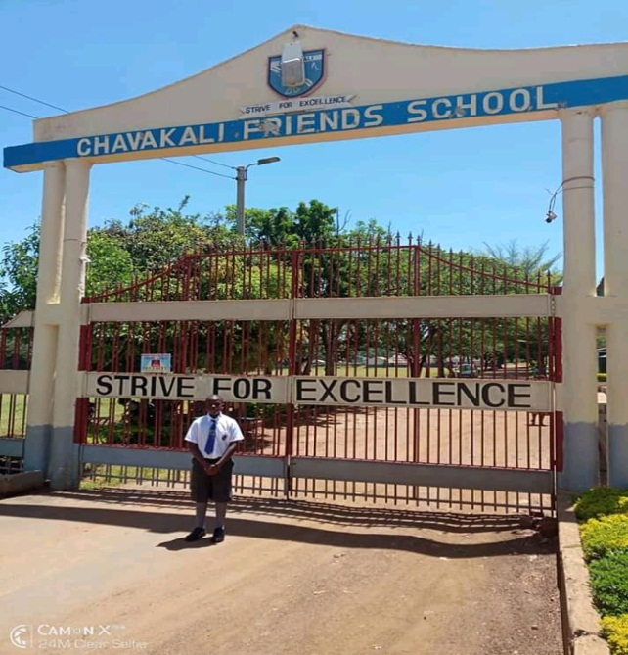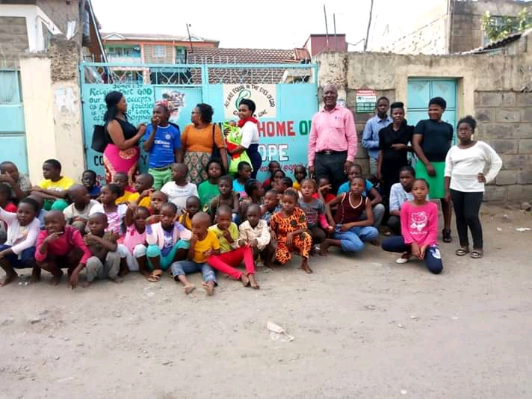
Our child in Chavakali High School. Our Children with visitors.

11
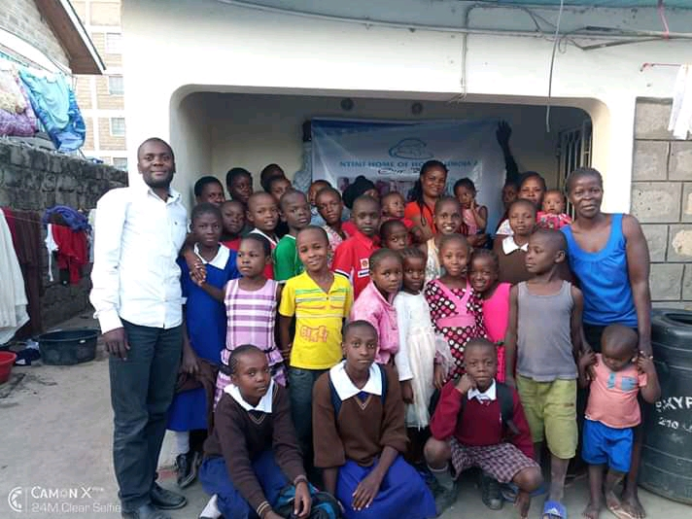
The upper primary school living in Ntimi Home off Hope.
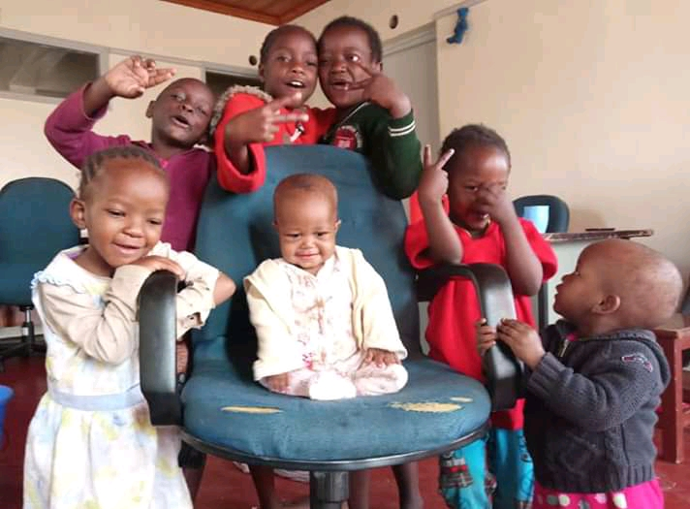
Lower Primary Children

12
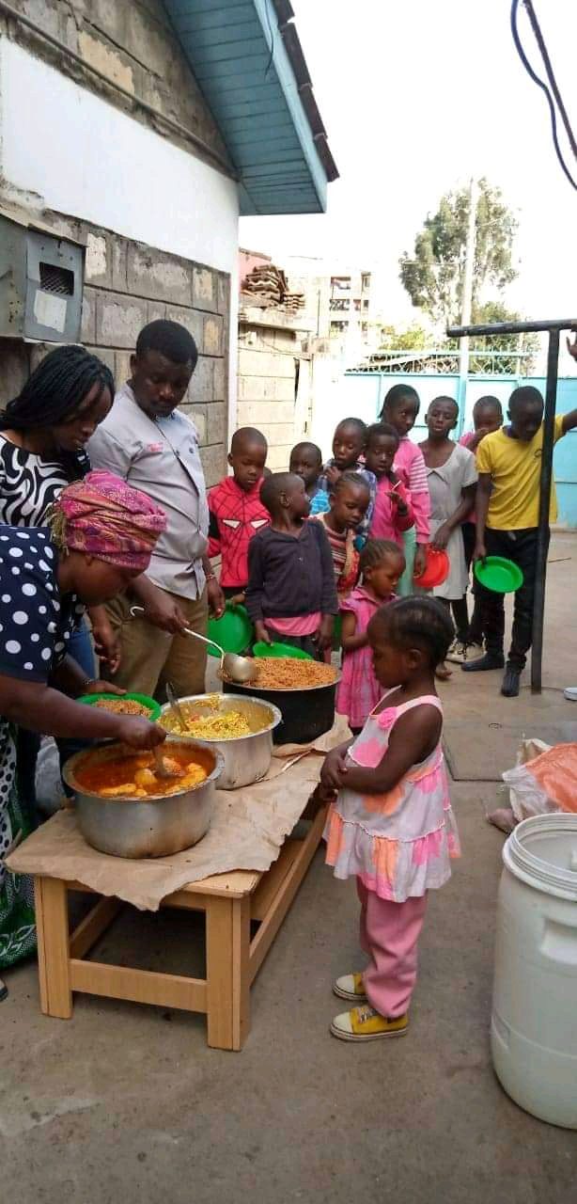
Ntimi Home of Hope vulnerable children having their balanced meal.
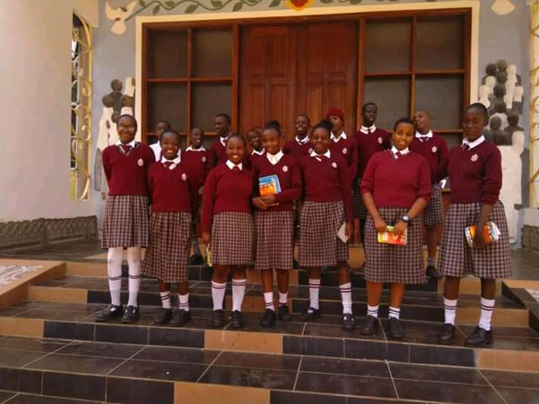
Our Children in the school.
13
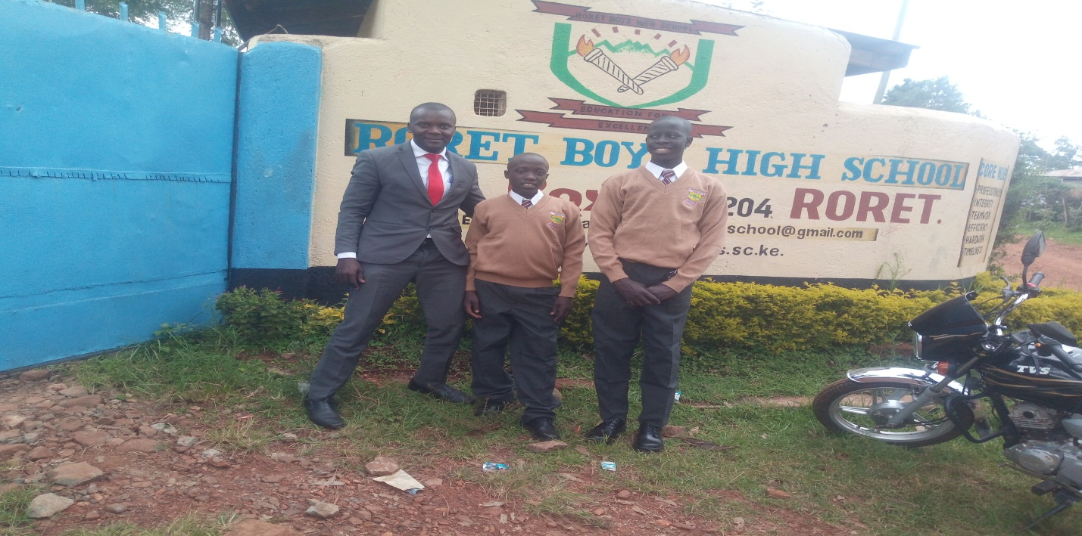
Our street boys Collins and Oscar joining High School
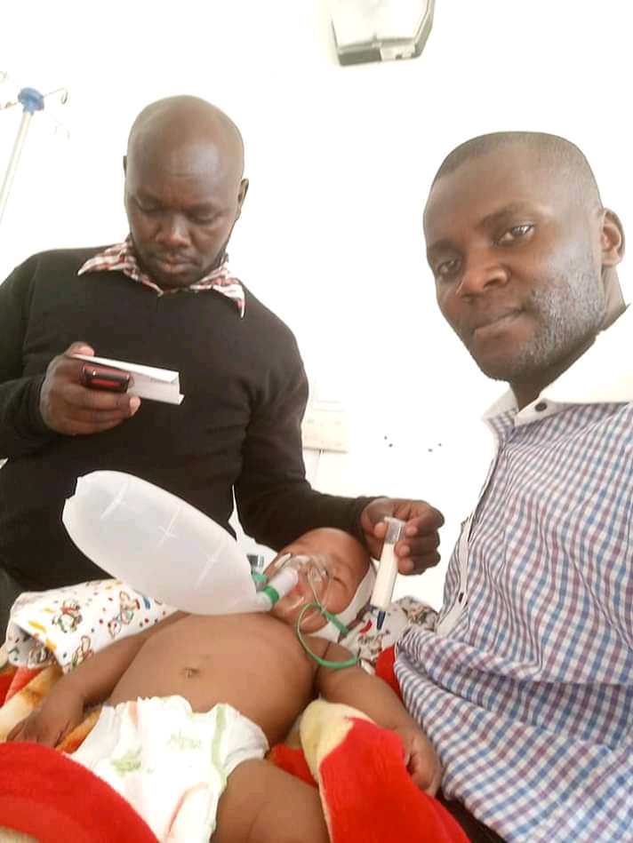
Baby Musa in the Hospital.

14
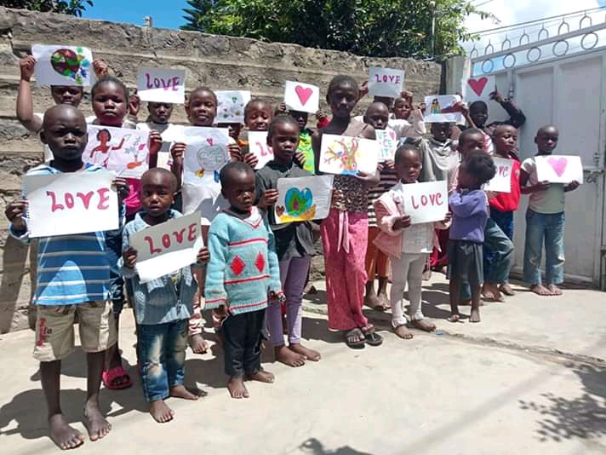
Our children participating in planting seeds of love initiatives.
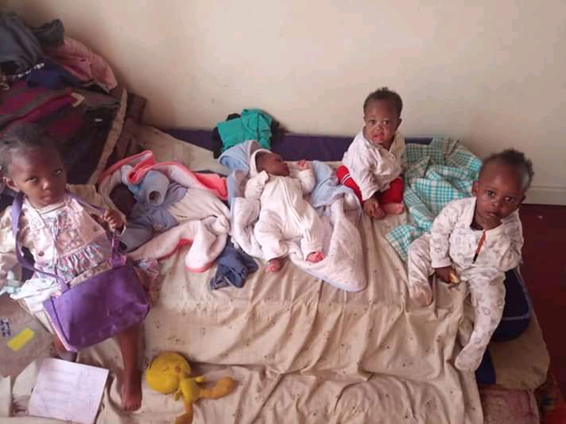
Babies under our Organization.

15
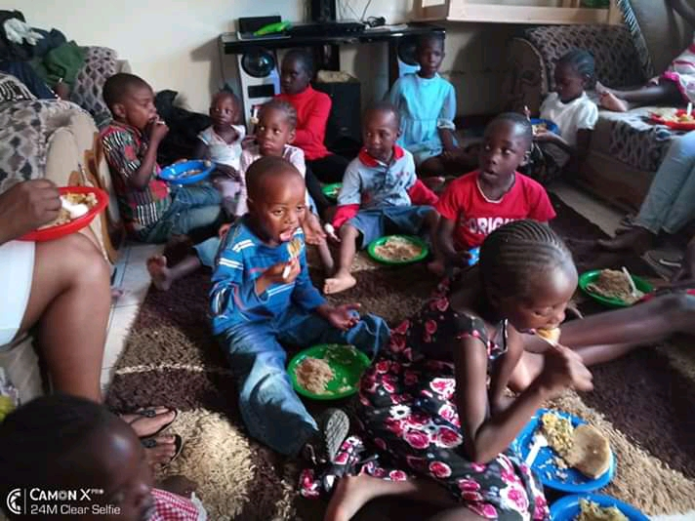
Children enjoying their lunch.
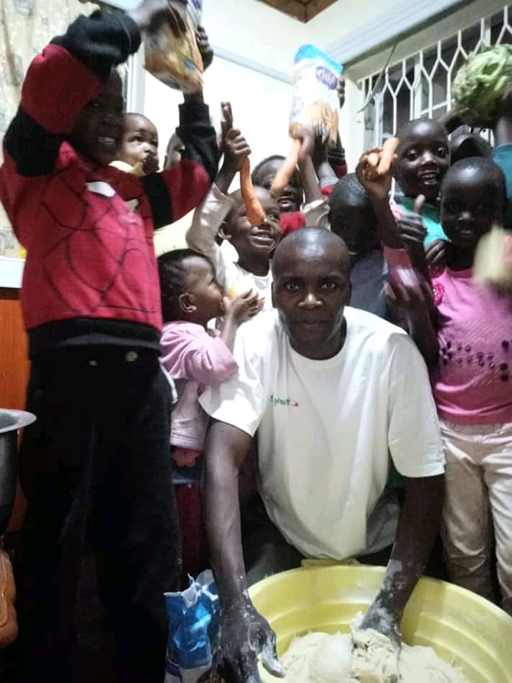
Our Director preparing snacks.

16
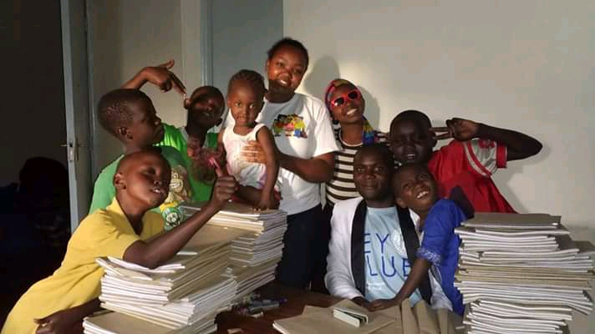
Back to School preparation.

17

