Centre Turereneza Ltd
Turereneza School
Project Title
Educate Children in Rural South Province, Rwanda
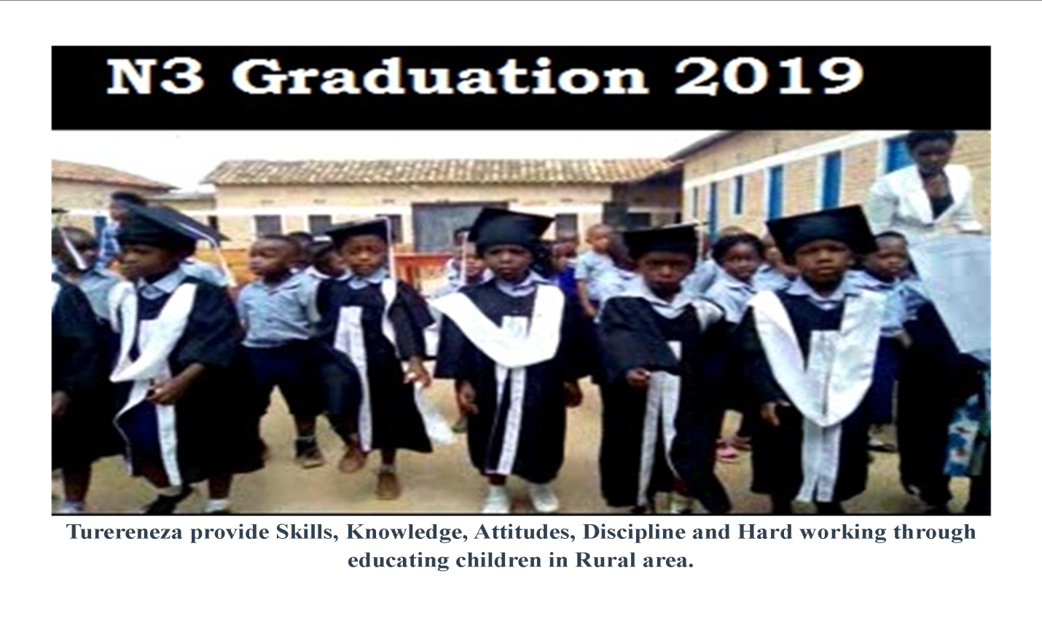

Name of Organization | CENTRE TURERENEZA LTD
Office Address | Address: Kabagali Sector, Ruhango District South Province, Country RWANDA  Phone: +250788559143  Postal Code: PO. BOX 2719 Kigali  Email:turereneza@gmail.com
Contact Person | MUGEMANYI Vedaste  Phone: +250788559143  Email: muveda001@yahoo.fr
Legal Status and Registrations | -Registration Certificate: 108472940  -School code: 02060307  -Statutes of Turereneza School  -Rules and regulations of Turereneza school

Organization Profile
Centre Turereneza Ltd is a company limited by shares under registration number 108472940, with a private School under the name of TURERENEZA SCHOOL which serves as nonprofit organization with both Nursery and Primary Section. It was established in January 2019 with total number of 140 pupils and 12 teaching staffs. Currently the School boasts 209 pupils and14teaching staff. The school has the projection of reaching the number of 300 pupils in the coming school year (September, 2020- June, 2021).
Required Support from donors:
We seek financial support to rehabilitate classrooms infrastructures, increasing school materials, establishing smart library, IT equipments and initiate the capacity building for teachers of Turereneza School for the coming year, 2020-2021 with the purpose of Providing affordable quality education, reduce illiteracy by increasing skills, knowledge, attitudes, discipline and hard work through educating children in rural area(s).

Current Funding Requirements:
The requirements of funds for 2020-21 are summarized below:
S/No | Description |  | Amount(USD)
1 | Rehabilitation of 9 Classrooms |  | $12,900
2 | School equipments |  | $17,125
3 | Teachers Training |  | $4,000
 | Total |  | $34,025

Detailed of finding requirements
S/No | Description | Qty/PCs | Amount(USD)
 | Rehabilitation of 9 Classrooms
1 | Rehabilitation of unfinished classroom | 4 | $3,000
2 | Rehabilitation of old classroom | 5 | $9,000
 | Sub/Total |  | $12,000
 | School equipments
3 | Laptops(1*350USD) | 33 | $9,900
4 | Library ( different books(1b*10USD)) | 200 | $2,000
5 | Classroom Learning Aids(Nursery section) | 100 | $2,000
6 | Screen | 1 | $550
7 | Projector and accessories | 1 | $650
8 | Classroom Desks | 91 | $2,925
 | Sub/Total |  | $18,025
 | Training of Teachers
9 | Teachers trainer & Parents committee | 11 | $4,000
 | Total |  | $34,025

Renewal of infrastructures:
Classroom:
Currently the school has 9 classrooms which need to be rehabilitated among those 9 there are 4 classes that need compound wall, roofing whereas the remaining 5 classes are totally substandard and old as recommended in the inspection January, 2020 conducted by Ministry Education.At the end of rehabilitation of these nine classrooms, the children would love school because of they will be studying in good condition and teachers willfeel happy to teach in. The classroom will allow the curriculum to be supported fully with theoretical and practical learning facilities.
Rehabilitation of unfinished classroom
S/No | Description | Unit | Qty | Amount(USD)
1 | Finishing classroom of 72sqm, compound wall and the verandah in front of the classroom, Blackboard,Roofing | 750 | 4 | $3,000.00

Rehabilitation of old classroom
S/No | Description | Unit | Qty | Amount(USD)
 | Transformation of old classroom with 54sqm for matching with normal standards measures(compound wall and the veranda in front of the classroom, Blackboard, Roofing, carpet, Window and doors, Electricity installation,) | 1800 | 5 | $9,000

Increasing Computers:
Following the Government of Rwanda program called one Laptop per child (OLPC), Turereneza School having in total 3 computers fixed in one room, which means that 8 students use one computer during ICT class lesson, however the school needs additional 300 laptops for all children in promoting and increasing technology skills.
Increasing computers
S/No | Description | Unit | PCs | Amount(USD)
1 | Laptop for one child | 300 | 33 | $9,900.00

Providing Projector and screen:
Turereneza School as center for excellence wants to adapt modern education using new technologies such as audio and visual strategies to help students well understanding what are being taught by teachers using screen and projector.

Providing screen and projector
S/No | Description | Unit | PCs | Amount(USD)
1 | Screen | 1 | $550 | $550
2 | Projector and accessories | 1 | $650 | $650
Total |  |  |  | $1,200

Establishing smart library and Nursery Equipment
Given that almost 30% of our students are first generation learners through reading books; their families are not in a position to help them with their lessons at home. Nor does their home environment provide adequate intellectual stimulation.To overcome these disadvantages and to ensure that the children are still able to learn well and understand what is taught to them, the school needs to provide additional learning aids that would compensate the aforesaid disadvantages they face in learning. To do this, the school should be having a smart library well equipped with text books, drawing books, and Nursery equipment and teachers guide.
Increasing Learning books
S/No | Description | Unit | PCs | Amount(USD)
1 | Text books and Teachers Guide (different books(1b*10USD)) | 200 | 10 | $2,000.00
2 | Classroom Learning Aids(Nursery section) | 100 | 20 | $2,000.00
Total |  |  |  | $4,000.00

Teacher Training Program

- How to use learning materials effectively, how to observe and gauge the level of understanding of the kids in the class, how to ensure kids are participating in the class and not drifting off.
- How to teach and maintain discipline without corporeal punishment, harsh words or humiliating the child.
- How to use positive reinforcements and rewards, to motivate the kids.
- How to conduct assessments to gauge the level of the kids, observe improvements on various skills which are monitored every month.
- Subject specific related training for Math, English, social studies and ICT,

The initial training is for 4 days and is followed by 2 other trainings held after each term of 3 days duration each, where there is a reinforcement of the initial training and addressing of practical difficulties faced by the teachers, as well as training on usage of learning materials required for 2nd and 3rd term.

Outcomes/Result expected

- The good infrastructure with normal standards recommended by Ministry of Education, well equipped classrooms and trained teachers will allow students to study in a good health condition which will make it the school excellent in theruralarea and also being significantly higher than public school at present where this intervention of CentreTurereneza is carried out. In addition to the above, teachers’ confidence, interest in teaching, attendance and commitment levels are also expected to be substantially increased
Monitoring and Evaluation

- The progress of the students is periodically monitored through tests prepare by school management, Districts and Ministry of Education to test understanding and progress made. The children are graded based on their performance in these tests. The tests are conducted every 3 months. Apart this, the graduate students in Primary six passes national examination to admit them in public secondary school or Private secondary school.
- The school transparency and accountability is totally assured and monitored by Centre Turereneza in collaboration of school management, Audit committee all headed by School General assembly in respect of law no23/2012 of 15/06/2012 governing the organization and functioning of Nursery, Primary and secondary education in Rwanda, statutes, school Rules and regulations of Turereneza School.

CENTRE TURERENEZA LTD
TURERENEZA SCHOOL
Legal Representative
MUGEMANYI Vedaste

