History or background of the Solace organization
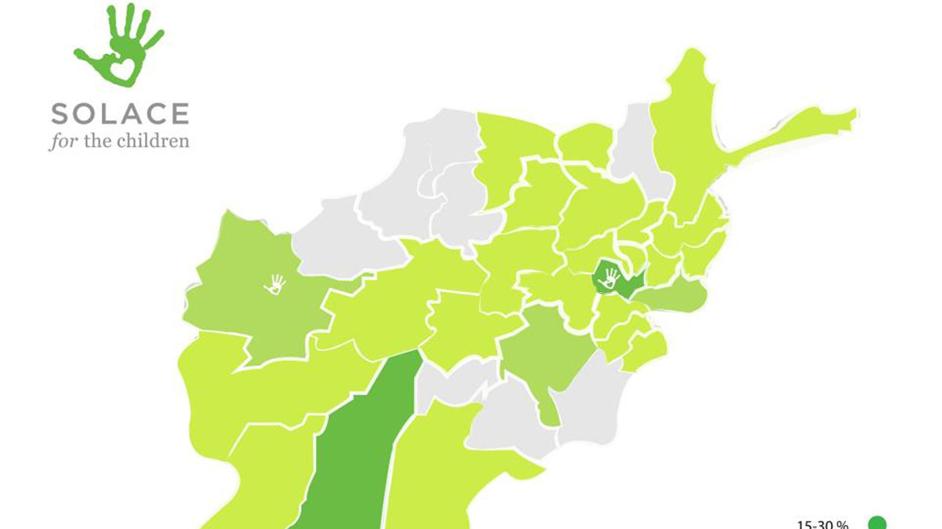
Starting as a small local organization in 1997 to help the children of the Chernobyl affected areas of Belarus. Eleven years after the disaster thousands of children continued to have serious health issues related to radiation levels higher than the Nagasaki and Hiroshima nuclear blast combined. The agency at first provided medical, dental, and optical care for the children that had been affected by the worst atomic power plant accident in history. Eventually the organization helped to support the National Cerebral Palsy Orphanage of Belarus providing humanitarian supplies such as clothing, blankets, and a modern dental clinic staffed by a trained hygienist.
Since administrations of the association were sought after in other area, in 2006 Solace for the Children started to divert its attention on the offspring of the world that are influenced by war. With more than 30 years of steady fighting Afghanistan has been called "the world's most unsafe spot to be conceived". A large number of kids had been slaughtered or severally harmed amid battling as of late however with 1 doctor for each 50,000 tenants medical care to kids was either rare on non-existence. Solace for the Children soon began plans for an international organization focused on providing that critical care. The agency developed relationships on the ground among the local population and the US military. A network was set up to transport patients and in 2007 the first children were brought to the US to receive treatment. Doctors and nurses volunteered their services. Host families were recruited as more funding became available. In 2011 staff was hired and an office was leased in Kabul for the day-to-day operations. Solace began to branch out in 2009 laying plans for an international organization focused on the children of Afghanistan. Currently, Solace operates programs in Charlotte, NC0.

