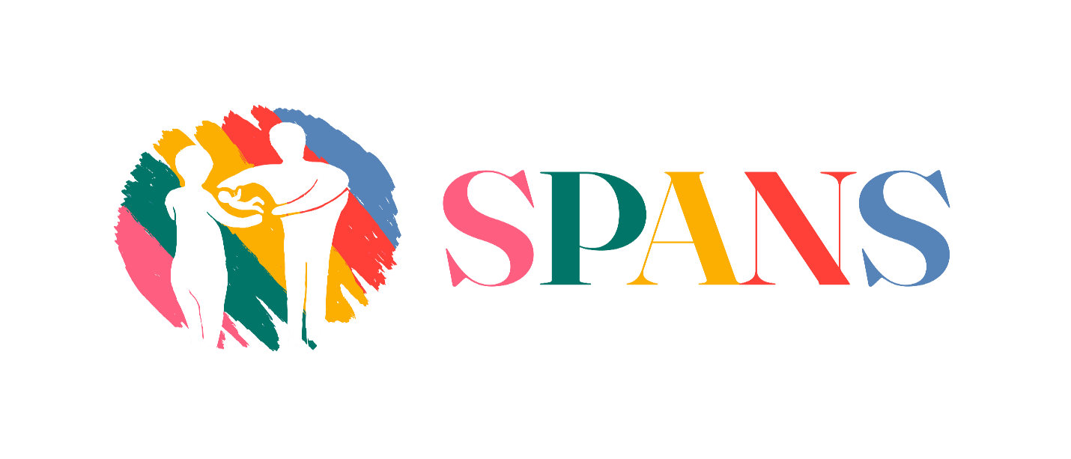
Society for Pre and Post Natal Services
PVO 12/15

COVID-19 AND COMMUNITY FAMILY MENTAL HEALTH
REPORT FEBRUARY, 2022

Introduction
On behalf of SPANS the leading organisation in Zimbabwe to promote sound mental health for all across the life cycle we write to give feedback on the programs that were funded by generous donors through our global giving page. We deeply appreciate and acknowledge their valuable precious financial resource to championing for enhancement of mental health care services which is an unmet service in our communities. Today we applaud their continued commitment to transform our community mental health care since there is no health without mental health.

SPANS being the national’s largest grassroots mental health organisation dedicated to promote sound mental health for the populace. SPANS is a voice for the youths, mothers, babies, fathers, and the whole family who are impacted by mental distress, mental health problems and mental illnesses. The SPANS team being committed citizens worked tirelessly during the entire COVID-19 responding to the mental distress, mental problems and mental disorders manifested before, during, and after the COVID-19 pandemic.
From March 2020 to February 2022, we reached to 50000 people with our COVID-19 community family mental health intervention strategies which are stated below with very limited funding.

Mental Health literacy/ Education sessions (ongoing)
As SPANS we noted that globally every nation is a developing country in mental health care services and we also noted that the first voice only focused on mental illnesses but not taking into consideration the three components of mental health which are, mental distress, mental health problems, mental health disorders and illnesses. The SPANS Mental health literacy and Education program has five components:
1) Understanding how local expressions of mental health problems 2) Understand how to optimize and maintain sound mental health 2) Understanding mental distress, mental problems and mental health disorders and their treatments 3) Decreasing Stigma 4) Enhancing help-seeking efficacy (knowing when and where to get help and having the skills necessary to promote community care and how to obtain good care)
During our day to day engagement with clients we noted the ignorance faced by many people on mental health care services. It is of great concern how most people were not aware of most of the issues that where affecting them. Most people were of the notion that mental health is associated with insanity, thus not being aware of the distinction between mental health and mental illness. This called for a massive reeducation and awareness which the SPANS team strived tirelessly to explain to the clientele during the educational sessions so that they understand the great needy for mental health care services.
Every weekday, Monday to Friday morning between 0730hrs and 0800hrs when both mothers and fathers who bring their babies for postnatal care visits start being attended by the clinical staff at the Primary Healthcare institution, SPANS Team members hold mental literacy/educational sessions with the parents on different subjects and topics which they encounter on a daily basis that may affect their mental health at home, at work or within their community. These discussions have proved to be helpful as witnessed by the positive responses by most of the parents. 2021 has seen an increase in the number of people who attend these Focus Group Discussions by 374% from the previous year. It also saw the initiation of these similar discussions in other 4 centres, Ruwa, Melfort, Caledonia and Chinyika Clinics.
Figures for Mental Health Literacy and Education at Ruwa clinic
Month | Number of mothers | Number of fathers | Total attendees for the month
January | 460 | 8 | 468
February | 500 | 12 | 512
March | 550 | 15 | 565
April | 700 | 10 | 710
May | 550 | 6 | 556
June | 400 | 7 | 407
July | 460 | 8 | 468
August | 550 | 6 | 556
September | 600 | 6 | 606
October | 700 | 16 | 716
November | 550 | 9 | 559
December | 400 | 9 | 409
Totals for the year 2021 | 6420mothers | 112 fathers | 6532parents

Figures for Mental Health Literacy and Education: Melfort, Caledonia, Chinyika
Month | Number of mothers | Number of fathers | Total attendees for the month
January | 1000 | 10 | 1110
February | 1200 | 15 | 1215
March | 1500 | 10 | 1510
April | 2000 | 05 | 2005
May | 1000 | 09 | 1009
June | 800 | 03 | 803
July | 900 | 05 | 905
August | 1200 | 10 | 1210
September | 2000 | 15 | 2015
October | 900 | 03 | 903
November | 1000 | 07 | 1007
December | 700 | 02 | 702
Totals for the year 2021 | 14200 | 94  fathers | 14294  Parents

Confidential Family Therapy Sessions
As indicated in SPANS’s MOU with the Republic of Zimbabwe represented by the Secretary for Health and Child Care, one of the organization’s responsibilities as articulated in the objectives being;
- to provide systemic family therapy and psychological support to the reproductive age group and to the whole community and
- SPANS therapists are therefore offering therapy sessions to community members who may have issues for which they need professional mental health assistance.
The organization is using a booking system in order to avoid congestion of clients awaiting counseling, and all necessary documentation, i.e.;
- Client Appointment Forms;
- Confidentiality Agreement and Consent Form for Family Therapy;
- Case Management Progress notes and
- Counseling service Feedback forms.
The team is working hands on in trying as much as possible to offer systematic professional counseling which involves a couple of sessions to ensure clients get quality professional therapy until their issues are resolved to the climax avoiding relapse or recurrence of the same issues or problems.
The team also makes use of fliers which they distribute to all community members who access the clinic and through community awareness.
Human resources practitioners are of the notion that people or human resource are at the center of the organization. This proved to be true as the beefing up of human resource by the engagement of social work interns especially from the Woman’s University in Africa, Great Zimbabwe University, Midlands State University, Reformed Church University, University of Zimbabwe just to mention a few psychologists, graduate social workers, development practitioners, media personnel, and student family therapists. This has helped the organization to be on the lead in offering and providing therapy sessions on a larger scale.
The mental health literacy and education sessions and focus group discussions strengthened the Health education program by the MoHCC that at every 15-30 minutes at every primary health care facility prior services provided it is necessary to provide Health Education. SPANS team is taking this opportunity to conduct mental health literacy and education. This helps the team to know that that parents and families have a lot of mental distress and mental health problems which need to be addressed which little professional interventions have been available. This little intervention is alleged and assumed to be due to the lack of information, shortages of mental health professionals, cultural and religious beliefs, just to mention but a few.
With intensive awareness promotion, as a result of mental health literacy and education sessions, focus group discussions and community awareness. The SPANS staff is experiencing a higher turnout of clients requiring therapy sessions in all of its four centers.

Mental Health States: Language Matters
As SPANS, during our mental literacy/education we realized that language matters by understanding three related components of mental health: mental distress, mental health problems and mental disorder.
The diagram above illustrates that mental distress are more common as indicated by the blue color on the diagram. Mental health problems follow with 25% whereas the least are mental disorders which were the main focus of the first voice
Covid-19 Community Family Mental Health Awareness Response
Continuing from where we left from in 2020, covid-19 proved that it was here to stay with us. We had to brace for the new normal. But the question was, was everyone ready for this new normal? The answer is, most people were not ready. What needed to be done was some serious education and awareness for people to understand the importance of taking the necessary measures and precautions so as to curb the spread of the virus. SPANS as a key partner with the MoHCC took it upon themselves to join hands with the Ministry in reaching out to the communities for COVID-19 education and awareness and also mental health awareness, as well as distributing PPEs.
High-risk behavior patterns such as non-use of face masks, non-observance of social distancing and lack of hand sanitizers at shop entrances were observed in the various communities visited and appropriate messages were disseminated, depending on the nature of risks observed.
The key messages were
- Unpacking the difference between mental health and mental illness;
- Calling for behavior change in the observance of COVID-19 rules and guidelines;
- Discouraging stigmatization of returnees and COVID-19 survivors;
- Alerting Health care personnel on the emergency Toll-free lines on noticing any suspicious symptoms on family members and/or neighbors;
- Confirming Returnee relatives have passed through the mandatory testing and quarantining;
- Emphasizing how strict observance of Preventative guidelines gives the community peace of mind and assurance of safety from infection and
- Maintaining of cordial neighborly relations and providing social support to one another during these trying times of the Covid-19 pandemic and its associated hardships.
Causes for concern
- Most adults observed at Solomio shops did not have face masks on;
- Very little evidence of sanitizing at shop entrances in both Solomio and Eastview;
- Totally no observance of social distancing at all shopping centres and
- Of the people encountered at Community water-points (boreholes) about 90% had no face masks and there was no observance of social distancing or sanitizing.
Common mental distress and mental health problems noticed to be most rampant in the communities included;
- Stress response: emotions/feelings (such as worrying, unhappiness, feeling energized, annoyance), cognitions/thinking (negative thoughts);
- physical symptoms (such as stomach aches and headaches, the stomach “butterflies”) and behaviors (such as avoidance of the situation, engagement of the challenge, positive energy, withdrawal from others, yelling at someone or helping someone);
- Some faced with these large stressors and experiences strong negative emotions (such as: sadness, grief, anger, demoralization, etc.);
- Some narrated that they experienced physical (for example: sleep problems, loss of energy, numerous aches and pains), and behavioral (for example: social withdrawal, avoidance of usual activities, angry outbursts, etc.);
- Some indicated that they experienced significant, substantial and persistent challenges with emotions/feelings (for example: Depression, panic attacks, overwhelming anxiety, etc.), cognition/thinking (delusions, disordered thoughts, hopelessness, suicidal thoughts, etc.)
- Post-Traumatic Stress Disorder;
- Other mental health problems and
- There was an interesting thing that we noted as SPANS that people can experience one or more mental health problems at the same time. A person can have good mental health and a mental illness concurrently.
All these issues proved that the pandemic has brought a mental pandemic which need to be addressed before it goes out of hand, thus the call for more mental health cadres.
