Summary
Le Tonle training guesthouse and restaurant is a social enterprise project of the Cambodian Rural Development Team (CRDT), a non-profit NGO in Cambodia). Le Tonle Training Guesthouse and Restaurant aims to provide free theoretical and practical training to young disadvantaged Cambodians in the area of tourism and hospitality such as front office, housekeeping, cooking, and hospitality. By providing these skills in the short term, vulnerable youths can obtain varied and worthwhile careers and can live by themselves independently and support their family by sending some of their earnings back home. In the long term, the training is providing an opportunity for youth to develop themselves further in tourism professions and giving them general knowledge, which will enable them to take careers as one of the country's human resources. This will help solve the human development program of Cambodia and lift the poverty rate in the future. According to the global Multidimensional Poverty Index (MPI) from 2018, thirty-five percent of Cambodians are living in poverty, especially in the countryside.

Our 8-month training program
Le Tonle training program is recognized by the Ministry of Tourism of Cambodia under the National Committees of Tourism Professional as the vocational certificate. Trainees are trained by our experienced trainers, many of whom were our graduates from 2008. Most of the training periods are focused on practicing and interacting with the tourism industry by supporting trainees to develop generic competencies such as computer skills and English proficiency.
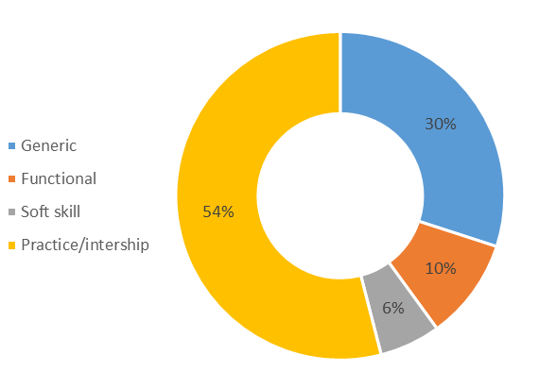

Progress report

We hope there will be no other time harder than this time!

The 20th of February 2021 was a nightmare for us as Cambodians and the team of Le Tonle. It was an event that we scare and don’t want to happen. Unfortunately, it is happening to us right now. The community spread of Covid019 is giving us even the harder time to fight with limited resources. Phnom Penh city is locking down and travel across provinces is banned. Tourism? Kind of dead at the moment including domestic. At the same, one of our landlords decided to increase the renting fee to 100% which is not an understandable decision making. This gives us no choice but to eliminate one of our buildings since we cannot afford it. The good news it will still want Le Tonle to restart after the pandemic and we thought more training regarding technology will be included in the training to respond to the Cambodia industry 4.0 era (technology skills). Therefore, we are keeping the reputation alive and maintain one staff to do all of this work.

Our current biggest challenges
1- We need to re-strategize Le Tonle. However, we have no capacity in doing this.
2- Need to find a way to respond if covid-19 is not ending in the 6 months as it might the end of our reserve resource

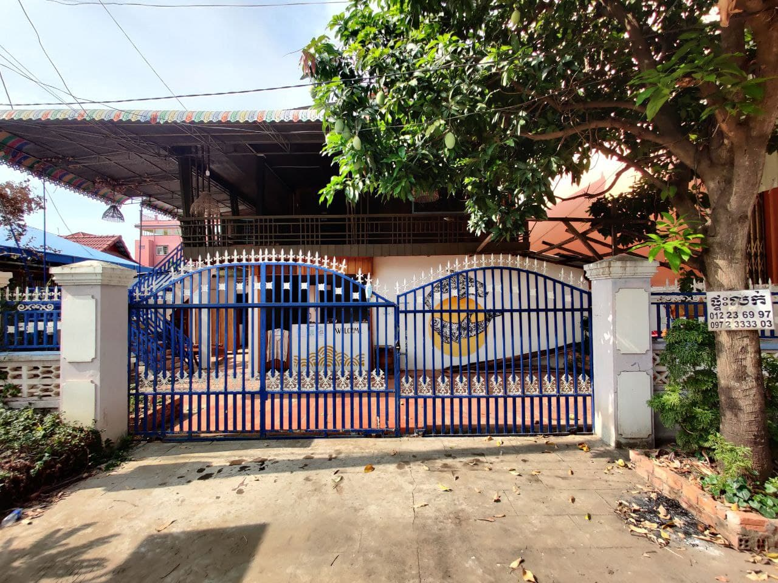
One of our building that give back to owner since we can’t afford the rent
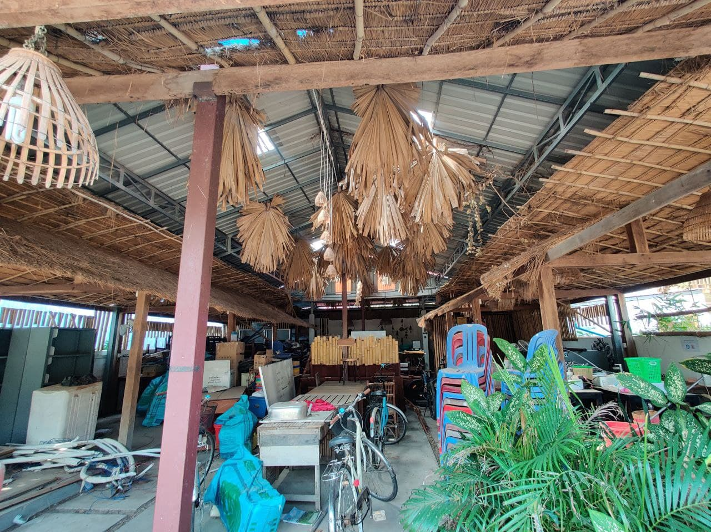
Our restaurant is now our store room
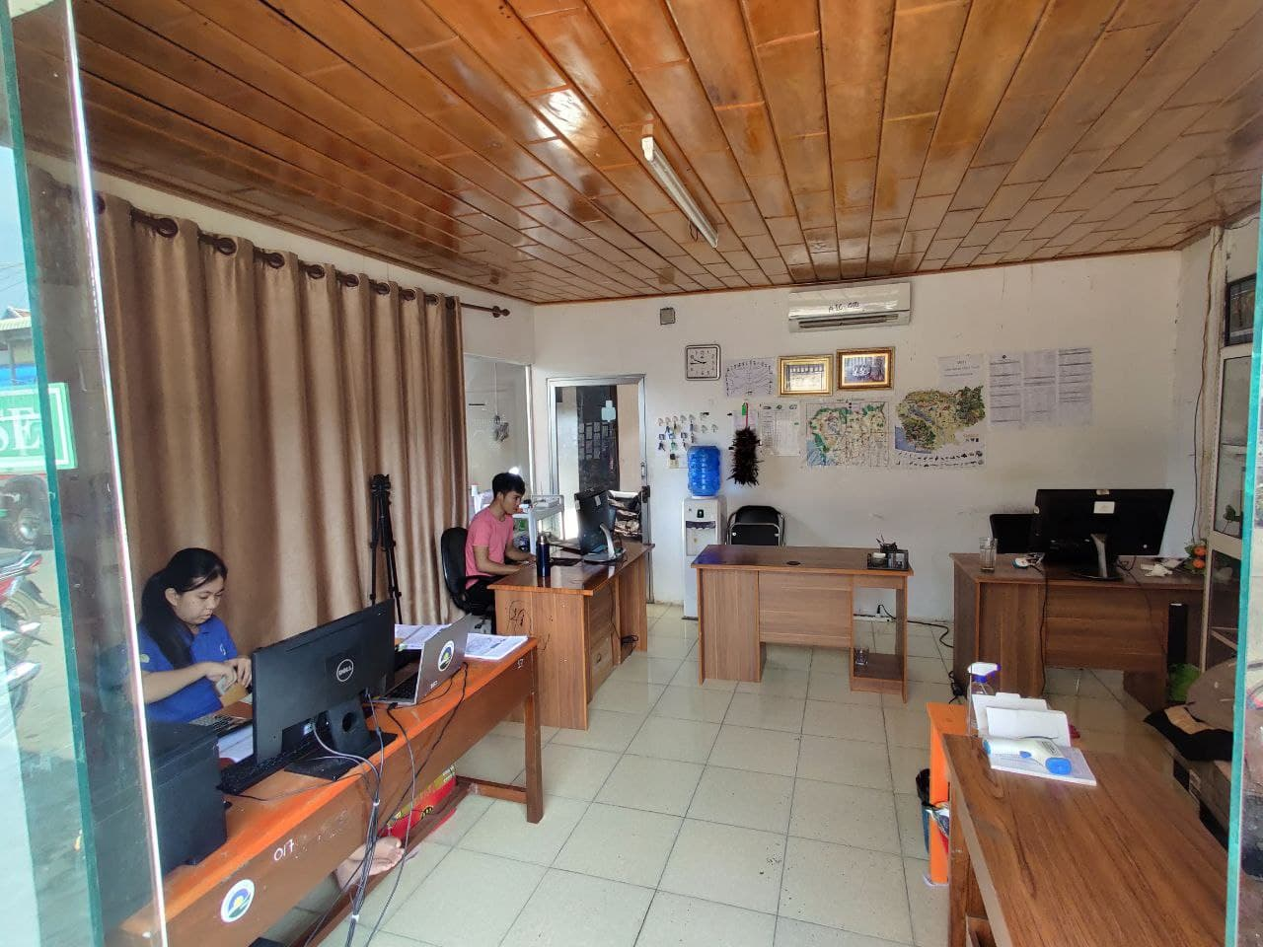
Our 5 team members,
2 are working from home

