January 2022 Report

Topic Gender with homeless youth people
In November 4th, ednica´s crew work with adolescents and homeless youth people of the Morelo´s community center, the topic in that session was gender, in specific the subjetc related to stereotyped roles for men and women.
The session was called "productive and reproductive work" in which the following activities were carried out; First of all, a small talk was held on the concepts of productivity and reproductivity, the young people were asked what they understood when these words were mentioned to them.

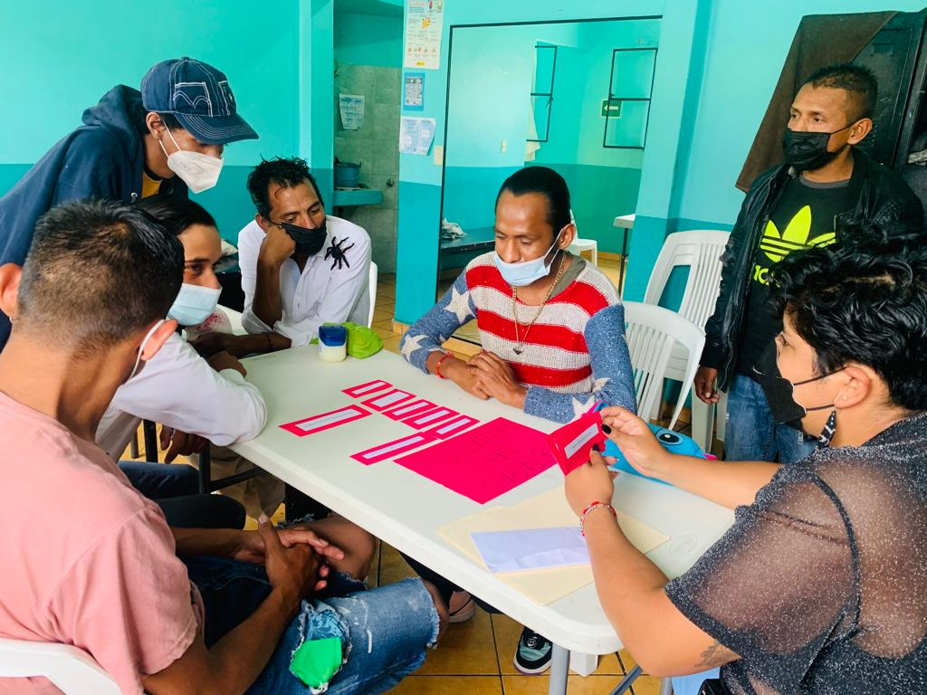

After this, the explanation of what these concepts mean within gender equality was made. Productive work refers to the tasks given by society to the male gender and has to do with the belief that men are the providers and are the ones who work to produce in economic terms.

On the other hand, the reproductive work is given to the woman because she will be in charge of procreating and taking care of the upbringing of the sons and daughters. They were questioned as to whether these positions are currently being replicated; if this distribution of tasks due to gender seems good or bad and if they continue to have these ideas in current life.

Subsequently, an analysis was made of a magazine where the example of these concepts was clearly shown and how some gender stereotypes occur even in the media such as television, magazines, etc.
.

Emotional health. Identification and recognition of emotions.
On the last months, the work with homeless youth people was about .
In the Ajusco´s community center had sessions with young people who live on the streets and they were asked which emotions they know, which they have experienced and in what situations. Each of the responses was discussed and reflected.
To reinforce the activity, the educator used the material from Cuidarte A.C's “Box of emotions”; The young people were shown the emotions and asked if they knew and had experienced them. The emotions that the educator did not know were explained to them.
At the end, the educator emphasized the importance of knowing and recognizing emotions.
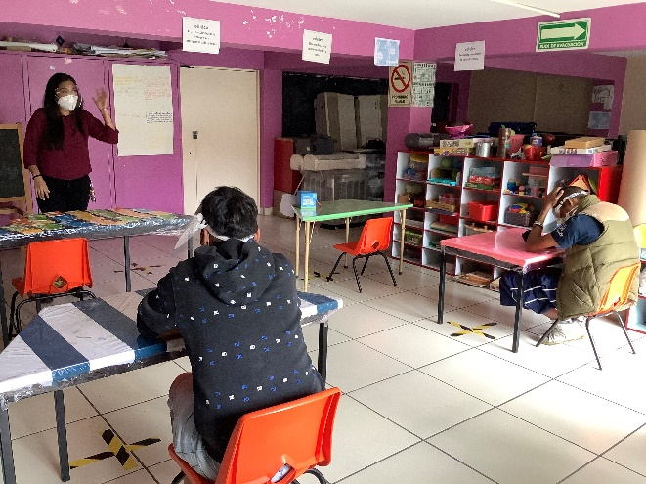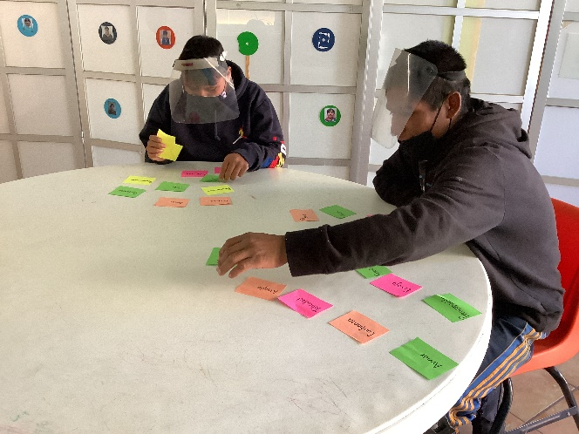
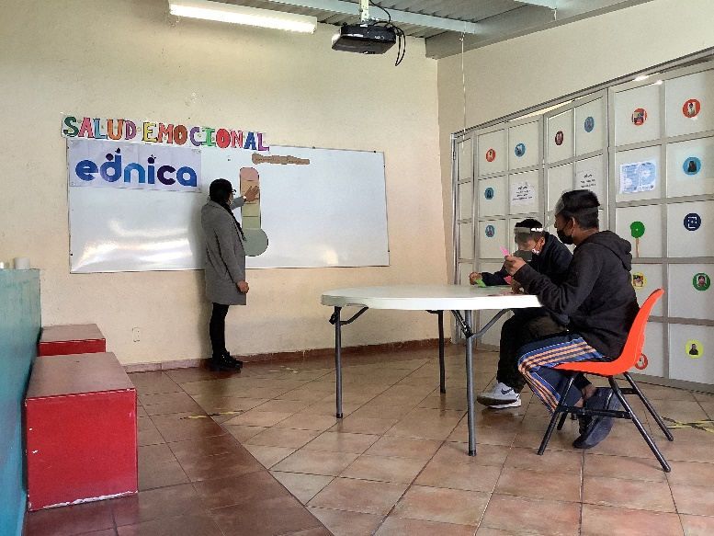

Health Fair and the Covid-19 vaccine
In November we had a Health Fair which the Covid-19 vaccine was applied for homeless youth people and they had a general diagnosis of their health was made that included measurements of: weight, height, body mass index, temperature, blood glucose, oxygenation level, grip strength and blood pressure.
