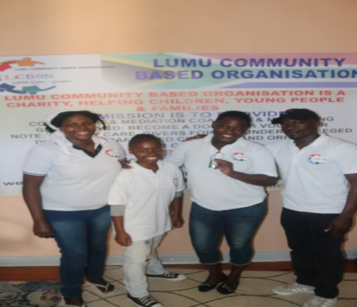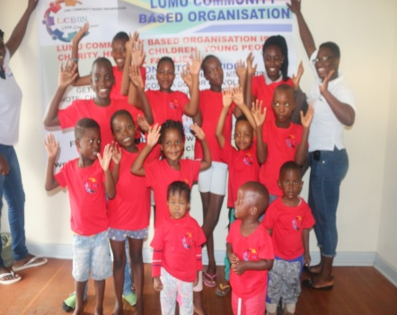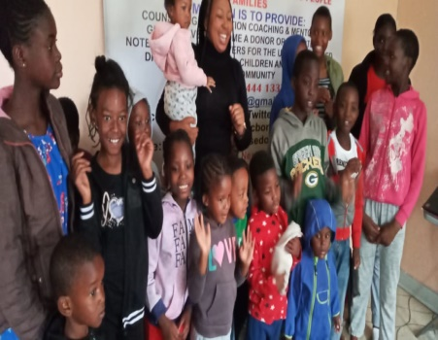
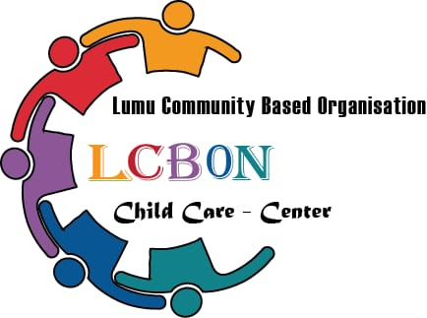

Organisation profile 2020

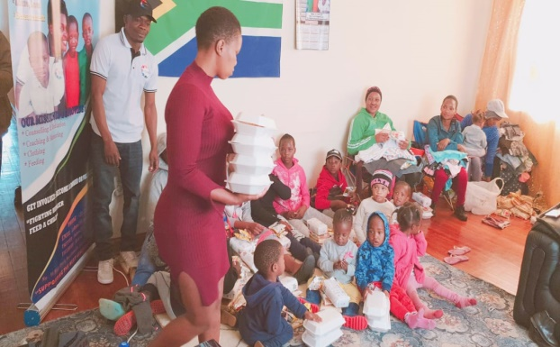

WHAT IS LUMU COMMUNITY BASED ORGANISATION
Lumu community based organization is dedicated to supporting children in South Africa. Founded and operated by Samuel Lumu, who saw the plight of underprivileged in his area and decided to do something about it, Lumu community based organization promises a long-term investment in the futures of the children for which it cares. More than a home, Lumu community based organization will strive to prepare children to be self-sufficient through academic and vocational training, and will give them a strong foundation in the Christian faith. It will also act as a community development center, training and employing community members while providing a focal point for community interaction and development.

WHAT MAKES US DIFFERRENT
- We are relentlessly committed to taking full responsibility and providing excellence in every project and endeavor
- We pride ourselves in taking on big challenges and seeing them through.
Mission Statement:

Our mission is to take maximum care of disadvantaged children in Johannesburg By providing help through donors and volunteers we shall be able to create a 4th generation of educated children that will spring up the future and responsible leaders of our society.

Aims and Objectives:
The project is specifically aimed at helping young children realize their potential. When children are empowered through education, they have the knowledge and skills to advocate for themselves and their communities, accomplish their goals and live healthier and more fulfilled lives.

MEET THE TEAM
Chairperson
Miss Zandile Ngcongolo
Vice Chairperson
Mr. Eric Khetho

Secretary
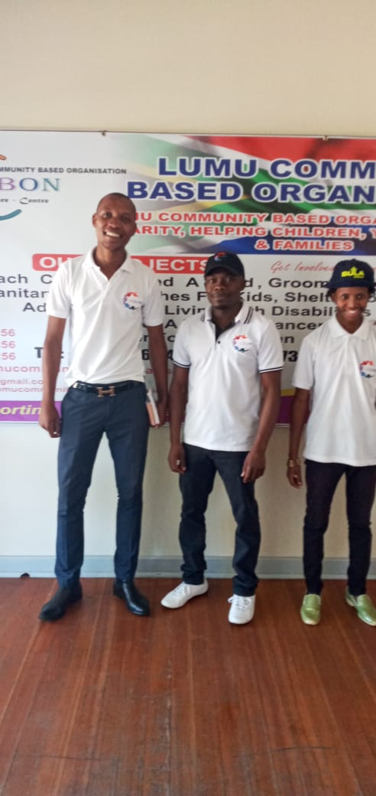
Founder, Executive Director
Mr. Samuel R Lumu

Social Worker, Associate Director
Miss Relivance Muzivi

Treasure
Mr. Thando Mfincane Gidion

Miss Kgadi Mashiane

Board Members
Miss Doreen Amazu
Mr. Shafik Mukwaya
Mr. Isma Ssekimwanyi
Marketing director
Mr. Denis Kato

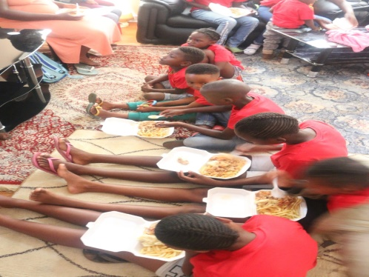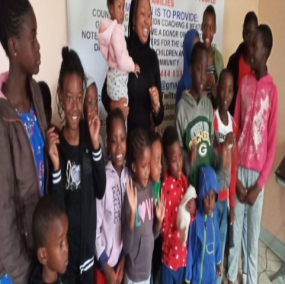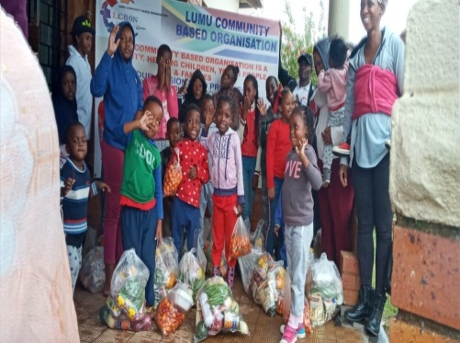

CONTACT DETAILS
Lumu Community Based Organisation NPO 232-713
184 Church St, Turffontein, Johannesburg South, Gauteng, South Africa
FACEBOOK: https://www.facebook.com/lumucommunitybasedorganisation\
WEBSITE : https://lumucommunitybasedorganisation.com
EMAIL : Lcbon256@gmail.com
PHONE : +27 11 436 9474
CELL : +27 73 444 1337

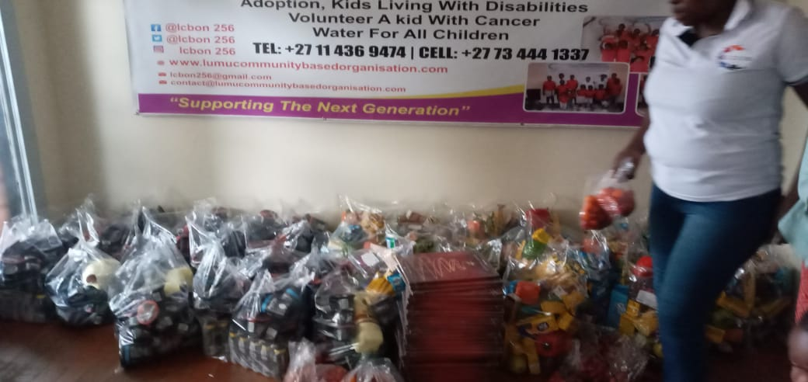

The picture above is the illustration of the food parcels that we give to our beneficiaries. The food parcel consists of vegetables and other items that kids can take to crèche.
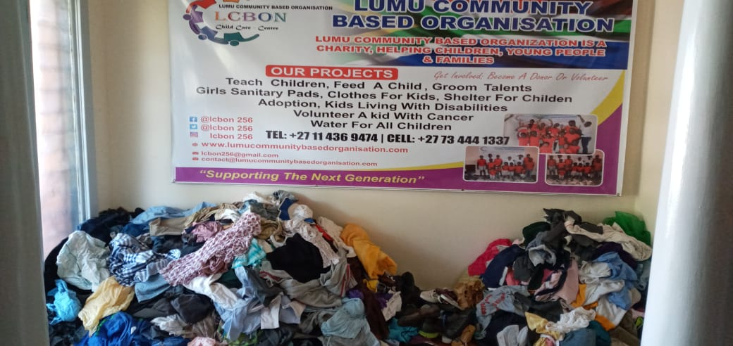

OUR PROJECTS:
- Feed a child
- Groom talent
- Girl’s sanitary pads
- Clothes for kids
- Shelter for children
- Adoption, trafficked children
- Kids living with disability, orphanage
- Kids with cancer
- Counseling, mentoring, mediation and coaching

