

**School Holidays Programme 2019**

**Programme Report**

**Background and Rationale**

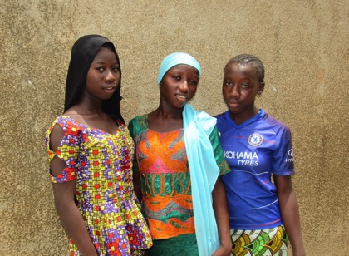School holidays are a joyous time during which children hope to be free to play as much as they want. In Senegal, a child’s desire for free time to play is often stifled due to economic reasons. Children often spend their summer holidays working with their families in agricultural activities to help them earn more money. The Grandmother Project school holiday programme is an excellent way to educate the community about the rights and responsibilities of children, especially in rural areas, whilst offering children a programme of activities to enrich their summer holidays with fun and exciting games and opportunities to learn about their community and culture.

*"During the rainy season when children are out of school for the holidays, we often have very strained relationships with children because of their reluctance to go to the field every day. This program helps us to amuse them in the village and also work together in the fields.”*

Meta Baldé grandmother in Saré Sancoulé

**Introduction**

During the period from 17 August 2019 to 25 September 2019, a ten-day holiday programme focused on the integration of cultural values ​​in school took place in 27 sites. Thirty-two teachers facilitated the activities, with the assistance of numerous elders (grandmothers and grandfathers) in the following villages: Nemataba, Wélia Siby, Saré Sancoulé, Coutoucounda, Koumera, Bakayoko, Saré Yira, Diamwély Yéro, Saré Mbirou, Mankacounda, Saré Nagué, Sinthiang Afia, Nassouroulaye, Thiankan, Sinthiang Saby, Kéréwane, Lambatara, Saré Samba Netty, Sare Thierno Bassy, ​​Kandia, Medina Adja, Kael Bessel, Djidda Modou, Dialaka, Medina Diambere and Doubirou; in the communes of Némataba, Kandia and Vélingara.

**Purpose of the summer holiday programme:**

➢ To strengthen collaboration between the school and the community for the development and well-being of children.

Objectives of the summer holiday programme:

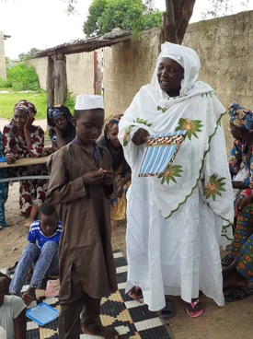➢ Increase children's knowledge of local cultural values ​​and traditions.

➢ To stimulate reflection among community actors on the importance of revitalizing and transmitting positive cultural traditions and values.

➢ Strengthen relationships between elders and teachers.

➢ Improve students' speaking and reading skills through the use of reading booklets, stories-without-an-ending and traditional stories.

➢ Give children opportunities for play and discovery

*“If we had this programme every year, I think that no child would want to leave the community for the summer holidays. We would be content to stay in the village and help our parents working in the fields, knowing that in the evening we can have fun and learn with the grandmothers.”*

Rougui Baldé, girl student, Mankacounda village

**Community Participation in School Vacation Activities**

The school holiday programme organized by GMP offers both children and other members of the community an opportunity to reflect on their culture, history and the needs of the community – especially the needs of children. Members from all groups in the community were invited and participated: young, old, men, women, mothers and fathers, elders and village leaders. Culture, tradition and community history are a focus of the programme activities, as are the importance of elders, strengthening intergenerational relationships and the rights and responsibilities of children in the community. A total of 11,046 people participated in the activities. As you can see in the table below, there was significant representation of all age and gender groups.

|  |  |  |  |  |  |  |  |
| --- | --- | --- | --- | --- | --- | --- | --- |
| **All sites/villages**  **involved** | **Grand- mothers** | **Mothers** | **Community**  **Leaders** | **Fathers** | **Children** | | **Total** |
| Boys | Girls |  |
| **Total:** | **1,155** | **1,163** | **593** | **758** | **3,529** | **3,848** | **11,046** |

All of the activities are facilitated by a teacher and assisted by elders (grandmothers and grandfathers) from the villages. The activities have had a lot of positive effects on both the children and the communities. The main components of the school holiday programme are the following:

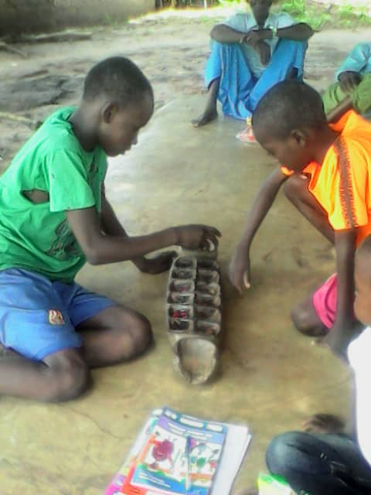• *The presentation and discussion of the 5 reading booklets:* with the assistance of elders as a resource, these sessions not only helped to reinforce the children's knowledge of their traditions, but aided in establishing a climate of trust and improved collaboration between the teachers, elders and children in the village. Students' reading and speaking skills improved, as did children’s self-confidence. The frequency with which students, especially girls, volunteered to read a booklet or to tell a story in public increased greatly. *"Before, I had trouble speaking in front of many people, but with the holiday programme, I got used to telling stories and riddles in front of my friends and even the elders. "* Sadio Barry, girl student  
• *The village's history:* This session allowed children, and even some adults, to discover the history of their village and school.

• *The use of stories-without-an-ending:* this very useful tool sparks dialogue and reflection around topics such as corporal punishment, teen pregnancy the importance of storytelling.

• *The traditional games “About Us”, cooki and wori*: the use of these collaborative games allowed the children to discuss with each other and to develop team spirit (think together as a group).

• *Visit an Elder*: Visiting with an elder not only helps to value grandmothers and grandfathers, but also builds trust and bridges the gap between children and elders.

• *The guessing game*: This game allows children to act like researchers while working together with elders to look for good riddles and find the answers to them – all in the search of the best riddles. This search for riddles has not only improved relationships between children and elders, but together with help from some of the teachers, has also created a “riddle bank”.

•*Traditional marriage:* This session focuses on the historical and cultural significance of the traditional marriage ceremony in local culture.

*"With this session, I realized that before there was more solidarity and less spending during ceremonies in the village. Today, we have adopted foreign practices so much that we disagree with each other and spend too much on weddings."*

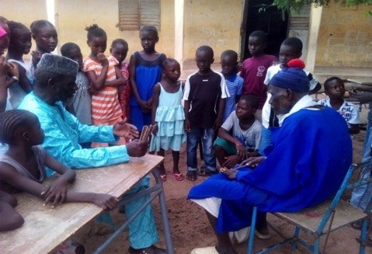Fatoumata Danso, young woman, Saré Mbirou

• *The breeding of yesterday (Mondé):* This session allowed the children to discover the traditional system of cattle deworming and the solidarity that it creates.

• Collective gardening *(the Maarou):* This session talked about the social aspects for both families and community members of collective gardening.

*Elders explain a traditional game to children.*

*"Today we have no real families; we have siblings who have only agreed to live in the same compound without any collaboration between them. Collective gardening that we did in the past has disappeared. It was a good example of solidarity, communication and mutual love. "*

Abdourahmane Barry, Imam, Némataba

**Sample School Holidays Programme – 2019**

Below is a program of the events that took place over the 10-day period:

**DAY 1:** Presentation of the reading book on the role of elders: The book and the different roles played by elders are discussed and includes the participation of grandmothers. This activity is an opportunity to create a collaborative atmosphere between the teachers, children and the elders (grandmothers). Activities include: stories-without-an-ending, presentation of the book on important African values, highlighting the importance of respecting elders, and discussion of on the history of the village.

**DAY 2:** Presentation of the history of the village, developed together the previous day. Presentation of a story that talks about solidarity and presentation of a session on the traditional marriage ceremony. Children are also informed about the storytelling contest that will take place on day 10.

**DAY 3:** Presentation of a session on the traditional marriage ceremony and two sessions on the content of the books on African proverbs and values.

**DAY 4:** Discussion of the book on children’s responsibilities and rights. There is lively discussion during each session, but particularly when participants are asked to choose the most important child rights and responsibilities.

**DAY 5:** "Who are We" game to discuss the relevance of traditional cultural values to children’s lives, with further discussion on the books on African values and proverbs. The session includes a visit with a grandmother who tells a traditional story.

**DAY 6:** Continuation of the session on traditional breeding practices, plus riddles & logic games.

**DAY 7:** Activity: Stories-without-an-ending on corporal punishment, presentation of the values booklet, visit to the village chief or other community leader to identify the various responsibilities and rights of the children. “Who are We?” game.

**DAY 8:** Traditional games and the “Who are We?” game. Preparation for the traditional game "MAAROU"

**DAY 9:** Review of what was learned from the “Who are We?” game played the previous day. Explanation of the riddle and storytelling contest that will take place the final day.

**DAY 10:** - Grandmothers and grandfathers tell stories before the riddle contest. Storytelling contest is held to choose the best storyteller and prizes are given out.

**Evaluation of the 2019 School Holidays Programme**

The school holidays programme for 2019 overall was successful. We would like to point out specific programme strengths and areas in which improvement is needed.

*Programme Strengths*

This year there was in increase in the number of villages that participated in the school holidays programme, which was due to the fact that GMP provided some of its own resources, along with those of our primary funder, to expand the programme. There was excellent participation from the grandmothers and the teachers were very enthusiastic and made themselves available. The preparation of the teachers was completed in two days and there were materials available for all participants in the program. Thanks to the availability of gifts for the best storytellers (school supplies), many children were able to get their school supplies for the new school year, which was a financial relief for many parents. And finally, the program offered teachers the opportunity to communicate with communities about classroom readiness. Because of this, grandmothers mobilized the communities to clean the classrooms and weed the school gardens before the start of the school year.

**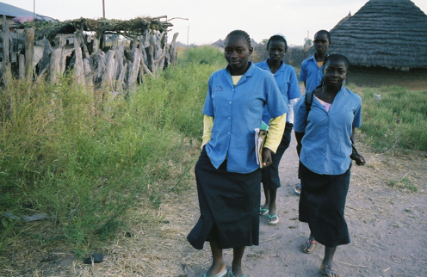***Program Points of Improvement*

In some communities where few elders participated in the activities, in the future grandmothers should be asked to mobilize them to ensure their participation. A need to develop a monitoring and evaluation tool was also identified, as was the need to determine which interviews to do ahead of time and whom to interview.