**Summary: Vulnerable children and their families are more exposed to the impact to the COVID-19 crisis than others. SOS Children’s Villages Bulgaria work with the most vulnerable and need the support of donors for purchasing of disinfection and sanitation supplies, face protection masks, computers and digital tools for home schooling of children and young people, materials and services for organizing workshops in small groups and entertainment activities for children, employment of additional caregivers to increase capacity of providing care during period when children do not attend school and co-workers might be in quarantine, for preventing „care gap” i.e. continuing quality care despite of the significant decrease in donated funds.**

**Vulnerable children and their families are more exposed to the impact to the COVID-19 crisis than others. SOS Children’s Villages Bulgaria work with the most vulnerable.**

The rapid spread of the COVID-19 virus has led authorities to take necessary measures to ensure citizens’ health and safety. SOS Children’s Villages’ staff is committed to take all possible steps to protect children and assist families in vulnerable situations and calls on authorities, care providers and communities to carefully monitor the situation, and act to guarantee every child’s protection and care.

Although children are generally affected at a lower rate by the virus, according to the latest medical research, authorities, caregivers, organisations and the community need to be vigilant to avoid that the current situation leads to child rights violations and long-lasting trauma for them.​

Children and young people who live in circumstances where they risk neglect, abuse, abandonment, exploitation and discrimination might face additional risks if care, support and monitoring by care professionals and social workers is restricted due to the coronavirus emergency. ​Moreover, children and families who face social exclusion and discrimination, live in overcrowded and unsanitary environments or have pre-existing health conditions.

​The general feeling of insecurity and instability due to changing daily routines and measures caused by COVID-19 response measures affects children and causes increased distress, especially for those who have experienced neglect, abandonment, abuse and exploitation.

How life has changed in the Bulgarian SOS programs?​ Taking measures all the time. Constant monitoring of the health of the caregivers. All staff members have responsibly limited their contacts with the outside world. In case children and young people show symptoms of the virus, physicians and pediatricians need to be contacted. Special attention goes to children and teenagers with special needs who have fragile health and specific health issues. The workload is to the maximum level day and night.

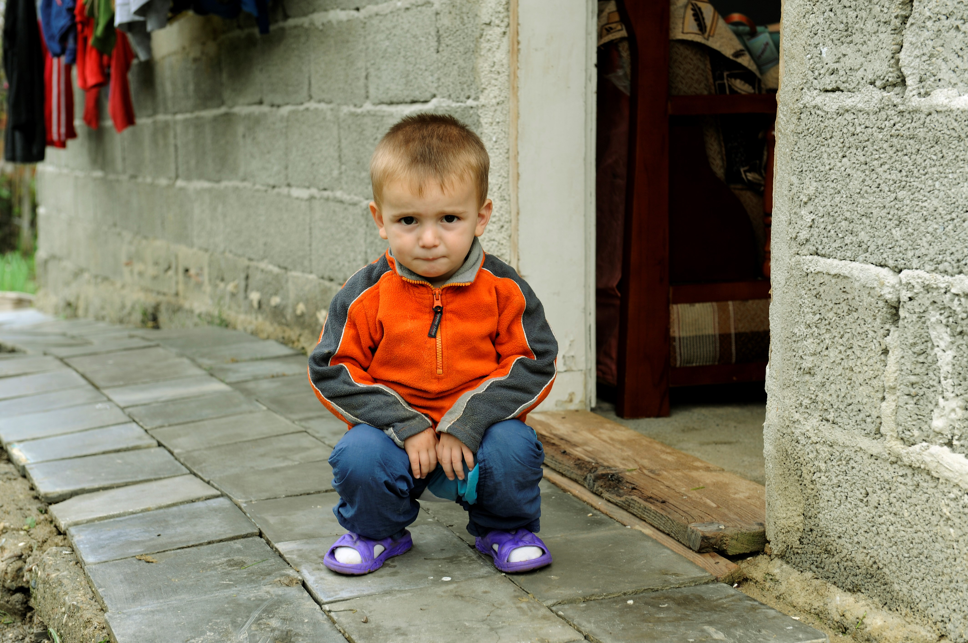

**SOS Children’s Villages Bulgaria take the following preventive measures:**

* Increased hygiene measures ​- regular aerating of rooms, regular washing of hands, regular cleaning of surfaces in the premises
* Only virtual contact: nobody goes in or out. No visitors, meetings between minors and their families have been suspended and are exclusively held by video calls, children and teenagers are not leaving the SOS Programs, etc.​
* Special attention to educational and psychological support. Raising awareness and educating children and young people about the rules to protect their own health​

**Mental health and psycho-social aspects ​of the crisis situation at SOS programs​**

Children and teenagers living in SOS programs feel generally safe thanks to the constant information and support they are receiving. ​

It is more complicated for younger children to understand and accept the situation. They may protest to staying in the house. Their frustration is understandable and we try to make them realize the importance of following the rules. ​

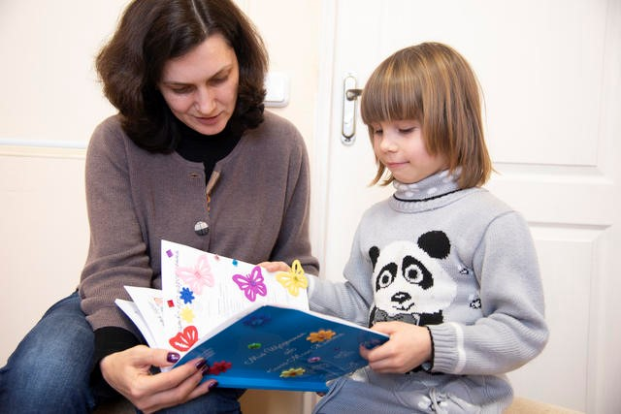

​

Children miss their parents. They might be scared about what is going to happen to their families of origin during the emergency situation. This kind of distress and grief or children needs to be addressed. ​

​

Children and teenagers are missing their daily routine, their everyday life, even going to school. They miss their friends and teachers.  ​

​

During an emergency situation children might show changes in wellbeing and behavior like clinging to caregivers, anxiety, withdrawal, agitation, nightmares, etc. ​

The wellbeing and mental health of children needs to be addressed in preventive manner.​

Children need special support to cope and feel safe.  Our experts work with children, families and communities to reduce stress and anxiety.

**What additional financial resources do SOS Children’s Villages Bulgaria need for in a time of crisis?**

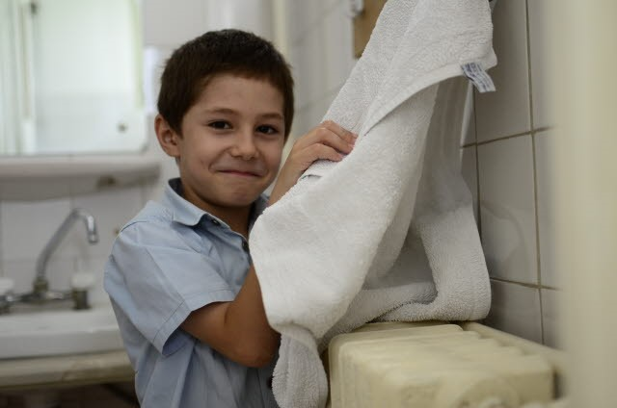

* For purchasing of disinfection and sanitation supplies, e.g. hand gels, products to disinfect surfaces
* For purchasing of face protection masks recommended by authorities
* For purchasing of computers and other digital tools that are needed for home schooling of children and young people
* For purchasing of materials and services for organizing workshops in small groups and

entertainment activities for children

* For employment of additional caregivers to increase capacity of providing care during period when children do not attend school and co-workers might be in quarantine.
* For preventing „care gap” i.e. continuing quality care despite of the significant decrease in donated funds

**What SOS guarantees:**

* holistic approach covered by a variety of programs
* international coverage and experience-share
* non-religious and non-political approach
* professional colleagues who understand business
* variety of programs, local flexibility
* tangible USP and 70 years of track record