KATALEMWA CHESHIRE HOME FOR REHABILITATION SERVICES
REPORT ABOUT THE INTERNATIONAL SPINA BIFIDA AND HYDROCEPHALUS DAY HELD ON THE 24TH OCTOBER AT HOTEL AFRICANA
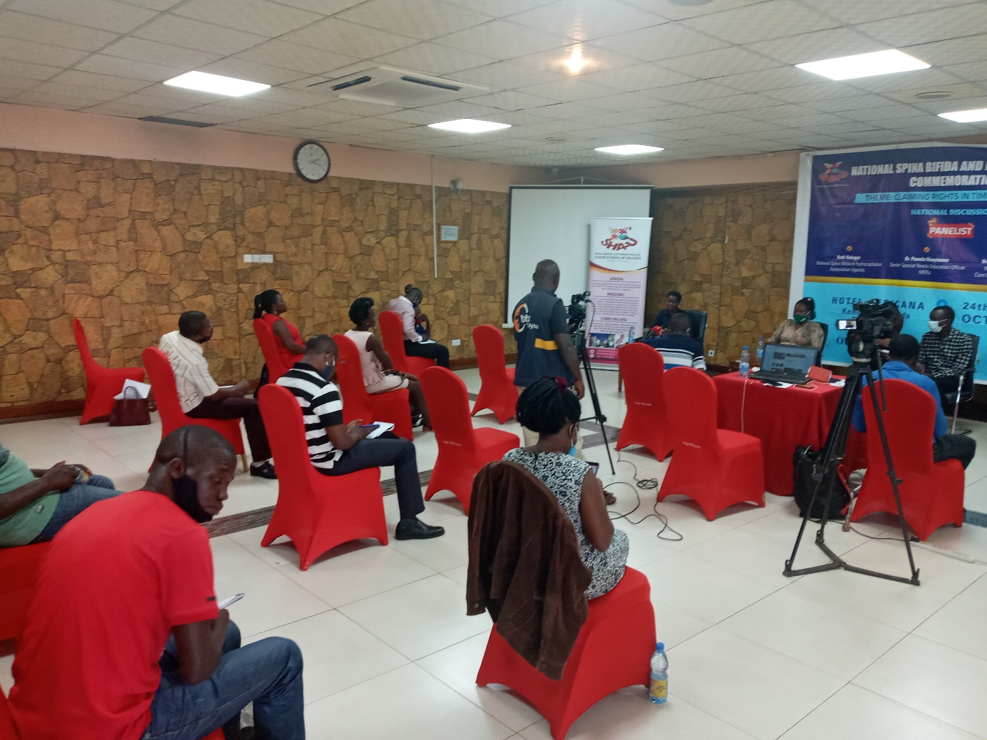
Katalemwa Cheshire Home was represented at the celebration of the International Spina bifida and Hydrocephalus day that was conducted in a scientific manner at Hotel Africana on the 24th October 2020 from 11:00am to 1:00pm. Due to the COVID 19 pandemic, we were unable to conduct the usual communal celebration and we opted for a Webinar that streamed live on the different social media pages, Zoom and it aired on some media houses. This celebration was organized in collaboration with the National Association of parents of children with Spina Bifida and hydrocephalus, CURE Hospital in Mbale and the Ministry of Health and below are some of the activities that were held on the day on that Day

Webinar
We organized a panel of 4 representatives from the National Association of parents of children with spina bifida and hydrocephalus, The Uganda Consumers association, a Doctor from Cure Hospital Uganda and a representative from the special needs department Ministry of Education and Sports. These deliberated on causes, identification and management of Spina Bifida and hydrocephalus, the impact of COVID 19 pandemic on children with spina bifida and hydrocephalus, the fortification of foods rich in folic Acid and Inclusive Education. The theme for the day was “CLAIMING RIGHTS IN TIMES OF COVID-19”
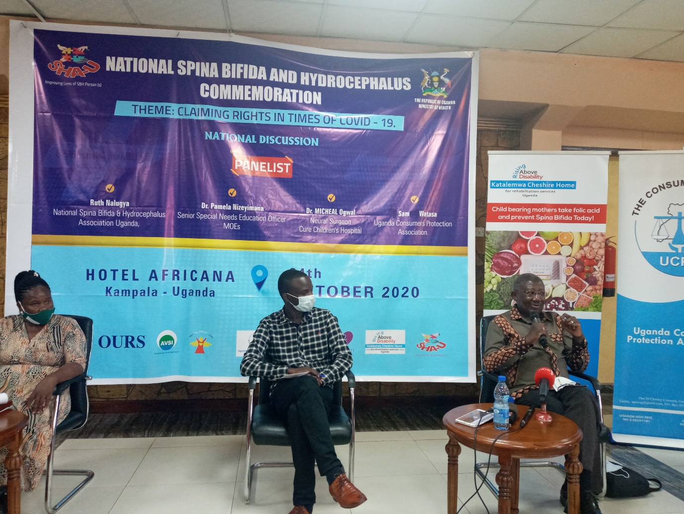
Some of the panelists at the International Spina Bifida and Hydrocephalus day
Press conference.
A number of media houses were represented at the E conference these covered the proceedings of the webinar and Katalemwa facilitated 4 media personals from print and radio. However, our partner organization invited more media houses like NTV, NBS, New Vision and online reporters to cover the event.
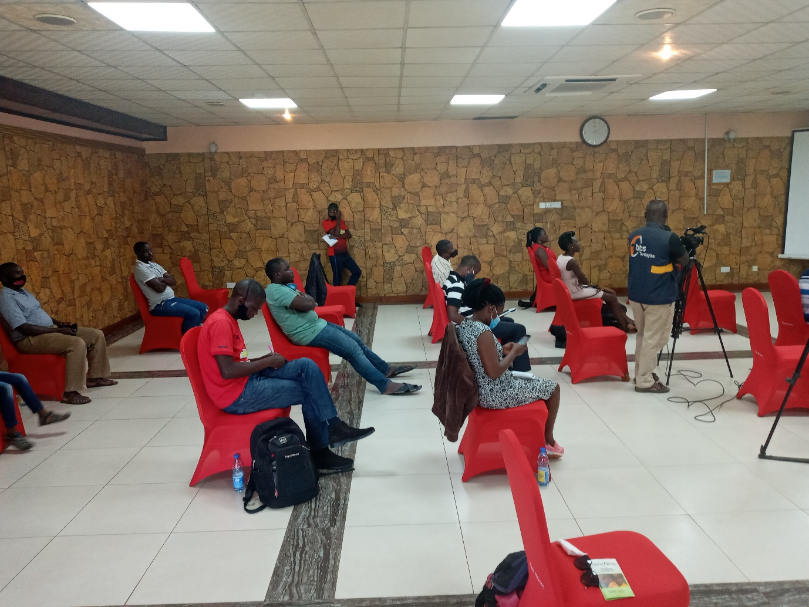The different media houses present
Inconclusion its was a fruitful deliberation, media presence gave the event good publicity and we hope that rights bearers will address plight of children with spina Bifida and hydrocephalus during the COVID-19 pandemic.

Compiled by

Namudope Barbara
Advocacy and Networking Officer

