A report about the Status quo of Katalemwa Cheshire Home during the COVID-19 era
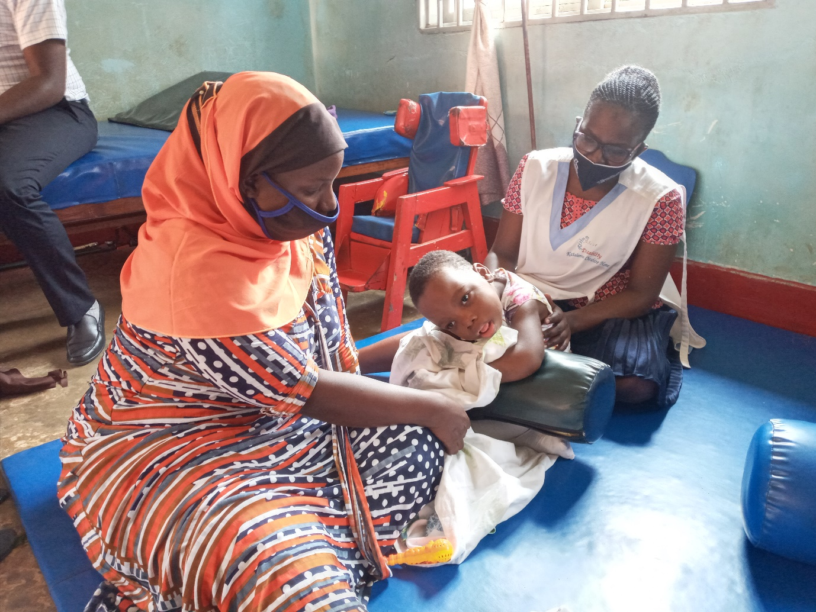
Brief background about Katalemwa
Katalemwa Cheshire Home (KCH) is a development non-government organization in Uganda involved in the rehabilitation process of children with disabilities and fulfillment of rights since 1970. KCH’s mandate is to rehabilitate children between the ages of 0-18 years and to offer support to their families in developing their potential to address the underlying causes and challenges of disability. We rehabilitate over 15,000 children annually with physical, mental psychological and neurological challenges. KCH programmes focus on medical and social rehabilitation, production of assistive devices, promotion of quality inclusive education and livelihoods programs to enable CWDs live independent and meaningful lives.
The Main activities of Katalemwa
Medical rehabilitation; KCH provides comprehensive quality medical rehabilitation to children with disabilities at the centre and in the community. We provide physiotherapy, occupational therapy, nutritional therapy, speech therapy, mental health care and have an early learning center that trains children with learning challenges in activities of daily living.
Assistive device production (disability appliances); We design, fabricate and fit tailor- made appliances and aids for person with disabilities. A wide number of appliances are produced mainly using locally available raw materials and appropriate technology.
Community Based Inclusive development (CBID); KCH uses the CBID approach to take services nearer to children with disabilities and empowers communities to take responsibility of rehabilitating these children.
Child empowerment (Educational support); KCH recognizes that education is vital to the transformation of any community and that quality education is every child’s right. Inclusive education creates a platform for the needs of children with disabilities to be identified and addressed.
Livelihood and socio- economic development; This programme exists to improve on the socio-economic status of CWDs and their families through imparting practical skills like training caregivers in entrepreneurial skills, VSLA group formation, craft making trainings to enable them generate household income.
Advocacy and Networking; KCH advocates for the plight of children with disabilities to reduce stigma and discrimination of these children. We work closely with right’s holders to advance different causes that affect our CWDS and stakeholder ranging from civil society, companies, individual to support our children with disabilities.
What changed during the COVID-19 pandemic;
- Our community outreach clinics were halted because they involve mass gathering which makes it a threat to the spread of COVID-19. This has affected many children with disabilities that are unable to reach out to our center. And some center-based clinics have been suspended because they bring together many children i.e. neurological clinics.
- Livelihood trainings are currently designed for a few people because social distancing measures have to be observed.
- As schools have been closed for almost four months now, our education programme has also been on halt and we are embarking on distributing learning materials for our beneficiaries to learn from home.
- With Advocacy, we have been using social media to advocate for the plight of children with disabilities and our advocacy team participates in networking meetings most especially online and in mini sized meetings.
Challenges
- The number of children with disabilities accessing our services have reduced because of the economic situation in the country due to prolonged lockdowns, hiked public transport costs and as a result some children have retarded.
- Limited orders for assistive devices at our orthopedic workshop which has affected our income to support running projects
Way forward
- Katalemwa is embarking on strengthening the home-based care function so as to reach out to more children with disabilities in the community.
- We currently need funds to support affected families with startup kits, business boasts to improve on incomes for families of children with disabilities
- KCH is now designing activities that involve less people as we observe the social distancing measures to limit the spread of COVID-19.

Conclusion
Katalemwa is working tirelessly to extend medical rehabilitation services to the most vulnerable children with disabilities in accordance with the standard operating guidelines during this COVID-19 pandemic, however it’s a costly venture that’s why we need donors to support our cause and bring a smile to vulnerable children with disabilities in Uganda
Compiled by
Namudope Barbara
Program Leader

