About Ashray
Ashray Social Welfare Foundation is a Non-Government Organization rooted on philanthropic values for the empowerment of the people in the underserved rural areas. The efforts are directed in providing the vulnerable sections of the society a respectable life without having to migrate to urban areas in search of livelihood. Our role is to act as a catalyst to channelize and fine tune the local skills and potential available in the rural sectors, redefine them to make them self-reliant and self-sufficient for a bright and healthy future.
Vision
Transforming lives to build a resilient society.
Mission
Reaching the underserved through innovation, capacity building and empowerment for a better tomorrow.
Our Partners
We have been working with State and Central Governments along with International funding agencies from last 13 years.
Geographical Coverage
The organization has been majorly working in the states of Gujarat and Rajasthan.

Thrust areas

Core Strengths

Core Competencies

Registration Details
Registration under Bombay Trust Act 1950 | Bearing No: F/ 12361/ Ahmedabad  Date of Registration: 05/10/2006
Registration under Societies Registration act of 1860 | Bearing No: GUJ/ 12500/ Ahmedabad  Date of Registration: 05/10/2006
PAN | AABTA8472B
Registration under 80G | Bearing No.: DIT(E)/ 80G(5)/ 1445/2007-08 Dated 26-06-2008
Registration under 12AA | DIT(E)/12AA/348/06-07
FCRA | Registration No.: 041910428  Nature: Cultural, Educational, Social
Niti Ayog | GJ/2009/0023482

Profile Summary
Name of the Organization | ASHRAY SOCIAL WELFARE FOUNDATION
Head Office | B-504, Samudra, Near Girish Cold Drink Crossroad,  Off C. G. Road, Navrangpura,  Ahmedabad – 380009, Gujarat
Name of the President | Shachi Johari
Contact Person | Nalin Johari, Executive Director  Mobile: +91- 9426749629
Phone | +91-79-79607664
Mobile | +91-9898030611
Website | www.ashrayfoundation.org
E-mail | ashray.ngo@gmail.com

Project Summary

Title | To combat COVID-19 by providing aid to the rural communities of 73 villages of Santalpur Taluka, Patan, Gujarat through our Mobile Medical Unit
Specific Objectives | - To understand and contain COVID-19  - To understand better the impact of both pandemic and lockdown on workers and their families  - To create awareness about this epidemic among the masses and teach them about the precautions to be taken through Information Education Communication (IEC) materials, conducting household visits, health and hygiene and emphasizing on the importance of social distancing  - To improve efficient patient management and public health preparedness and response to the current and analogous outbreaks that may come in the future.
Project Location | 73 villages of Santalpur Taluka, Patan District of Gujarat
Project Duration | 3 months
Total Budget | $15,000
Target Beneficiaries | - 25,000 families in 73 villages of Santalpur Taluka of Patan district in Gujarat  - Target groups  - Geriatric Population  - Pregnant mothers  - Lactating mothers  - Children in all age groups  - Adolescents  - Men and Women
Project Need
Healthcare is the right of every individual but lack of quality infrastructure, dearth of qualified medical functionaries and non- access to basic medicines and medical facilities hardly reach to 60% of population in India. A majority of people lives in rural areas where the condition of medical facilities is deplorable. Considering the picture of grim facts there is a dire need of new practices and procedures to ensure that quality and timely healthcare reaches the deprived corners of the Indian villages.
To control the spread of diseases and reduce the growing rates of mortality due to lack of adequate health facilities, special attention needs to be given to the health care in rural areas. The key challenges in the healthcare sector are low quality of care, poor accountability, lack of awareness, and limited access to facilities. About 66% of rural Indians do not have access to critical medicines. 31 % of the population travels more than 30 kms seeking healthcare in rural India. In this scenario healthcare facilities need to be increased at doorsteps.
Our existing Mobile Medical Unit (MMU) operates to provide a range of health care services for populations living in remote, inaccessible, un-served and underserved areas mainly with the objective of taking healthcare service delivery to the doorsteps of these populations. The MMUs services are also intended to cater to the urban poor and vulnerable population and provide fixed services in areas where there is no infrastructure By this the community will be accessible to better health services and better care. Due to scarcity of human resources in the Government health facility, people do not find primary health care services at their door step.
The corona virus COVID-19 has spread across multiple countries and infected thousands of people. The virus has caused more than 40,000 deaths worldwide. Millions of Indians living in the rural areas are at great risk of contracting the corona virus because of lack of awareness and their poor living conditions. India's lockdown has closed all non-essential businesses & services, as the government ramps up preventative measures to combat COVID-19. The pandemic is disproportionally affecting the lives of those living in rural areas. COVID-19 is directly affecting the families in our work area. The lockdown imposed due to the virus has forced workers to be in their homes, cutting off any means of earning a living. These people now face the prospect of not being able to feed their families. The government has begun its support in more accessible areas, but families in more remote locations are not yet being reached. As we find ourselves in this situation, our thoughts go to those who do not have access to the basic necessities, which may help save their lives.
Project Area

The proposed location for the project is Santalpur Taluka of Patan District of Gujarat.

Patan District was formed on 2-10-97 from the parts of Mahesana and Banaskantha Districts. Patan District has 9 Talukas, Patan, Siddhpur, Chanasma, Harij, Shankheswar, Sami, Saraswati, Radhanpur and Santalpur Talukas. The head quarter of the District is Patan. The area of Patan District is 5792 sq. k.m. In the north and north-west borders there is Banaskantha District and in the west there is the border of Kutch district. In the south and southeast there is Desert of Kutch and some part of Surendranagar District. Besides this, there is Mahesana District situated in the east part of Patan. The major centers of the district are Siddhpur, Santalpur, Patan, Chanasma, Harij, Radhanpur and Sami.

Patan district located in the northern arid region in Gujarat and badly environmentally depleted resulting in poor growth and human development. It has a large population of socially and economically backward castes, a strong patriarchal society. According to UNDP District Human Development Report, 2016, on Human Development Index Patan ranks 20th, on Gender Development Measure-1 (GDM-1) Patan ranks 21st among the districts, this is far behind from state index. Patan from the bottom of districts in overall GDM-1 is 19th in education index, 22nd in health and 20th in housing index.

Santalpur is one of the most disadvantaged and least developed talukas not only in the district but state too. It is prone to drought and has closer proximity to Rann. In Santalpur taluka, less and inconsistent rainfall and proximity to Rann led to scarcity of sweet water, low farm productivity and poor vegetation cover and in turn affecting the major occupations of people - agriculture and animal husbandry. People have limited livelihood opportunities; the area becomes a classical example of push migration, where the people are forced to move out of their habitat for search of food and basic amenities like health, education etc. However, people residing in the villages of the Taluka live in extremely poor conditions. Water borne diseases and Skin disorders are also prevalent in these villages because of infrequent bathing, hand washing, use of contaminated water of the nearby ponds and wells for drinking and domestic purposes. There are a lot of villagers who require preliminary treatment and currently it takes a few hundred rupees for the poor villagers of these villages to reach the nearest doctor approximately 20 kms far. Lack of awareness about hygiene, sanitation, nutrition and child care further makes women and child more susceptible to illness and disease.
Purpose of the Project
Our existing MMU will act as a lifeline for these villagers. Health and hygiene promotion and behavioral change for sustained health seeking will be done through locally empowered women with effective communication skills, trained and appointed as Community Health Workers (CHW) for the villages. They will conduct awareness and training activities on COVID-19, its symptoms, precautions to be taken, health, nutrition, hygiene and sanitation.MMU will provide curative services, while the health workers will cater to preventive and health promotion aspect of public health.

The objectives of the project-
- To understand and contain COVID-19
- To understand better the impact of both pandemic and lockdown on workers and their families
- To create awareness about this epidemic among the masses and teach them about the precautions to be taken through Information Education Communication (IEC) materials, conducting household visits, health and hygiene and emphasizing on the importance of social distancing
- To improve efficient patient management and public health preparedness and response to the current and analogous outbreaks that may come in the future.
Target population
Approximately 25,000 families in 73 villages of Santalpur Taluka of Patan district in Gujarat
Project Duration
3 months
Project Implementation Plan
Ashray has been actively providing free health care services to the beneficiaries in 73 villages of Santalpur Taluka, Patan, Gujarat. Our beneficiaries barely have access to clean water to drink, let alone wash hands or use sanitizers. Ashray has responded to the needs of the beneficiaries with urgency and strict protocols of sanitation. Our team, including the doctors, nurses, health workers, peer educators and field officer are following the route chart as per schedule along with the guidelines provided by Ashray and are continuously monitoring the health of the families and their children. There is no cross pollination of the teams, the MMU are being thoroughly sanitized every 2 hours.
Countless people have suffered the loss of daily wages due to the COVID-19 lockdown, due to which there is fear among the villagers, which causes them to associate in groups to discuss about migration or other options. This is one of the major challenges we have faced. In view of this, our team is continuously working on-ground guiding, counselling the beneficiaries to remain calm, educating and sensitizing about COVID-19.
We have printed and put up posters, distributed pamphlets about the symptoms of Corona virus, precautions to be taken by using masks, soaps, wipes, sanitizer. We are also spreading awareness about the same, by discussing about the precautions to be taken, as suggested by WHO, by conducting meetings in small groups, doing household meetings, teaching the beneficiaries the 6 steps to hand washing and maintaining social distance, as suggested by our Hon’ble Prime Minister Modiji, at the same time. Ashray team is following the strictest of protocols to keep themselves safe as well. For now, we are monitoring the communities and children, providing services and raising awareness regarding this epidemic to keep them as safe as possible.
We think it is critical to support the vulnerable rural community in the following way, at the block/ village level, community health workers (CHWs) resident in the village being the agents of change-
- Raise awareness rapidly – the information being accurate, valid, and useful to the community triggering desired behavior change
- Enumerate migrants and old people (60+)
- Be a motivational support to front line health workers in terms of private protective equipment, etc.

Ashray has been helping the communities with much needed hygiene supplies. Our 6+ years of working in Patan District gives us the ability to reach these families quickly &sensitize them about the importance of health and hygiene, to help them survive. Many of our staff live in these rural areas, meaning we can efficiently undertake relief activities. We plan to conduct awareness sessions among the villagers to practice the correct hygiene practices and curb the spread of Covid-19 in their remote communities. This will be conducted following government guidelines & social distancing.

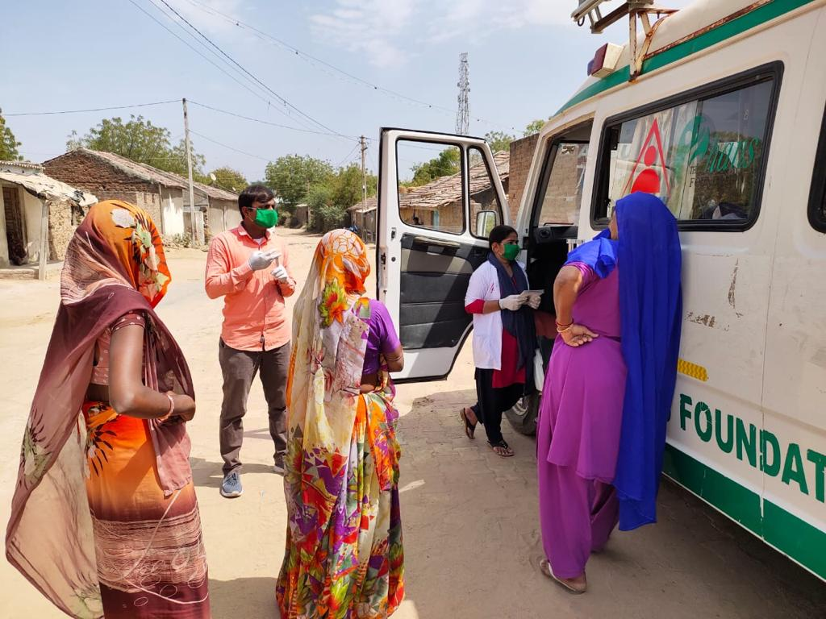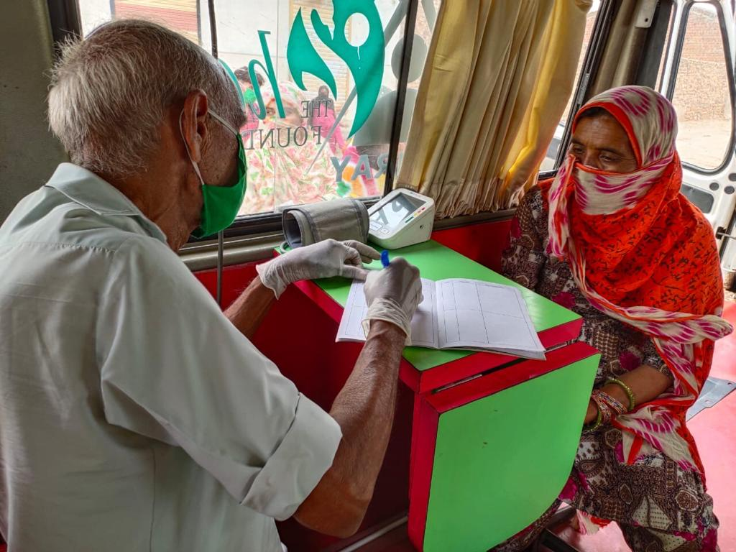

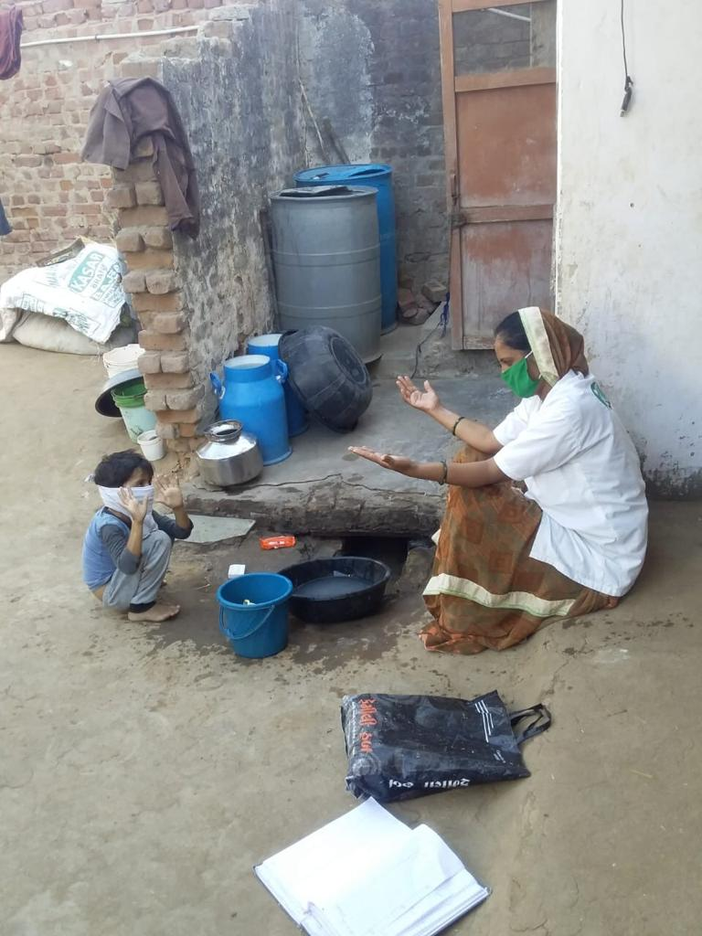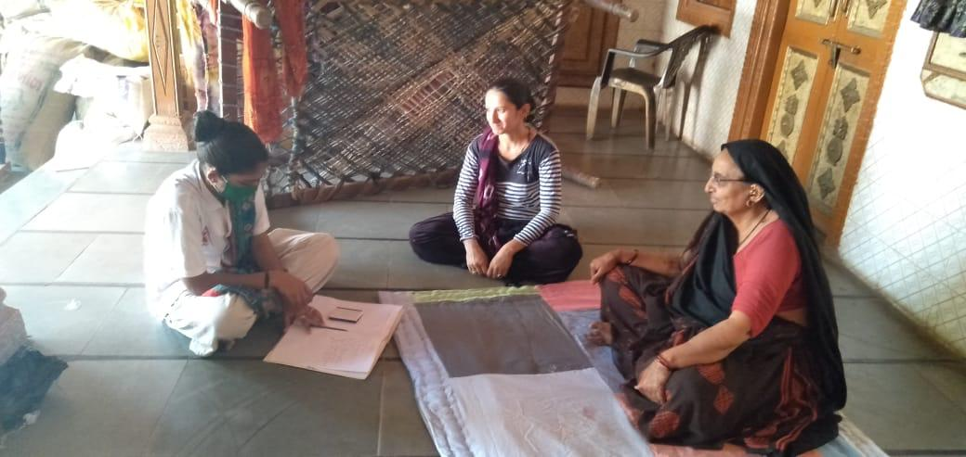

Project Implementation and Monitoring

Ashray will be responsible for project implementation and overall reporting as well as being in contact with the donor. Ashray will take permission of the local authorities to work in the project villages.

For better management of this project the management team of Ashray will develop a system, which would be practical, transparent and effective. For this purpose, Ashray will make work break down structure which will be based on Project Implementation and Monitoring Committee and Audit Committee. These committees will have their own role and responsibilities and will work under the umbrella body of Ashray.

Ashray’s monitoring and review system will begin with designing project specific monitoring formats and change capturing systems by the Project Implementation and Monitoring Committee. The system will be designed to track operations, changes and compile detailed status and completion reports.

Project Implementation and Monitoring Committee-

This committee will be comprised of a team who will be accountable to control the quality of project and will ensure effectiveness of the project.

The project monitoring will be done by ASHRAY head office on a monthly basis against the work plan, progress against the indicators and the project outputs. Records of the progress will be maintained at field and organisation level for all completed activities under the project. The progress review of the project activities will be conducted on monthly basis at the project team level and on quarterly basis at the head office level.

Audit committee-

The audit committee will strongly audit each and every activity of the project and will make the audit report of the project. Ashray will follow its robust finance management policies and procedures for all procurement and purchases in line with its policies.

Reporting

Ashray will define internal reporting mechanisms to facilitate monitoring of progress in accordance with donor requirements. The narrative & financial donor reports will be submitted on a quarterly basis to donor along with success story, media reports and feedback from the community.

The reporting format will include both narrative and financial report submitted at the end of every quarter. The narrative format will have sections like:
- Summary of the project achievements
- Direct & indirect reach
- Description of the activities undertaken with photographs
- Any changes in the external environment
- Case study
- CA certified Utilization Certificate

A project completion report will be submitted at the end of the project.

Expected Outcomes
- Educating and sensitizing on corona virus and train possible prevention methods through awareness sessions to about 25000 families in Santalpur Taluka.
- Community cooperation will be established to stand against any kind of disaster
- Adopting clean and hygienic habits among the beneficiaries
- Importance of social distancing, health and preemptive measures

