Appeal for:
CORONAVIRUS (COVID-19) Relief Fund
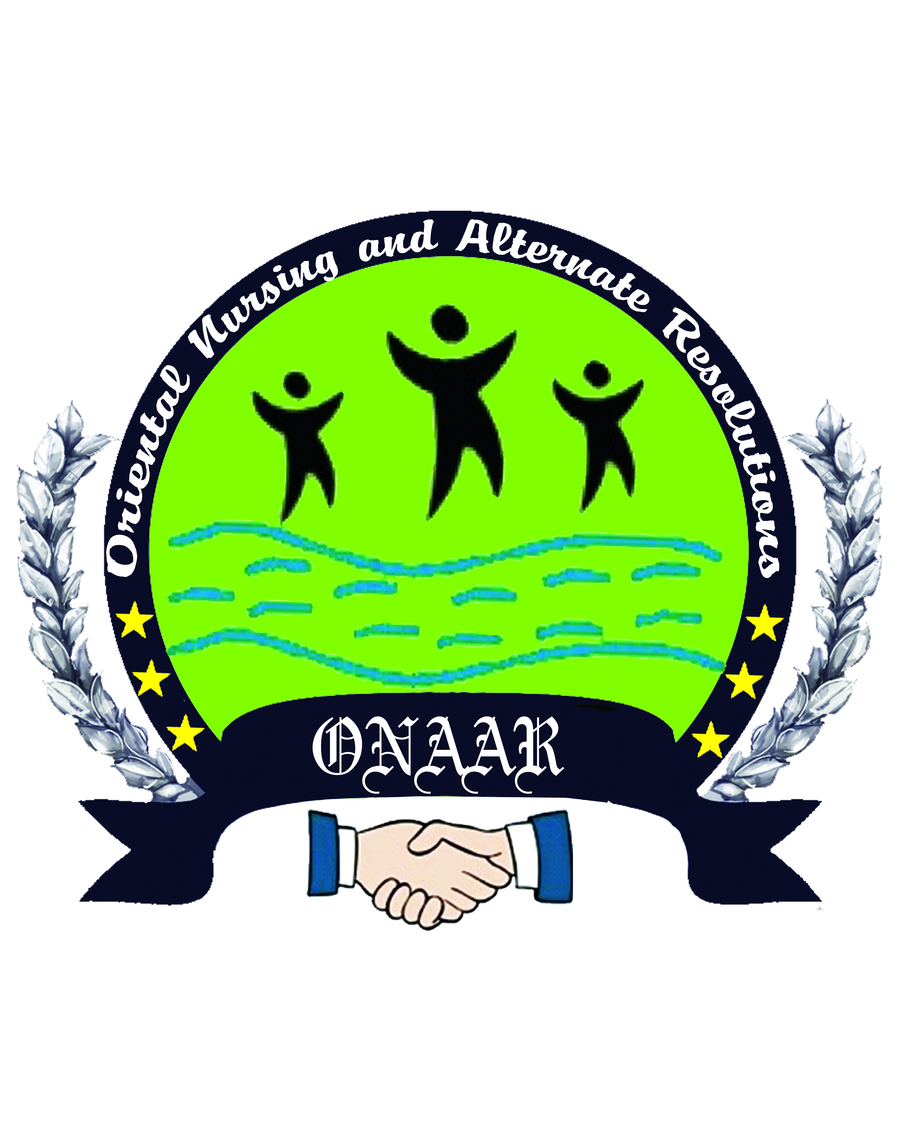
ONAAR Development Organization
Our Mission
- “Making Efforts for Solid Contribution in Welfare of Society through Legal, Social, and Commercial activities”.
Project Title:
Rehabilitation Fund for COVID-19 Affected Families
ONAAR is going to provide Support and Livelihood Assistance to Rehabilitate 300 affected families by Corona virus COVID-19 in KPK of Pakistan especially house hold women/girls & PWDs. These deprived & vulnerable groups of society are already living under the Poverty Line. Due to lockdown these deprived & vulnerable groups become more down and also become dependent and waiting for our help and Financial Support.
The District Mansehra, Battagram, Kohistan and Torghar are the most deprived districts are situated and consists of very far flung hilly and tough areas in KPK province of Pakistan. About 90% area of these districts is backward and undeveloped. Due to COVID-19 lockdown the Poverty level become very high and the financial life of these group is swearly damaged and are now in the Death and Life struggle. The targeted groups have no resources to resettle and restore their living status as damaged and ruined badly.
For the said purpose and to restore and uplift the targeted groups, families living under poverty line we / ONAAR managed this project to Providing Support for Livelihood Assistance in entrepreneurship/micro finance for different kinds of home based business activities,i.e. home based Poultry forming, Kitchen Gardening, Sheep Forming, home based Shop&Bakery, home based Tailoring shop & Sewing Centers, School Fee & Uniforms for their children education and schooling, and providing Food Packages to the targeted 300 deserving and affected families of these districts of Kpk.
Now we appeal to all of you to Donate now to our this project. The project title is;
Rehabilitation Fund for COVID-19 Affected Families
S/No | Amount | Description
1 | $ 10 | School Fee: 10 x 100 = 1000
2 | $ 25 | Uniform: 25 x 100 = 2500
3 | $ 50 | Food Packages: 50 x 100 = 5000
4 | $ 100 | Tailoring Equipment: 100 x 50 = 5000
5 | $ 200 | Sewing Machines: 200 x 50 = 10,000
6 | $ 500 | Livelihoods Assistance in live stock/Goats&Sheep: 500 x 20 = 10000
7 | $ 1000 | Livelihoods Assistance for home based Poultry forming: 1000 x 10 = 10,000
8 | $ 200 | Livelihoods Assistance for home based Shops and Kitchen Gardening: 2000 x 10 = 20,000

Organizational Background:
- “Oriental Nursing and Alternate Resolutions” ONAAR Development Organization is Humanitarian and Social Welfare organization working in the KPK Province of Pakistan. ONAAR works in diversified sectors such as Advocacy, Health, Education, Livelihood, Infrastructure, community Empowerment and work for the Betterment and Fight for the Rights of Vulnerable Children, Women, PWDs, CWDs and Marginalized people of the Society.
ONAAR Struggle to take active and positive role in the process of Sustainable Development in all spheres of life through participatory approach.

ONAAR is a Pool of Social Scientists, Researchers, Implementer, Professionals and Social Activists. ONAAR, Believes in Sustainable Action for Advocacy and Provision of Human Rights as well as Protection of Child Rights & Women Rights.
- ONAAR Development Organization (ONAAR) is a Non-Governmental, Non-Political, Non-Religious and Non-Profit Organization in Public sector, Established in 2008 and Registered under the “Voluntary Social Welfare Agencies” (Registration & Control) Ordinance 1961 (XLVI of 1961), Bearing Registration No. DSW / NWFP / 3208.
- ONAAR is registered with PADOR wide Registration #: PK-2013-CXI-1203770259

Our Strategy
ONAAR Development Organization has the code of ethics, organizational implementing strategy and M&E best policies of Accountability and Transparency.
- The ONAAR Development Organization engaged in diversified activities with in the ONE constituency, and that constituency is the PUBLIC.
- ONAAR aims to improve the condition of people. In doing so, ONAAR commits it selves to the ethical principles as under;
- ONAAR aims to work in partnership of society, based on Justice, Equality, Transparency, Accountability and Respect of Human Rights.
- ONAAR is not aligned or affiliated to any political or Religious groups.
- ONAAR’s activities are carried out without any discrimination of nationality, casts, color, sex, disability, religion or political affiliation.
- ONAAR respects the Values, Dignity, Culture and Religion of the communities.
- ONAAR provides public, the targeted or focused groups of population, donor and government with accurate information about all activities, Finances and other relevant information.
- ONAAR ensures that its Relationships with funding agencies/Donors are honest and transparent.
- For the Quality of work, ONAAR conducts regular monitoring and evaluation of the organizational management and the program.
- For ensuring the participatory approach, the ONAAR ensures the participation of its Focused or Targeted groups/stakeholders in development process.
- ONAAR actively participates in development sector networks and events to improve coordination, disseminate information, share experiences.
- ONAAR internally conducts and documents regularly information-sharing meetings and also externally makes its available reports.
- The Executive Management committee (Project Committees) meets regularly and meetings are documented, for decision making processes.
- ONAAR describes the Fundraising communication accurately for the organization/ONAAR identity, purpose, programs and scope of achievements.
- For the betterment or Rights of the staff, ONAAR has clear and fair written staff Policies and procedures.
- ONAAR has the policies and procedures to promote gender equity.
ONAAR is a value based organization and believes in practicing transparency, mutual respect, gender sensitivity, honesty & integrity, impartiality, participation and accountability.
Our Vision and Goal
- Is peaceful and Prosperous Society based on Social Justice.
Our Mission
- “Making Efforts for Solid Contribution in Welfare of Society through Legal, Social, and Commercial activities”.

- Struggle to take active and positive role in the process of Sustainable Development in all spheres of life through participatory approach.

- Thematic Areas:
- Advocacy
- Human Rights
- Education
- Health
- Women & Child Rights Protection
- Livelihood & Food Security
- Awareness Raising
- Skills Development

- Cross-Cutting Themes
- Women & Child Rights Protection
- Disaster Risk Reduction (DRR)

- Supporters and other helpers:
- 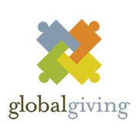 , , Save the Children Sweden ,

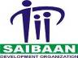
- CRAN (Child Rights Advocacy Network) 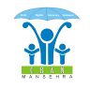,

- SRSP – PRIDE Project, 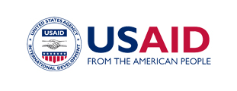, IRC 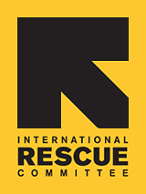 ,

- Working Area:
District Mansehra and KPK Province, extended to the whole of Pakistan including AJK, Gilgit Baltistan and FATA.
“ONAAR”
Thank You

Oriental Nursing and Alternate Resolutions
ONAAR Development Organization
District Mansehra,
KPK
Message :

“Now is the time for all good people to come to the aid of the Society/Humanity”

