KASC COVID-19 Response
- Summary
In Korea, the number of COVID-19 confirmed since April 3 has exceeded 10,000. 78.5% of all confirmed cases and 91.5% of deaths occurred in Daegu and Gyeongsangbuk-do. KASC will help the Mungyeong Third Life Treatment Facility where confirmed patients were transferred from Daegu and Gyeongsangbuk-do. It will be used for PPE equipment for medical staff, Various Medical supplies for confirmed patients in living and treatment support center.

- HOW WILL THIS PROJECT SOLVE THE PROBLEM?
The most important thing to survive and cure is to support medical field. In order to achieve our goals, we will deliver your fundraising to Mungyeong Third Life and Treatment support Center. The necessities of supplies continue to change depending on the situation. In order to cure and survive, we will provide medical supplies required by the medical field.

- Result
The number of confirmed patients at the Mungyeong Third Life Treatment Facility fell(decreased) sharply in April. Therefore, PAPR PPE (Powered Powered Air Purify Respirator Personal Protective Equipment) is no longer needed.
Instead, if medical masks (N-95 and splash masks) are needed, the following sponsorship was given to Seoul National University Hospital, which operates the Mungyeong Third Life Treatment Facility.
Most of all, medical staff can buy more masks than NGOs buy. The medical staff directly purchased the mask at a discount of about 90%. The purchased masks were used in screening clinics where demand increased intensively.
Execution history
(Exchange Rate(about) : 1USD = 1,203.33KRW)
 |  | sheets | unit price | KRW | USD
1st purchase  (27-April) | N-95 Medical Mask | 1,920 sheets | 1,500KRW | 2,880,000 | 2,393
2nd purchase  (4-Jun) | Dental Mask | 53,400 sheets | 86KRW | 4,592,400 | 3,816
3rd purchase  (30-Jun) | N-95 Medical Mask | 2,100 sheets | 1,500KRW | 3,150,000 | 2,618
additional fee |  |  |  | 116,600 | 97
total |  |  |  | 10,739,000 | 8,924
NGO proceeds, Transportation / Storage cost, etc. |  |  |  | 1,193,214 | 992
Grand Total |  |  |  | 11,932,214 | 9,916

Donation history
Ford Fund & GlobalGiving
 | Donor | KRW | USD
14-Apr | Initial Donation(Ford/GlobalGiving) | 2,406,284 | 2,000
27-Apr | Second Donation | 3,625,930 | 3,000
total |  | 6,032,214 | 5,000

Ford Korea & Dealer(Local Donation)
 | Donor | KRW | USD
13-Apr | The PARK | 1,000,000 | 833
15-Apr | Lee Han Motors | 500,000 | 417
17-Apr | Ford Korea | 400,000 | 333
20-Apr | Premier Motors | 1,500,000 | 1,250
23-Apr | Sunin Motors | 2,500,000 | 2,083
total |  | 5,900,000 | 4,916

# Pictures
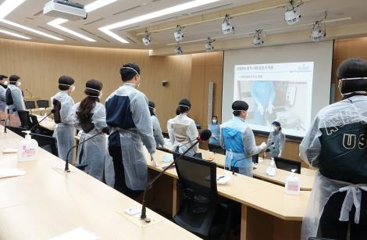  Self education for COVID-19 compliant medical staffs. | Contents posted on the website
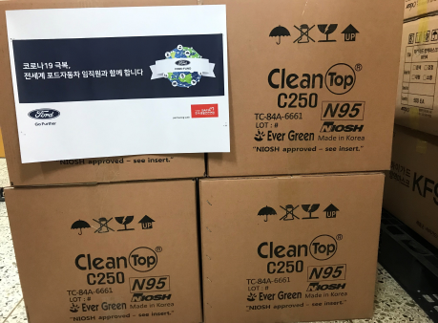
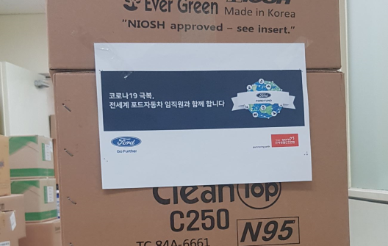
First mask purchased for medical staff
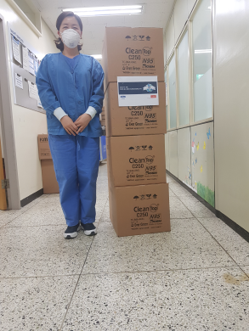
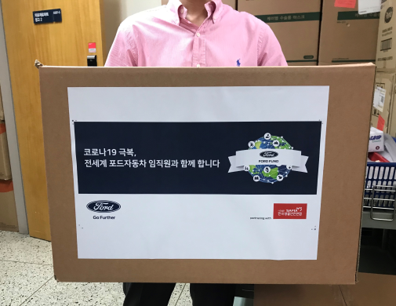
Medical staff (left) and logistic staff (right) who are seated to use the mask
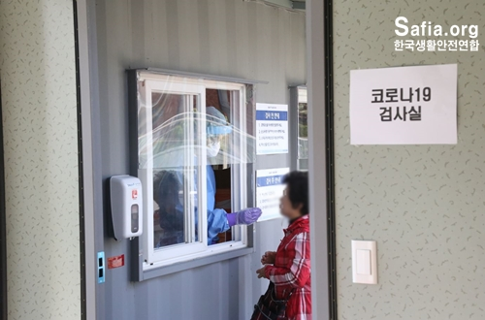
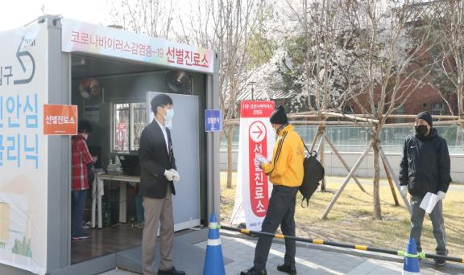
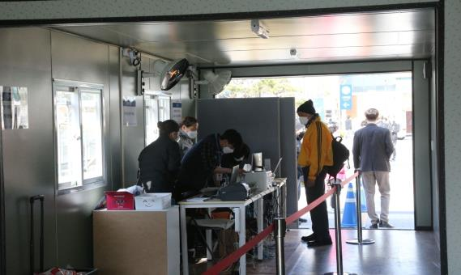
Screening Clinic site and masks used
*Photographs on site are limited due to COVID-19.
- Proof of results
#KASC Spended 2times and total amount is 1,0739,000KRW(8,924USD)
#1 Donation Confirmation of Seoul National University Hospital(Mungyeong Third Life Treatment Facility’s Operation Hospital) 27-April
* Seoul National University Hospital gave the confirmation because the medical staff purchased it directly.
#2 Donation Confirmation of Seoul National University Hospital(Mungyeong Third Life Treatment Facility’s Operation Hospital) 4-jun
- Medical staff thanks and Pictures
# Medical staff’s thnks to GlobalGiving
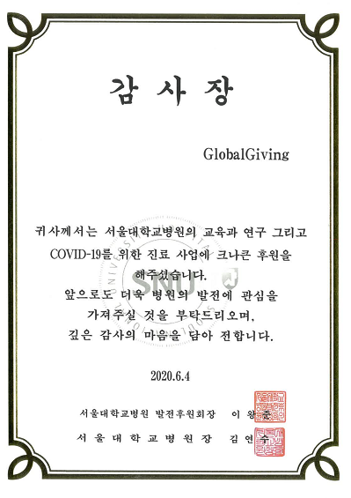
The medical staff was very surprised and thankful that the support was provided abroad.
The medical staff sent a letter of appreciation in the name of the hospital with a small sincerity. Special thanks to GlobalGiving, Ford and its dealers
#Translation

# Medical staff’s official thank you letter to Ford & Dealers
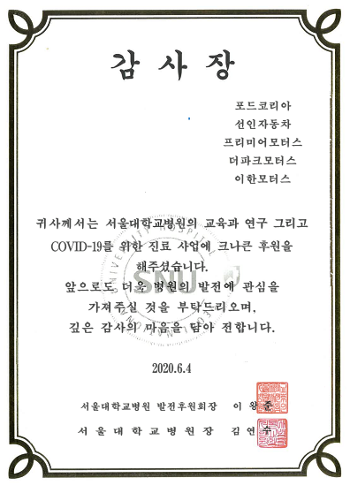
Official thank you letter to Ford and Dealers.
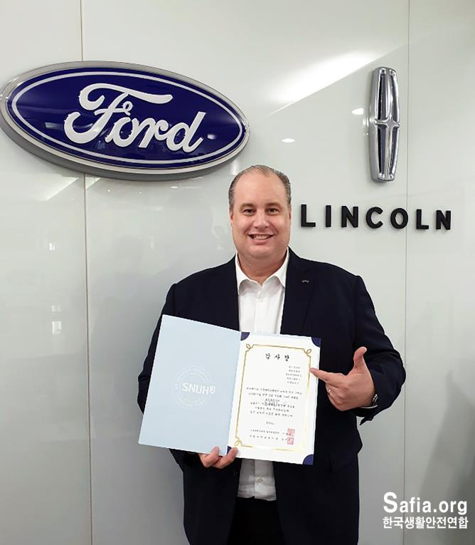
Official thank you letter & Ford Korea CEO

