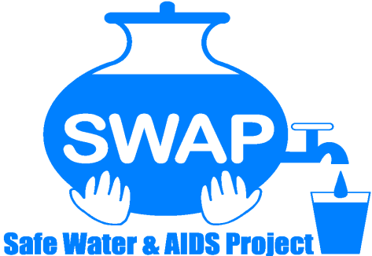
GLOBAL GIVING REPORT
JANUARY 2022

Help protect 1,000 health workers in Western Kenya
Introduction
Safe Water and AIDS Project (SWAP) has been operating in Western Kenya since 2005 with public health programs, research and emergency response. SWAP's mission is to provide innovative solutions for improved health and economic status of communities.
SWAP has a wealth of experience in public health interventions and has worked in collaboration with County Health Management Teams to respond to COVID-19 especially with focus on health care facilities supporting and protecting the frontline work force and the community at large from COVID-19 spread.
For that reason, the Global Giving platform was used to source for crowd funding from donors and well-wishers in our effort to protect health workers, reduce the COVID-19 spread and mitigate the impact.

COVID-19 Current Status in Kisumu
In this region we experienced a fifth wave now mostly with the new variant Omicron. The people who get very sick and need hospitalized are mostly those unvaccinated. The new variant is also spreading very fast. This triggered the need to accelerate vaccination. The County Department of Health reached out to partners to support COVID-19 vaccination outreaches. There has been increased supply of donations of vaccines in the country and this has now also allowed people to get vaccinated including getting boosters. However, there is still a problem with many being hesitant to visit the assigned health facilities were vaccination is done. For others they lack transport or are too vulnerable to visit those sites. At the same time the most vulnerable are at higher risk and need to be protected.
Strategy to accelerate vaccination
In collaboration with partner organizations and the County Department of Health SWAP came up with targeting the most vulnerable and hard to reach communities to ensure they get vaccinated. These are the physical disabled, street families, people from informal settlements, families affected by flood, elder community members and others from low income or remote areas.

Vaccination drive in Ombaka, Nyando Sub County
Ombaka is an area which is prone to flooding which has displaced several families. Most have lost their crops and livelihood and others had their homes destroyed and are living in tents. SWAP has been intervening preventing disease outbreaks by providing food and non-food items. The local chief reached out to SWAP requesting for a COVID-19 vaccination outreach to protect his community members.
SWAP organized two COVID 19 vaccination outreaches on the 3rd of December 2021 and 12th of January 2022 to ensure that the community members could get first dose and second dose. There was very good mobilization done and good attendance. Nyando Sub County Department of Health sent two vaccination teams consisting of vaccinators and data clerks who did real time entry in the MOH portal for vaccinations. Vaccination was done under the trees. During the first outreach 470 people were reached and during the second 312 got vaccinated.
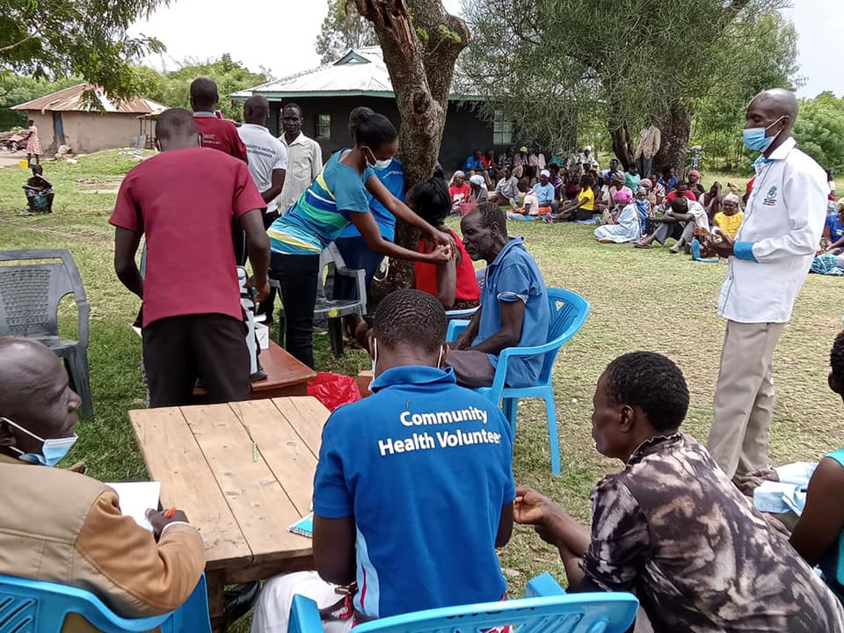
COVID-19 Vaccination Outreach Ombaka
COVID-19 vaccination for physical handicapped and street families
On the 15th of December 2021 SWAP joined hands with other stakeholders during a COVID-19 vaccination outreach for physical handicapped and street families at CITAM Church in Kisumu County. Transport was arranged for the physical handicapped to be ferried to and from the vaccination site. Other partners donated milk, biscuits, sanitary pads and reusable face masks. In total 132 people living with disability and 189 street family members above 18 years were vaccinated. A total of 321. A follow up of the same will be done on the 2nd of March 2022. The exercise was really appreciated because most of these families are left out when it comes to such health campaigns.

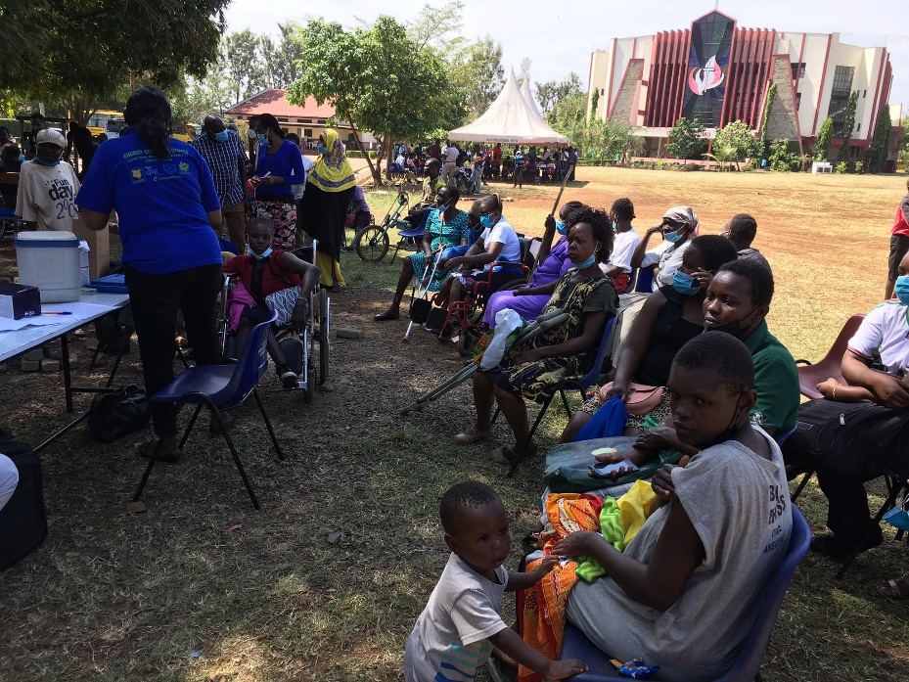
COVID-19 vaccination outreach for physical disabled and street families
A similar exercise was repeated now in Nyando Sub County and spread out over 3 days to get enough coverage. The exercise was done on the 18th, 19th and 20th of January 2022 and also opened up for the general public. Every day two vaccination teams gathered at designated places easy accessible by the public. Prior mobilization was done by community health volunteers informing the public about the vaccination days and venue. During the 3 days we managed to get 909 people vaccinated.

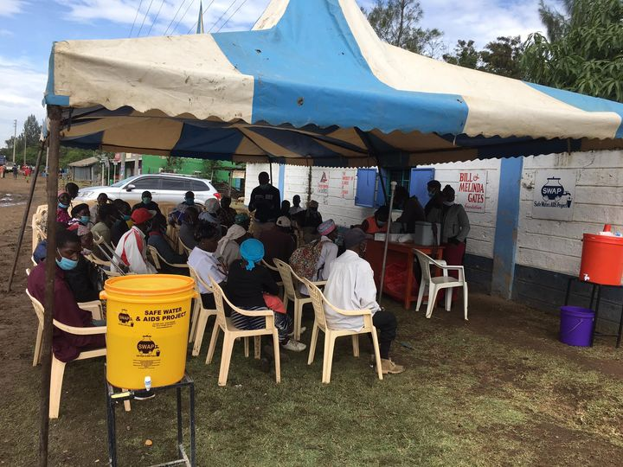
COVID-19 vaccination outreach for vulnerable families at the SWAP model village
Moving forward SWAP has committed to do one COVID-19 vaccination outreach per week for all the 7 Sub Counties in Kisumu mostly targeting vulnerable low income community members. We aim to reach people where they are for example pitching tent at market places to get crowds. This has been a very successful approach and much appreciated by the County Department of Health and the communities. After getting more people vaccinated there will be less strain on the health sector.
Distribution of Hand Washing Stations and soap to Health Care Facilities
SWAP continued reaching out to 47 public health care facilities in Nyando and Nyakach sub counties on monthly basis to ensure they can practice proper hand hygiene to protect the health workers and patients. Hand washing stations were installed and soaps provided. Monitoring of proper use continued by health care workers and patients visiting the facility. The hand washing stations are placed in most of the patient care areas as well as at the entrance and close to the toilets.
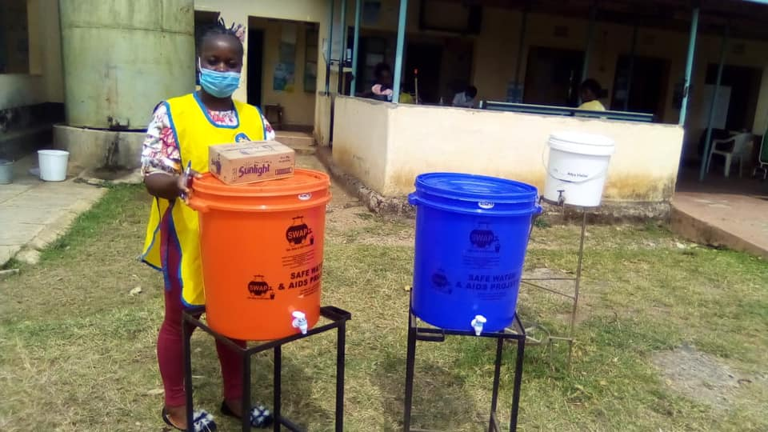
Hand washing stations and soap distributed to health facilities

Alcohol Based Hand Rub (ABHR) production and distribution
The objective was to improve hand hygiene and to produce, distribute and monitor consumption of Alcohol Based Hand Rub at public health care facilities. Technical support was provided for the production which was done at the Water Lab with appropriate safety measures, capacity building and quality control measures. SWAP received approval from the Kenya Bureau of Standards in November 2020 and started monthly distribution in January 2021 to 47 health care facilities and later 34 hot spot areas in Nyando and Nyakach Sub Counties. The 47 health facilities are in rural Kenya and often lack sufficient water. Some are only relying on rain water, but during the dry season do not have any reliable source. So Alcohol Based Hand Rub is ideal for the health workers to protect themselves when handling patients.

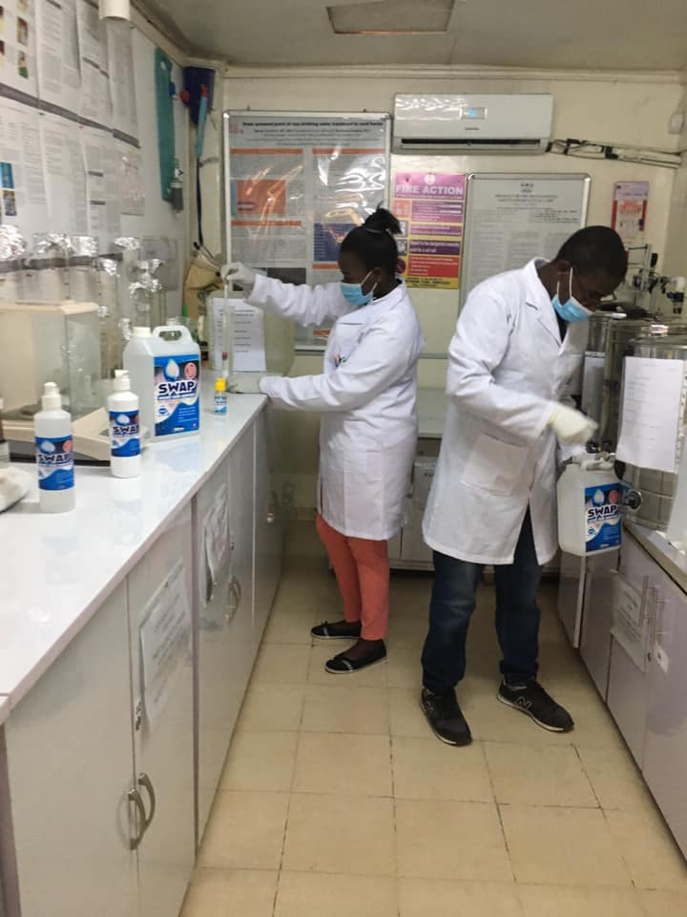
Production of ABHR in our water lab

We evaluated ABHR usage and developed a monitoring system and electronic database for ABHR consumption/use by service point with built-in feedback to production unit to produce and redistribute ABHR when stocks are low, development of localized estimates for monthly/yearly stocks needed by size of facility to aid future projections for consumption. The distribution was free but for sustainability SWAP included ABHR in the basket of products and sold to partner organizations and individuals. In 2021 3845 liters of Alcohol Based Hand Rub was produced in the lab.

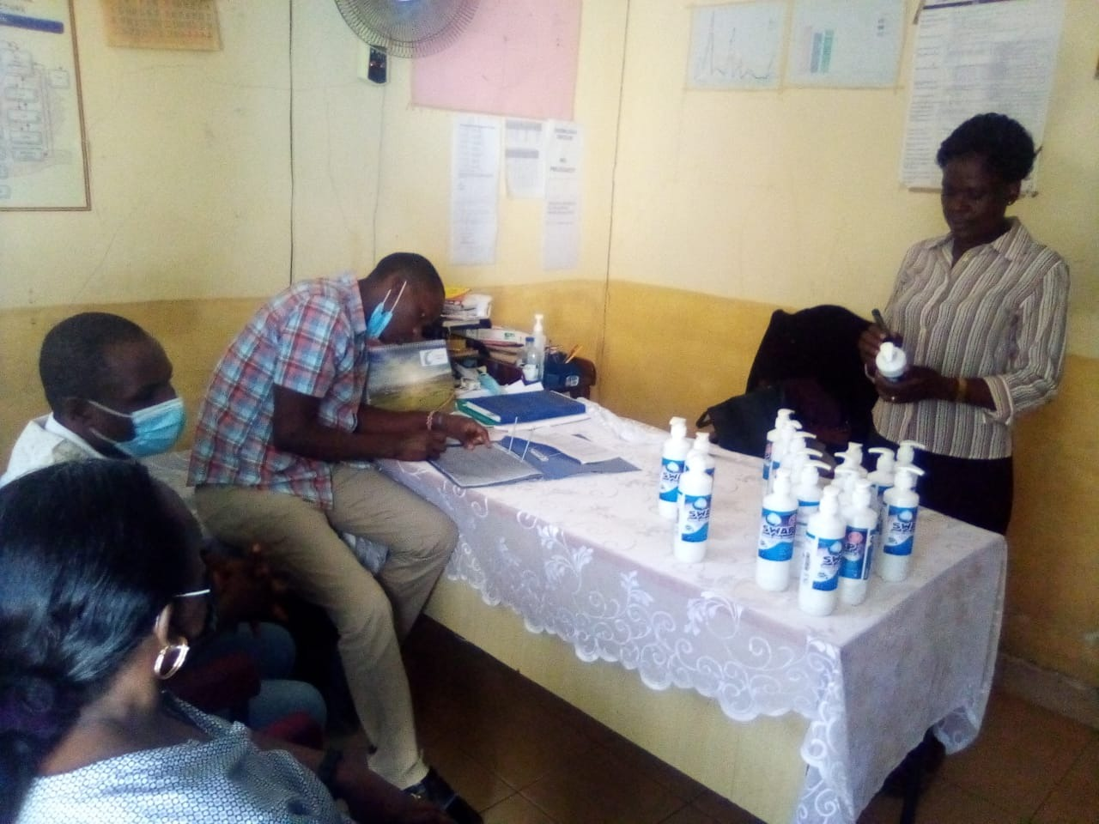
Distribution of supply of Alcohol Based Hand Rub
WE THANK YOU FOR YOUR ONGOING SUPPORT AND DONATIONS

