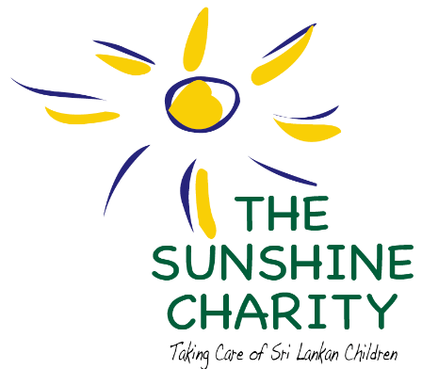

Sambalthivu, Trincomalee
The Sunshine Charity was founded in the aftermath of the December 2004 tsunami to take care of children affected by the devastation through the establishment of a day care centre in Sambalthivu, Trincomalee District, Eastern Province, Sri Lanka.
In 2019, The day care centre was granted pre-school status by the Pre-school Education Bureau of The Eastern Provincial Council.
Today, the 50 children attending include orphaned and vulnerable children and those affected by poverty. With generous funding received from local philanthropists and international donors, the centre has provided the children with not only their basic needs like nutritional food and clothing but more importantly with creative opportunities, medical and health care, pharmaceutical drugs, worming treatment, foot wear to prevent worm infection, learning skills and educational tools.
Additionally, the Charity has empowered members of staff through teacher training programmes, which have encouraged the teachers to be engaging, committed and understanding of the children's needs. The Sunshine Charity has also conducted numerous workshops for the mothers of the children on oral hygiene, nutritional needs and medical programmes with follow-up advice. Through its programmes, the organization seeks to strengthen the capacity and improve the lives of the children served.
We are thankful to our local partners, international and local donors, well-wishers, friends, and media sponsors, without whose support it would not have been possible to celebrate ten years of operation.
The Sunshine Charity is a charitable, not-for-profit civil society organization, registered in Sri Lanka by a Trust Deed (Deed no: 2019 dated 30th Decembe, 2005 and Deed no: 234 dated 8th February, 2011) and managed by five Trustees who are directly engaged with the children.
For more information log onto www.sunshinecharity.org where you can also click on our donation page.

