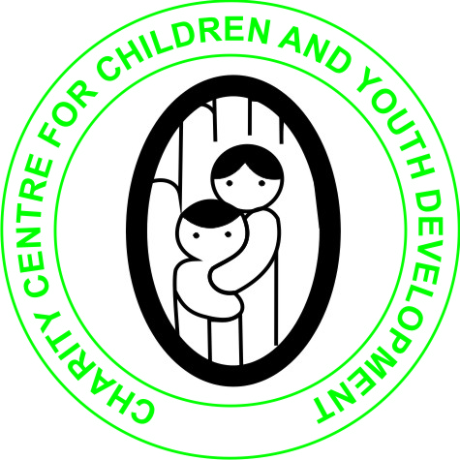
CHARITY CENTRE FOR CHILDREN AND YOUTH DEVELOPMENT

AUGUST 2020 REPORT
ON THE CORONAVIRUS RELIEF FUND FOR VULNERABLE WOMEN IN SOLWEZI, ZAMBIA.
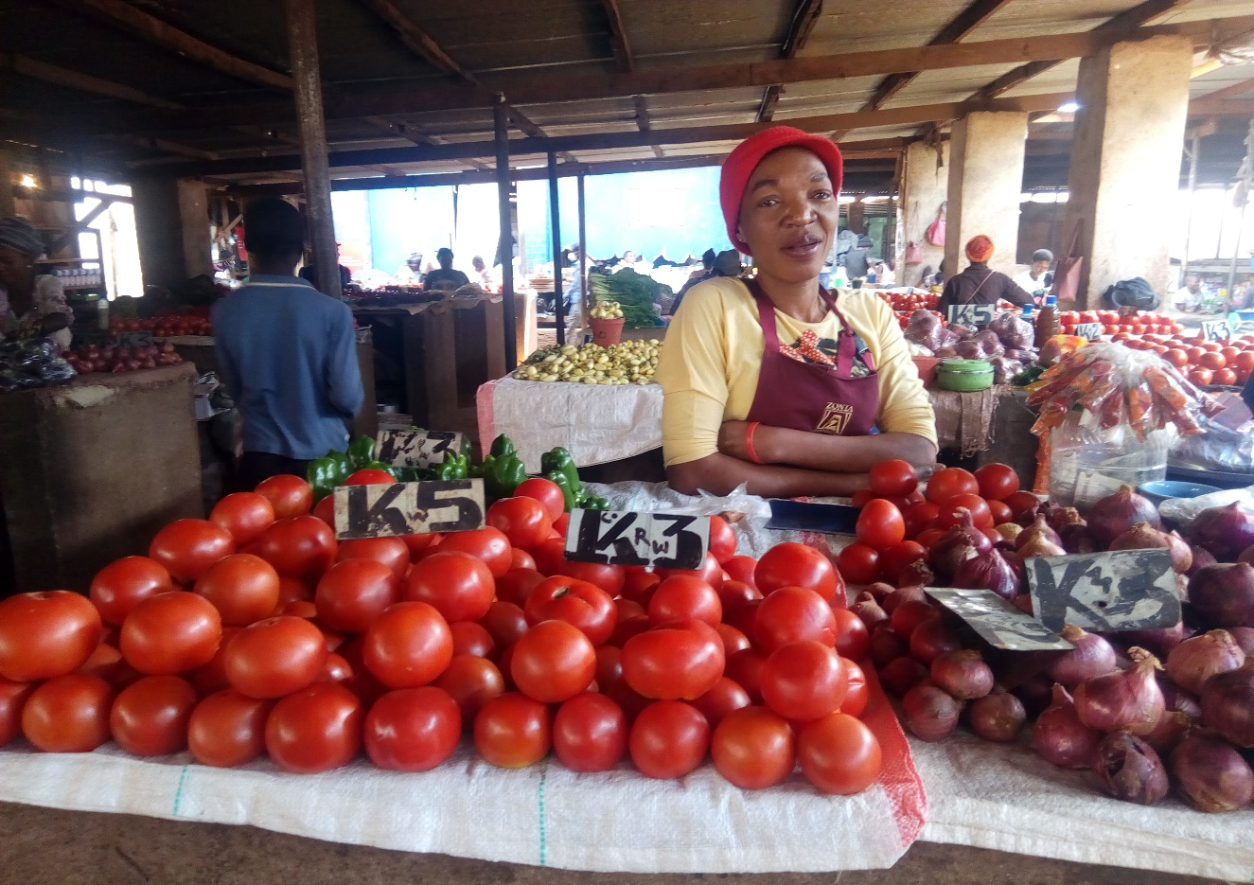
SUBMITTED
TO
GLOBAL GIVING
BY
ALEX BWALUKA
29TH AUGUST 2020

DESCRIPTION OF THE ORGANIZATION
Charity Centre for Children and Youth Development (CCCYD) is a Non-profit, Non-political and Nonreligious Organizations which was established to help Orphans and vulnerable children (OVCs), Youth, women and persons with physical challenges improve their standards of Living through the provision of several life skills, education support, HIV/AIDS awareness and prevention, provision of micro-entrepreneurship skills and soft loans as well as material support.
We envision a society that will work towards eradication of poverty, HIV and AIDS, illiteracy among Orphans and vulnerable children, youths and women in Society.
The Organization's mission is to promote and enhance the capabilities of children, youth and women in North Western Province and beyond to effect positive social change that would necessitate the development of their lives, communities and the nation at large
Zambia is among the many Countries that have been affected by the Corona Virus which has claimed lives in many Countries around world and Solwezi District has not been spared from the pandemic.
Most of the poor People especially vulnerable women in Zambia live on less than a $ per day and COVID-19 has just worsened the situation. Women are the most affected people in the communities. In Solwezi, all the families have been confined in their homes spending the little income raised from their small business. Therefore, COVID-19 has left families in Solwezi without food, soap and other essential basic needs such as medical bills etc which are cardinal for human survival.
The loss of business and employment opportunities due to COVID-19 has has caused many vulnerable women to be involved in prostitution and other illicit activities to enable them earn a living which compromises their human dignity.
The COVID-19 relief fund will provide revolving fund to vulnerable women keeping orphans and vulnerable children to start a small home based business that would help them recover from major negative impacts of COVID-19. Vulnerable women are disproportionately impacted by COVID-19. Women in Solwezi feeds households and helps children attend school and meet health costs.
The goal of this project is to help 500 vulnerable women recover and sustain families from COVID-19 shocks. Micro entrepreneurship is key in attaining local development and improved income at household level. Since this shall be a revolving fund, many people shall benefit and the majority beneficiaries will remain with a capital which they have lost during the Country's lock down. All the beneficiaries will also be trained in micro business management etc. When we empower a woman we have empowered the whole family hence developing this initiative to respond to COVID-19 economic impacts.
COVID-19 pandemic, like other calamities, has come at a colossal cost to human life. The COVID-19 pandemic is emblematic of this. Women are disproportionately impacted by COVID-19 as compared to men because already many women depends on their small business to provide for their families. According to FinScope Zambia, 68% of women are financially excluded and women have less access to bank institutions at 11.6% compared to 17.5% for men. On the other hand, women have higher usage rate as concerns informal loan providers at 12.2% compared to 10.3% for men. (Interestingly, more women say they would spend potential credit on starting businesses than men.) As mentioned above, most women have low incomes earned outside the formal sector and less access to collateral or other security. Some banks have gender-biased policies insisting that the husband should give his consent to a wife’s application and/or collateral being proposed.

BELOW IS JULY 2020 DISBURSEMENT FOR CORONAVIRUS MICRO-RELIEF FUND FOR VULNERABLE WOMEN IN SOLWEZI.

SN | NAME | SEX | DATE | AMOUNT ZMW
1 | NJOMBI JUDITH | FEMALE | 17/07/2020 | 500.00
2 | MUTUPA MAGGIE | FEMALE | 17/07/2020 | 1,000.00
3 | GINE MALIPENGA | FEMALE | 17/07/2020 | 500.00
4 | FUNNY NACHALWE | FEMALE | 17/07/2020 | 500.00
5 | KAMBINYI J. TANDALESS | FEMALE | 17/07/2020 | 500.00
6 | DOREEN NKWABILO | FEMALE | 17/07/2020 | 500.00
7 | DOCAS KAMULOSU | FEMALE | 17/07/2020 | 500.00
8 | MAGGIE KAVUNGU | FEMALE | 17/07/2020 | 500.00
9 | HARRIET M. CHISHA | FEMALE | 17/07/2020 | 500.00
10 | MELODY MUSANVU | FEMALE | 17/07/2020 | 500.00
11 | KAPEMBA EDITH | FEMALE | 17/07/2020 | 500.00
12 | CHIYEMA LUCY | FEMALE | 17/07/2020 | 500.00
13 | IREEN MUKUZHI | FEMALE | 17/07/2020 | 500.00
14 | EVELINAH SONDASHI | FEMALE | 17/07/2020 | 500.00
15 | JAINESS KALUPELA | FEMALE | 17/07/2020 | 500.00
16 | FLORENCE CHOZA | FEMALE | 17/07/2020 | 500.00
17 | MEMORY MPANDE | FEMALE | 17/07/2020 | 500.00
18 | PRUDENCE MWEEMBA | FEMALE | 17/07/2020 | 500.00
19 | KIPANANSA BEAUTY | FEMALE | 17/07/2020 | 500.00
20 | JEAN KAMBINGA | FEMALE | 17/07/2020 | 500.00
21 | JOSEPHINE NGELESHI | FEMALE | 17/07/2020 | 500.00
22 | KASOLU IREEN | FEMALE | 17/07/2020 | 500.00
23 | LIATIMA LOTI LANNY | FEMALE | 17/07/2020 | 500.00
24 | KATANYA LOYDAH | FEMALE | 17/07/2020 | 500.00
25 | KUMBI DOCURS | FEMALE | 17/07/2020 | 500.00
26 | YOMENA MERCY | FEMALE | 17/07/2020 | 500.00
27 | MUZHAMU ELIZABETH | FEMALE | 17/07/2020 | 500.00
 | TOTAL |  |  | 14,000.00

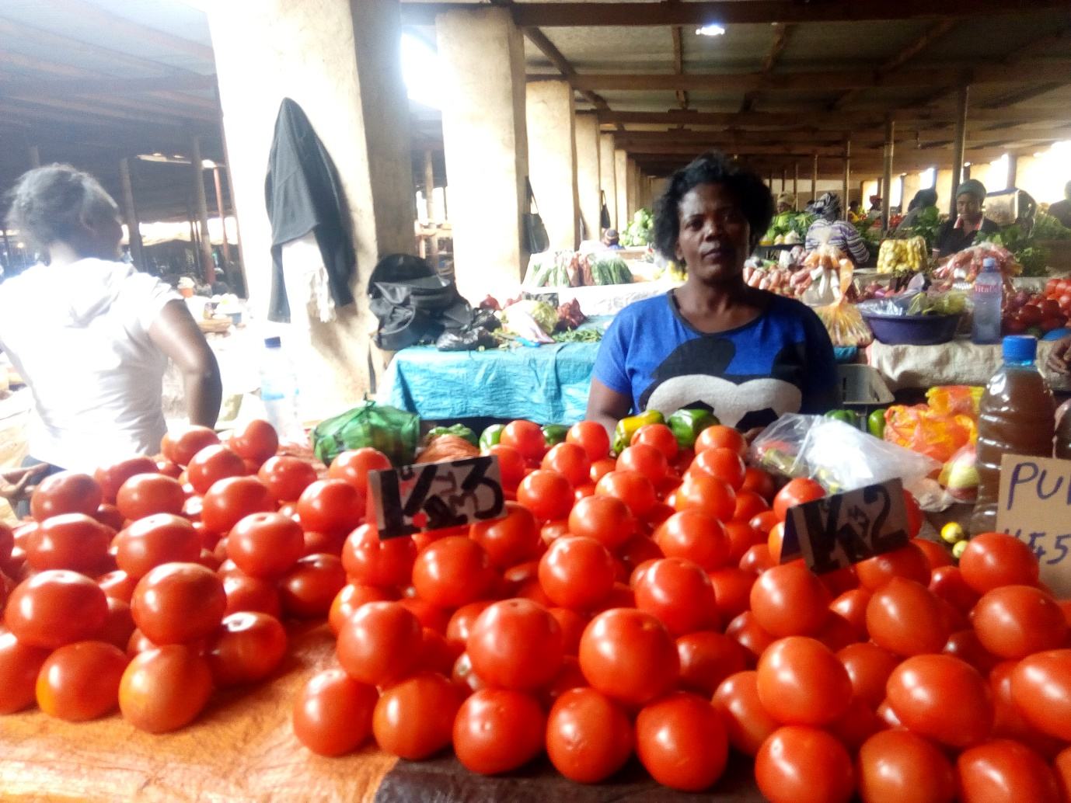
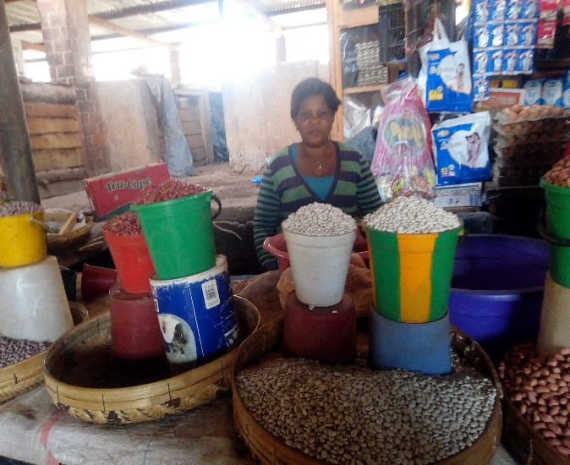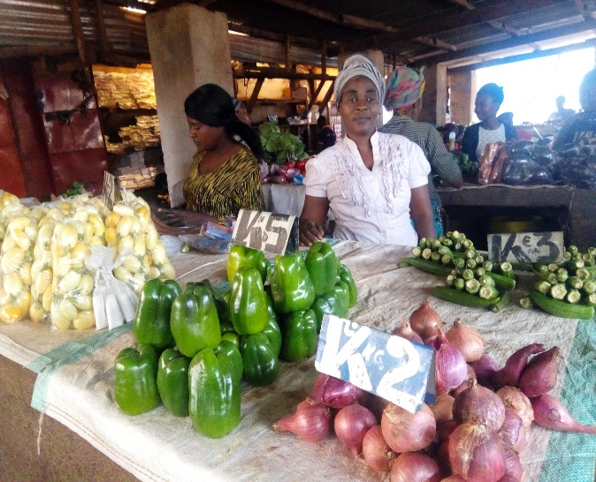
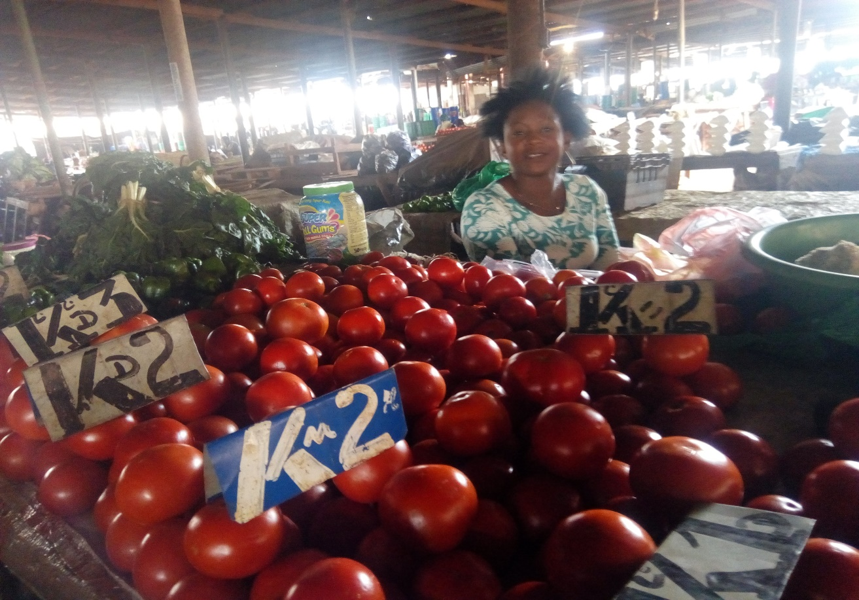
Some of the Coronavirus micro relief fund for vulnerable women beneficiaries in Solwezi
With your continued support, we shall reach out to many vulnerable women in Zambia. So far, $1,311 has been raised out of $3,500 goal.
Donate here: https://www.globalgiving.org/projects/coronavirus-relief-fund-for-vulnerable-women/
Our email: info@charitycentreforchildren.org
Mobile (whatsapp) +260 965 737377
Report compiled and submitted by
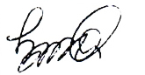
ALEX BWALUKA
31st July 2020

