COMBATING COVID -19
by United Way Bengaluru

#fightcorona #liveunited

Background: According to WHO, Coronavirus disease (COVID-19) is an infectious disease caused by a newly discovered coronavirus. Most people infected with the COVID-19 virus will experience mild to moderate respiratory illness and recover without requiring special treatment. Older people, and those with underlying medical problems like cardiovascular disease, diabetes, chronic respiratory disease, and cancer are more likely to develop serious illness. The COVID-19 virus affects different people in different ways. COVID-19 is a respiratory disease and most infected people will develop mild to moderate symptoms and recover without requiring special treatment. People who have underlying medical conditions and those over 60 years old have a higher risk of developing severe disease and death.

COVID-19 Outbreak situation Globally
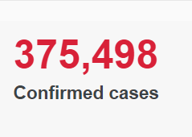 | 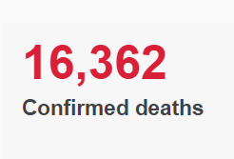 | 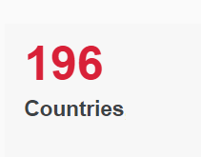
(SOURCE: WHO)
INDIA
The spread of novel coronavirus in India is rapidly increasing with each passing day. In the 10 days between March 10 and 20, the number of people in India who tested positive for Covid-19, the disease caused by novel coronavirus, jumped from 50 to 196. And as on March 23, it further rose to 434. Of these 434 patients, 35 (8.06 per cent) patients have recovered following treatment, while nine have died--one each in Delhi, Punjab, Karnataka, Bihar, Himachal Pradesh, West Bengal and Gujarat, and two in Maharashtra.
India, like most countries, is currently battling its worst health emergency in several decades.
COVID-19 Outbreak situation in India

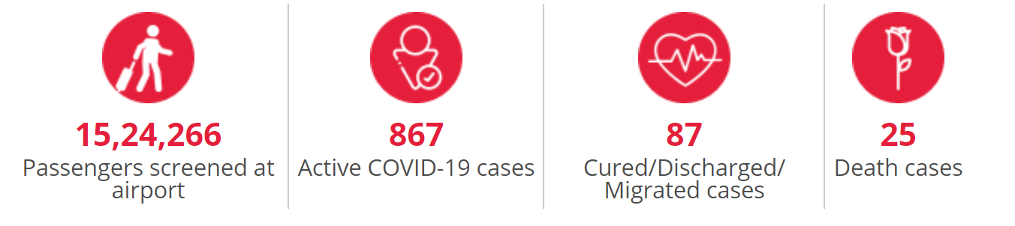

United Way Bengaluru’s Plan of Action

Objective: To prevent further spread of the virus and to support Govt. in strengthening the Hospitals, PHCs and Healthcare staff in combating COVID 19.

Proposed activities
- Distribution of hygiene/safety kit to communities and Hospitals. We shall also include the BBMP Pourakarmikas who help keep our city clean.
- Distribution of Protective Kit for Healthcare Staff, Paramedics.
- Infrastrucural support to Hospitals and PHCs.
- Ration Kit for Migrant and daily wagers groups

UWBe’s STRATEY:
- UWBe has identified and partnering with Govt. Hospitals, PHCs to carry out these interventions
- Hygine kits will be distributed to the individuals who visit the hospitals and to vulnerable groups.
- UWBe along with Health Dept. and BBMP will drive this initiative.

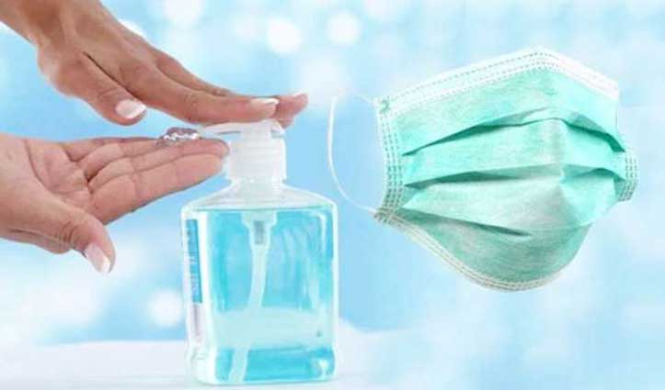

Target groups: Frontline Health Workers, BBMP Pourakarmikas and other vulnerable groups.

Components
Hygine Kit | Kit for Healthcare Staff | Grocery Kit | Infra Support to Govt. Hospitals
Mouth Masks - 1  Hand wash liquid (650 ml) - 1  Soaps 75g - 3  Face Towels – 1  Pouch - 1 | Mask - 1  Cover-all Gown - 1  Disposable shoe cover - 1  Surgical gloves - 1  Goggles – 1  Apron - 1  Hood cap - 1  Biohazard bag -  Hand sanitizer - 1 | Rice - 5 Kgs  Ragi Flour - 3 Kgs  Atta/Wheat Flour - 2 Kgs  Dhal - 2 kgs  Sun flower oil - 1KG  Groundnut - 1Kg  Sugar - 1 KG  Salt - 1 KG | Supply of Oxygen Ventilators

Project Locations (while these are Karnataka locations, we are raising this for PAN INDIA)

- Rajiv Gandhi Institute of Chest Diseases, Bangalore
- Victoria Hospital, Bangalore
- Kidwai, Bangalore
- Govt. Hospital Doddaballapur
- Kodagu Govt. Hospital
- Chikkaballapur Govt. Hospital
- Mangalore Govt. Hospital
- Mysore Govt. Hospital
- Kalburgi Govt. Hospital
- Govt. Hospital, Dharwad

Timeline (The sourcing of the items would start once we accumulate over 2 Cr threshold fund. We shall keep you posted every week)
Activities | Week 1 | Week 2 | Week 3 | Week 4 | Week 5 | Week 6
Sourcing of Hygiene kit to community & hospital level
Distribution of Protective Kit of health care workers

#IndiaFightsCorona

