Report

Objective: To prevent further spread of the virus and to support Govt. in strengthening the Hospitals, PHCs and Healthcare staff in combating COVID 19.
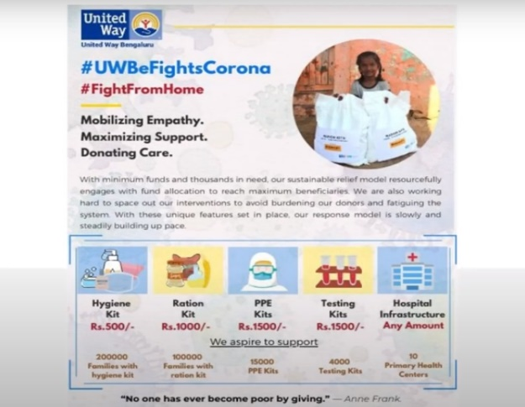
Proposed activities
- Distribution of hygiene/safety kit to communities and Hospitals. We shall also include the BBMP Pourakarmikas who help keep our city clean.
- Distribution of Protective Kit for Healthcare Staff, Paramedics.
- Infrastrucural support to Hospitals and PHCs.
- Ration Kit for Migrant and daily wagers groups
Target groups: Frontline Health Workers, BBMP Pourakarmikas and other vulnerable groups.
COVID 19 Response Support
We are focusing on two main aspects:
- Livelihood
- Health

Pictures from the field:
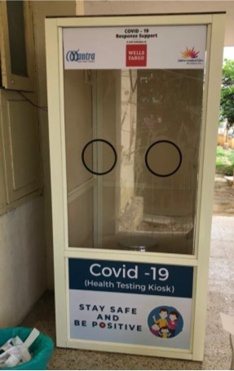
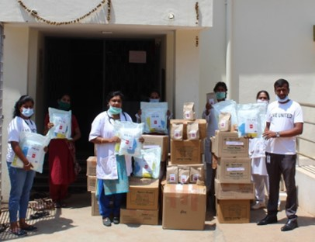
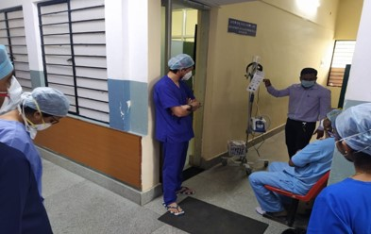
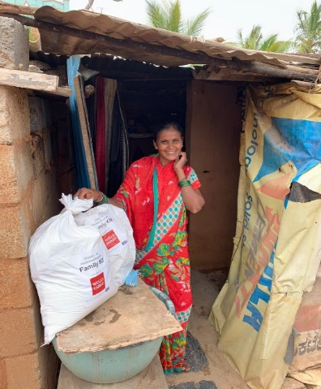
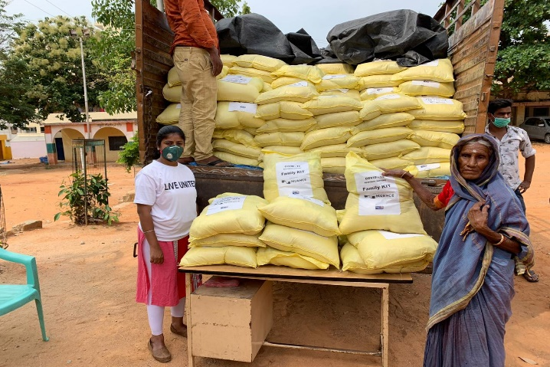
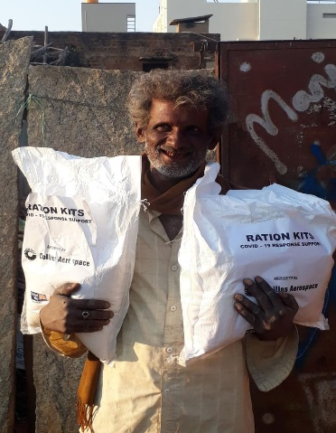
Figure 2: Distribution of kits & HFNC Machines in hospitals
Figure1: Distribution of Ration Kits

