Kampala Slum

Covid19 Lockdown: Food for Kampala Slum Families Facing Starvation

Slum dwellers live from hand to mouth. They work in the informal sector with no savings, no social security and no medical insurance. Men do odd jobs like carrying goods in the markets, loading lorries, washing cars, roadside vending of household products, working as porters on construction sites, gabage collection, and other menial jobs. The lucky ones are employed as operators of the ubiquitous motorcycle taxis (locally known as bodaboda).

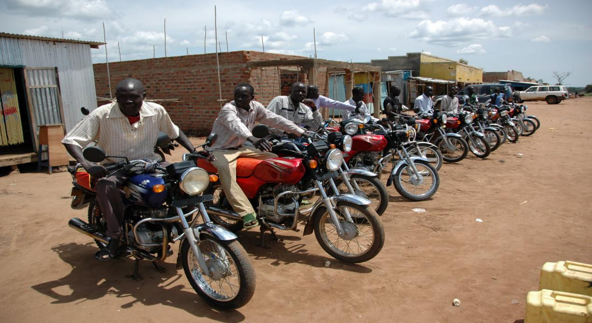

Slum women sell fruits and vegetables in makeshift stalls; sometimes sell fruits on the roadside carrying the fruit baskets on their heads, and sell cooked food in shack eateries. They also provide cheap services like braiding hair, child-minding, domestic cleaning, and other low skill work.

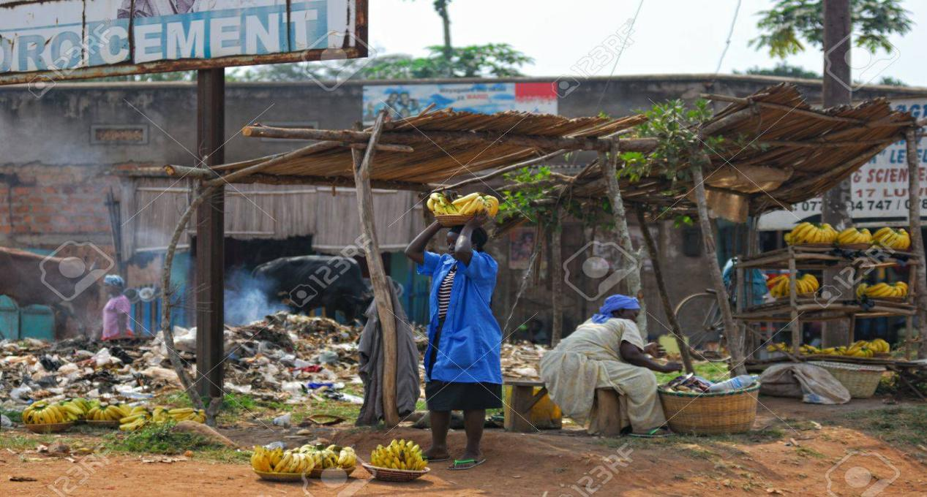

Families typically earn enough for their daily food and paying the necessary bills. When a family member falls sick, they have to forego food and other amenities like electricity in order to pay hospital costs.

Let’s take the example of the Musana family composed of Mr. James Musana, his wife Mary and three children. The children are attending a government primary school near their home. Mr. James Musana works as a laborer at a construction site. After paying for transport and lunch, his daily take-home income is about 3 US Dollars. His wife, Mary, sells vegetables in a make-shift stall near their home. After deducting her expenses, she makes an average profit of about 2 US Dollars. Many families in the slums earn less than the Musanas.

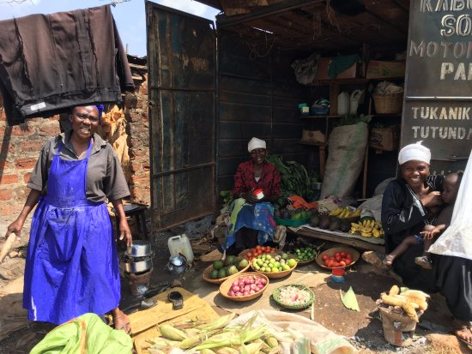

Under normal circumstances, an average family composed of 2 adults and 3 children needs at least 5 US Dollars a day for food alone. The breakdown is as follows: 2 kg of maize flour at 2 USD; 1 kg of beans at 1 USD; 0.25 kg of Sugar at 0.5 US Cents; 0.25 litre of cooking oil at 0.5 US Cents; tomatoes, onions and other vegetables at 0.5 US cents; cooking fuel (charcoal or firewood) at 0.5 US cents. The total is 5 USD, assuming that all of the family members have their meals at home.

The above calculation takes care of food alone. If we include the basic minimum of other services such as electricity, water, medicine, transport, communication, and schooling for children, an average family spends at least another 4 US Dollars per day, making a total of at least 9 USD per day or about 2 USD per person.

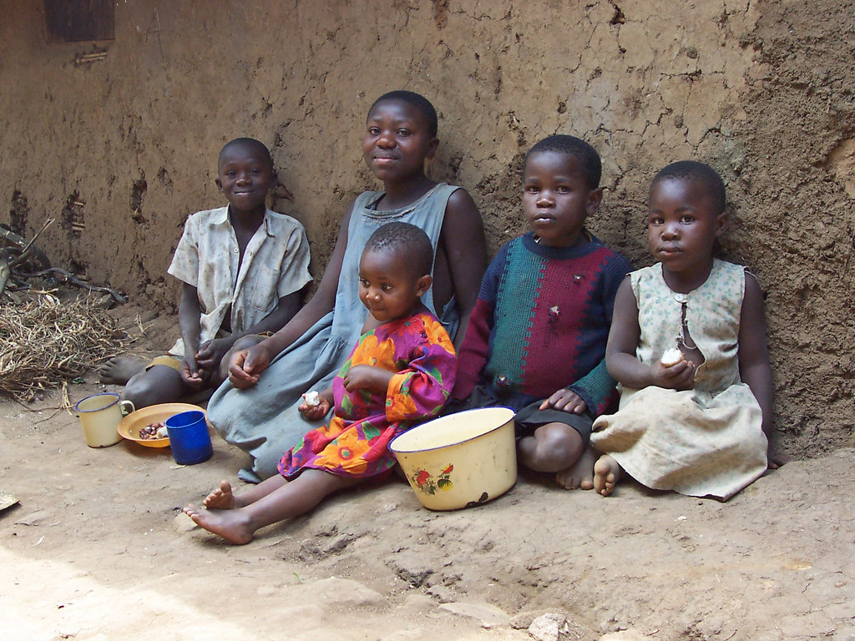

Now things have dramatically changed with the Corona Virus Pandemic.

On 19 March 2020, Ugandan President Yoweri Museveni announced stringent measures to contain the Corona Virus outbreak. These included the immediate closure of all educational institutions and all businesses in the city, and a ban on all means of public transport including the popular motorcycle taxis (also known as bodaboda). All local markets and petty businesses have been ordered closed.

The zeal and brutality with which the police and local authorities have implemented these orders have left virtually all slumdwellers without a source of income. Ugandans who live in the rural areas where food is grown can at least get access to basic food items. For those living in urban areas where everything has to be bought, lack of income means no food on the table.

Unfortunately the restrictions of means of transport, coupled with human greed, has increased the prices of foodtuff and other essential items by more than 100 percent only one week after the President made the first announcement.

This means that families that needed at least 5 US Dollars a day to survive, now need at least 10 USD Dollars. Yet their means of earning a living have been closed.

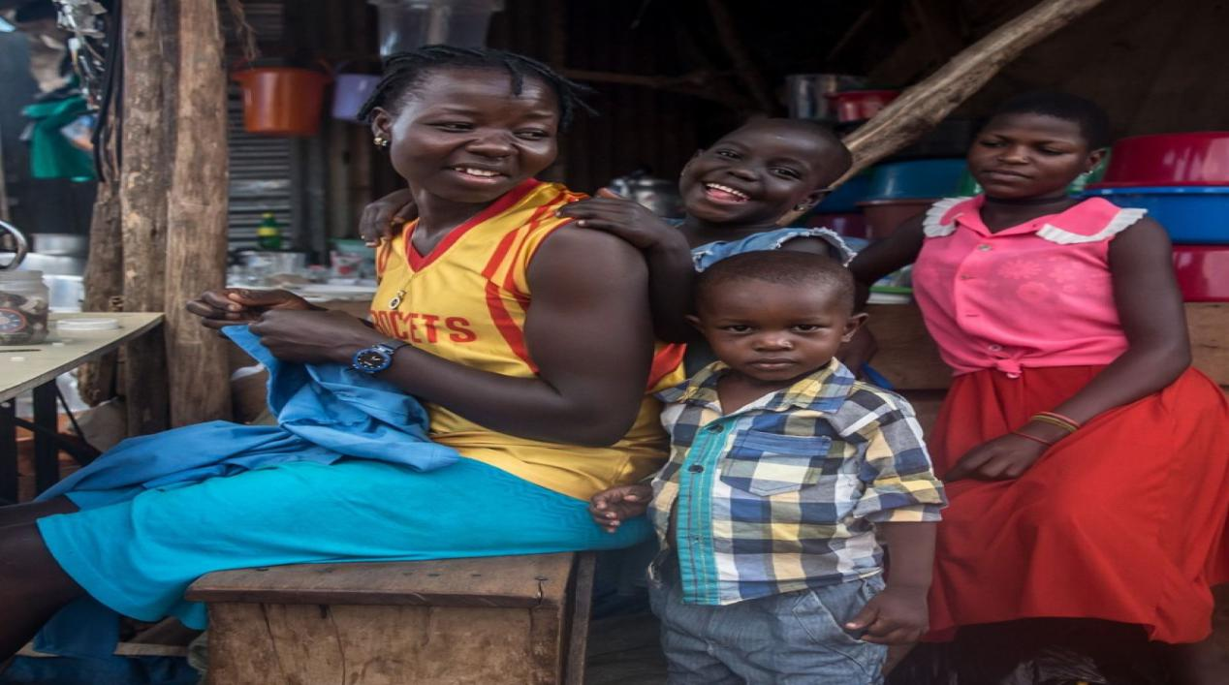

This is serious.

While we are worried about the possibility of some people getting infected by the Coronavirus, we should be more worried about the fact that millions of low-income people in Uganda, especially the urban poor, are already starving. And the situation is getting worse by the day.

You can save a life by contributing as little as 1 US Dollar.

May God bless you.

DONATION LEVELS

Food for 1 person 2 USD
Food for 1 family 10 USD
Food for 10 families 100 USD
Food for 20 families 200 USD
Food for 50 families 1000 USD

BACKGROUND OF THE ORGANIZATION:
Fitness Evolution ( FE) is a women-led organization established by a group of educated Ugandan women focusing on improving the lives of Ugandan Women. One of the founders, Rukia Kalanzi, explains its background as follows:

My name is Rukia, a Ugandan professional woman aged in the early thirties. I am telling you my story so that you understand the seriousness and urgency of empowering teenage girls livin in the slums. I spent my early childhood in the slums of Kampala, Uganda. My parents were teachers in one of the slum schools. We actually lived in more than one slum where I attended kindergarten and early primary school. I still vividly remember the terrible living conditions there: the congestion, loud noises, open sewers, rubbish, rampant crime, etc. Unlike most of my peers in those slum schools, I was fortunate enough to have a good secondary education which opened the way to university education and graduate school.

Sadly, when I think about it now, more than half of my friends from the slum schools are dead. Of those who are surviving, most of the boys are criminals on the street or in jail, while the girls are miserable women leading hopeless lives. Almost all of them dropped out of school at an early age, had children during their teenage years, got infected with HIV/AIDS, and are living with their children in the same filthy conditions with no hope of things improving. If nothing is done, their children are bound to go through the same cycle.

Considering that bleak picture, my friends and I established Fitness Evolution with the objective of empowering young women in Uganda’s slums and rural areas. We have so far conducted programs for the awareness, prevention and management of HIV/AIDS in schools and communities; promoting healthy lifestyles; reproductive health and hygiene; and sexual rights in general. With the help of our donors, we have also provided direct support to families in the form of food, clothes, scholastic materials and even assistance with tuition fees.

Contacts:
Email: kalanzir@gmail.com, Tel.: +256774070715; WhatsApp: +256792303455
Website: www.fitness-evolution.net

