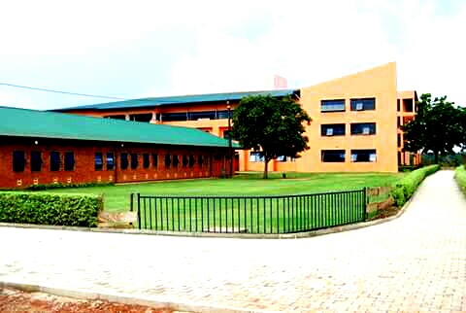
Project premise
Our motto : we work with God
Mission statement : To empower women through quality education, livelihood
Skills and God fearing citizen as an investment for steady
Development of communities.
Vision : To be global social support enterprise and educational giant
That the best understands and satisfies the needs and services of
Women globally
Our core values : Accountability
Integrity
Perseverance
Diligence
Professionalism
Objectives : To equip adolescent girls and women with skill for
Self-Reliance
To produce and promote women of high Integrity.

To prevent and reduce HIV prevalence in adolescent girls and
Women in schools, colleges, public places and communities.
To secure evidence on the impact of menstrual hygiene management informed WASH on girl’s education.
To equip the girls with ability, to contribute to the building of an integrated, self-sustaining and independent economy

Background of the projects
Harlon Nursery and primary school, promotes social and economic development, prosperity and Education to vulnerable communities helping adolescent girls, through free distribution of sanitary pads, social support Fund for underprivileged families, hands on skills for various economic productions, Many girls drop out of school altogether once they begin menstruating as a result girls miss 20% of school days in a given year due to luck of facilities like menstrual libraries, menstrual hygiene clubs in school, menstrual stigma, hunger during school or luck of information and inadequate sanitary products .
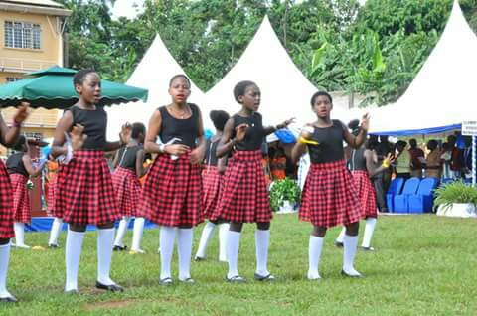
Adolescent Girls performing menstrual hygiene Poem
We should care and treasure menstrual hygiene management because it can further social and economic empowerment and growth. It can also contribute to achieving a number of sustainable Development goals including though not limited to quality education, gender equality clean water and sanitation.

Our concern in menstrual hygiene management is to make easy access to adequate information, preparation and support with which to manage menstruation in health, safe and dignified manner.

Student volunteers 2018

ADMINISTRATIVE STRACTURE (BOARD OF MANAGEMENT)
Names | title | qualification | origin
Barren sadra/Folds mike | Chief of party | M.A management | Australia
Catrina stayl | Head of outreach-SP | BBA | UK
Rilay joel | Head of outreach-ED | Social work | Ireland
wobayila Amos. w | Co-coordinator | Planning and management | Uganda

It is important to support our innovations and dozens of social responsibility and working to bring sanitary products and health education to women around the Africa. Going forward the

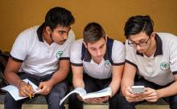
Education Team looking at the curriculum content that can simply integrate practical skills for self –sustenance

Our community Volunteering menstrual health

Organization will continue advancing and supporting menstrual hygiene management effort to ensure that young girls are seen and empowered through a holistic and inclusive approach in menstrual management in all schools
Our T.O.T showing a book on menstrual cycle occurrences To volunteers

Our inspirational message to the beneficiaries

Success will never lower its standard to accommodate you, Raise your standard, God provides food to every bird but not in its nest!
Our eyes are in front because it is more important to look ahead than to look back, Do not dwell on the past, learn from it and keep moving forward.
Do not pray for easy life, pray for strength to endure the difficult and work to come out successfully
Success is not accident, it is hard work, perseverance, learning, studying, sacrifice, and most of all,Love of what you are doing””

Sanitary products ready for free distribution to adolescent girls
When a girl finished secondary school, she is less likely to experience child marriage, face domestic abuse and suffer from long term health complications. As a result educated woman and girls are more likely to have fewer, healthier children, who are then, in turn more likely to get education and pull themselves out of poverty.
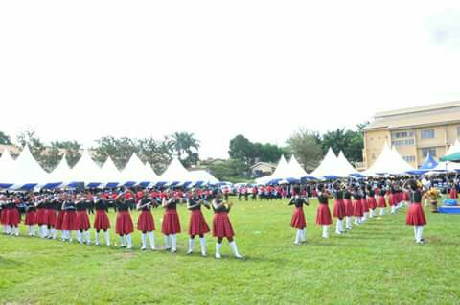
Training girls on life skills, and hands on to know their Talent and potential live good life
Improved menstrual hygiene awareness in school it address girls absence from school. The development of the society can be judged by measuring g the issues that extends educational inequality prevalent in the society.
Challenges
- Menstruation stigma and discrimination during periods, this leads to 131 million girls out of schools and this requires a lot of funds to curb it down.
In practice, this can leave serious consequences, girls are forced to stay in menstrual huts / homes far removed from their communities for example just in this February “ a girl died from smoke inhalation in a menstrual hut after she tried to make fire to keep herself warm”
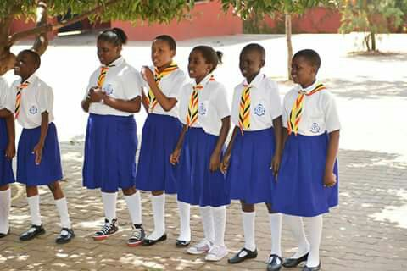

School menstrual club welcoming stigmatized girl back at school after 2 weeks absent

- High level of poverty this cripples girls in school women in both formal and informal sectors and this adopts them to use unhealthy menstrual solutions like rags, old newspapers, clothes barks, banana leaves etc. unclean materials can lead to vaginal infections, Bacteria infections like Hepatitis B and others
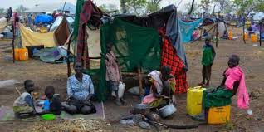

Families striken by poverty and hunger effecting women and
children in rural communites
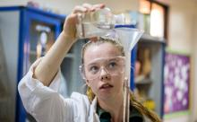

Testing and sampling the local materials

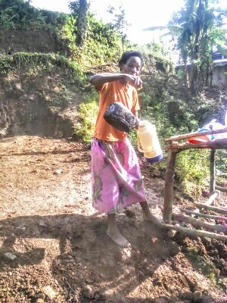

Woman indigenous community serving hot break TEA
Hunger at school for many poor families, school is the only place where children can expect a good meal. Reliably providing good meals is one of the top ways schools keep students from dropping out.

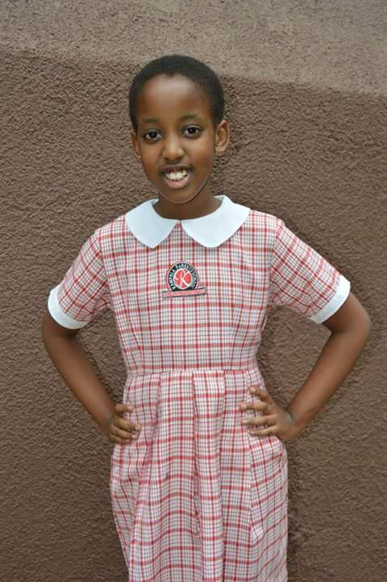

Adolescent girl posing photo after learning how to deal with menstrual stigma

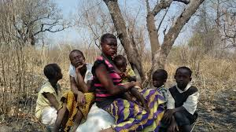

One mother caring for 5 children in poorest communities
Area affected with dry spell

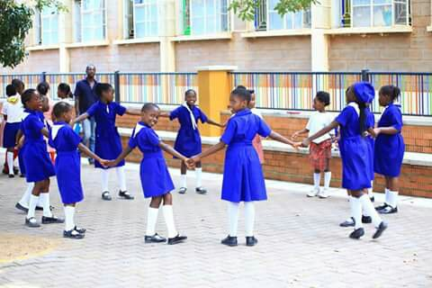
Teaching girls how Traditional cultures and beliefs affect girls future!

- Poor cultural attitudes toward girl child education some societies children do not feel that they are capable of learning, others considers children’s education finished once the child has learned how to read and write.

What we are doing on ground
- Identification of suitable local materials for making safe, affordable and re-usable pads and Training local tailors on how to make pads and priority is given to women pads producers groups.

- Supporting trained tailors in mass production of sanitary pads – Raw materials are provided.
- Establishing menstrual awareness clubs in school to handle menstrual stigma.
- Sensitize and mobilize school head and sector agencies in public school to set school with toilets for girl and boys doors with lock access to socially acceptable deposal facilities, access to water for washing near the toilets and space for changing.
- Advocating for a set of schools with menstrual hygiene management
- Providing financial live hood support to mothers, girls of disadvantaged communities to avoid transactional sex (sex in exchange of sanitary pads, food, shelter, school fees grades etc.

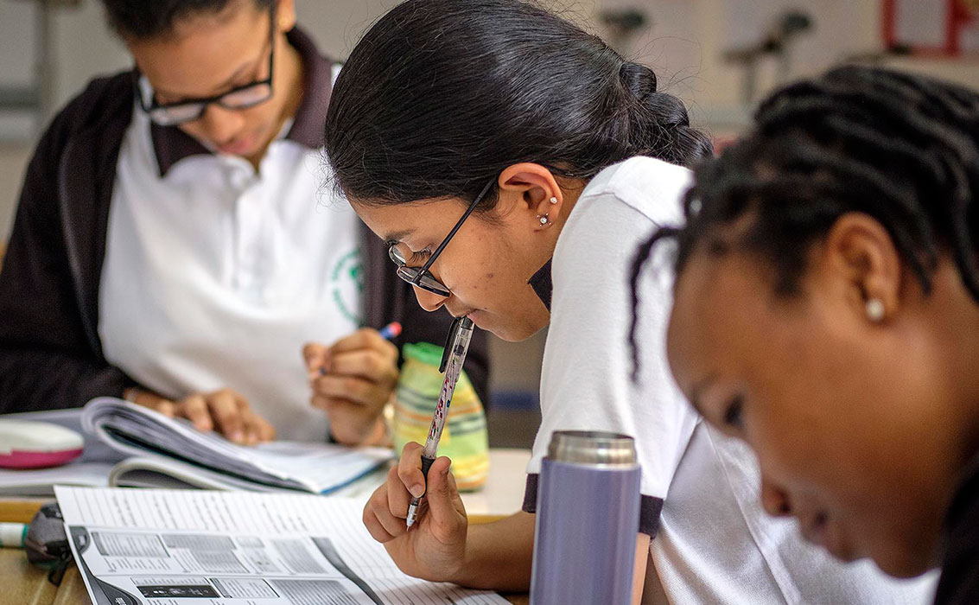
Looking at registers of beneficiaries of social livelihood for girls in schools

- Share resources.

- Female teachers in various schools and colleges have been trained and inducted to handle all menstrual cases and counseling session for girls to remain at school.
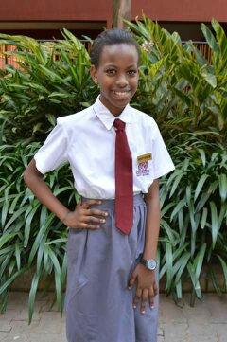
Agirl who was saved from menstrual hut in local village now she has hope for her future
- Development partners, Donors and well-wishers companies to invest more money in making the environment more favorable and sensitive for women globally

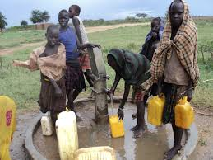
Borehole water provided by the organization to communities

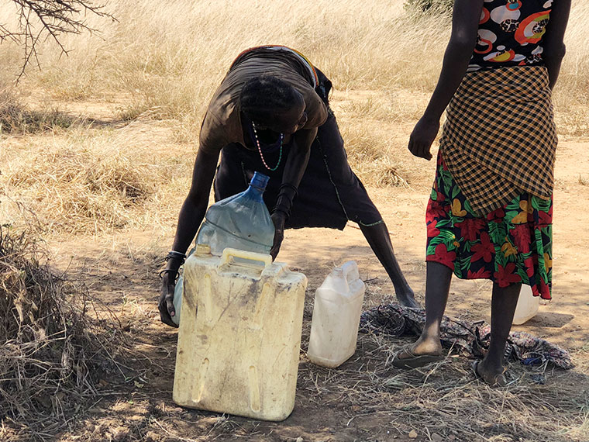
’Together as One Girls have to Shine” “
As women struggle for water possesses them to health challenges

- Compose poems, drummer videos to raise awareness on menstrual hygiene management in schools worldwide.

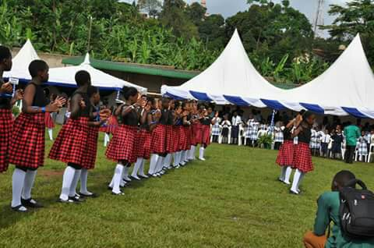

Girls on menstrual hygiene management awareness campaign

Our social concern to this cause!
- Once girls drop out of school or missing from classrooms while they are on their periods, it deprives them of getting quality education and right to human dignity violet. This has long term impact on their living economics status.

- If women are unable to maintain their daily life activities because of adverse circumstances that limit the proper practices of their MHM, they may not fully realize their potential ability, Talents.
- Countries may experience decreased productivity due to mental tension or even have to skip work for the time during their period. This can reduce opportunities for women to earn money, particularly women and girls who are employed in the informal working sector.
- Menstrual hygiene management is not only linked to education but also to gender equality in general and the empowerment of women, which has and it embed the millennium development goals for communities’ nations.

RECOMMENDATIONS,OBSERVATIONS AND APPEALS

Based on the above discussion, our experience provides a few important recommendations which the policy planners may adopt for future intervention.

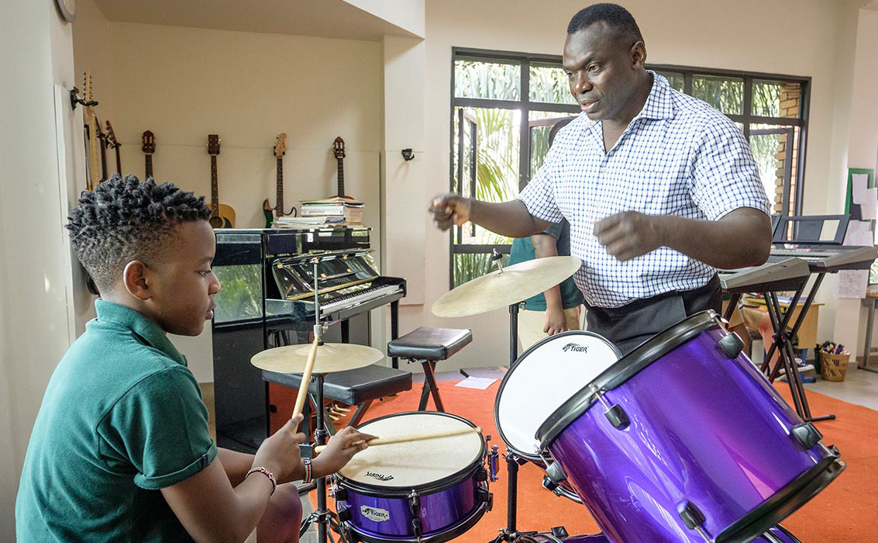

Teaching Student other Alternative Skills ( School Drop Outs)

All education sector players should plan some special policies to improve female education like introducing special stipends for female students and so making education free for them.

Although some countries have already taken some steps in this regard, it is important to expand for other countries mostly African communities

It is also necessary for schools, to invest more money in making the environment favorable and sensitive for girls.

Ministries should also provide school supplies adequately according to the demands of the students. In both primary and secondary schools.

Trained and qualified female teachers especially during the developmental stage of girls should be made available which can also prevent pregnancy problem among girls leading to dropout.

Using wet (washing of cloth is very common in schools, skin irritations. The absence of appropriate sanitary facilities, like toilets, sufficient amount of water and soap can also present a challenge. If there are no or not enough gender separated toilets the adolescent tend to leave class to go to forests or home to change pads and sometimes do not return.

Prospecting for hidden places additionally exposes them to risk of getting harassed, abused or kidnapped and to other kinds of danger.

The lack of waste disposal and places for washing, either oneself, cloths or used materials, can lead to shame and embarrassment as well as foster unhygienic circumstances, this can facilitate the spread of bacteria or infections like Hepatitis B which does not only affect the girl herself but also her environment.

Some girls could potentially access sanitary items but do not have the financial means due to poverty and /or social support. Girls in Uganda for example engage in transection sex’. They thereby offer sexual services to men in exchange for presents’ like sanitary pads or cash which they invest in pads.

In some African societies, menarche is associated with a girl’s readiness to get married. The risk of early marriages and pregnancies often followed by dropouts from school thus increases. These challenges inhabit girls and women, particularly in under-developing countries, in their daily life activities during menstruation.

The consequences resulting from those inadequate conditions for religious scripts such as the Bible or the Quran or are verbally delivered. Additionally they are interpreted differently depending on the region or sub-group (especially casts in the Hindu system) and are abided by more or less strictly.

Many African females are confronted with restrictions which they have to follow, sometimes out of fear of undesired consequences. There are restrictions on using water sources, eating certain types of foods and on cooking and bathing. Some are excluded from societal activities such as religious ceremonies family or outside the house.

Others are not allowed to get in contact with men. These practices have the potential to restrict girls on attending school. Hence, it is fairly obvious that the lack of knowledge Challenges them and in consequence hampers their school Attendance.

Their physical and mental well-being can further more be influenced by menstruation. Some girls perform worse in school due to lack of concentration because of pain or shame.

Due to the stigmatization, girls’ need to handle menstruation with dignity is often disregarded.
This is reinforced by poverty because the acquisition of goods needs to be prioritized and traditional gender Roles favours men in the decision making processes.
Due to the lack of involvement and lack of social support, girls face difficulties to access appropriate infrastructure and sanitary items. Sanitary items are too expensive. A box of eight to ten sanitary pads costs for example in Uganda between 0.70$ and 1.20$.
This represents, for families with many females, a financial burden and is often not affordable.
Girls are thus often afraid to stain their clothes and therefore prefer to stay at home during menstruation.

The absence of safe sanitary item further forces girls to find alter-native ways of handling their menstruation. They thus either use alternative methods such as toilet paper, rags, cloth, banana leaves, mud or resign from sanitary protection at all. These materials offer minimal absorption and still pose the risk of leaking and staining their clothes.
This in turn affects their mental well – being as they often feel fear, shame, embarrassment and stigmatization. Unhygienic materials further more foster the risk of adverse impacts on health. Unclean materials can lead to vaginal infections.
Gender equality is one of the main aims of the millennium development of communities the fact that at some educational levels this equality is still not achieved has led to enquiries about the causes of the failure of the economies
Our research through communities reveals many girls in undeveloped countries are challenged by management of menstruation in their educational settings. Absenteeism during menstruation is a consequential occurrence that can potentially lead girls to drop out of school completely.

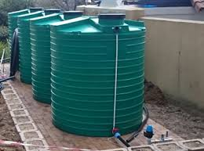
Water extension to public places to unable girls eccess easily
We have established programs aiming to improve the management of menstrual hygiene in the respective communities.
We believe that, good menstrual hygiene management (MHM) has far broader potentials and can contribute to fulfillment of other economic aspects as well, MHM-programs are credited with the overall goals of increasing school attendance
“””””””””””””””Together as One girls have to shine”””””””

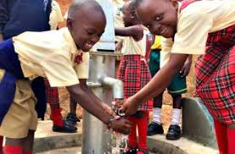

School girls washing hands at bore hole

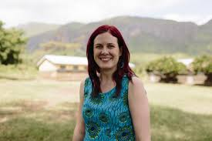
Volunteering in water extension to public schools

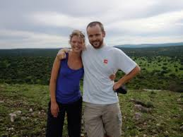
Community hygiene and safe water campaign coordinators

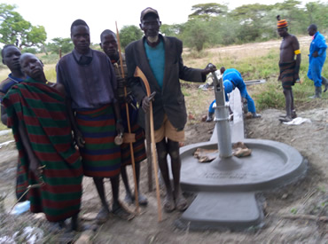
Young girls and women are given hope for the future water has been provided

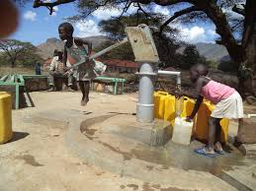
Safe and clean water

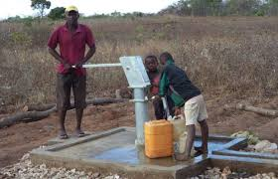

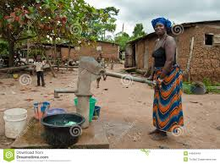

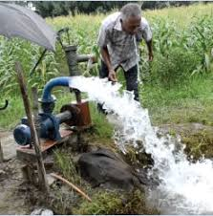
Water extension is among ways of solving menstrual hygiene in girls

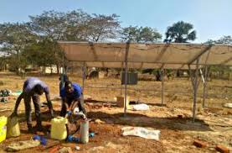
Water extension

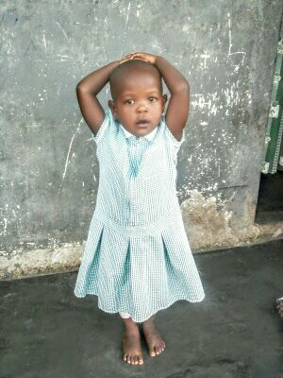
Girls of 4 years age, under care

Work plan for social support and community out reach

ACTIVITY | TARGET | OUT PUT | BUDGET | PERIODS (TIME FRAME) |  |  | MODE OF VARIFICATION
Building capacity to make reusable pads (locally) | 130 girls. | Sanitary pads locally produced (made) | Ugx 19.06 m  USD 513.1 | TERM I  UGX 6.353 M | TERM II  UGX 6.353M | TERM III  UGX 6.353M | - Reports.  - Payment voucher  - Attendance.
Instructional material for manufacturing- reusable pads | 3.5 bales of cotton fabrics | 120 reusable pads | UGX 20 M  USD 5405.4 | UGX6 .6 M | UGX 6.6 | UGX 6.6M | - Reports.  - Payment voucher  - Attendance.
Training in advocacy and policy on menstrual hygiene management. | 200 adolescent girls | Menstrual hygiene improved among adolescent girls | UGX 14 M  USD 3783.7 | UGX 4.6 | UGX 4.6 | UGX 4.6 M | - Reports.  - Payment voucher  - Attendance.
Procurement of sawing machines. | 45 sowing machines | Sowing machine bought | UGX 13.5M  USD 3648.6 | UGX 13.5M | - | - | - Reports.  - Payment voucher  - Attendance.
Training of counselors on HIV/AIDS epidemic in children. | 10 counselors | Counseling skills acquired | UGX 9 M  USD 2432.4 | - | UGX 9 M | - | - Reports.  - Payment voucher  - Attendance.
Training on the use of antire traviral Therapy. | 10 health works | Management of antiretraval Therapy Skills acquired | UGX 9 M  USD 2432.4 | UGX 9M | - | - | - Reports.  - Payment voucher  - Attendance.
Training in poled and nutrition for children under 5 years. | Community Health workers | Nutrition skills and knowledge acquired | UGX 9 M  USD 2432.4 | UGX 9M | - | - | - Reports.  - Payment voucher  - Attendance.
Hands on skilling for school dropout girls. | 200 girls reached | Basic practical skills acquired. | UGX 14M  USD 3783.78 | UGX 4.6M | UGX 4.6M | UGX 4.6M | - Reports.  - Payment voucher  - Attendance.
Procuament or stationary materials | Assorted | Stationary bought | UGX 4M  USD 1081.08 | UGX 1.3M | UGX 1.3 M | UGX 1.4M | - Reports.  - Payment voucher  - Attendance.
Procurement of make shift Tents & chairs | I big Tent & 100 chairs (plastic) | Furniture bought | UGX 8M  USD 2162.16 | UGX 8M | - | - | - Reports.  - Payment voucher  - Attendance.
Adult classes for women community | 60 women | Women are trained to read and write | UGX 6M  USD 1621.6 | UGX 2 M | UGX 2M | UGX 2M | - Reports.  - Payment voucher  - Attendance.
Improving of sanitation and hygiene in communities | 150 families | Hygiene & sanitary improved places, slum areas. | UGX 35 M  USD 9459.4 | UGX 7M  11.6 | UGX 11.6 | UGX 11.6 M | - Reports.  - Payment voucher  - Attendance.
Provision of clean and safe water | 5 bore holes | Clean and safe water provided | UGX 35M  USD 9459.4 | - | UGX 35M | - | - Reports.  - Payment voucher  - Attendance.
Total project cost. $ 50,000 to run the 13 activities thought year.

OUR BUDGET FRAME WORK PAPER
- Capacity building
- Facilitation of instructors 2@ 300,000 x 3 month = 2m
- Stationary @ 2m
- Meals & drinks transport refund @ 10 5m
- Out pocket @ 5m
- Instructional materials
- 3.5 bells of cotton fabrics each @ 5714.2 x 3500kg = 20m
- Training in advocacy & policy on menstrual hygiene management
- Mentrual hygiene management
- Facilitator 2m
- Stationary 2 m
- Meals drinks 10m
- PROCUREMENT SOWING 45 Machines x 300,000 = 13. 5m
Machines
- Training of consellors on
- HIV/AIDS
- Facilitation for trainer 2 @ 500,000 per month x 3month = 3m
- Stationary all @ 2m
- Per night @ 30,000 x 10 people x 90 days = 2.7 m
- Meals and drinks all @ = 1.3 m
- TRAINING ONE USE OF ANTIRETRAVAL
- Therapy
- Facilitation 2 @ 500,000 per month x 3 month
- Stationary all @ 2 m
- Per night @ 30,000 x 10 people x 90 day = 2.7 m
- Meal & drink all @ = 1.3 m
- TRAINING IN FOOD & NURTRITION
- Facilitation of trainer @ 3 m
- Stationary @ 2 m
- Meals @ 1.3 m
- Per night @ 2.7 m

- HANDS ON SKILLING ON SCHOOL DROPOUTS GIRLS.
- Facilitation 2 @ 2 m
- Meals & drinks @ 10 m
- Stationary all @ 2 m
- PROCUMENT OF
Assorted stationary all @ 4 m
- Procurement of make shifts.
- Tents 1 big tent @ 3 m
- Chairs plastic 100 chairs @ 50,000 x 10 = 5m
- ADULT LITERACY CLASSES FOR WOMEN COMMUNITY
- Instructors 3 @ 150,0000 x 12 month = 5,400,000/=
- Stationary all @ 600,000 = 600,000/=
- Improving of hygiene of sanitation in a community
- Drilling machine 2 days @
- Water pipes
- Provision of clean water and sanitation$
10 bore holes each each @ 3,500,000 m = 35m
Safe water to community

Total budget 180.000,000/= UGX
Total Amount in $ USD 50,000$

