PROGRESS REPORT ON AWARENESS AND PREVENTION OF COVID 19
- Project Goal and Objectives :
KARMI works in Golamunda and M.Rampur blocks of Kalahandi district and Boden block of Nuapada districts on awareness and prevention of COVID 19 since the problmes arise in the blocks when about 15000 migrants have been return back form the metro cities who are migrated there as seasonal migrants. The lack of awareness on the novel corona virus was a challenge. KARMI undertaken the programme and improving relief and rehabilitation of migrants who have been returned back from metro cities by effects of COVID 19 and lose their livelihood and employment. Thousands of human beings lost their respectful lives due to this dreadful disease. Presently the migrants, elderly, children and women need essential services like food, medicine, kits, and relief materials immediately and long-term relief and recovery to the helpless deprived. The remedial majors has been taken and check the spread of Corona virus is to educate people and distribute soaps, masks, sanitizer to the vulnerable communities. The illiterate and rural masses are getting scared about this dreadful disease. KARMI have been undertaken the programme on through awareness generation, keep preventive majors and meet the emergency need of the victim people specially the migrant families who are working in the metro cities and daily wage earners. Mass gathering, and coming to home is also a major problems in transport sector supply by government machinery and other voluntary agencies. Due to curfew and lockdown poor people, daily wage earners, small venders, children, women, disable people are suffering a lot of problems like food, water and other essential commodities. Presently in an emergency need these communities’ needs hygiene kits, emergency community outreach, relocation assistance. KARMI undertaken programme on providing of rasan, cooked food, sanitizers, and given priority on awareness and mobilise to maintained the social distancing.
KARMI undertaken programmes on providing direct support for risk people of Coronavirus such mask, soap, sanitize item and livelihood support to the daily wage workers families, who lost work and earning. The precaution on the aged people and big awareness and counseling to poor and marginalized people is also a main component of the project. This needs to be facilitated to access ongoing social protection schemes and programmes including the welfare package announced by the central and state government to cope with ongoing COVID crisis. Sensation on issue of COVID, strengthen the Panchyatraj system, Paramedical workers, community mobiliser, and cadres to cope with situation and It will support Creating a community cadre at the block level, Spreading awareness of the various social protection schemes, Building capacities and supporting the frontline workers and PRI functionaries, Technical support to local administration especially the Gram Panchayat and the Block in accelerating the opening of MGNREGA works with proper preventive measures and, increase uptake of work and ensure employment to the migrants workers and their families. Create awareness on social distancing and other preventive measures for COVID 19 among the various target groups.
The Govt of India stricken on use mask to safe from the pandemic and it was compulsory for every body. So KARMI take necessary arrangement on shortage and distribution of face masks by collect free avible and purchase some general fund money and distributed to the target people. We distributed 4000 masks in M.Rampur and Golamunda blocks But panic buying of the masks made the situation even worse. Amid all these, the SHG women started making masks so that each and every citizen of Odisha will have an access to face masks as government made it compulsory to use while stepping out of the house. Our Team members started distribution of these masks in different villages & slums to check the spread of the virus.
KARMI given special emphasis on awareness of the Pandemic as much as by keeping social distance and using sanitary. We try our level best to inreached all the target area but due to lock down it was difficult for to reach everywhere. We keeping social distance and also demonstrated on the usage of face masks & hand washing with soap and water. We also aware the target people to avoid touching their faces as it increases the chance of getting infected to safe them by corona 19.
KARMI during this pandemic, when he has no income, no opportunity to work and earn, it becomes difficult for him to feed himself & his family. Then he’s left with two options: either to starve or to break the lockdown rules set by the government, which will in return increase the 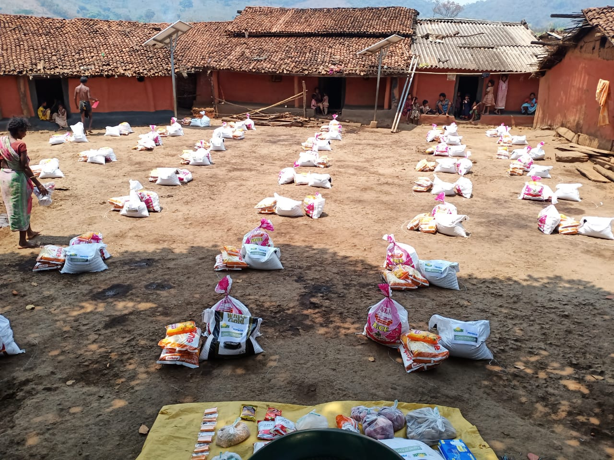chances of spreading of the deadly virus in the community.
KARMI provide necessary to the cadres on the Social Protection in the crisis period of COVID 19. Enhancing their capacity to manage economic and social risks and accordingly link with social security schemes. Vulnerable households will be facilitated to access ongoing social protection schemes and programmes including the welfare package announced by the central and state government to cope with ongoing COVID crisis. The project team will at least reach 20, 000 Households with information on social protection schemes of the Centre and State governments in the defined geographies. The Community cadre will facilitate linking of rural households to social protection schemes by assisting filling applications and supporting PRIs to facilitate registrations. Minimum of 20,000 Households will be linked with at least one of the social protection benefits. KARMI has been focus on entitlements programmes of Government and try to level best to ensure 20 entitlements of each migrant family. Linkage with social security schemes and financial services, proper implementation of Government programmes as linkage with MGNREGA, insurances, and pension schemes, PMAY, Ujala, and other entitlements services. Apart from that KARMI undertake programme like organise the unorganized sectors through collectives, leadership building, and capacity building of collectives by operative Migration resources in the GP and Block level and proving services to the migrants and their family members.
KARMI presently working with the MGNREGA Arrest migration programme implement by Govt. of Odisha through DRDA in Golamunda, Boden and Khariar blocks to provide 200 days works to the job card holders. Following the above approach the PI will conduct the capacities of the PRI institutions in the identified geographies to analyse the trend of pandemic spread in a specific area and develop readiness plans. The focus will be on number of cases, tracing COVID cases and identifying probable cases, addressing the village level and panchayat level initiatives that need to be carry out and how to link to state responses. The PI will Coordinate and support local administration especially the Gram Panchayat and the Block in accelerating the opening and uptake of MGNREGA works with proper preventive measures. The PI will give specific focus for uptake of works by the most vulnerable groups like migrants household, women headed households, SC/STs, and who have been came back during the COVID period from destination no have work or jobless etc. The PI will provide technical support to district/block administration in providing authentic information about the decisions of the central, state government and local administration on implementation of MGNREA. Further, coordinate with the government institutions to identify and reach out to the left over beneficiaries of other social protections to accelerate delivery of the benefits. The workers who are working with Arrest migration programme also partly work for the project in a convergence mode and the project also help them to strength their capacity and able to give an opportunity to use their full potentiality to fight against the adverse effect of COVID 19.

