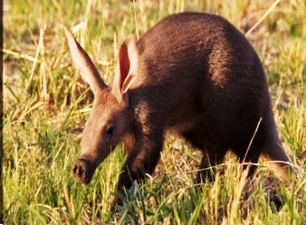
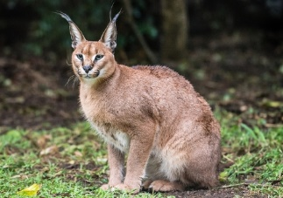
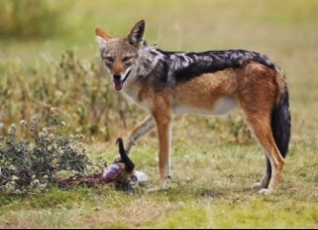
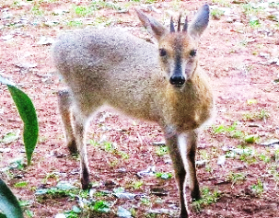
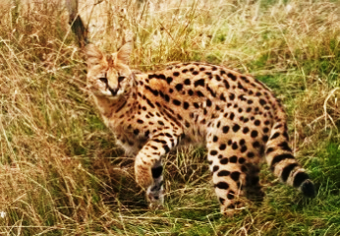
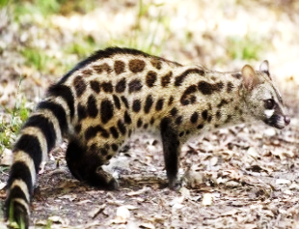
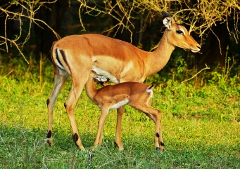
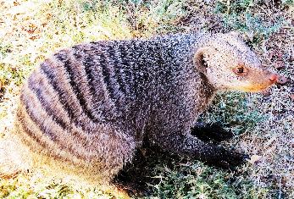
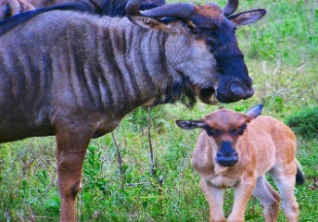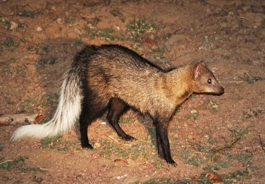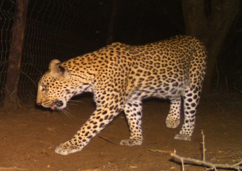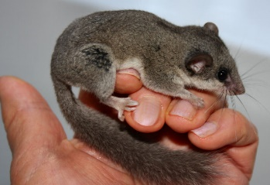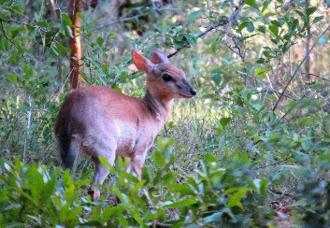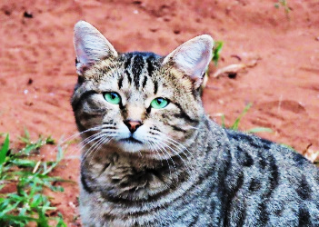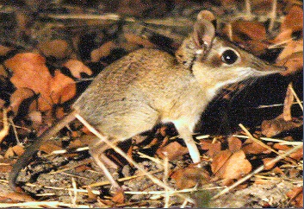
MAMMAL SPECIES
LEOPARD WALK NATURE RESERVE -SUNI- RIDGE CONSERVANCY –
(Photos selected own + free sources)

Black backed jackal Lupukella mesomelas
Serval Leptailurus serval
Large-spotted Genet Genetta tigrina

Caracal Caracal caracal
Leopard Panthera pardus
Dormouse Gliridae
White- tailed mongoose Ichneumia albicauda
Suni Antilope Neotragus moschatus
Blue Wildebeest Connochaetes taurinus

Aardvark Orycteropus
African Wildcat
Felis lybica
Grey duiker Sylvicapra grimmia

Impala Aepyceros melampus
4 toed elephant shrew Macroscelididae
Banded mongoose Mungos mungo
Porcupine Erethizon dorsatum

