****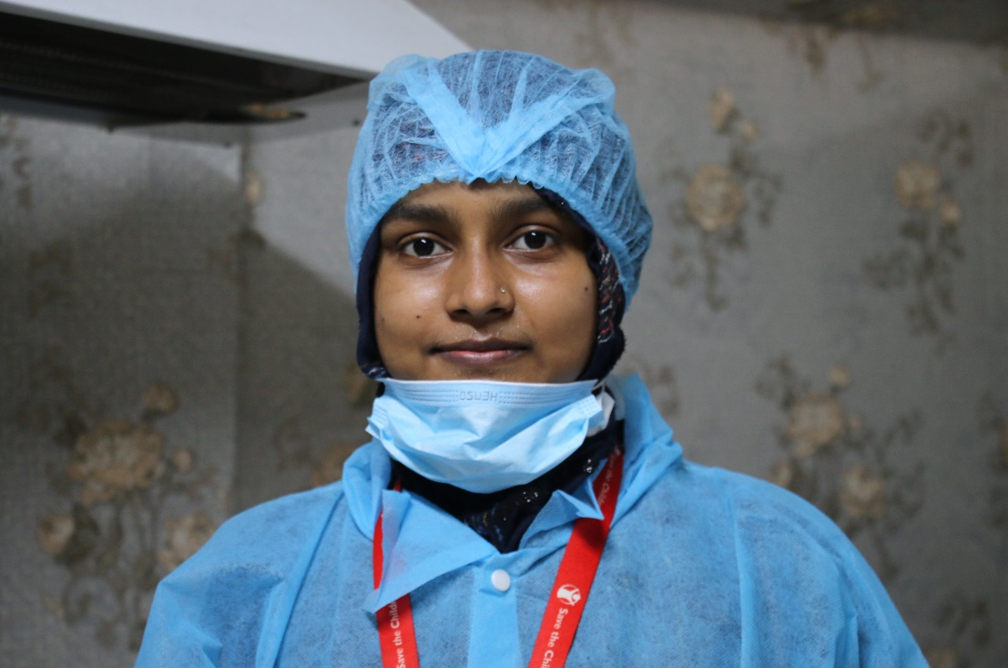

**JULY 2020**

**Keeping children and families safe:**Supporting children separated from family or care, supporting parents to keep their children safe, connecting those at risk, especially women and girls, to support networks, social workers and other protective services.

**Saving lives by preventing and managing the pandemic**: Maintaining life-saving health services, expanding the reach of community health workers to fight COVID-19, and protecting the most vulnerable, at-risk populations like refugees, displaced families and communities affected by conflict.

**Helping children learn, stay safe and return to school:**   
Creating opportunities for distance learning and building psychosocial well-being, supporting teachers and parents and providing guidance to governments and schools on how to support children as they return to school.

**Supporting family survival and food security:**Scaling our cash assistance programs, providing food and other essential items, and supporting governments to create and provide safety nets for those living in poverty, as well as the millions who will become poor.

Sharmin is a midwife at our primary healthcare facility in a Rohingya refugee camp in Cox’s Bazar, Bangladesh. In addition to the center, which provides essential care to refugees and people from surrounding communities, we have opened a COVID-19 isolation and treatment facility in coordination with the World Health Organization. It provides a higher level of care to those with COVID-19, and has a dedicated area where women with the virus can safely give birth.

*Photo: Sonali Chakma/Save the Children*

Skyrocketing cases of COVID-19 in the U.S. and global hotspots in Central and South America and South Asia are prompting warnings from the World Health Organization and global health experts that the pandemic cannot be checked unless governments and people do more to suppress the rapid spread of the virus.

Our U.S. and international teams are on the front line of the global fight to reduce transmission and mitigate the pandemic’s impact on the most vulnerable children and families – from America’s remote rural communities to densely packed refugee camps where social distancing is impossible. As the virus spreads we are innovating and sharing learnings across our country offices to quickly respond as conditions drastically change.

**Pillars of Our Response:**

**Responding and Innovating in the U.S. and Internationally as COVID-19 Surges**

**We are working nonstop, sharing what we learn among our teams and building our global knowledge for this response and for future disease outbreaks.**

**JULY 2020**



**A Lifeline to Those in the Rural U.S.**



Over the first months of our response, Save the Children interacted with nearly 40,000 children each week, providing them with a broad array of support, focusing first on distributing food, education materials and other essentials to keep them safe and healthy.

To date, we’ve supported the delivery of more than 1.8 million meals to families and have helped schools sustain their food programs through small grants. These grants made a difference in keeping children’s hunger at bay in places like the Lake Quinault School District in Washington State, where the local food bank recently closed, and in Morgan County, Tennessee, where there is no major grocery chain. This summer, we are partnering with a national dairy company to provide 8,000 gallons of milk a week to families in four states who are struggling with the pandemic’s economic fallout.

We also provided over 2 million items, ranging from hygiene supplies, clothing, learning materials and toys to rural families facing financial hardship.

Our new pilot project in rural California and Kentucky is providing over 800 families enrolled in our early childhood development program with prepaid cards to cover essentials like food and health care. Our local staff, who already work with these families, will provide coaching on nutrition, smart grocery shopping, healthy eating and financial literacy.

Our virtual summer learning programs and book deliveries are reducing learning loss and keeping children engaged in reading. We also continue integrating our disaster-proven psychological and emotional support programs into our pandemic responses to help children build their resiliency to the daily stresses they are facing.

**Around the World: Spotlighting our Commitment to Children’s Education**

In every emergency, we prioritize children’s quick return to learning and minimizing disruptions to their education. Children and parents repeatedly tell us that education is the key to their future, their protection, their happiness and their health.

For the first time in history, an entire generation of children globally have had their education disrupted. Some 1.2 billion children remain out of school today because of COVID-19.

As the virus begins to subside in some countries, early childhood centers and schools are beginning to reopen. Our education teams are working with education authorities in these communities to help plan for teachers’ and children’s safe return.

In places where schools remain closed, we are developing and distributing distance-learning materials, such as books and home learning kits, and partnering with governments and teachers to provide children with lessons and support via radio, television, phone, social media and messaging apps. We provide guidance for parents and other caregivers so they can support their children’s learning at home.

On July 13, we launched *Save our Education*, a global campaign to mobilize governments, countries and donors so that COVID-19 does not rob children of the future they deserve. It sets out a plan to keep children learning and get them back to school when it is safe.

We’re calling for a global emergency education response for children like Hamza, 13, a displaced Syrian boy who told us: “I want to learn here and to become a teacher when I grow up. I want teaching to be my future.”

**In our 101-year history, Save the Children has never mobilized such a sweeping humanitarian response – one reaching vulnerable children and families simultaneously in the U.S. and around the world. Your generous support will help us sustain and scale work that’s critical in alleviating needs the pandemic has created.**