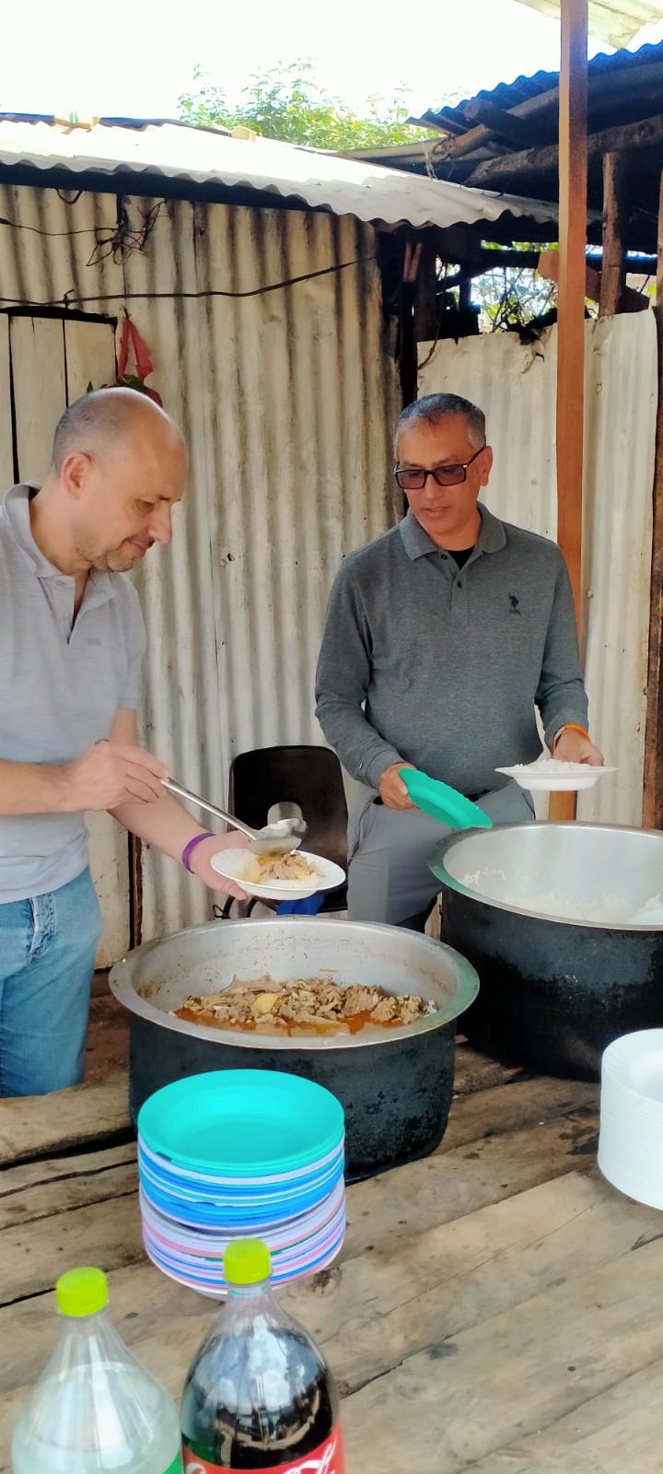
Dear Esteemed friends,
You have helped us raise $571 since we launched the project our target is $3000.
Many poor families living in Slums are starving due to high food prices. One meal per day is proving impossible. Your donation will help feed a child every day from poor families living in sprawling slums of Nairobi.

We feed several children every day by providing breakfast and Lunch.
The fund will help poor families build resilience during this hard economic times of hiked food prices. Lose of livelihood has made life very difficult and unbearable for most poor families and they need help to help them stand again and live normal lives. This project will help poor families become resilience and revamp back to normal lives. They will be able to return their children back to school and grow their income once again and be able to feed their families. The project will break the long chain of deep seated poverty through education of children and grow family economy through micro business and provision of stable food through keeping of livestock and farming.

