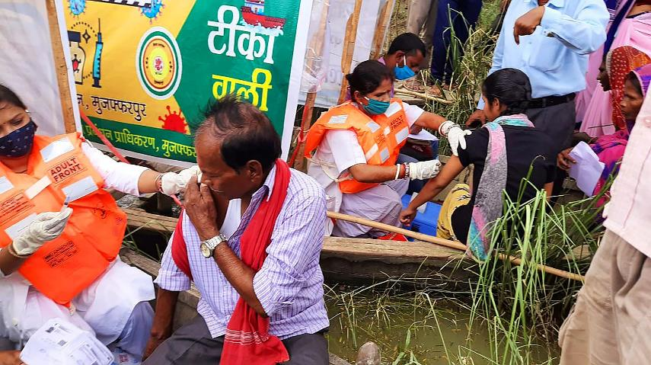

COVID-19 SECOND WAVE FUND

Harnessing collective power to combat a global pandemic

Background
The massive second wave in COVID-19 infections has completely overwhelmed fragile health systems in many countries since April 2021. Hospitals ran out of beds, oxygen and personal protective equipment (PPE). Most rural areas lack proper testing facilities or healthcare infrastructure, and vaccine hesitancy remains high in many communities due to misinformation. Indeed, the pandemic’s impact is only beginning. Most low-income countries have not yet felt the full effect of COVID-19 and its emerging variants. The virus and the economic aftermath likely will push 426 million people into poverty – more than the population of the U.S. and Canada combined – and potentially reverse development progress by up to 10 years.

To counter these challenges, we must fight harder than ever. Your support to CARE’s COVID-19 Second Wave Fund has helped us provide lifelines – establishing COVID treatment centers, supporting vaccination campaigns, delivering nutritious food, and supporting economic recovery. The evolving situation has highlighted the importance of flexible funding that can be allocated quickly where it’s needed most. This report highlights some of CARE’s response activities in most-affected countries that received immediate resources through the Second Wave Fund. Overall, we allocated funding to Afghanistan, Bangladesh, Honduras, India, Indonesia, Nepal, Pakistan, Papua New Guinea and Vietnam.

CARE is on the ground in these and other countries that are struggling to hold their ground against the COVID-19 resurgence. We have integrated COVID prevention activities into existing projects around the globe, and CARE teams are hand-carrying vaccines on walking paths or making deliveries by motorcycle or boat to ensure that the lifesaving shots reach people in the hardest-to-reach communities and do not expire. Speed is of the essence, and you have helped enable that through the Second Wave Fund.

CARE’s Response
Since CARE was created 75 years ago, emergency response has been embedded in our DNA. Even before the second wave started in early 2021, we had mounted the largest emergency response in our history to combat COVID-19 and increase awareness of the escalating threat of gender-based violence during the pandemic. CARE acted fast on the frontlines in 2020, reaching 40% more people through our emergency response programming compared with 2019. Today, over a year and a half later, we are seeing the ripple effects of the pandemic on the world’s most vulnerable populations, especially women and girls. While CARE’s response has been extensive, and vaccines bring new hope, the crisis is far from over. We had set a $60 million goal for second-wave support. To date, we are at 44% of this goal ($26.3 million). Full funding is needed to sustain CARE’s response over the coming months and ensure that fast and fair vaccination initiatives reach marginalized populations.

Examples of CARE’s interventions supported by the Second Wave Fund to date include:

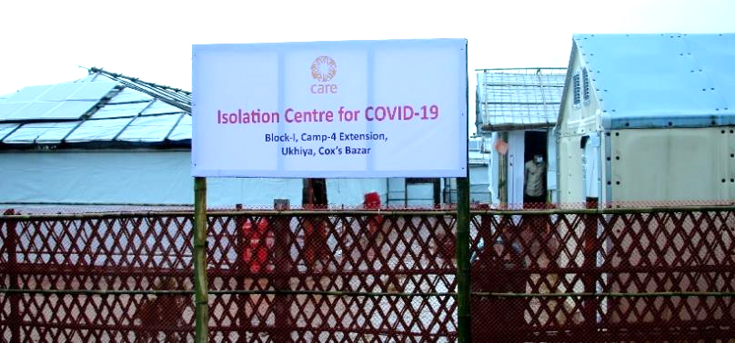
Bangladesh has had 1.56 million confirmed cases of COVID-19, with 27,531 deaths. The country went on lockdown from July-August 2021 as second-wave cases escalated. CARE has been distributing PPE to frontline health workers and community volunteers; supporting COVID care centers for patients in Dhaka, Gazipur, Narayanganj and Chattogram; training government frontline health workers to improve the vaccination process; and orienting community health volunteers on vaccination registration and awareness to reduce stigma and misconceptions. Of particular concern is the Cox’s Bazar district, where 860,000 Rohingya refugees live in the world’s largest refugee camp. High population density, poor hygiene practices and unsanitary conditions are fueling the perfect environment for the virus to spread. In Cox’s Bazar, CARE is building isolation centers as well as using our existing health posts and outreach clinics to refer suspected COVID-19 cases to the isolation centers for testing and further support. Most recently, on August 1, we established a 30-bed isolation center in Camp 4, in collaboration with the government and using resources from the Second Wave Fund. Isolation centers provide separate areas for female and male patients, washrooms, solar electricity, meals, medicine, oxygen, ambulance services and 24/7 care from doctors and other health professionals. Severe cases are referred to intensive care centers for advanced treatment. Moreover, CARE’s community outreach activities in Cox’s Bazar and other districts aim to reduce vaccine hesitancy as well as build community resilience to prevent future surges.

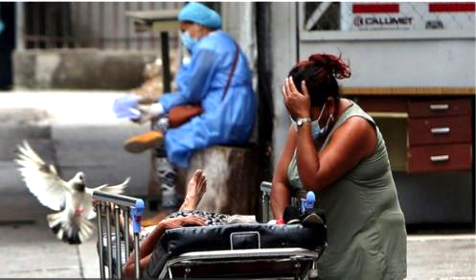
Honduras has had 369,000 confirmed COVID-19 cases and nearly 10,000 deaths. The highest number of deaths was recorded in July 2021, as three variants are now present in the country. Hospitals are filled to capacity with serious cases, and medical supplies and PPE are running low. CARE’s immediate priority is to support 14 municipalities in the western region – the poorest part of the country with the largest indigenous population. CARE channeled Second Wave funding through our existing HOGASA (community health) project, which already was well-positioned to support communities and healthcare providers. We are strengthening service providers and health volunteers in COVID-19 prevention and surveillance; distributing lifesaving equipment and supplies to three hospitals, 14 health centers and three isolation centers; delivering hygiene kits to 2,100 vulnerable familes; designing a communications campaign to reach people through community radio stations and social media; and advocating with municipal governments to include prevention and vaccination campaigns in their plans and budgets. Overall, your support is helping the entire population in the targeted municipalities – approximately 50,000 people – with better care through protection and quality healthcare services.

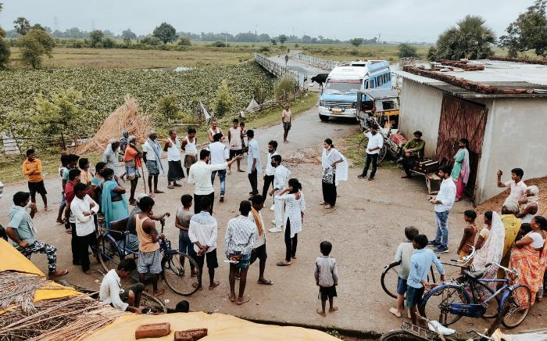
In India, the massive second wave in COVID-19 infections overwhelmed the country’s health system between April and June 2021. Hospitals ran out of beds, oxygen and PPE. Since then, active cases have leveled off, from a peak of 400,000+ new infections a day to around 15,000 today. To date, 20.5% of the Indian population has been fully vaccinated, compared with 1.2% in late April. Since the onset of the second wave, India has been CARE’s top priority, given the explosive impact the pandemic has had on the country. CARE has been working with state governments and local administrations to establish and operate 14 COVID-19 intensive-care centers, distribute lifesaving oxygen and medical supplies, conduct community prevention activities and support mega-vaccination campaigns, including deploying mobile vaccination vans and boats to hard-to-reach rural communities, where misinformation and vaccine hesitancy is most pervasive. Between April and September 2021, CARE’s COVID-19 second-wave response reached more than 11 million people across 17 states. Our targets include supporting 64 million vaccine doses by December 2021 and upgrading 25 district hospitals and 50 community health centers so they are prepared to address future surges.

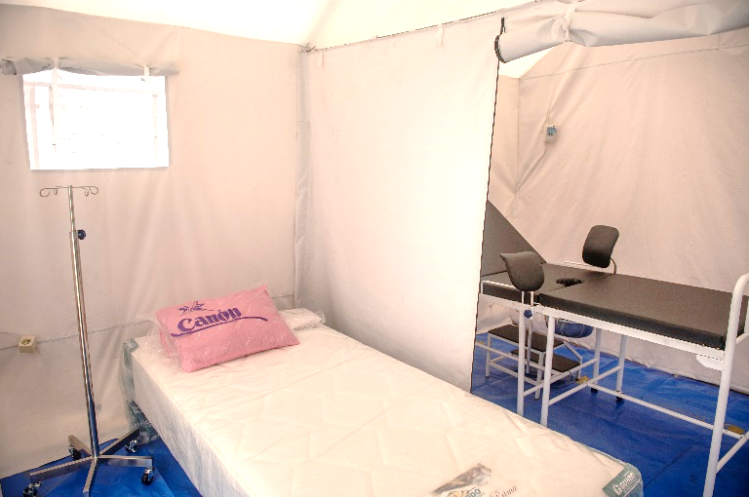
Indonesia is now a major epicenter of the COVID-19 pandemic. Total cases have topped 4.2 million, with more than 142,000 deaths. Only 19% of the population has been fully vaccinated. The current spike is primarily attributed to the strength of the Delta variant, combined with very low compliance of communities following recommended health protocols. As in Honduras and India, hospitals are overflowing and lack medicine, PPE and oxygen. In response, CARE has been ramping up the capacity of 31 health centers (oxygen/medical supplies), providing inflatable negative-pressure tents and beds to accommodate COVID-19 patients, as well as PPE kits and food supplements to 310 frontline health workers. Separate tents are being used as temporary maternity wards, allowing delivery for pregnant women with COVID-19 (pictured at right). We also are providing nutritious food, vitamins, hand sanitizer and face masks to women and children under 5 who tested positive and are isolating at home. To date, this response in Serang district has directly benefited nearly 12,000 people. In addition, CARE is distributing tents, oxygen tanks and medical supplies to 10 health centers/100 health workers in Central Sulawesi and five health centers/50 health workers in West Sulawesi.

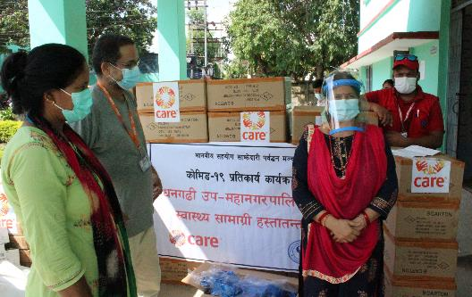
Nepal has more than 800,000 confirmed COVID-19 cases, with 11,192 deaths. Only 22% of the country’s 29 million people have been fully vaccinated. Supported by Second Wave funding and other sources, CARE is responding primarily in three districts: Nawalparasi, Rupandehi and Kapilvastu. Working in close collaboration with the Ministry of Health, we have provided 28 health centers with essential equipment and supplies, including COVID testing kits, PPE, beds, oxygen concentrators, pulse oximeters, thermometers, hand sanitizer, self-isolation kits and construction materials. CARE also has mobilized approximately 200 women community health volunteers to support the vaccination campaign; provided equipment to ensure that vaccines are stored properly on their way to vaccination sites; and aired prevention and vaccination messages via radio, texts, posters and social media. Simultaneously, in Banke and Kanchanpur districts, CARE has provided quarantine kits (nutritious food and hygiene supplies) to an initial 546 people – infants and pregnant women – with more distributions planned. In the coming weeks, to address the economic impacts experienced by the most vulnerable farming families, we will provide seeds, fertilizer and equipment to help restart livelihoods that have been put on hold during the pandemic. Overall, to date, CARE’s response in Nepal has benefited 171,891 people.

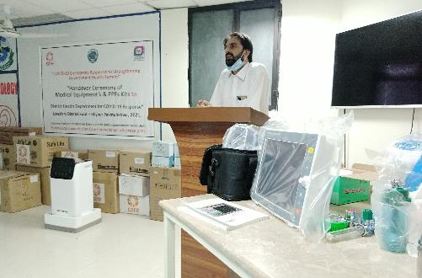
Pakistan has had 1.26 million confirmed COVID-19 cases and 28,032 deaths; only 14% of the country’s 266 million people are fully vaccinated. The current surge has put significant stress on the existing health system, with intensive-care units reaching capacity and oxygen supplies running low. Vaccination hesitancy remains a serious problem. CARE launched a rapid response in three districts (Swat, Abbotabad and Quetta), supporting nine health facilities and 12 vaccination centers that serve 270,000 people. At these facilities/centers we are distributing medical equipment and a steady supply of PPE. CARE also is distributing food and hygiene kits to vulnerable families and supporting 15 schools (five per district) with handwashing stations and water as well as conducting hygiene promotion and COVID-19 awareness, and establishing vaccination centers in surrounding communities. Health workers, who are directly involved with children and their parents, have been trained to play a central role in prevention and control. Banners and billboards with COVID-19 messages are displayed on local transport (rickshaws and vans), and influencers like popular cricket players have been engaged to disseminate messages and reduce hesitancy. We also have established advocacy groups in the three districts to further strengthen and monitor the vaccination process with the government.

Conclusion
CARE is working in countries and communities hardest hit by the surge of COVID-19 and its variants. Thank you for supporting the Second Wave Fund, which is helping us meet the most pressing humanitarian needs during this ongoing crisis.

October 2021

