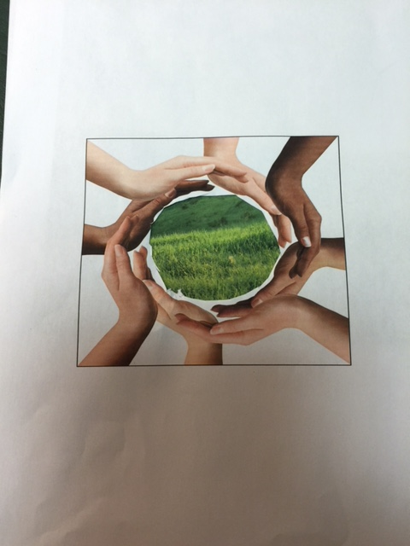Renewable Energy Solutions Fund

Project
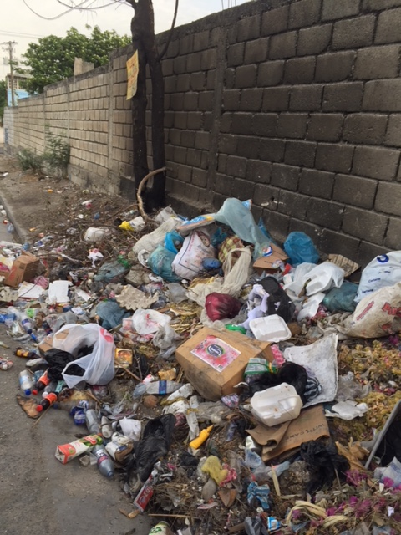

Environmental Protection – The Haiti Environmental Management & Sustainability Institute
Haiti’s Waste Management Issues
Haiti‘s population growth coupled with poor urban planning in the past decade has led to an increase in generated waste and deteriorations of its resources from the mountains to the its coasts. The problem is exasperated near the capital Port-au –Prince and its medium sized cities. Waste collection is minimal as only 30% of waste is collected in the capital city. Uncollected waste is burned in open air causing major environmental impact or dumped on the tops of the mountains, causing major flooding during rainy seasons. Waste minimization or recycling methods are not known.
Although progress has been made after the earthquake most of the country side and cities outside of Port-au-Prince suffer from access to energy and hygienic systems. Only 11% of people in the country side have access to energy and 16 % have access to improved sanitation. Although extreme poverty has improved in larger cities it has remained the same for rural areas for the last 12 years.
The Haiti Renewable Energy Solution fund seeks to create an Environmental management and sustainability Institute. The main goals of the Institute will be:
Environmental Projects & Impact
Education
The institute will provide secondary curricula leading to degrees in Urban planning, sustainable development, waste management, and related training certifications. Graduates will have career opportunities in urban planning, environmental ministry, Coastal management, water and air pollution control and management and waste management in institutions such as hotel, restauration, hospitals, and process industries.
Environmental Awareness Promotion
The institute will deliver campaigns aimed at educating the local populations on waste minimization, pollution control and understanding and minimizing the negative impact of their actions on the environment. We will work with local commerce, international institutions and the government to finance the hiring of women in those roles.
Reduction in Poverty and Women Empowerment through Economic Development This project will engage the local communities by helping women develop commercially profitable activities in waste recycling, waste to energy systems, and water conservation.
Environmental Cultural awareness
The institute will organize regular thematic events, to facilitate exchanges and transfer of knowledge with the international institutions and government representatives in Haiti. The institute will visit other countries to promote Haiti’s environmental management efforts.
The goal is for this institute to become the center of reference on how to treat environmental protection matters in Haiti, and to help Haiti develop an environmental policies aligned with the World’s directives.
Opportunities for Women
Reduction in Poverty and Women Empowerment through Economic Development: This project will engage the local communities by helping women and underprivileged youths develop commercially profitable activities in waste recycling, Waste to energy systems and management.
We are grateful for any consideration for the startup funds that are badly needed for this project. The funds needed to cover the first year for startup are listed below:

Expenses year 1 Months 1-12
 | US D
 | 1
Registration of entities in Haiti  And associated lawyer fees | 7000
Travel to and from and related costs while in Haiti | 2000
Opening and rental expenses for Institute . | 15,000
Staff ( Institute) | 1000
Teachers | 15,000
Materials | 10,000
Total | 50,000

