- 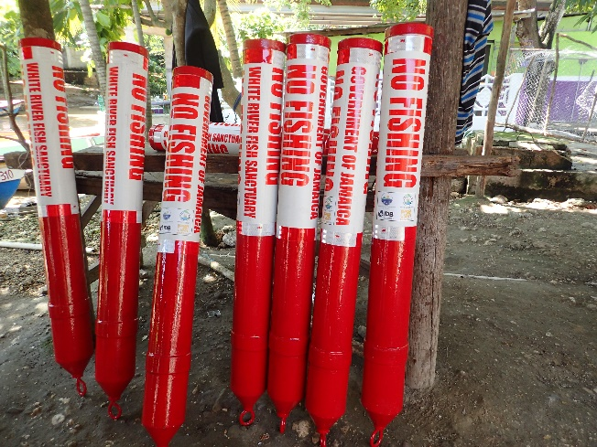 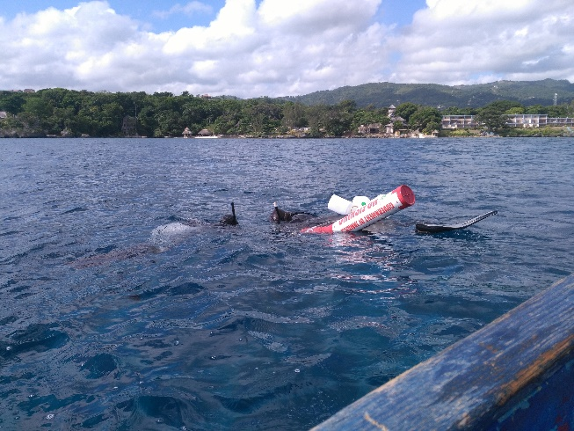
sponsor a buoy – One of, if not the most important aspect of the sanctuary is its border. It is the floating devices in the water that delineate the protected area. Its presence informs fishermen, tourists, dive operators and others the beginning and end of the no-take zone, where they can and cannot set fish pots, shoot fish, or remove any marine organism from the water. It is therefore very important that we maintain the sanctuary borders. The WRFS is proposing to interested persons to sponsor a sanctuary buoy. This allows you to directly support a tangible item toward the sanctuary. Companies/organizations can even advertise their by placing their logos on the buoy. For more information, reach out to us through email whiteriverfs@gmail.com

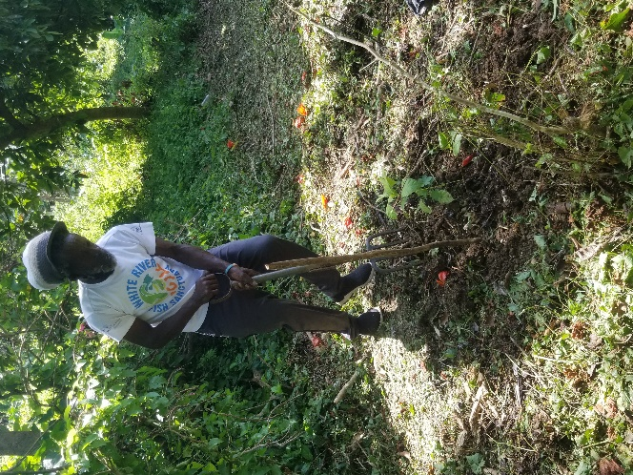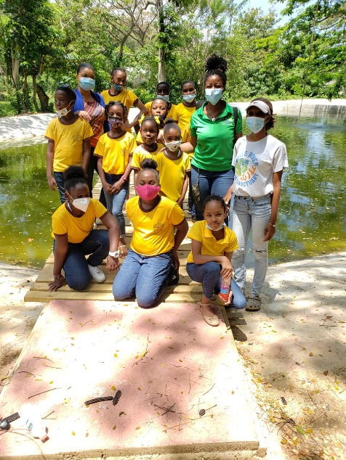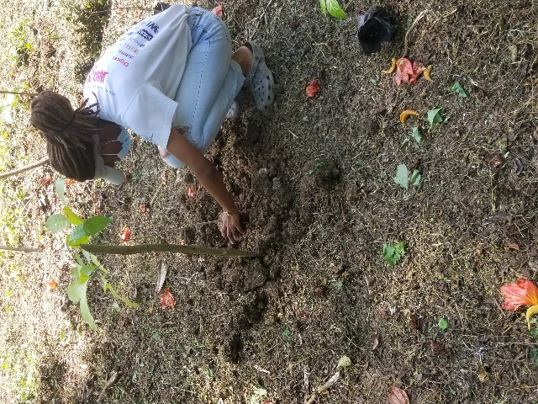
-earth day
April 22nd is recognized as Earth Day and was founded in 1970 as a day of education about environmental issues. The day is now a global celebration that’s sometimes extended into Earth Week, a full seven days of events focused on green living. This year, WRFS team members partnered with the National Planning and Environment Agency (NEPA) and the Ocho Rios Nature Preserve Trust to plant ONE HUNDRED fruit trees. A variety of mango, breadfruit, golden apple (june plum) sugar apple (sweetsop) and more. Truly a fulfilling day!

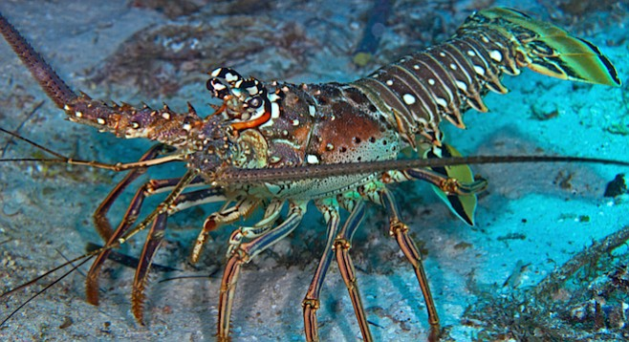
- closed lobster season
Many persons may be wondering what a “closed season” is or why lobsters are not always in season in Jamaica. The Annual Lobster breeding season in the waters around Jamaica arrives in late spring and ends in early summer. That's why each year, April 1st through June 30th, is considered to be a 'closed' season. During the closed season, fishing for lobsters is illegal, and no lobsters should be kept alive in any holding device. However, lobsters unintentionally captured in the fishing gear must be put back into the sea right away. It is our duty as consumers to refrain from buying/requesting lobster meat during the closed season, as well as to report persons, restaurants and/or other business that are selling lobsters, to the relevant authorities. As we Jamaicans would say “Low dem mek dem grow!”

Sea turtle Week
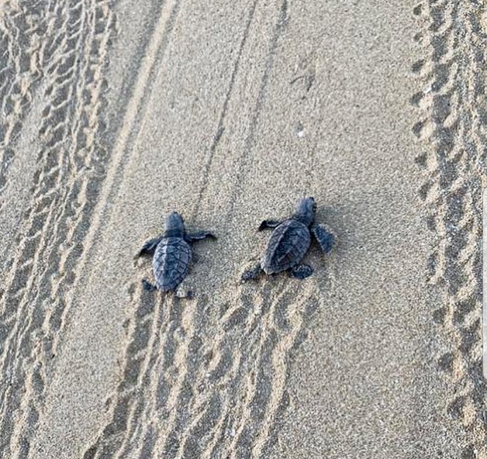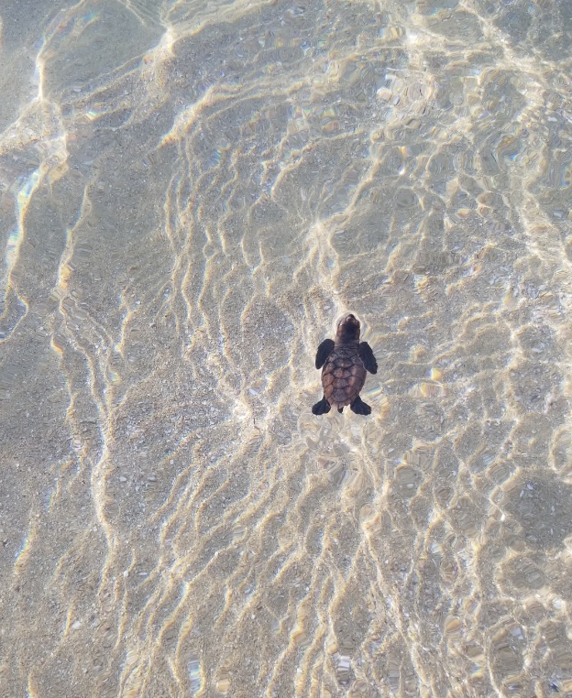
This year, June 08th – 16th will mark the third annual Sea Turtle Week. It is a global effort where each of the seven sea turtle species are highlighted along with some of the threats they face. The week kicks off with World Ocean Day and concludes with World Sea Turtle Day. Six of the seven species are threatened or endangered at the hand of humans. Unfortunately, they face many dangers as they travel through the sea — including accidental capture and entanglement in fishing gear (also known as bycatch), the loss of nesting and feeding sites to coastal development, poaching, and ocean pollution including plastic. Fortunately, there are many organizations in Jamaica and globally, that promote conservation of sea turtles by looking after nests, reducing plastic use and organizing and participating in beach clean ups.

DID YOU KNOW?
While there are some causes of climate change that are natural, like volcanic eruptions, the reason we are facing a climate crisis now is because of human activity. The main causes of climate include:
Burning fossil fuels for energy
Intense farming and agriculture to produce meat and crops
Removing forests and trees to make space for other land uses

